December 20, 2022
For Immediate Release

Cass McCombs Expands North American Tour

Heartmind Out Now on ANTI-
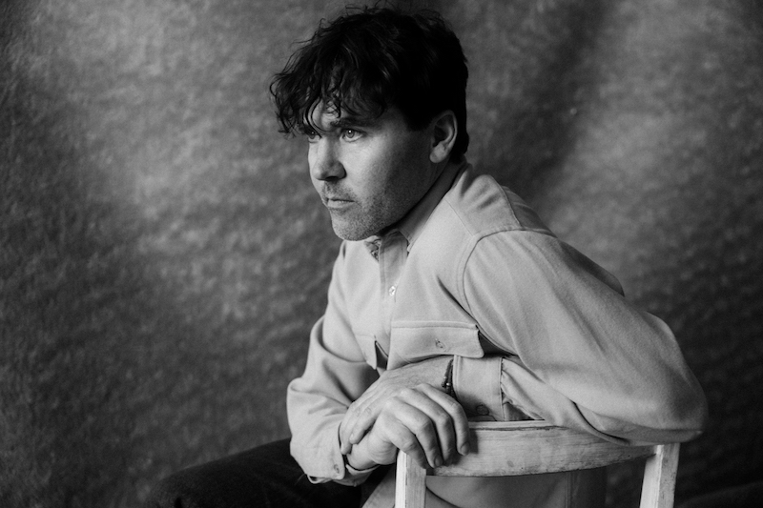
Photo Credit: Ebru YIldiz

Cass McCombs is “one of America’s most reliably excellent singer-songwriters” (The Guardian), and with his tenth album Heartmind, out now on ANTI-, he’s “still functioning at [his] highest level at an age when many of their peers have stagnated” (Wall Street Journal, The Best Music of 2022). In support of the album, today he announces he’s expanding his winter North American tour, which will follow a European leg. On the heels of a European tour, and in addition to many previously-announced dates throughout the eastern half of the US, this new batch of shows includes a slew of west coast dates, many in California. This will be the first time Cass is playing songs off of Heartmind, and will feature a full band. Tickets for all dates are on sale now.

Watch/Listen/Share
Purchase Heartmind
“Belong to Heaven” Video
"Unproud Warrior" Video
“Karaoke” Video
“Instrumental Karaoke Version”

Cass McCombs Tour Dates
(new dates in bold)
Fri. Jan. 13 - Amherst, MA @ The Drake
Sat. Jan. 14 - Providence, RI @ Columbus Theatre
Sun. Jan. 15 - Boston, MA @ The Sinclair
Tue. Jan. 17 - Indianapolis, IN @ Hi-Fi
Wed. Jan. 18 - Chicago, IL @ Thalia Hall
Fri. Jan. 20 - Toronto, ON @ Great Hall
Sat. Jan. 21 - Pittsburgh, PA @ The Andy Warhol Museum
Sun. Jan. 22 - Charleston, WV @ Mountain Stage
Tue. Jan. 24 - Washington, DC @ 9:30 Club
Wed. Jan. 25 - Ardmore, PA @ Ardmore Music Hall
Thu. Jan. 26 - New York, NY @ Bowery Ballroom
Sat. Feb. 18 - San Luis Obispo, CA @ SLO Brew
Sun. Feb. 19 - Sacramento, CA @ Harlow’s
Tue. Feb. 21 - Felton, CA @ Felton Music Hall
Thu. Feb. 23 - San Francisco, CA @ The Independent
Sat. Feb. 25 - Portland, OR @ Doug Fir
Sun. Feb. 26 - Seattle, WA @ Neumo’s
Tue. Feb. 28 - Sonoma, CA @ Sebastiani
Wed. March 1 - Ojai, CA @ Deer Lodge
Thu. March 2 - Joshua Tree, CA @ Pappy & Harriet’s
Fri. March 3 - Los Angeles, CA @ Teragram

Praise for Heartmind

“McCombs sings here, quite possibly from his highest songwriting heights. . . In channeling the sweetness of the Everly Brothers and the finesse of Roy Orbison, an unknowable troubadour sends a bright, devastating eulogy to one of their neighbors.”
- Washington Post, Best Songs of 2022

"As a writer, McCombs has never sounded so confident or intentional.” - Pitchfork

“‘Heartmind’ is an arresting collection of songs that tackles pain and uncertainty with humor and grace, from an underrated troubadour who makes it look easy.” - Wall Street Journal

"Within [Heartmind’s] classic run-time of 8 songs and 43 minutes is a genuine attempt at avoiding betraying direction and attempting to understand more of the world around us.”
- Aquarium Drunkard

"In its melodies and structures, [Heartmind] has the same wristwatch-like quality as all of his best work, beautifully simple on the surface despite the intricate complexity underneath.”
- The FADER

"The characters and narratives on Heartmind reflect some of the most mature writing of McCombs’ career.” - FLOOD

"[Cass] has pieced together one of the more sonically mesmerizing, and intellectually thought-provoking discographies in the realm of indie-country-Americana rock.” - SPIN

Download Cass McCombs’ hi-res press images and album art

Heartmind Cover Artwork (photo by Cass McCombs)

Website | Facebook | Instagram | Twitter

For more information, contact:
Jessica Linker | Pitch Perfect PR – jessica@pitchperfectpr.com, 773-942-6954
Jaycee Rockhold | Pitch Perfect PR - jaycee@pitchperfectpr.com, 816-731-8260

