DANNY ELFMAN DEBUTS
XIU XIU REMIX OF “SERIOUS GROUND”

A BRAND NEW REIMAGINING OF MUSIC
FROM ELFMAN'S ACCLAIMED NEW
DOUBLE ALBUM BIG MESS

LISTEN NOW HERE

“Serious Ground (Xiu Xiu Remix)” Single Artwork

October 12th, 2021 (Los Angeles, CA) - Today, Danny Elfman has debuted a brand new Xiu Xiu remix of “Serious Ground,” one of the songs initially featured on Elfman’s acclaimed new double album Big Mess [ANTI- / Epitaph Records]. The track serves as an experimental reinterpretation, pairing Xiu Xiu’s signature industrial noise sensibilities with chopped samples of Elfman's original vocals and instrumentation. Listen now HERE.

“I was introduced to Xiu Xiu by Stu Brooks, who kickstarted and co-curated the remix concept for “Big Mess,” says Elfman. “They have a fresh, progressive sound that I thought would make for a great collaboration. Expecting the unexpected is the most fun part of this whole project so I was really curious and excited to see what direction they’d go in. I’m very happy to have them be a part of the “Big Mess” project.”

Xiu Xiu’s remix of “Serious Ground” marks the fourth collaborative effort for Elfman from Big Mess, as he previously joined forces with Zach Hill of Death Grips for a remix of “Kick Me,” worked with Squarepusher for a glitchy remix of “We Belong,” and teamed up with Trent Reznor to unleash a new duet version of his song “True.” Showcasing a sonic collision of two musical icons, the reimagined single of “True” caught the eye of Entertainment Weekly, Vulture, Pitchfork, Rolling Stone and more upon its release this summer. Watch the music video for the track now HERE, which was directed by Aron Johnson, who contributed visual effects to the Sarah Sitkin-directed music video for the album version of “True.” Combining segments of Sitkin's archived footage along with brand new 3D modeling, the visual serves as a remix in itself of the original music video, reinterpreted through the eyes of Aron.

Following the release of several dynamic singles and aesthetically groundbreaking videos over the past year, Elfman officially unveiled ‘Big Mess’ in June, his first solo record in thirty-seven years. Clocking in at 18 tracks, the expansive double album finds the 4x Oscar nominated, Grammy and Emmy Award-winning composer breaking bold new ground as both a songwriter and a performer. Joined on the album by drummer Josh Freese (Devo, Weezer, The Vandals), bassist Stu Brooks (Dub Trio, Lady Gaga, Lauryn Hill), and guitarists Robin Finck (Nine Inch Nails, Guns N’ Roses) and Nili Brosh (Tony MacAlpine, Paul Gilbert), the project has garnered widespread praise since its release:

“A fiercely political work filled with bombastic peaks and strikingly meditative valleys.” - LA Times

“The best representation of himself he’s ever created in his half-century career.” - SPIN

“Expertly conceived, meshing sawing classical strings, gutsy rock, electronics and enough energy to power a small city.” - American Songwriter

“A sonic howl — part glam rock, part orchestral, part punk, with driving, industrial songs that are liable to disintegrate or tear off into a different direction.” - Associated Press

“9 out of 10...A whirlwind of unbounded creativity as only Elfman could envision and produce." - Metal Injection

The songs on ‘Big Mess’ unite both harmonically complex arrangements and simple high energy driving music with biting, acerbic wit as they reckon with the chaos and confusion of the modern world. These feelings of anger, angst and frustration that permeate ‘Big Mess’ are explored in the album’s artwork and music videos, which push the boundaries between art and technology and each feature Danny in distinct ways. For the cover artwork, Elfman was 3D scanned and transformed into a grotesque looking digital sculpture by Sarah Sitkin. Using CGI, 3D technology, motion capture and artificial intelligence, each music video was uniquely made and are inextricable from the songs that inspired them. Led overall by Elfman’s creative director Berit Gwendolyn Gilma, each of the video’s directors - Aron Johnson (“Happy”), Jesse Kanda (“Sorry”), Sven Gutjahr (“Love In The Time of Covid”), Petros Papahadjopoulos (“Kick Me”), Sarah Sitkin (“True”), Sam & Andy Rolfes (“Insects”) – have created individual statements that shape a diverse but cohesive whole. The Big Mess album and visuals were produced by Danny Elfman and executive produced by Elfman’s longtime manager Laura Engel.

‘Big Mess’ is out now via ANTI- / Epitaph Records and is available on all digital streaming platforms here.

###
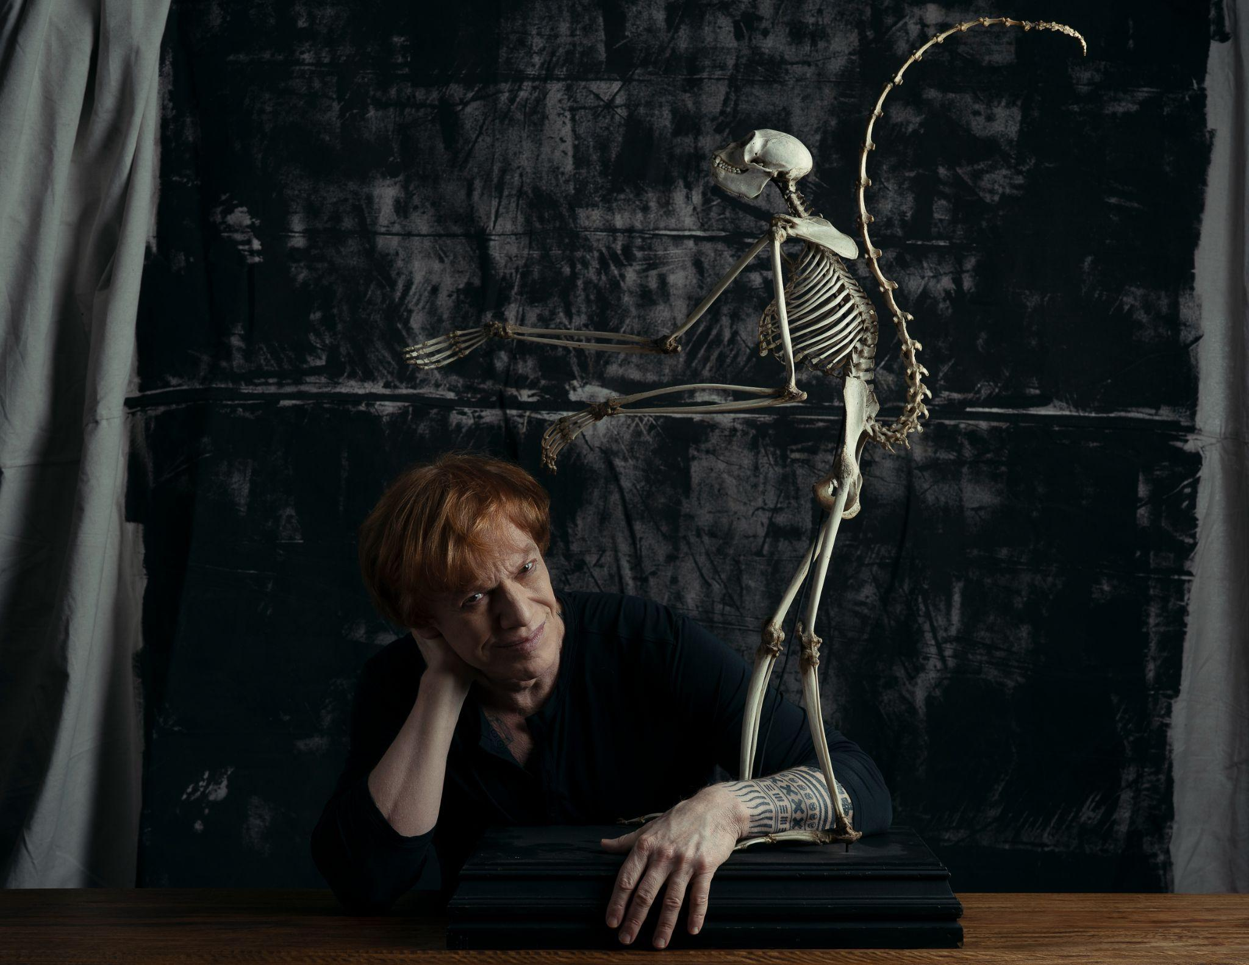

CONNECT WITH DANNY ELFMAN:
https://www.dannyelfman.com/
Instagram | Facebook | Twitter | Spotify

