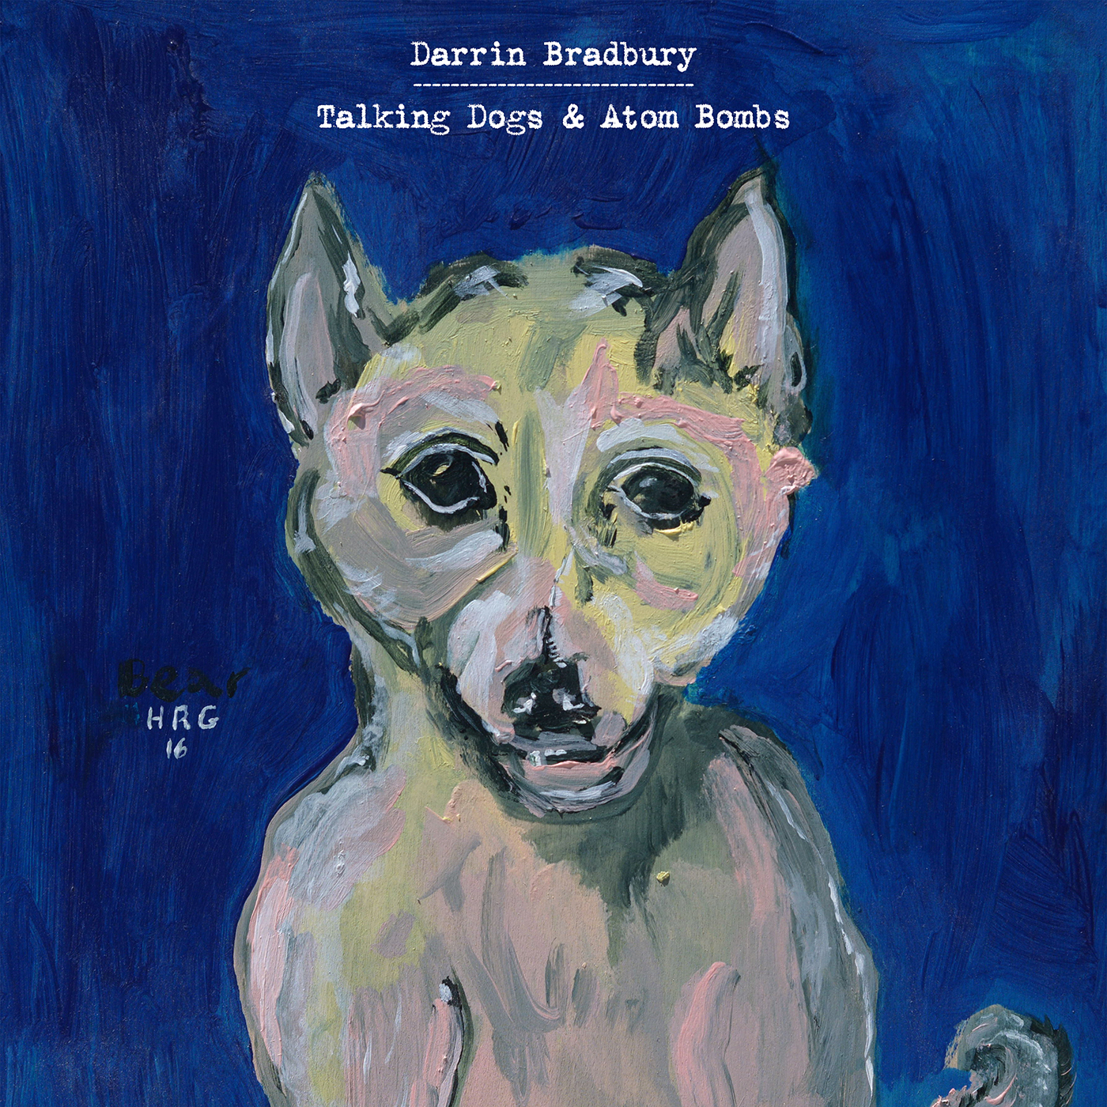

For Immediate Release—

Darrin Bradbury Announces New Full-Length Talking Dogs & Atom Bombs
Album set for September 20th release on ANTI- Records, first single out now

July 24, 2019 - Nashville, TN - Like a more self-deprecating, decidedly morose John Prine, or perhaps a more jovial Guy Clark, New Jersey native Darrin Bradbury’s songs are riddled with hilarious, obvious-once-you-hear-them observations on mundane everyday life. The eleven songs on Talking Dogs & Atom Bombs, Bradbury’s new release on ANTI- Records, leave listeners singing along with sometimes ridiculous, often dark, but instantly familiar tunes. Take 60 seconds to learn more about Darrin Bradbury here.

Produced by Kenneth Pattengale (The Milk Carton Kids), Talking Dogs & Atom Bombs is a collection of songs born from dealing with depression and the pressures of life in the only way Bradbury knows; by poking fun at it. “It’s an album trying to combat depression, to laugh your way out of depression, and to be honest and accurate with that depression,” Bradbury quips. “I try to write things that make me chuckle, and that chuckling is usually making peace with the existential dilemma of both the times and life in general.” Today, Wide Open Country premiered the title track from Talking Dogs & Atom Bombs, calling it “philosophical” and noting that “Fans of John Prine, Steve Goodman and other lyricists who're as quick-witted as they are hilarious will find a kinship with Bradbury.” The album is available for pre-order today.

With only one co-writer on the entire album—ANTI- label-mate, friend, and fellow esteemed Nashville musician, Jeremy Ivey—Bradbury’s one-of-a-kind style is allowed to shine brilliantly, unobstructed by outside opinion. The tracking of Talking Dogs & Atom Bombs was completed in a similarly simple way; using the same combo of musicians for every song on the record. Aside from producer Pattengale’s mellotron and vocal contributions and the aforementioned Ivey’s bass and piano playing, only two extra musicians were called to round out the band; Alex Muñoz on additional guitars and Dillon Napier on drums. The only exception is the lone guest vocalist on the album, modern outlaw country queen and longtime supporter of Bradbury, Margo Price, who adds a somber harmony to a track titled “The Trouble With Time.”

Of the eleven songs on Talking Dogs & Atom Bombs, only two of them are more than three minutes long. The shortest of which, “Strange Bird,” clocks in at one minute, seventeen seconds. “In the writing of this album, what was important to me was that the song was over when the thought was over. It wasn't about having to fill a certain amount of space,” Bradbury says. “If I'm not motivated to say anything more about this particular thing, I won't force it. I would rather have a minute-and-a-half song that I felt conveyed something unique.”

Talking Dogs & Atom Bombs will be Darrin Bradbury’s first release on ANTI- Records. “Darrin possesses a wonderful, darkly sardonic sense of humor and a matter of fact wisdom that reminded me of some of my favorite writers from Chuck Berry to Mose Allison to John Prine,” says ANTI- founder, Andy Kaulkin. “I haven’t heard anyone do this sort of thing on this level for a very long time. His songs keep me on the edge of my seat.”

“When I write, there are things that I want to get away with,” Bradbury says. “I want to get away with the line, ‘I woke up this morning and I got out of bed / Tripped on my pants and fell on my head.’ ” Overall, Talking Dogs & Atom Bombs is a beautifully refined version of Bradbury’s writing; going for broke, connecting the dots, and doing it with blunt honesty that brings it all home. “If I can get you to take that seriously, and not skip a beat when you listen to it, that's what I want.”

Track listing:
- Talking Dogs & Atom Bombs
- Breakfast
- Hell’s More or Less the Same
- The Trouble with Time (feat. Margo Price)
- Strange Bird
- Nothing Much
- The American Life
- This Too Shall Pass
- Motel Room, Motel Room
- So Many Ways To Die (Frozen Pizza)
- Dallas 1963

On Tour:
September 10-15 – Nashville, TN – AMERICANAFEST
September 30 – Baltimore, MD – Creative Alliance at the Patterson (with John Moreland)
October 1 – Alexandria, VA – The Birchmere (with John Moreland)
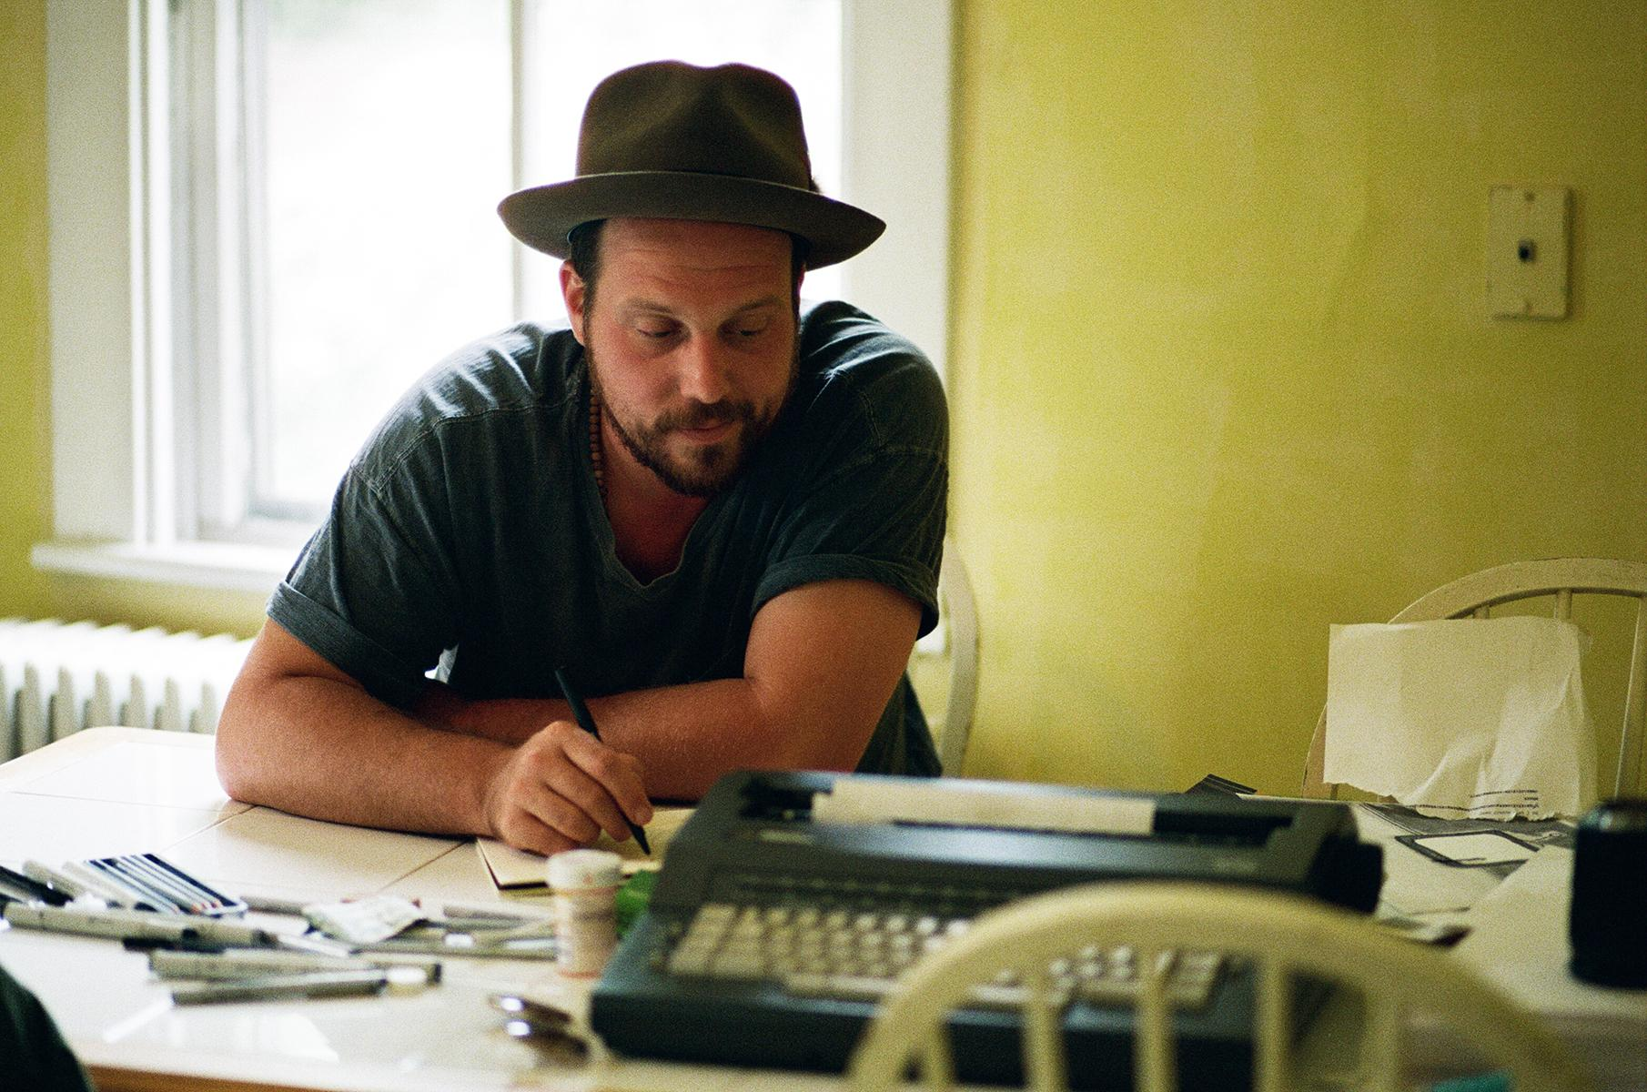
About Darrin Bradbury:
Darrin Bradbury writes about the way things really are in America – a singular perspective shaped by a natural gift for storytelling, a lingering battle with depression, and a sly sense of humor. A self-described folk satirist who has toured the country for more than a decade, Bradbury collects his oddball observations in his newest album, Talking Dogs & Atom Bombs.

Bradbury grew up in New Jersey with an early interest in performing, partly because of his mother’s career as a circus clown. At the age of 7, he felt certain that he would either become a songwriter or a cartoonist. He learned to play guitar as a vessel to tell his stories -- and because his handwriting and grammar steered him away from being a novelist. By the age of 18, he’d discovered Bob Dylan, Jack Kerouac, and Paul Simon, and decided to hit the road.

At 25, he moved from Charlottesville, Virginia, to Nashville, to try making it as a songwriter. For three months, he slept in his car in a Walmart parking lot, and developed a local following by playing open mic nights. With a handful of self-funded EPs and albums, Bradbury steadily cultivated a national audience by touring constantly. Produced by Kenneth Pattengale of the Milk Carton Kids, Talking Dogs & Atom Bombs is Bradbury’s first release for ANTI- Records.

###

