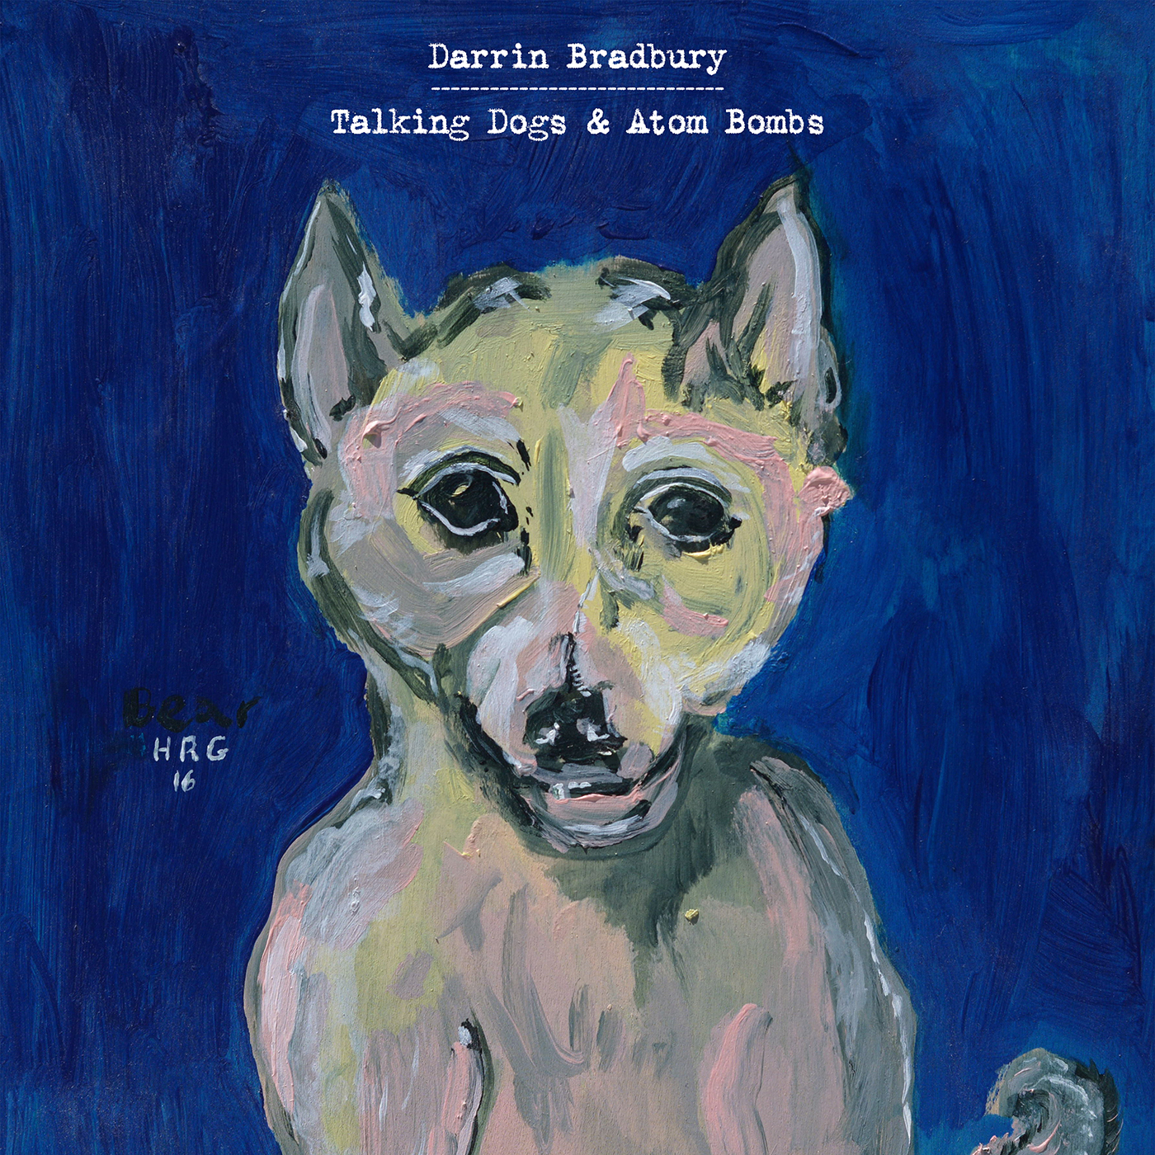

For Immediate Release—

Darrin Bradbury Releases New Single “Breakfast”,
Announces International Tour Dates
Talking Dogs & Atom Bombs set for September 20th release on ANTI- Records

August 21, 2019 – Nashville, TN – Mixing humor with obvious-once-you-hear-them observations on mundane, everyday life, Darrin Bradbury’s unique wit makes for songs that are instantly relatable; this is evident on “Breakfast,” the second single from his highly-anticipated new album Talking Dogs & Atom Bombs, slated for release on September 20 via ANTI- Records. Yesterday, The Bluegrass Situation premiered the new track and video; read more and watch here. Today, Bradbury announced that he will join Texas songwriter Jarrod Dickenson for a UK tour beginning in London, following U.S. dates supporting John Moreland (full schedule below). Talking Dogs & Atoms Bombs is available for pre-order today.

Produced by Kenneth Pattengale (The Milk Carton Kids), Talking Dogs & Atom Bombs is a collection of songs born from dealing with depression and the pressures of life in the only way Bradbury knows; by poking fun at it. “It’s an album trying to combat depression, to laugh your way out of depression, and to be honest and accurate with that depression,” Bradbury quips. “I try to write things that make me chuckle, and that chuckling is usually making peace with the existential dilemma of both the times and life in general.” Pattengale recounts, “For awhile there Darrin and I would meet about once a week at my neighborhood coffee shop under the guise of me dispensing advice to him, despite repeated warnings that I am NOT in the advice giving business. As these things go, there was not much to say, and not much to learn—just friendly commiseration about the torrential weather bashing at the faces of anyone who dares to attempt a career in music. So maybe it was apt that I took the wheel for Darrin’s album about depression. Captain and co-pilot leading a more diverse Ship of Fools in circles out at sea.”

Last month, Wide Open Country premiered the title track from Talking Dogs & Atom Bombs, noting that “Fans of John Prine, Steve Goodman and other lyricists who're as quick-witted as they are hilarious will find a kinship with Bradbury.” Rolling Stone Country named the single one of the “10 Best Country and Americana Songs To Hear Now” and described it as a unique blend of, “Bradbury’s signature gumbo of countrified talking blues, oddball folk, and black humor, with some stoner-worthy philosophy about the origins of microwaves tossed into the pot.”

Described as a “stellar singer and songsmith” by Nashville Scene, Bradbury enlisted the help of only one other writer for the entire album—ANTI- label-mate, friend, and fellow esteemed Nashville musician, Jeremy Ivey. The tracking of Talking Dogs & Atom Bombs was completed in a similarly simple way; using the same combo of musicians for every song on the record. Aside from producer Pattengale’s mellotron and vocal contributions and the aforementioned Ivey’s bass and piano playing, only two extra musicians were called to round out the band; Alex Muñoz on additional guitars and Dillon Napier on drums. The only exception is the lone guest vocalist on the album, modern outlaw country queen and longtime supporter of Bradbury, Margo Price, who adds a somber harmony to a track titled “The Trouble With Time.”

Talking Dogs & Atom Bombs will be Darrin Bradbury’s first release on ANTI- Records. “Darrin possesses a wonderful, darkly sardonic sense of humor and a matter of fact wisdom that reminded me of some of my favorite writers from Chuck Berry to Mose Allison to John Prine,” says ANTI- founder, Andy Kaulkin. “I haven’t heard anyone do this sort of thing on this level for a very long time. His songs keep me on the edge of my seat.”

“When I write, there are things that I want to get away with,” Bradbury says. “I want to get away with the line, ‘I woke up this morning and I got out of bed / Tripped on my pants and fell on my head.’ ” Overall, Talking Dogs & Atom Bombs is a beautifully refined version of Bradbury’s writing; going for broke, connecting the dots, and doing it with blunt honesty that brings it all home. “If I can get you to take that seriously, and not skip a beat when you listen to it, that's what I want.”

On Tour:
Aug 23 – Nashville, TN – WMOT’s Finally Friday
Sept 10-15 – Nashville, TN – AMERICANAFEST
Sept 30 – Baltimore, MD – Creative Alliance *
Oct 1 – Alexandria, VA – The Birchmere *
Oct 4 – Garwood, NJ – Crossroads *
Nov 22 – London – The Cavendish Arms ^
Nov 23 – Broadhempston – Broadhempston Church ^
Nov 24 – Shrewsbury – Henry Tudor House ^
Nov 25 – Manchester – Gullivers ^
Nov 27 – Halifax – The Lantern ^
Nov 28 – Norwich – Waterfront Studio ^
Nov 29 – London – The Cavendish Arms ^
Nov 30 – Liverpool – Prohibition Recording Studio ^
Dec 1 – Glasgow – The Blue Arrow ^
Dec 2 – Edinburgh – The Voodoo Rooms ^
Dec 3 – Newcastle – Cluny 2 ^
Dec 5 – Bristol – Rough Trade ^
Dec 7 – Belfast – Ulster Sports Club ^
* supporting John Moreland
^ supporting Jarrod Dickenson
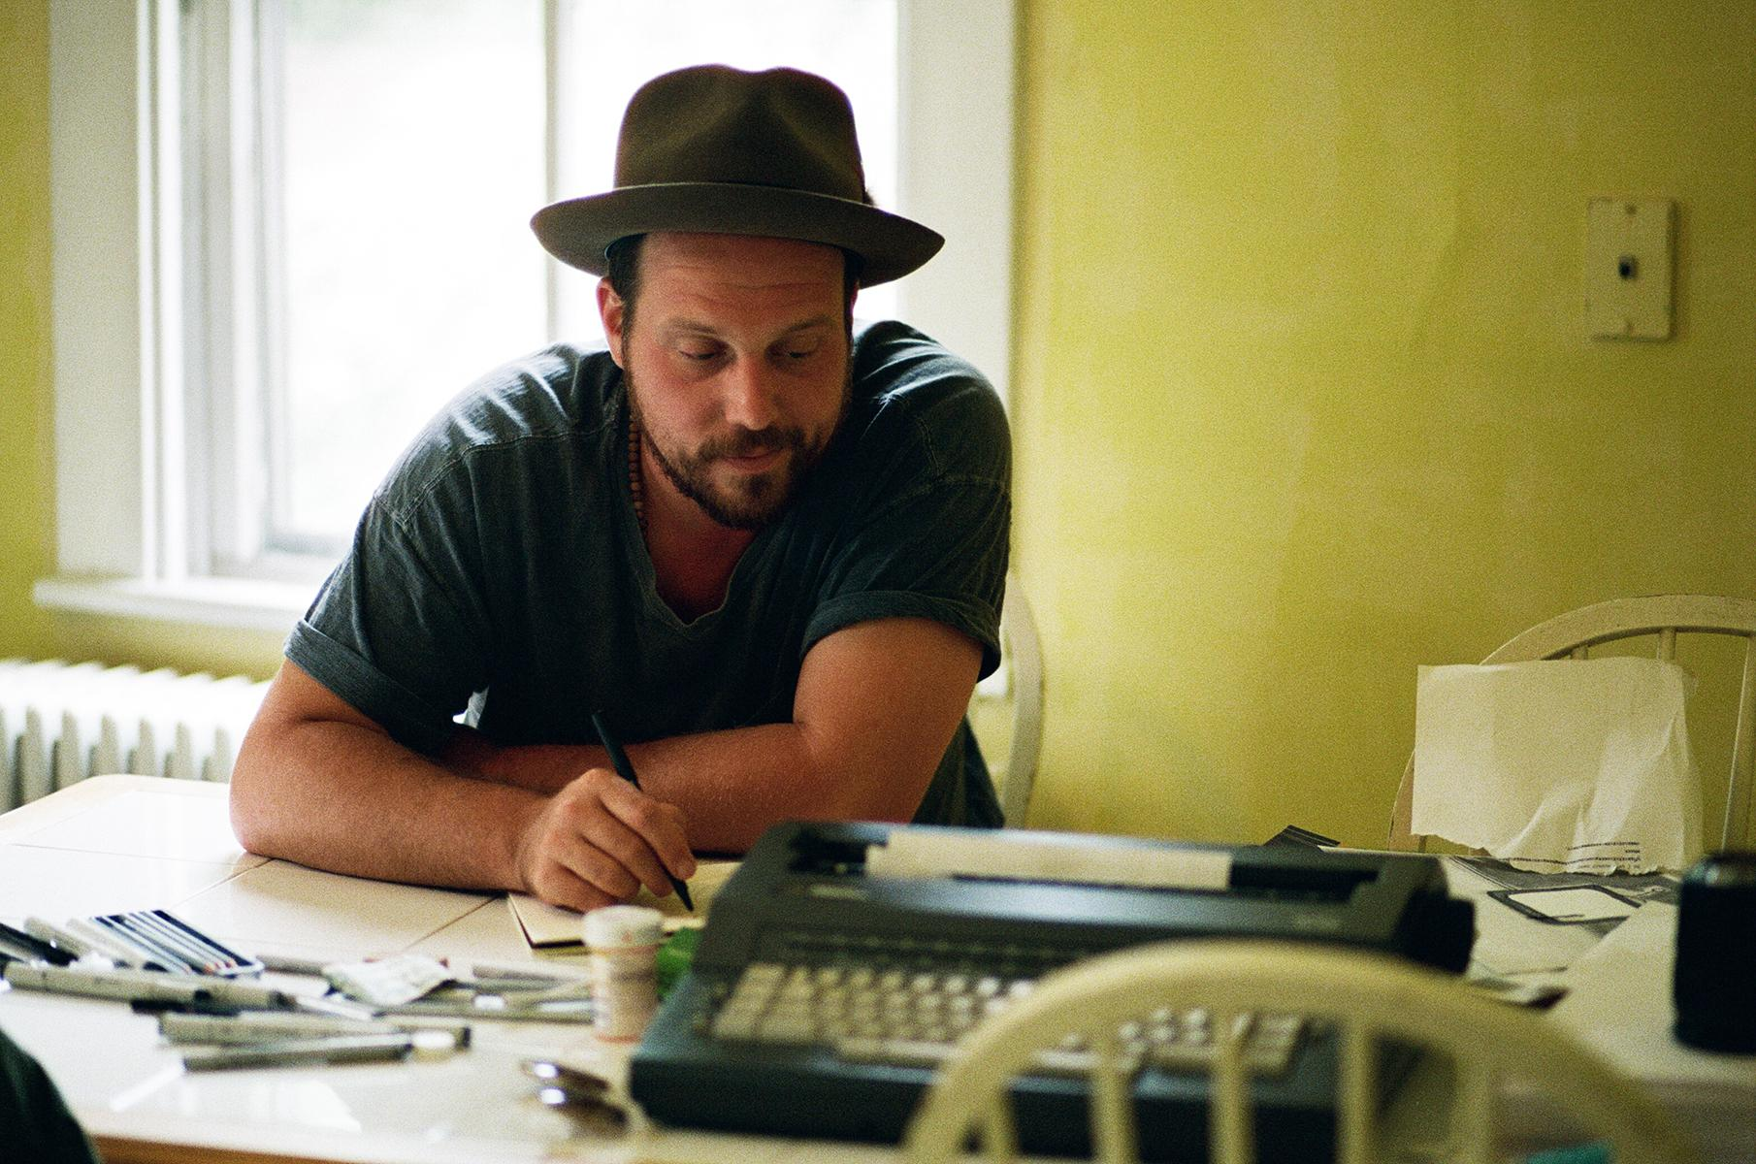
About Darrin Bradbury:
Darrin Bradbury writes about the way things really are in America – a singular perspective shaped by a natural gift for storytelling, a lingering battle with depression, and a sly sense of humor. A self-described folk satirist who has toured the country for more than a decade, Bradbury collects his oddball observations in his newest album, Talking Dogs & Atom Bombs.

Bradbury grew up in New Jersey with an early interest in performing, partly because of his mother’s career as a circus clown. At the age of 7, he felt certain that he would either become a songwriter or a cartoonist. He learned to play guitar as a vessel to tell his stories -- and because his handwriting and grammar steered him away from being a novelist. By the age of 18, he’d discovered Bob Dylan, Jack Kerouac, and Paul Simon, and decided to hit the road.

At 25, he moved from Charlottesville, Virginia, to Nashville, to try making it as a songwriter. For three months, he slept in his car in a Walmart parking lot, and developed a local following by playing open mic nights. With a handful of self-funded EPs and albums, Bradbury steadily cultivated a national audience by touring constantly. Produced by Kenneth Pattengale of the Milk Carton Kids, Talking Dogs & Atom Bombs is Bradbury’s first release for ANTI- Records.

###

