August 9, 2022
For Immediate Release

Ezra Furman Shares New Single/Video, “Poor Girl A Long Way From Heaven”

From New Album, All of Us Flames, Out August 26th via ANTI-/Bella Union

Tickets for North American Tour On Sale Now

(Photo by Tonje Thilesen)

"Ezra Furman is ready to get away from all of the bulls–t.” — Billboard

“With influences from Sixties girl groups to Bob Dylan’s Eighties records, [Furman] wrote the album during the early days of the pandemic, meshing growling vocals with songs about building communities in the ashes of a hostile world.” — Rolling Stone

"Furman’s uncompromising delivery allows her to triumph over her own personal trials, and she channels that determination into bringing others together behind the same defenses.” — Consequence

Ezra Furman releases a new single/video, “Poor Girl A Long Way From Heaven,” off of her forthcoming album, All of Us Flames, out August 26th via ANTI- / Bella Union. On "Poor Girl A Long Way From Heaven," Furman recounts a childhood encounter with God, a gesture of spiritual yearning that flows into the album's biblical facets. Her voice resonates over building instrumentation, bolstered by layered vocals. “The spiritual life ain’t all pious platitudes,” she elaborates. “This song is about how weird it gets, when you’re in love with the Source of Being and She’s not texting you back. Ever since it hit me that I was never going to be loved and accepted on the scale of my pop star heroes, me and my bandmates have started to work on a different vision of pop, one more our own, one that gestures at the stranger truths of the human mind. Here we are in thrall to verbally adventurous nineties music like Bjork and Beck and the Silver Jews and them kinda non-linear geniuses.”

As for the video, directed by Haoyan of America, Furman “basically told Haoyan a story I made up about a trans Joan of Arc narrowly avoiding her public execution, and then gave him free reign to do whatever he wanted with it, as long as Daphne Always (also seen in our recent ‘Forever in Sunset’ video) played Joan. I adore the cracked brilliance of what came out.”

Watch Ezra Furman’s Video for “Poor Girl A Long Way From Heaven”

A singer, songwriter, and author whose incendiary music has soundtracked the Netflix show Sex Education, Furman has for years woven together stories of queer discontent and unlikely, fragile intimacies. All of Us Flames is “a queer album for the stage of life when you start to understand that you are not a lone wolf, but depend on finding your family, your people, how you work as part of a larger whole. I wanted to make songs for use by threatened communities, and particularly the ones I belong to: trans people and Jews.”

The third installment in a trilogy of albums, beginning with 2018's Springsteen-inflected road saga Transangelic Exodus and continuing with the punk rock fury of 2019's Twelve Nudes, All of Us Flames was written during the early months of the pandemic. Furman drove to seek solitude, parked in arbitrary quiet spots around Massachusetts, and began to write. The songs that came flowed toward ideas of communality and networks of care, systems of survival cultivated by necessity among people who have been historically deprived of them. With Furman’s widened focus, All of Us Flames paints transformative connections among people who unsettle the stories power tells to sustain itself.

Pre-Order All of Us Flames

Watch “Forever In Sunset” Video

Watch “Book Of Our Names” Visualizer

Watch “Point Me Toward the Real” Visualizer

Ezra Furman Tour Dates:
Sun. Aug. 14 - Des Moines, IA @ Val Air Ballroom ^
Tues. Aug. 16 - Milwaukee, WI @ UWM Panther Arena ^
Wed. Aug. 17 - Indianapolis, IN @ TCU Amphitheater at White River State Park ^
Thu. Aug. 18 - Crickhowell, UK @ Green Man Festival
Tues. Aug 23 - Edinburgh, UK @ Edinburgh International Festival
Wed. Aug 24 - Leeds, UK @ Brudenell Social Club
Mon. Sep. 12 - Montreal, QC @ La Sala Rosa !
Tue. Sep. 13 - Toronto, ON @ Rec Room !
Wed. Sep. 14 - Detroit, MI @ The Loving Touch !
Thu. Sep. 15 - Pittsburgh, PA @ Mr Small's !
Fri. Sep. 16 - Baltimore, MD @ Ottobar !
Sun. Sep. 18 - Philadelphia, PA @ Underground Arts !
Mon. Sep. 19 - Providence, RI @ Fete Ballroom !
Tue. Sep. 20 - Boston, MA @ The Sinclair !
Wed. Sep. 21 - New York, NY @ Webster Hall !
Thu. Sep. 22 - Dover, DE @ Firefly Festival
Mon. Oct. 31 - Bruges, BE @ Cactus Club *
Tue. Nov. 1 - Paris, FR @ Le Trabendo *
Wed. Nov. 2 - Utrecht, NL @ Tivoli Vredenburg *
Thu. Nov. 3 - Hamburg, DE @ Uebel & Gefährlich *
Sat. Nov. 5 - Cologne, DE @ Kulturkirche *
Sun. Nov. 6 - Berlin, DE @ Festsaaal Kreutzberg *
Mon. Nov. 7 - Prague, CZ @ Roxy *
Tue. Nov. 8 - Vienna, AT @ Arena Wien *
Wed. Nov. 9 - Graz, AT @ Dom Im Berg *
Thurs. Nov 10 - Leipzig, DE @ Transcentury Update Festival
Sat. Nov. 12 - Fribourg, CH @ Fri-Son *
Sun. Nov. 13 - Munich, DE @ Freiheitshalle *
Mon. Nov. 14 - Frankfurt, DE @ Zoom *
Wed. Nov. 16 - Brighton, UK @ St Georges Church *
Thu. Nov. 17 - London, UK @ The Roundhouse *
Sat. Nov. 19 - Birmingham, UK @ The Mill *
Mon. Nov. 21 - Manchester, UK @ O2 Ritz *

^ w/ Jack White
! w/ Art Moore
*w/ The Golden Dregs

Download cover art & hi-res images of Ezra Furman

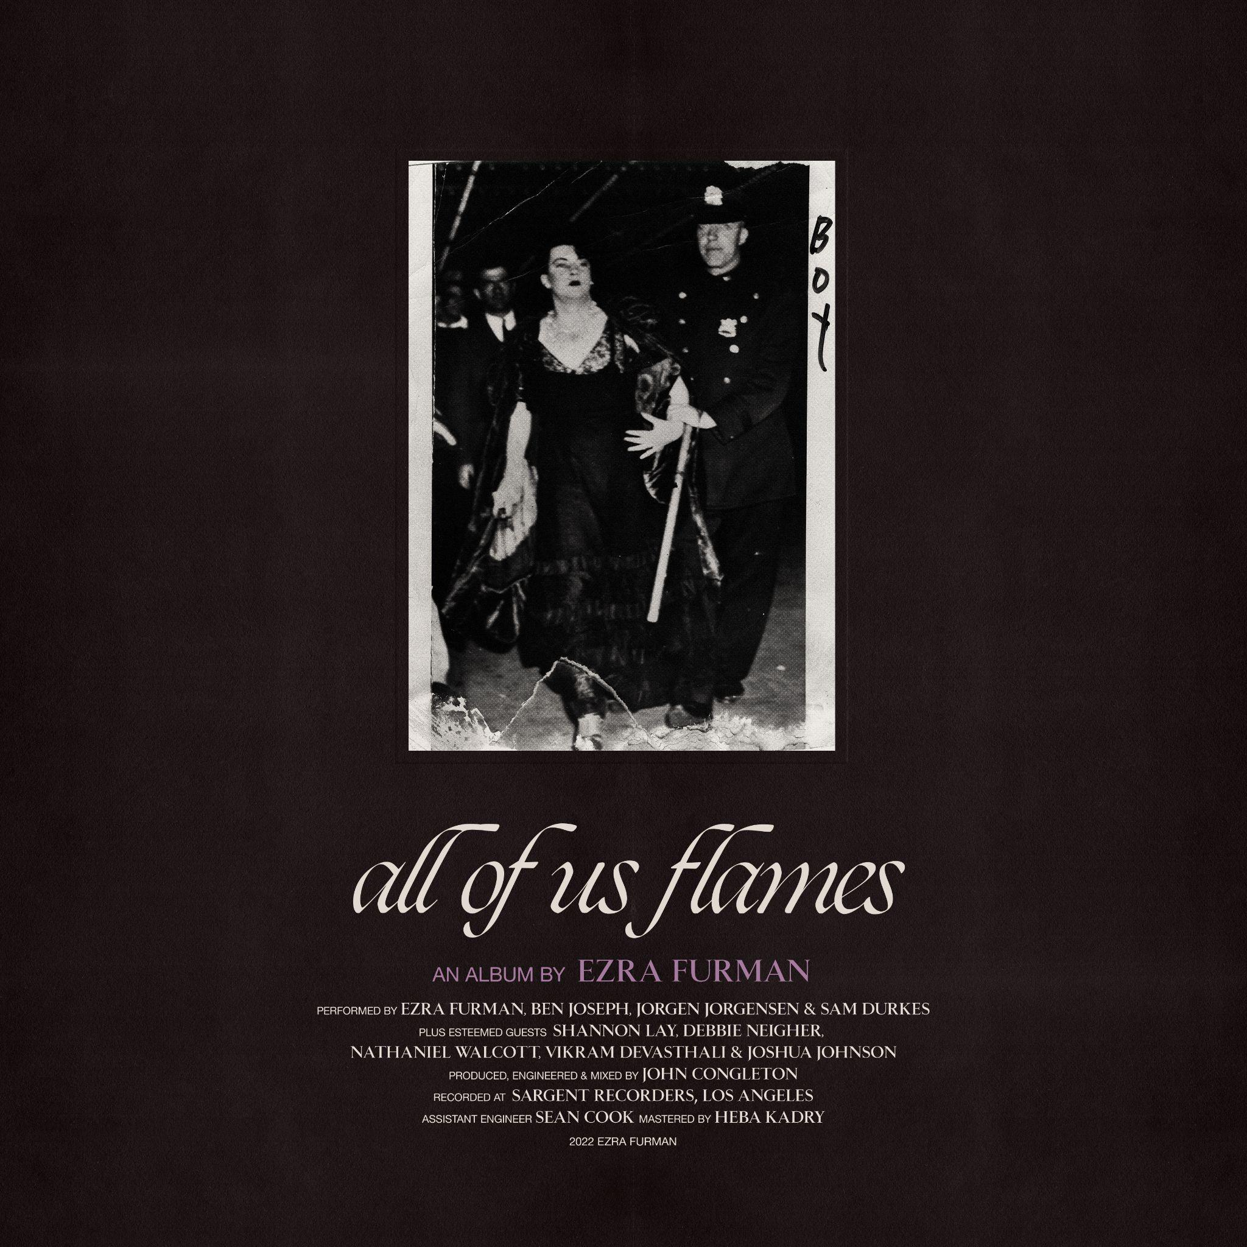
(All of Us Flames Cover Artwork)

Ezra Furman Online:
Official Site | Facebook | Twitter | Instagram

For more information, please contact:
Yuri Kwon | Pitch Perfect PR – yuri@pitchperfectpr.com, 773-654-1477
Sam McAllister | Pitch Perfect PR - sam@pitchperfectpr.com, 773-942-6573

###

