FLEET FOXES RELEASE VIDEO FOR “CAN I BELIEVE YOU” OFF OF SURPRISE FOURTH ALBUM SHORE

OUTDOOR SCREENINGS OF SHORE FILM ANNOUNCED

ALBUM OUT DIGITALLY ON ANTI- NOW

https://youtu.be/L2E2DpWO3-Y

[Los Angeles, CA - October 7, 2020] Last month, on the Autumnal Equinox, Fleet Foxes surprised fans with the digital release of their fourth studio album Shore. Today, Fleet Foxes shared the video for “Can I Believe You” off of the album.

Frontman Robin Pecknold spoke about the track, saying “This song draws from the age-old folk tradition of headbangers about trust issues. The verse is the chorus, the chorus is a bridge, the bridge is a different song, it’s all backwards but that was what made it so fun to make. Please enjoy!”

Sean Pecknold, who directed the video, said "With this film, I created an interpretation of what trust (or the uncertainty of it) feels like as two characters journey towards one another through a pulsating world. This film also reflects the frustration and lack of human connection brought to all of us during the pandemic of 2020. Our dedicated film crew worked hard to bring this to life and we hope you find metaphors in it you can relate to as you listen to the music and watch the film. As always, Adi Goodrich and I loved bringing Robin's songs to life with mesmerising visuals. This is the third part of a three-video FF trilogy starring Jade-Lorna Sullivan and Jean Charles.”

Fleet Foxes also have today announced outdoor screenings of the film companion to the album, a 16 mm road movie of the same name by Kersti Jan Werdal that showcases the landscapes of the Pacific Northwest set to the score of the album was also released. The outdoor screenings, presented in part by YETI, will take place in Portland, LA, Brooklyn, Austin, Seattle and Chicago starting October 18. Tickets go on sale Thursday, October 8 at 10AM local time and can be purchased at fleetfoxes.co. See below for a full rundown.

Shore was recorded before and during quarantine in Hudson (NY), Paris, Los Angeles, Long Island City and New York City from September 2018 until September 2020 with the help of recording and production engineer Beatriz Artola.The fifteen song, fifty-five minute Shore was initially inspired by Robin Pecknold’s musical heroes such as Arthur Russell, Nina Simone, Sam Cooke, Emahoy Tsegué-Maryam Guebrou and more who, in his experience, celebrated life in the face of death. “I see “shore” as a place of safety on the edge of something uncertain, staring at Whitman’s waves reciting ‘death,’” commented Pecknold. “Tempted by the adventure of the unknown at the same time you are relishing the comfort of the stable ground beneath you. This was the mindset I found, the fuel I found, for making this album.” Read the full artist statement HERE.

UPCOMING OUTDOOR FILM SCREENINGS:
10/18 – Rose City Rollers Drive-In – Portland, OR
10/18 – Ace Hotel – Los Angeles, CA
10/18 – Elsewhere – Brooklyn, NY
10/19 – Blue Starlite (Mueller) – Austin, TX
10/24 – Vasa Park Resort Drive-In – Seattle WA
11/1 – The Drive-In At Lincoln Yards – Chicago, IL

ACCLAIM FOR SHORE:
“Shore looks to the world and realizes there is already enough, as if staring into a darkness and responding with beauty, acceptance, and light." - PITCHFORK (BEST NEW MUSIC)

"A gorgeous folk-rock song cycle about life, death, and art, full of deep mourning and glimmers of relief on the other side. Track for track, Shore is the most immediately rewarding Fleet Foxes record since their brilliant 2008 debut." - ROLLING STONE (⅘ STARS)

“You soothe our worried minds and fraying souls with some gorgeous-as-fuck artisanal splendor." - ROLLING STONE (⅘ STARS)

"When you’ve got a song on your album called “Quiet Air/Gioia,” and it’s every bit as pretentious as that title suggests and yet in no way sucks, you’ve done your artistic betters proud." - ROLLING STONE (⅘ STARS)

"The gorgeous record found tonal balance amid the chaos of recent months, when the project suddenly seemed inconsequential to its creators and, therefore, more like a refuge. Though still primarily the creation of the band’s front man, Robin Pecknold, “Shore” is a collective effort that includes many contributors, and its glistening arrangements are reflective of the unburdening that collaboration fosters. " THE NEW YORKER

"The album is uniformly gorgeous, sometimes overwhelmingly so when taken in all at once...Every now and then there’s a moment of brightness, an actual good thing, that alleviates the darkness of the wretched year that is 2020. This is one of those good things." - STEREOGUM

"Fleet Foxes made the perfect album for this moment." - VULTURE

"Filled with epic, sweeping songs."- ENTERTAINMENT WEEKLY

"These 15 tracks are the work of an artist taking in everything dark and corrupt about this year, and choosing to craft an artifact of hope." - UPROXX

"There are lush soundscapes, fluttery brass cacophonies and subdividing rhythms...there is an acknowledgment of the past, but in a way that throws into sharp relief the potential that lies ahead and the legacy that is carried into the future" - ASSOCIATED PRESS

"Lucid, warm, and with no shortage of heart, Shore is a wonderful album to lead us into the concluding chapters of what has been a heartbreaker of a year." - CONSEQUENCE OF SOUND

"Shore is their most collaborative, most joyous album, and also one that transcends what Pecknold called the agrarian fantasies of their early days for an earnest plea to hear the call of the wild." THE RINGER

"Robin remains an extremely gifted songwriter, and these songs find him weaving in deceptively simple arrangements and some of the most instantly-satisfying melodies he's written yet." - BROOKLYN VEGAN

"Both vibrant and vital." UNDER THE RADAR

"Their most gorgeous full-length yet." NOISEY

"An absolute tour de force of rich melodies, heavenly hooks, luxurious production and songs packed to the brim with key/tempo/mood shifts that keep you constantly on your toes, it’s one of the most formidable albums we’ve heard this year, full stop." - GUITAR WORLD

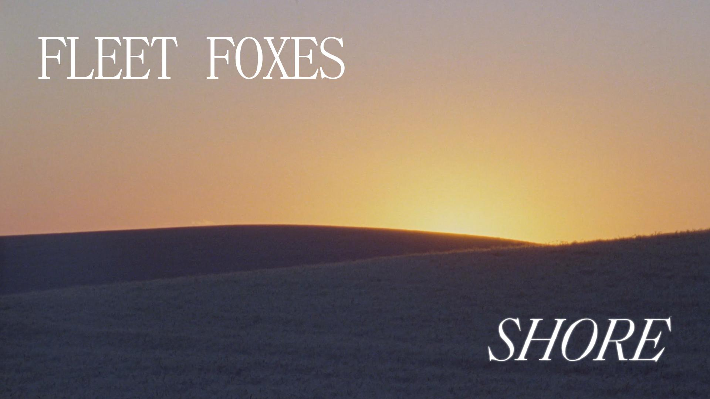

About Shore The Film

Shore is an art piece filmed over the course of a month in Washington, Oregon, and Western Idaho on 16mm film.

“I listened to the album while driving, and observationally shot landscapes that I felt resonated with the music, yet also stood on their own,” explained Director Kersti Jan Werdal. “The film is intended to co-exist and engage with the album, rather than be in a direct and symbiotic relationship with it. The urban and narrative scenes interact with the more surreal landscapes, rather than sit in opposition of one another. My hope is that the film, much like the album does, reflects optimism and strength.”

Kersti Jan Werdal is an artist working in film, photography, installation, and collage.

Fleet Foxes’ self-titled debut made a profound impact on the international musical landscape, topping numerous “Best Of” lists, including Rolling Stone’s 100 Best Albums of the 2000’s and Pitchfork’s 50 Best Albums of 2008. Fleet Foxes is certified Gold in North America and Platinum in both the UK and Australia. The follow-up album Helplessness Blues was met with the same critical praise as its predecessor (MOJO five stars, Rolling Stone four stars, Pitchfork Best New Music); that album debuted at No. 4 on the Billboard Top 200, went Gold in the UK, and earned the band a GRAMMY nomination. Six years later, the highly anticipated album Crack-Up was released, with AP saying “Rewarding, involving and meticulous, Crack-Up has been well worth the wait” and Uncut calling the album “Astonishing. Crack-Up may be the most anticipated release of the year, a welcome return. Ambitious, mature, meticulous.” The band embarked on a world tour that saw them headlining major festivals and their own sold-out shows throughout 2017-2018.

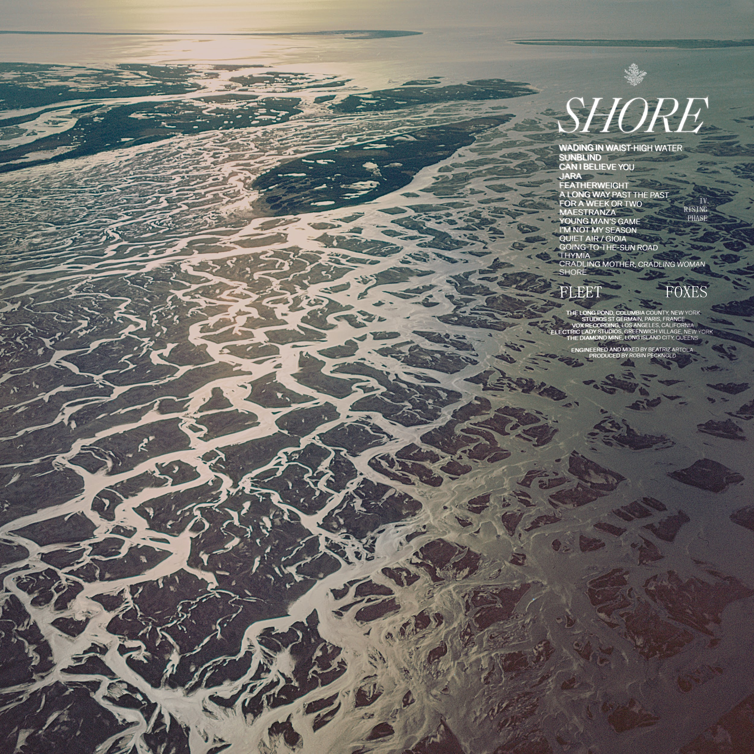
(front cover)
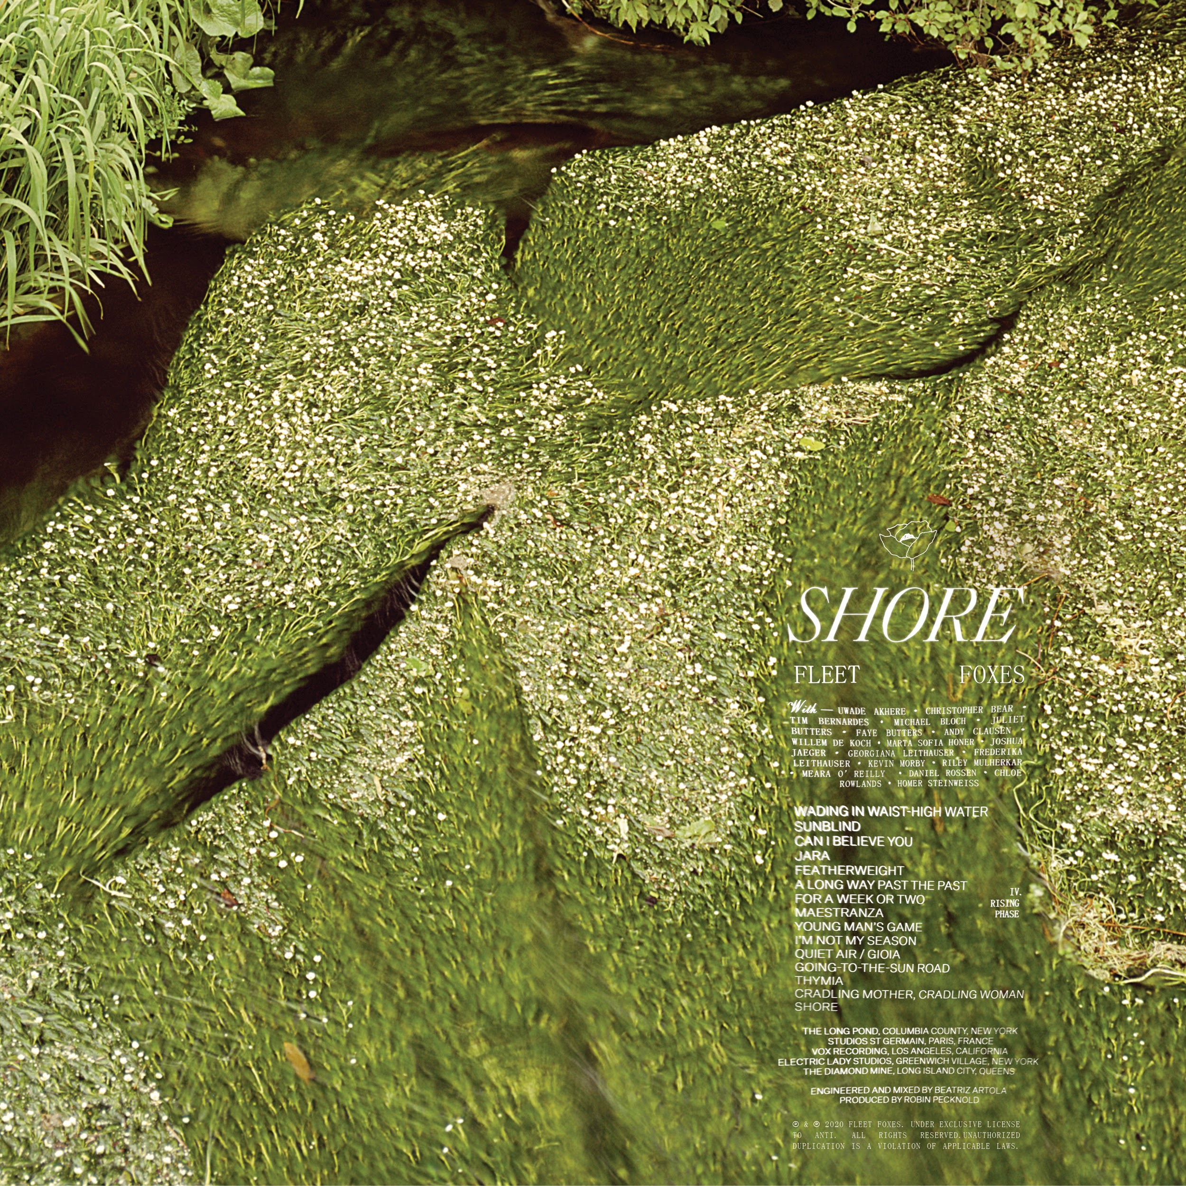
(back cover)

Promotional Materials Available HERE

Shore Track Listing
- Wading In Waist-High Water: lyric video HERE
- Sunblind: lyric video HERE
- Can I Believe You: lyric video HERE
- Jara: lyric video HERE
- Featherweight: lyric video HERE
- A Long Way Past The Past: lyric video HERE
- For A Week Or Two: lyrics video HERE
- Maestranza: lyric video HERE
- Young Man's Game: lyric video HERE
- I'm Not My Season: lyric video HERE
- Quiet Air / Gioia: lyric video HERE
- Going-to-the-Sun Road: lyric video HERE
- Thymia: lyric video HERE
- Cradling Mother, Cradling Woman: lyric video HERE
- Shore: lyric video HERE

Photo Credit: Emily Johnston

Follow Fleet Foxes:
Website - Instagram - Robin’s Instagram - Facebook

For more information on Fleet Foxes, please contact Grandstand Media:
Kate Jackson - katej@grandstandhq.com
Katie Nelson - katien@grandstandhq.com

