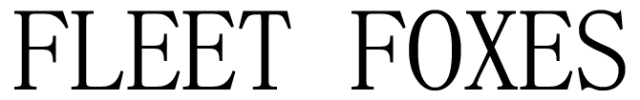

Release Live Covers of The Strokes’ “Under Control” featuring Uwade + Joni Mitchell’s “Hejira” featuring Daniel Rossen and Greg Pecknold

North American Tour Kicks Off Tonight in Cleveland

Includes 3 August Co-Headline Shows With My Morning Jacket

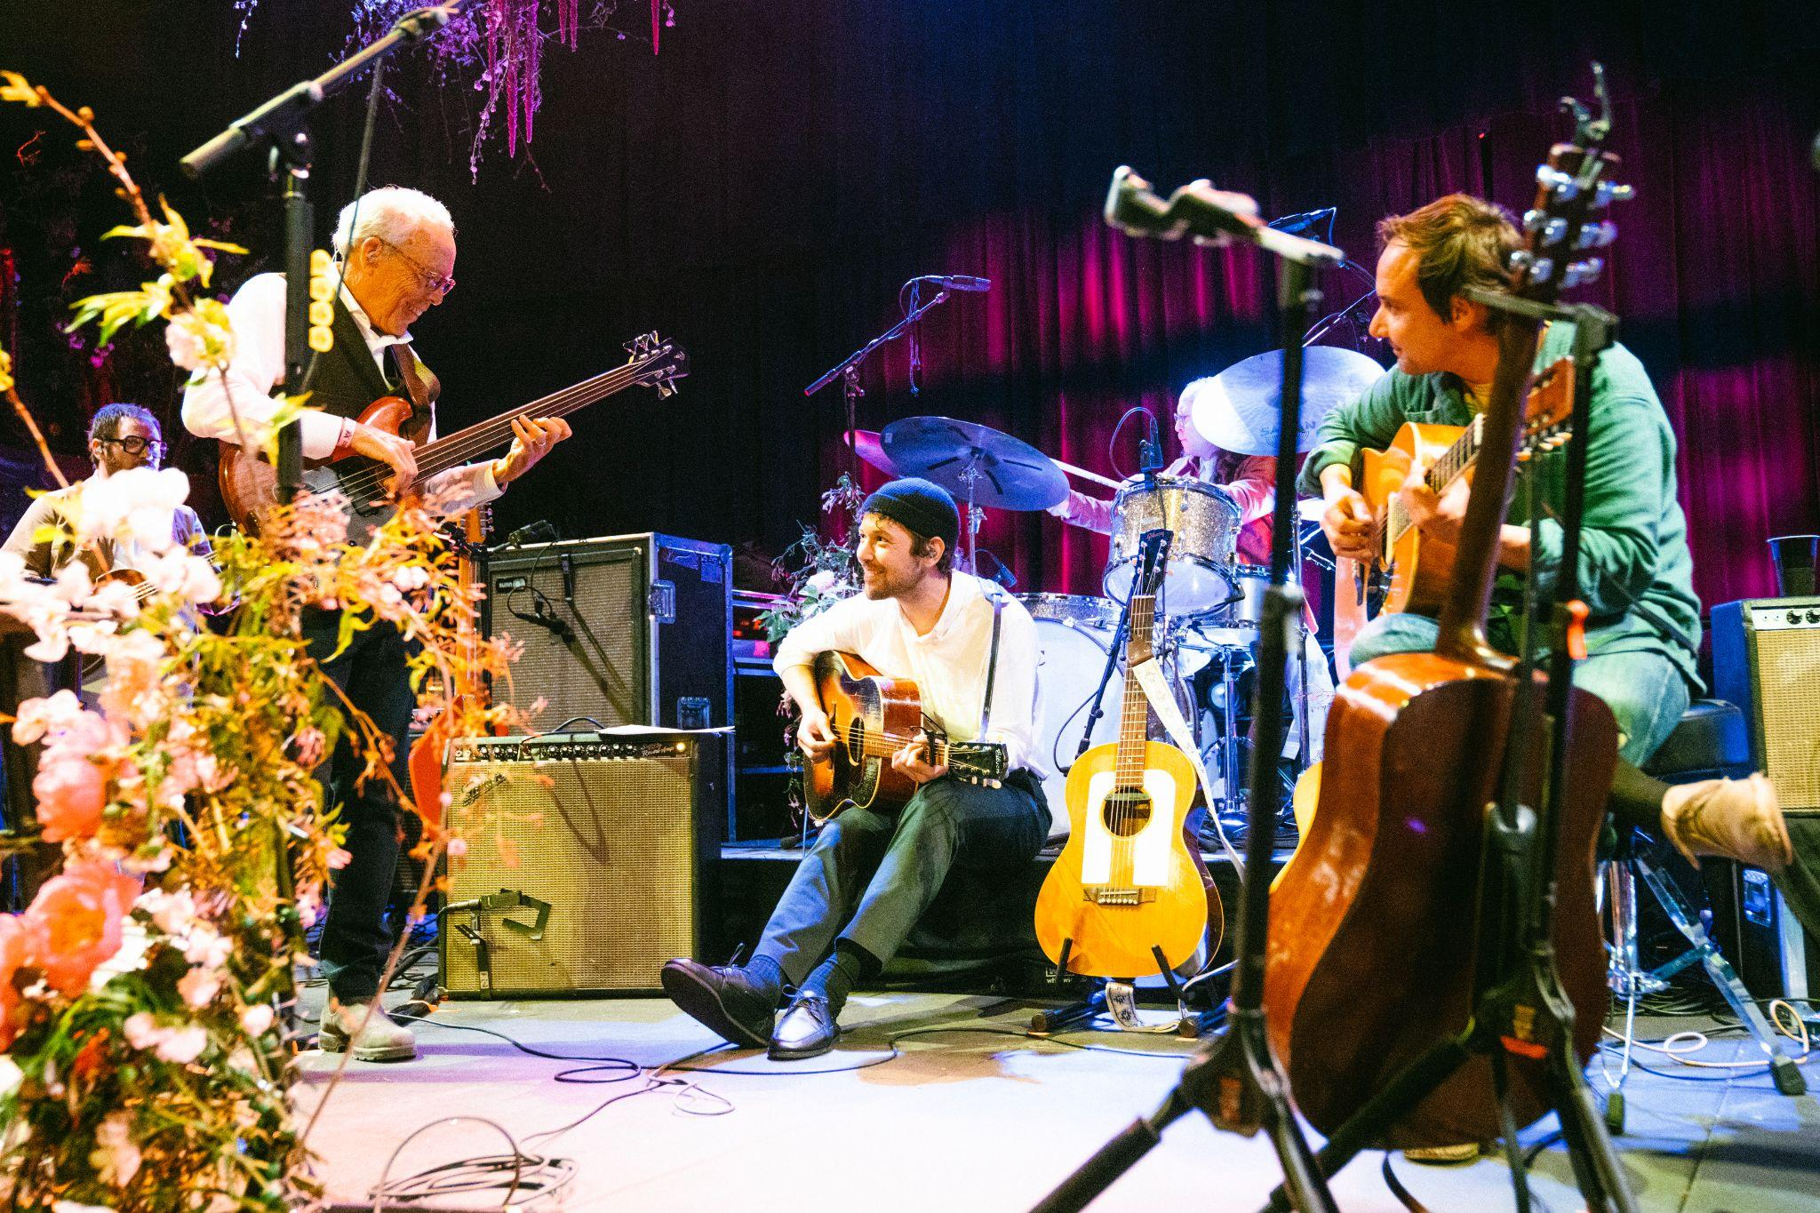
Photo Credit: Pooneh Ghana | download high-res here

[Tuesday, June 13, 2023] To celebrate the kickoff of their North American tour this evening in Cleveland, Fleet Foxes have released covers exclusively via Bandcamp of The Strokes’ “Under Control” featuring Uwade and performed live at Forest Hills Stadium in New York last year, as well as Joni Mitchell’s “Hejira,” featuring Daniel Rossen and Greg Pecknold, taped during “The Spring Recital” at The Belasco in Los Angeles in March. Both tracks also feature horns by frequent collaborators, The Westerlies. Listen to “Under Control” here and “Hejira” here.

Robin Pecknold spoke of “Under Control,” saying “Last summer we were honored to have the incredible vocalist and songwriter Uwade Akhere open for us on tour. One thing we all bonded over backstage was a shared love of The Strokes — hearing Uwa’s voice echoing down the halls as she sang “The End Has No End” or “Reptilia” was always a highlight of the day. Considering this, I thought she might get a kick out of singing 'Under Control' with us and the Westerlies at Forest Hills Tennis Stadium in Queens, so we pulled it together at soundcheck and asked her — it was amazing! She ruled it. Thank you Uwade!”

On “Hejira,” Pecknold said “My father built bass guitars and played in bands in his twenties and thirties in the Northwest; his dream was to be Joni Mitchell’s bassist, like the great Jaco Pastorius. Right before our surprise show with Joanna Newsom in March, I bought back for him one of the fretless basses he had made in the 80’s, and I thought it would be sweet for us to play ‘Hejira' together, on the same bill as Joanna, the Joni of our time. It was also an honor to be joined by Daniel Rossen for this, one of the greatest musicians of the last 20 years. Thank you Dan and Dad!”

Fleet Foxes’ North American tour also includes stops at the Bonnaroo Festival, Halifax Jazz Festival and three co-headline dates with My Morning Jacket in August. A full rundown of dates can be found below.

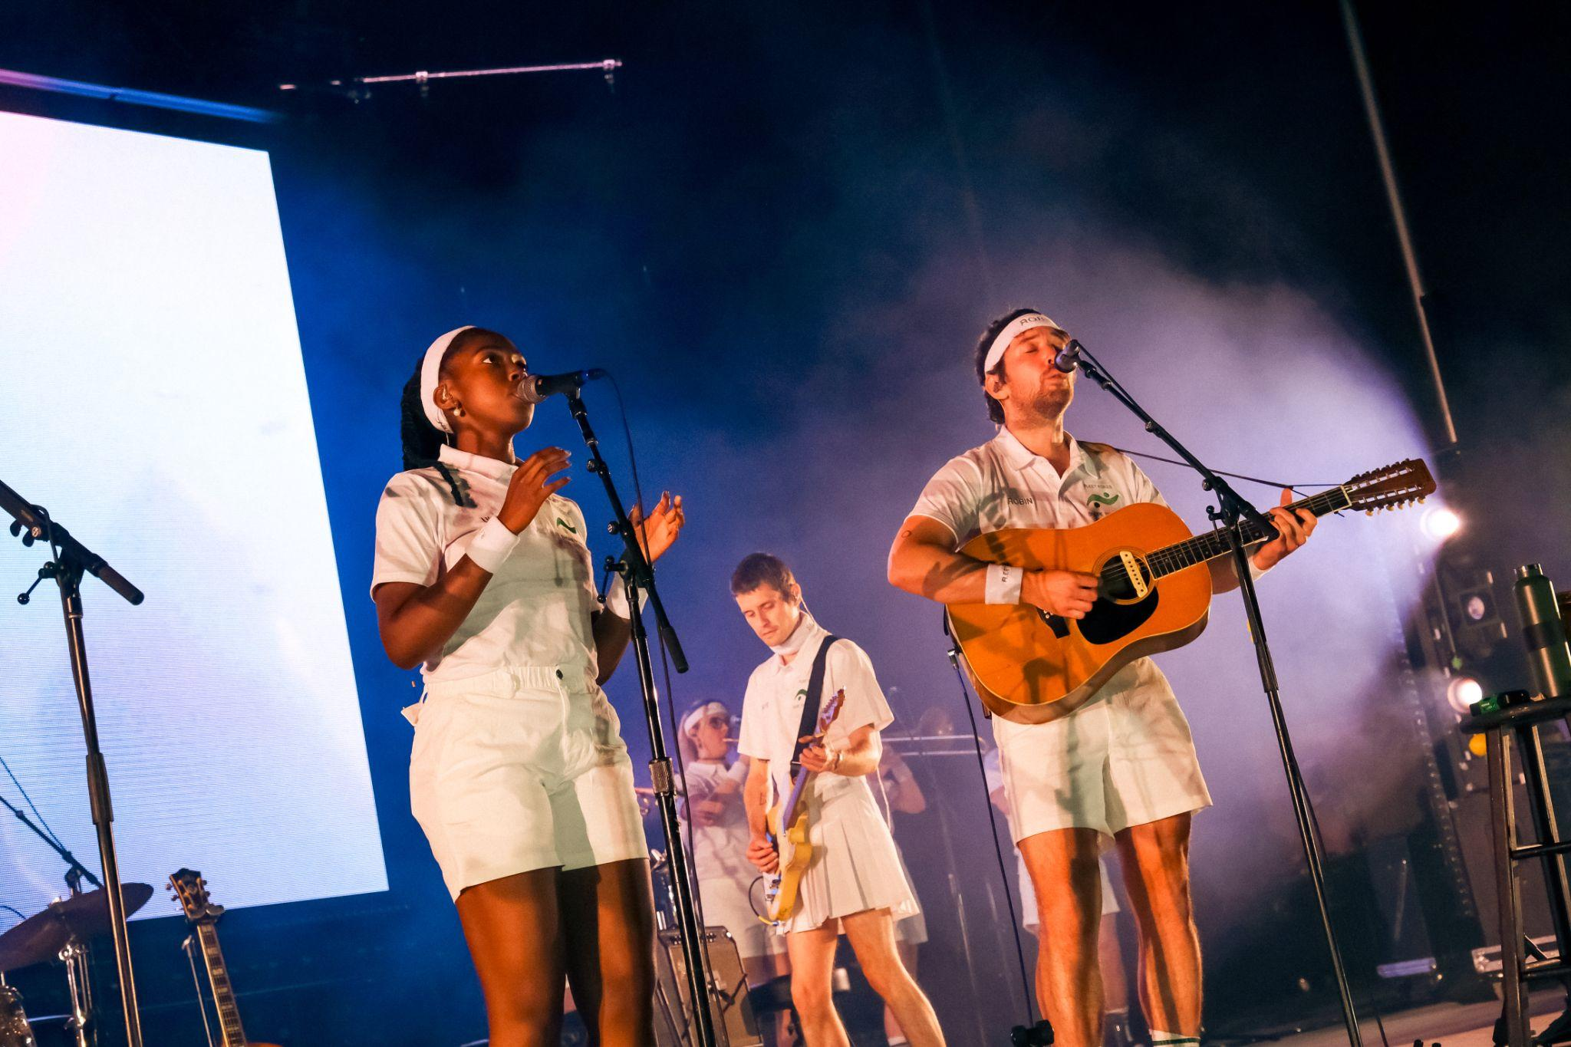
Photo Credit: Kevin Condon | download high-res here

PRAISE FOR FLEET FOXES LIVE:

"[Robin’s] palpable joy truly made the night as we eagerly and finally devoured Shore tracks live two years after its release" - FLAUNT MAGAZINE

"sounding as harmonious and mesmerizing as ever on tour" - THE STAR TRIBUNE

"one of the warmest homecoming shows I’ve ever seen" - SEATTLE TIMES

"Here, the songs are catchier than they have been in the past, and singer Robin Pecknhold sounds even more free." - DALLAS OBSERVER

ACCLAIM FOR SHORE:

“Shore looks to the world and realizes there is already enough, as if staring into a darkness and responding with beauty, acceptance, and light." - PITCHFORK (BEST NEW MUSIC)

"A gorgeous folk-rock song cycle about life, death, and art, full of deep mourning and glimmers of relief on the other side. Track for track, Shore is the most immediately rewarding Fleet Foxes record since their brilliant 2008 debut." - ROLLING STONE (⅘ STARS)

"The gorgeous record found tonal balance amid the chaos of recent months, when the project suddenly seemed inconsequential to its creators and, therefore, more like a refuge. Though still primarily the creation of the band’s front man, Robin Pecknold, “Shore” is a collective effort that includes many contributors, and its glistening arrangements are reflective of the unburdening that collaboration fosters. " THE NEW YORKER

"The album is uniformly gorgeous, sometimes overwhelmingly so when taken in all at once...Every now and then there’s a moment of brightness, an actual good thing, that alleviates the darkness of the wretched year that is 2020. This is one of those good things." - STEREOGUM

"Fleet Foxes made the perfect album for this moment." - VULTURE

FLEET FOXES SUMMER 2023 TOUR DATES:
06-13 Cleveland, OH @ Agora Theater*
06-14 Grand Rapids, MI @ GLC Live at 20 Monroe*
06-16 Manchester, TN @ Bonnaroo
06-17 St. Louis, MO @ The Factory*
06-18 Louisville, KY @ Old Forester’s Paristown Hall*
06-20 New Haven, CT @ College Street Music Hall*
06-21 Pittsburgh, PA @ Stage AE*
06-23 Asheville, NC @ Rabbit Rabbit*
06-24 Charleston, SC @ Firefly Distillery*
06-25 Orlando, FL @ Hard Rock Live*
06-27 Birmingham, AL @ Avondale Brewing*
06-28 New Orleans, LA @ The Fillmore*
06-30 Tulsa, OK @ Cain’s Ballroom*
07-01 Kansas City, MO @ The Midland Theatre*
07-02 Omaha, NE @ Steelhouse Omaha*
07-04 Minneapolis, MN @ First Avenue*
07-09 Indianapolis, IN @ The Murat Theatre at Old National Centre*
07-11 Portland, ME @ Thompson’s Point*
07-12 LaFayette, NY @ Beak & Skiff*
07-16 Halifax, NS @ Halifax Jazz Festival
08-18 Berkeley, CA @ The Greek Theatre ^^
08-19 Berkeley, CA @ The Greek Theatre ^^
08-20 Los Angeles, CA @ Hollywood Bowl ^^
08-22 Paso Robles, CA @ Vina Robles Amphitheatre*
08-24 Portland, OR @ Pioneer Courthouse Square*
08-25 Port Townsend, WA @ Thing Festival
11-17 Mexico City, MX @ Corona Capital

*with Uwade
^^ Co-headline with My Morning Jacket

Follow Fleet Foxes:
Website - Instagram - Robin’s Instagram - Facebook

For more information on Fleet Foxes, please contact Grandstand Media:
Kate Jackson - katej@grandstandhq.com
Katie Nelson - katien@grandstandhq.com

For tour-related inquiries:
Jessica Puchli - jessicap@grandstandhq.com

