RELEASE NEW SINGLE & VIDEO "FAULTLINE”

Photo Credit: Alexis Gross (download hi-res)

Girlpool, the Los Angeles duo comprised of Avery Tucker (he/him) and Harmony Tividad (she/her), have shared an alluring new single titled "Faultline" with an Julian Klincewicz-directed video.

Of the song, Harmony Tividad says: "The Faultline represents everything you do as a means of escape that pushes you further into the very thing you’re escaping."

Last year, Girlpool released “Like I’m Winning It,” which PAPER Magazine “textural, dark and exciting in new ways,” and The FADER called “strip club-ready banger.”

WATCH "FAULTLINE" VIDEO

PRAISE FOR GIRLPOOL:
"A meditative and expansive album that showcases Girlpool's restless desire for growth... What has remained at the heart of Girlpool's music is Tucker and Tividad's shared resolve to simultaneously revel in and make sense of the chaos of being alive." -NPR

"The gravitas in their voice accompanies a newly embodied confidence; where Tucker once sang tentatively, now they sound rooted and sure. Their lyrics remain in the present tense, but their delivery suggests a retrospective candor, an indexing of past selves in order to make room for the self that's still becoming." -Pitchfork

"Nobody can stop Avery Tucker and Harmony Tividad right now." -The FADER

"Overwhelming and undeniable... Girlpool have more going on musically on What Chaos Is Imaginary than on any of their previous albums." -Stereogum

"One of the greatest modern day indie rock bands." -Jezebel

"Viscerally personal music... A compelling record of transition and triumph." -i-D

"Ever-evolving as songwriters has led to each album being a snapshot of a band in the midst of evolution, and What Chaos Is Imaginary is Girlpool's biggest leap yet." -Consequence of Sound

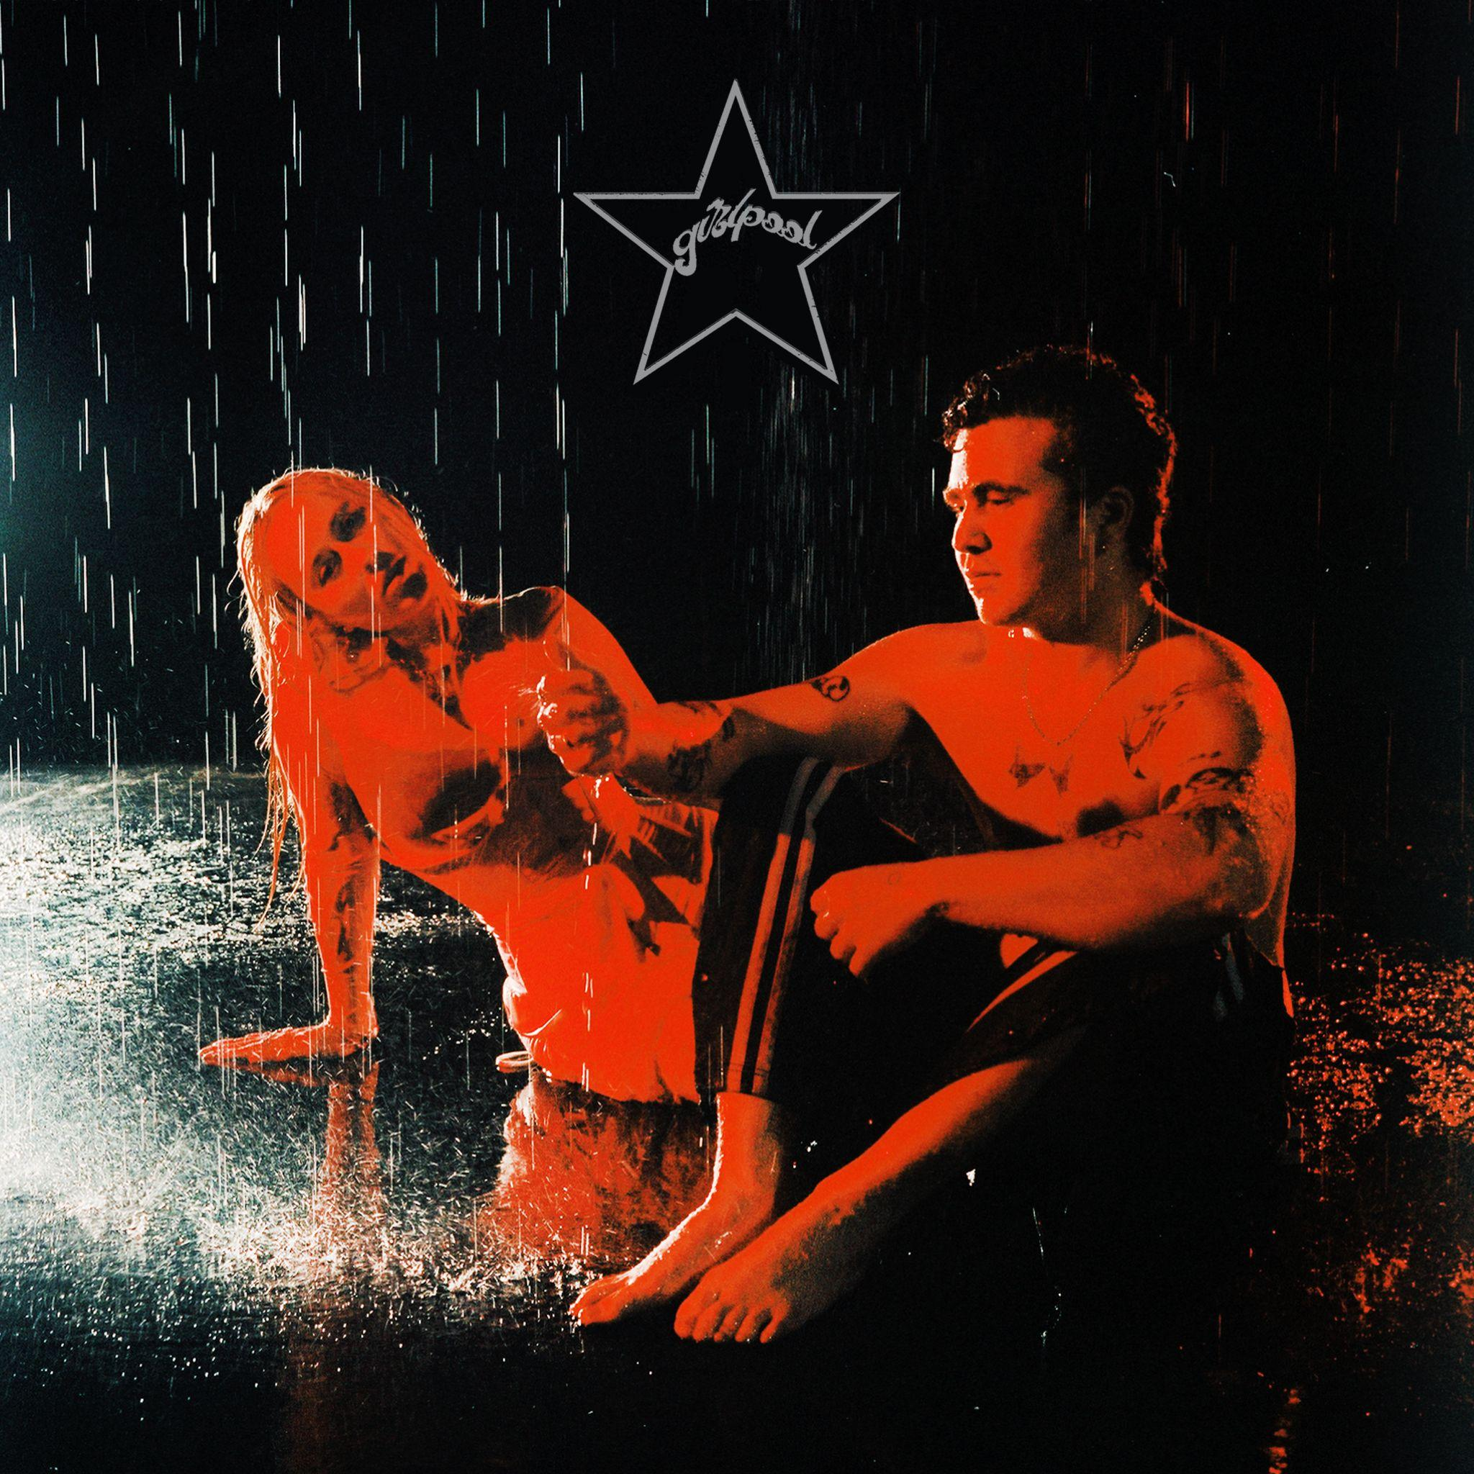
Artwork Credit: Petra Collins (download hi-res)

WEBSITE | TWITTER | INSTAGRAM | FACEBOOK | BANDCAMP | SPOTIFY

