HALF WAIF

ANNOUNCES NEW ALBUM MYTHOPOETICS
OUT JULY 9TH VIA ANTI-

WATCH THE VIDEO FOR LEAD SINGLE "SWIMMER"

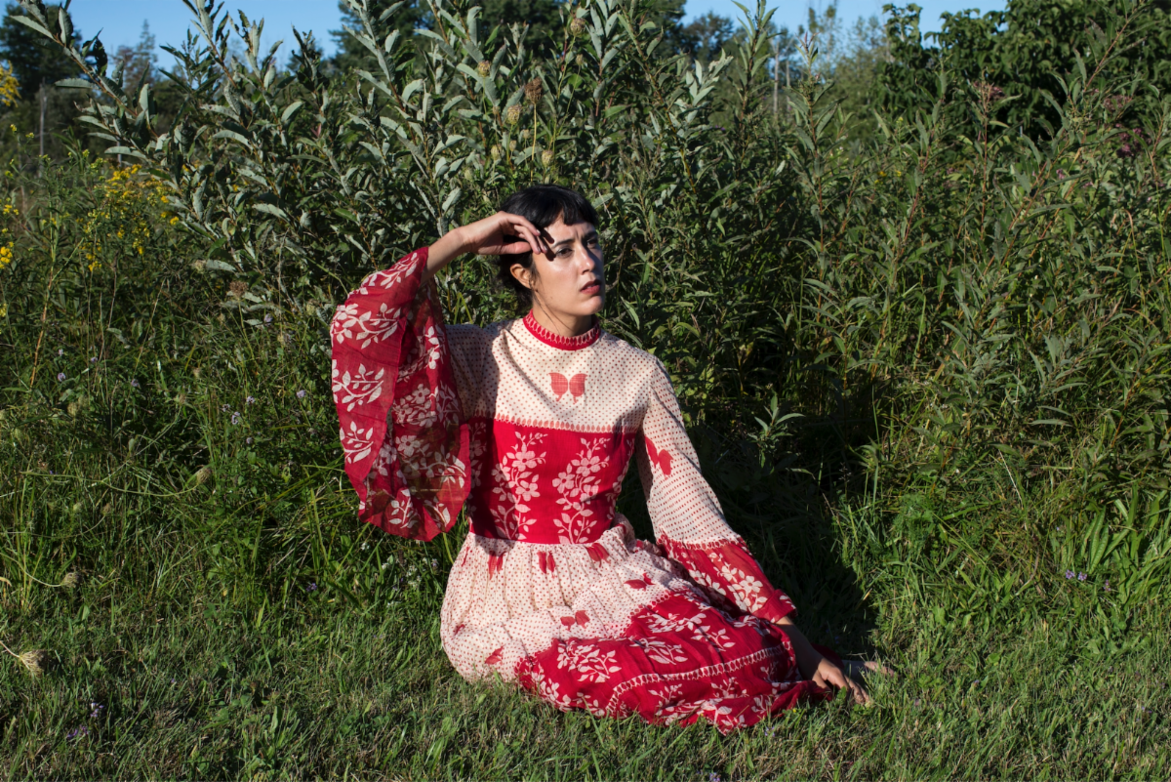
Photo Credit: Ali Cherkis (download hi-res)

Half Waif, the project of Nandi Rose, has announced her new album, Mythopoetics, with a Kenna Hynes-directed video for its lead single "Swimmer." The video, which co-stars Rose's mother, rounds out the storyline started in "Orange Blossoms," "Party's Over," and "Take Away The Ache," which were released earlier this year.

"I wrote Swimmer after visiting my aunt, who has Alzheimer’s. I’ll never forget the summer we were swimming at the lake where our family has a cabin - her mind was already slipping, but her body was still strong enough to swim across to the other side," says Rose. "It was incredible, how both things could be true. Now the only way I can reach her is through music. I sing for her with my hand on her shoulder, feeling the soft weight of her body through the blanket, pouring all of the love I have from my voice into that warm arm. I try to reconcile what is still here with what has already gone."

Of the video, she says "The idea for the music video came to me while I was recording 'Swimmer': a motorcycle chase, a quest to find a magic flower, and then the final scene where the flower is laid at the feet of an old woman, who bursts into light and is set free. I’ve always loved fantasy, the way it can capture the most poignant human emotions even when wildly surreal things are happening. When I brought the idea to Kenna, it set us on a journey to create a four-part music video series that develops the story further, starting with the first single 'Orange Blossoms' - in which the elf princess is woken from a kind of catatonic state and inspired to go outside to plant a golden seed - and ending with 'Swimmer' - when the princess (now a motorcycle-riding warrior, after being spurned one too many times from one too many parties) retrieves the golden flower and returns to her castle to set her future self free. We filmed the castle scene at the property where my aunt lives, and the older version of me was played by my mom, which made it all the more meaningful. It’s a kind of personal mythology."

Mythopoetics is available for pre-order now and due July 9th via ANTI- Records.

WATCH THE "SWIMMER" VIDEO
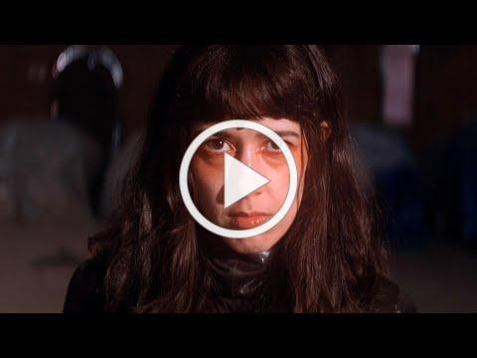

For Nandi Rose, writing a song is an act of transformation. As Half Waif, Rose pieces together the patchworks of our darkest and most vulnerable moments with a golden thread, crafting a majestic evocation of the human experience that permeates with a graceful strength. On new album Mythopoetics, the Hudson Valley-based artist breaks the familial patterns handed down to her, transforming this source of pain into something bearable, beautiful and celebratory. It is an essential reminder that we have the power to shape the stories we tell and the myths we make of our lives.

Half Waif’s previous albums The Caretaker (2020), Lavender (2018) and Probable Depths (2016), garnered acclaim for their compelling journeys through solitude, desire and the search for independence, blanketed under a spectacle of deeply-layered synth-pop. Her fifth full-length sees her stretch her creative muscles, as Rose pushes through the barriers of self-scrutiny and transports us into a world of mythic proportions. Charting territories of addiction, memory and loss, Mythopoetics is animated by the traces of what’s been left behind: the ghost of orange blossoms, the tail of a meteor across the sky, the taste of loneliness in a crust of bread. It is a kind of modern-day storybook where memory is spun into song and the self is explored and acknowledged with tender, nourishing care.

To bring together the world of Mythopoetics, Rose once again collaborated with multi-instrumentalist, film composer and producer Zubin Hensler. The pair came together for a recording residency at Pulp Arts in Gainesville, Florida, with the intention of creating stripped-back recordings of old songs, solely focusing on Rose and her piano. However, the playground of the studio soon transformed the project into a texturally diverse and kaleidoscopic sonic universe.

“This is the record I've been trying to make for 10 years,” Rose says. “My voice is changing, and my confidence has reached a point where I feel that I can sing however I want; I’ve finally come to a place where I don't have to conform to what I think other people want it to sound like.”

By unearthing this kind of self-assurance, Rose was poised to interrogate her life with a new lens. Lead single “Swimmer,” a song that examines the effect Alzheimer’s has on a loved one, sees Rose strive to use her voice as a tool for communication and healing. “I wanted to sing for you / So I'm going to sing for you,” she urges. “I thought of the voice as a wand, trying to reach across this boundary and remain connected with someone who's slipping away,” she says.

Mythopoetics is an album about processing past traumas in the quest for a new, sun dappled pathway, and the transformation that takes place as we take each tentative step. The artwork, shot by Ali Cherkis, sees Rose screaming in bright colors on the front, and naked, with a stoic expression on the back, representing the spectrum of emotions explored throughout each track. Change, evolution and joy take real courage, and it’s in the catharsis of telling your story that the calm, confident aftermath can finally reach the surface. Here, Half Waif is shunning the shadowed mass of generational trauma and the patterns passed down to her. Instead, she plants a seed, urging the orange blossom to sprout through the cracks in the concrete.

PRAISE FOR HALF WAIF:

"Half Waif's new album, The Caretaker, evokes the stifling feeling of wanting to force time forward and charge into a future that's nebulous and perpetually out of reach. These songs inadvertently speak to a period of uncertainty and isolation, and, though they're weighty, Half Waif's sombre elegance reflects the steely-eyed strength of a person who might just get through it."
-The New Yorker

"Beautifully rendered and deeply layered synth-pop."
-Pitchfork

"The swooping blend of organic instrumentation and fluttering electronics that has marked Nandi Rose's solo career as Half Waif looks to come into stark clarity with The Caretaker. A musician who has built her career on enigmatic presence and ambiguity steps into a lusher and more mature territory with her fourth album, guided as always by her clear and restless vocals, delivering poetic turns of phrase that can twist from grandly universal to painfully intimate within a single measure"
-The AV Club

"A whirring, deeply emotive window into self-sufficiency and the highs and lows of personal growth." -NPR
"Stormy chord progressions and eerie pitch-shifts convey disquiet, while sweeping strings and Rose's soaring vocals crash in waves of catharsis."
-Nylon

"Sparse and spectral."
-The FADER

"Characteristically gorgeous, emotive."
-Stereogum

"Often resembles a reversion to her sparser early work and away from the cavernous jolts of her more recent output."
-Paste

"Whereas her debut solo record, Lavender, took a more intimate approach to music, this new one goes for big emotions and even bigger music."
-Consequence of Sound

"Nandi Rose dials into the electronic elements of her musical repertoire."
-UPROXX

"Downright euphoric."
-MTV

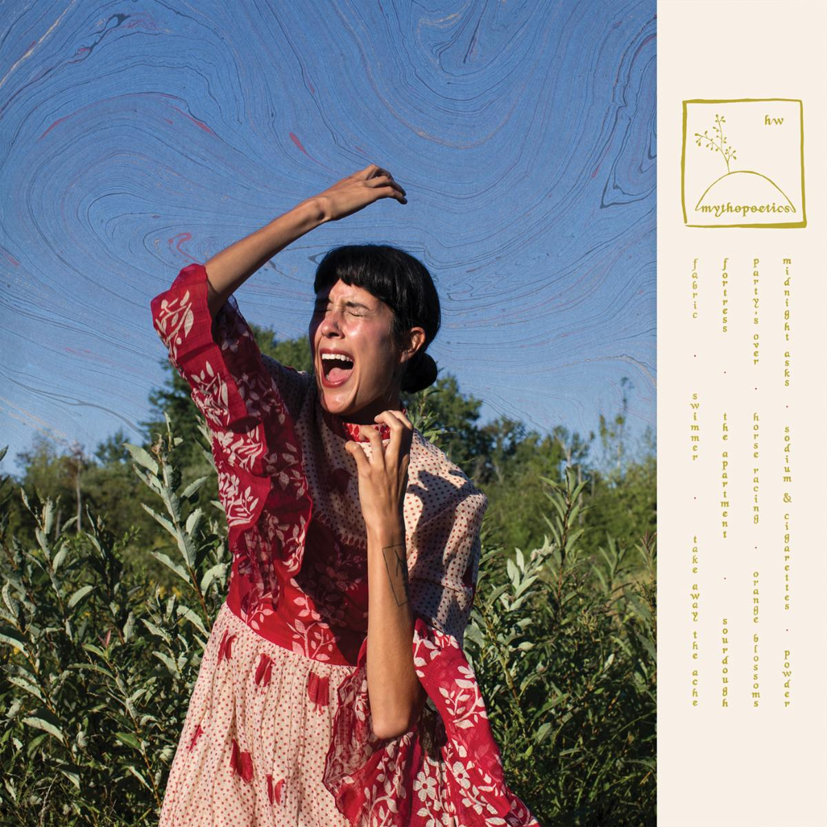

HALF WAIF
MYTHOPOETICS
ANTI- RECORDS
JULY 9, 2021
PRE-ORDER

1. Fabric
2. Swimmer
3. Take Away The Ache
4. Fortress
5. The Apartment
6. Sourdough
7. Party's Over
8. Horse Racing
9. Orange Blossoms
10. Midnight Asks
11. Sodium and Cigarettes
12. Powder

Website | Facebook | Twitter | Instagram

For more information please contact Grandstand Media & Management:
Eloy Lugo

