HALF WAIF

RELEASES LYRIC VIDEO FOR NEW SINGLE
"TAKE AWAY THE ACHE"

"ORANGE BLOSSOMS" B/W "PARTY'S OVER" 7"
OUT NOW VIA ANTI-

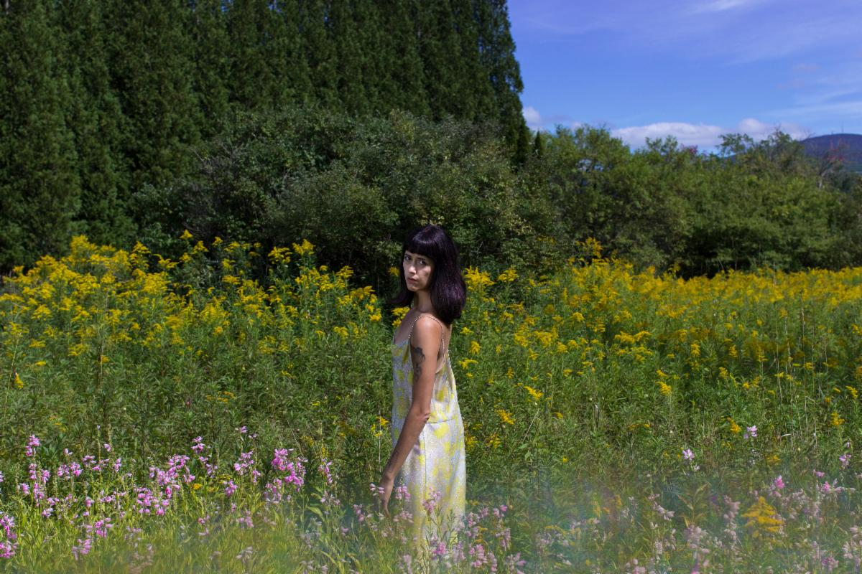
Photo Credit: Ali Cherkis (download hi-res)

Half Waif, the musical project of Nandi Rose, has shared a lyric video for her latest digital single "Take Away The Ache." The song continues a new chapter in Half Waif's ever-evolving story and sound.

"This is a song about the paradoxes of loving. How we ask the impossible of each other, how we promise what we can’t give. But I don’t mean this cynically - I actually find it quite remarkable" says Nandi Rose. "It’s kind of an incredible feat of imagination and will, the way we help each other transform our darkest moments into something bearable, like a game of make-believe. 'It’s not an ache,' you might say, 'it’s an ember.' And so together we stay warm by the fire of what we’ve created, lit by a sweet lie that makes it all okay for a while. To love is to believe in a kind of magic."

"Take Away The Ache" follows the release of her "Orange Blossoms" b/w "Party's Over" 7", out now via ANTI-.

WATCH THE "TAKE AWAY THE ACHE" LYRIC VIDEO

"Half Waif's new album, The Caretaker, evokes the stifling feeling of wanting to force time forward and charge into a future that's nebulous and perpetually out of reach. These songs inadvertently speak to a period of uncertainty and isolation, and, though they're weighty, Half Waif's sombre elegance reflects the steely-eyed strength of a person who might just get through it."
-The New Yorker

"Beautifully rendered and deeply layered synth-pop."
-Pitchfork

"The swooping blend of organic instrumentation and fluttering electronics that has marked Nandi Rose's solo career as Half Waif looks to come into stark clarity with The Caretaker. A musician who has built her career on enigmatic presence and ambiguity steps into a lusher and more mature territory with her fourth album, guided as always by her clear and restless vocals, delivering poetic turns of phrase that can twist from grandly universal to painfully intimate within a single measure"
-The AV Club

"A whirring, deeply emotive window into self-sufficiency and the highs and lows of personal growth." -NPR "Stormy chord progressions and eerie pitch-shifts convey disquiet, while sweeping strings and Rose's soaring vocals crash in waves of catharsis."
-Nylon

"Sparse and spectral."
-The FADER

"Characteristically gorgeous, emotive."
-Stereogum

"Often resembles a reversion to her sparser early work and away from the cavernous jolts of her more recent output."
-Paste

"Whereas her debut solo record, Lavender, took a more intimate approach to music, this new one goes for big emotions and even bigger music."
-Consequence of Sound

"Nandi Rose dials into the electronic elements of her musical repertoire."
-UPROXX

"Downright euphoric."
-MTV

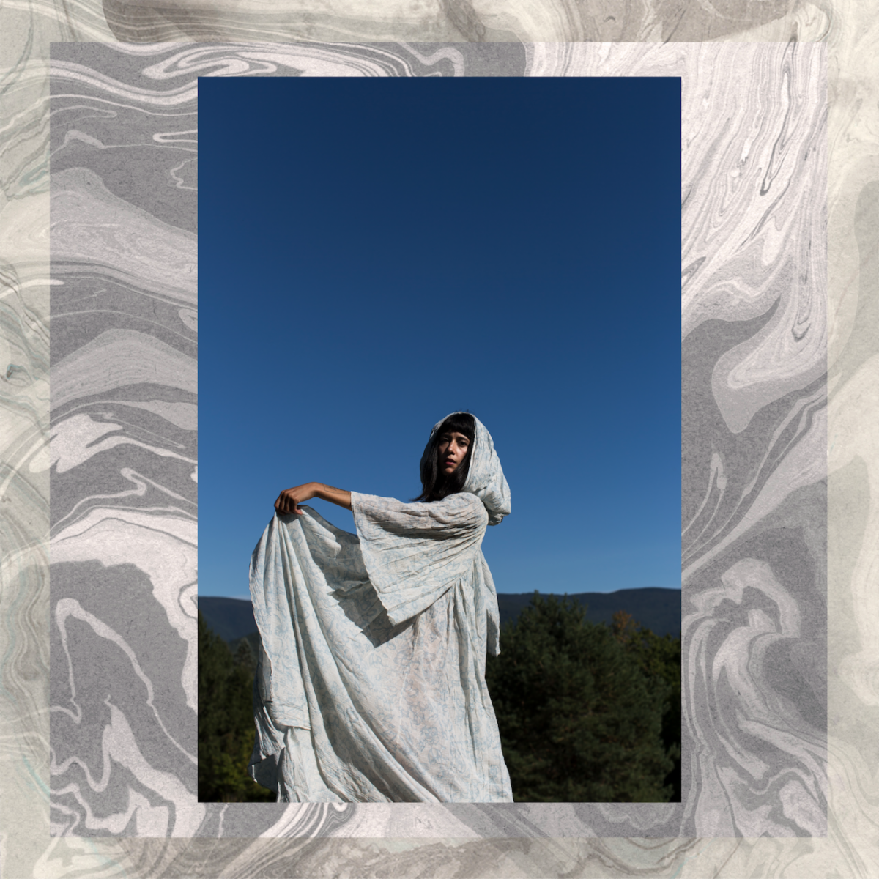

Website | Facebook | Twitter | Instagram

For more information please contact Grandstand Media & Management:
Eloy Lugo

