HALF WAIF
SHARES "HALOGEN 2" VIDEO

ON TOUR THIS SPRING

THE CARETAKER OUT MARCH 27TH VIA ANTI- RECORDS

Photo Credit: Brian Vu (download hi-res)

Half Waif (aka Nandi Rose) has shared "Halogen 2," the new single from her anticipated new album, The Caretaker, with a Kenna Hynes-directed video.

Of the song and video, Rose says: "'Halogen 2' is a song about isolation and the search for strength. The halogens are some of the most reactive elements on the periodic table, and in this song, winter and a life alone in the country are like halogen: an unrelenting force that produces change. I wrote this song at home in Upstate New York last March at a time when my sense of isolation was at its height. And yet I've always been someone who loves my alone time, so there was a sense of shame that I couldn't handle it this time. I needed to tell myself and anyone witnessing my restlessness: 'Don't misunderstand, I do what I must.' Nearly a year after writing the song, we shot most of the music video in the same location: my house and yard. The two opposing feelings presented by the verses and choruses are represented visually in the Blue World of cold, stagnant country life and the Orange World of the unfettered, fiery strength that lies beneath."

Last month, Half Waif announced The Caretaker with the release of its lead single, "Ordinary Talk," which earned accolades from NPR's All Songs Considered, Pitchfork, The FADER, Stereogum, Consequence of Sound, Paste, MTV, UPROXX, Brooklyn Vegan, Under The Radar and more.

The Caretaker is available for pre-order now and due March 27th via ANTI- Records.

WATCH THE "HALOGEN 2" VIDEO
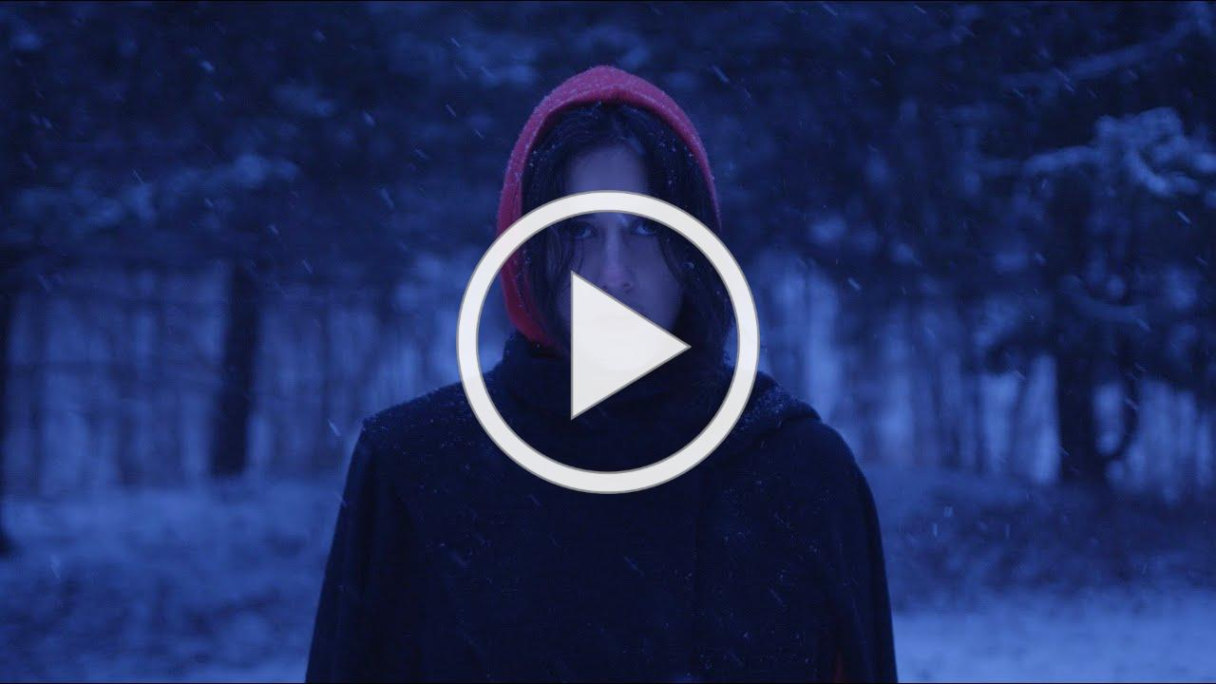
Nandi Rose is on her own again, and three songs into her forthcoming album The Caretaker, the singer, songwriter and producer declares her fearlessness: "Baby don't worry about me, I don't worry about you." Here, on "Ordinary Talk," Rose meditates on the heaviness of ordinary moments, the constellation of tears and chores and self-doubt and small talk that comprise being a person, accompanied by her most cinematic, pulsing arrangements to date.

It's an apt introduction to The Caretaker, an album that negotiates the space between working alone and with others, between isolation and connection. The result is her boldest work yet. Even the album cover seems to declare a statement of intent in high resolution, a deliberate move from the obscured, muted mystery of her previous work: the artist's sharp image radiates before a brilliant blue storm, staring you right in the eye.

Over the course of eleven songs, Rose creates the lush world of a humid summer night, dreaming of and reaching for a season in which she is her "best self." Referring to the album's title, she says, "I kind of created a character. She's someone who has been entrusted with taking care of this estate, taking care of the land, and she's not doing a very good job. The weeds are growing everywhere, and she's not taking care of herself." For Rose, the character of The Caretaker serves as a warning of who she could become if she's not more vigilant, and the resulting album sees her grappling with her desire for independence and the knotty reality that we need each other.

The Caretaker follows her critically acclaimed album Lavender, named for the lavender that once grew in her grandmother's garden. And on her most recent collection, Rose's family history and intergenerational stories continue to seep their way into the songs. "There's a family legacy of losing and seeking homes, a theme that has followed me," she reflects, pointing to her mother's journey as an Indian refugee from Uganda, and her grandmother's displacement from Lahore after the partition of India. Rose herself was raised surrounded by the Berkshire mountains in Williamstown, Massachusetts, and today she finds inspiration in the shock of seasons of the Hudson Valley where she currently resides.

WATCH THE "ORDINARY TALK" VIDEO
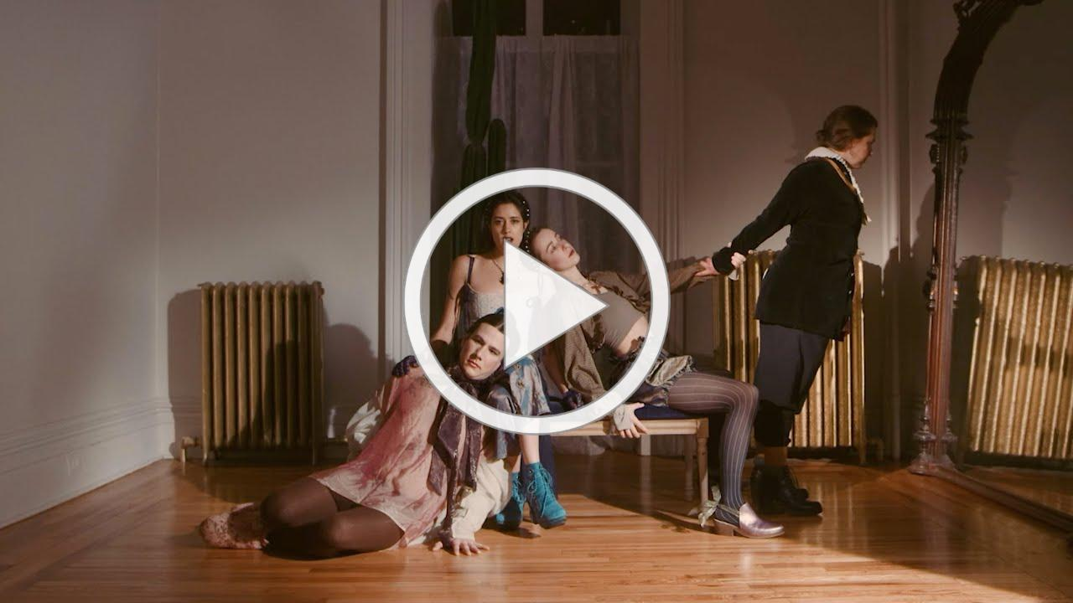
TOUR DATES:
3/27 - Brooklyn, NY @ Public Records ^
5/3 - Winooski, VT @ Waking Windows Festival 5/5 - Boston, MA @ Cafe 939
5/6 - Northhampton, MA @ Iron Horse
5/7 - Montreal, QC @ Bar Le Ritz PDB
5/8 - Toronto, ON @ Baby G
5/9 - Detroit, MI @ Deluxx Fluxx
5/10 - Chicago, IL @ Schubas
5/12 - Washington, DC @ Songbyrd
5/13 - Philadelphia, PA @ Johnny Brenda's
5/15 - Seattle, WA @ Sunset Tavern
5/16 - Portland, OR @ Mississippi Studios
5/18 - San Francisco, CA @ The Chapel
5/20 - Santa Ana, CA @ Constellation Room
5/21 - Los Angeles, CA @ Moroccan Lounge
6/6 - Peterborough, NH @ The Thing in the Spring

^ The Caretaker release show

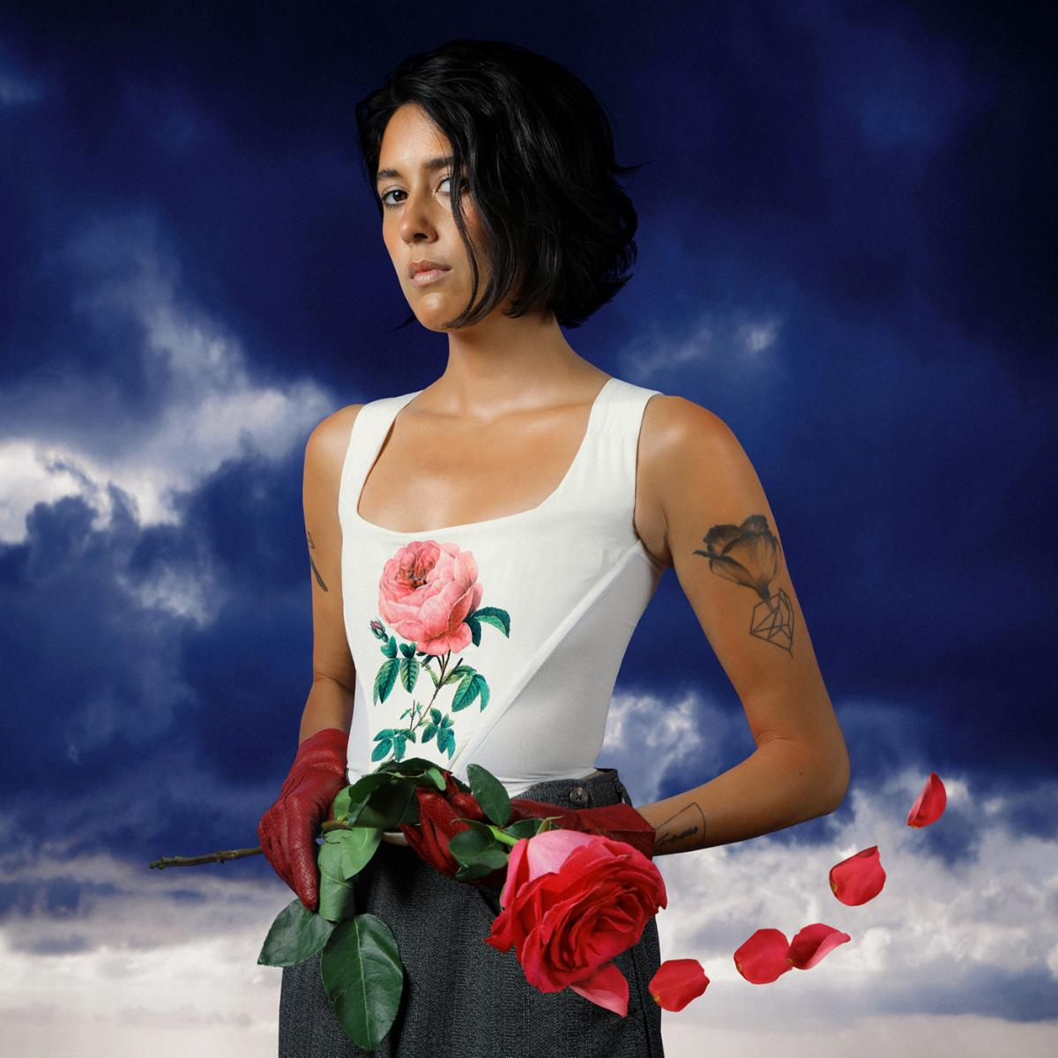
Photo Credit: Brian Vu (download hi-res)
.
HALF WAIF
THE CARETAKER
ANTI- RECORDS
MARCH 27, 2020
PRE-ORDER

1. Clouds Rest
2. Siren
3. Ordinary Talk
4. My Best Self
5. In August
6. Lapsing
7. Halogen 2
8. Blinking Light
9. Brace
10. Generation
11. Window Place

half-waif.com | facebook.com/halfwaif
Twitter @halfwaif | Instagram @halfwaif

