HALF WAIF

SHARES NEW SINGLE "HORSE RACING"

PLAYING VIRTUAL RECORD RELEASE SHOW ON 7/21
TOURING IN THE FALL

MYTHOPOETICS OUT JULY 9TH VIA ANTI-

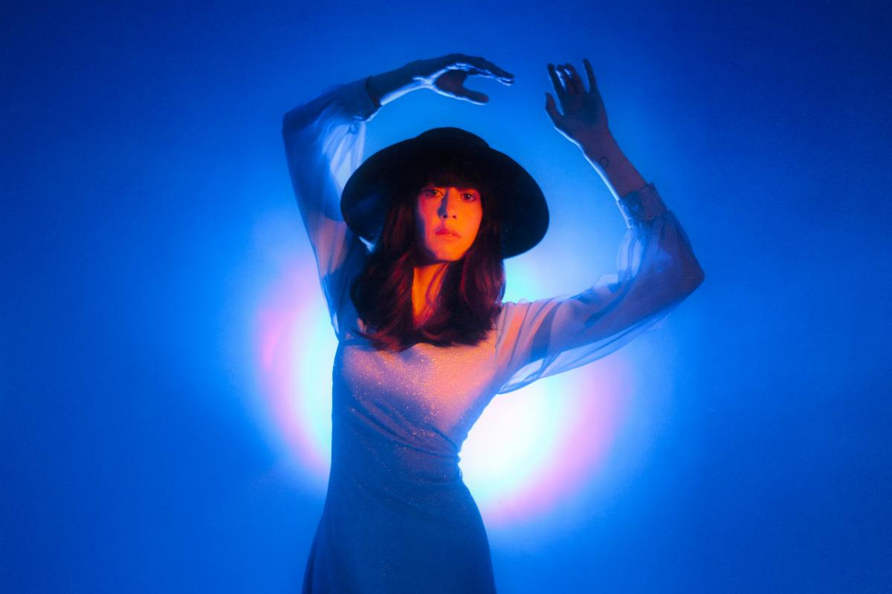
Photo Credit: Lissyelle Laricchia (download hi-res)

Half Waif, the project of Hudson Valley, NY-based artist Nandi Rose, has shared "Horse Racing," a propulsive new single from her anticipated forthcoming album Mythopoetics, available for pre-order now and due July 9th via ANTI- Records.
Of the song, written at the beginning of the Covid-19 pandemic, Rose says: "I started writing 'Horse Racing' in an Airbnb in Brooklyn that week in March 2020 when everything got really real. Alone in an unfamiliar apartment, as an unseen force took over our lives, I was struck by how much of a wake-up call it all was. How we were being shaken by our shoulders and told to face something really ugly and monstrous about our ways of being. It felt like we were race horses who had only just realized we were on a track, going around again and again. There’s no end in a circle. And maybe now that we recognized this, we could break out of it, bust right out of the ring - which is what the end section feels like sonically to me. A shot at freedom."

Mythopoetics is Half Waif's most self-assured album to date, with the New York Times calling it "larger than life" and Stereogum praising it as "massive-sounding." "This is the record I've been trying to make for 10 years,” Rose says. “My voice is changing, and my confidence has reached a point where I feel that I can sing however I want; I’ve finally come to a place where I don't have to conform to what I think other people want it to sound like."

Additionally, Half Waif has announced a virtual record release show via Noonchorus on 7/21, tickets are available now.

Half Waif is also hitting the road on a month-long Fall tour that kicks off in Los Angeles, CA on November 2nd and wraps in Chicago, IL on November 21st. Tickets are on sale now.

LISTEN TO "HORSE RACING"

TOUR DATES:

11/2 - Los Angeles, CA @ The Echo *
11/3 - San Francisco, CA @ The Chapel *
11/5 - Portland, OR @ Mississippi Studios *
11/6 - Seattle, WA @ Barboza *
11/7 - Vancouver, BC @ The Wise *
11/13 - Philadelphia, PA @ Johnny Brenda’s ^
11/14 - Washington, DC @ Songbyrd ^
11/15 - New York, NY @ Bowery Ballroom ^
11/16 - Boston, MA @ Sonia ^
11/18 - Montreal, QC @ Bar le Ritz ^
11/19 - Toronto, ON @ Drake Hotel ^
11/21 - Chicago, IL @ Schubas ^

* w/ Lisel & Booker Stardrum
^ w/ Lightning Bug

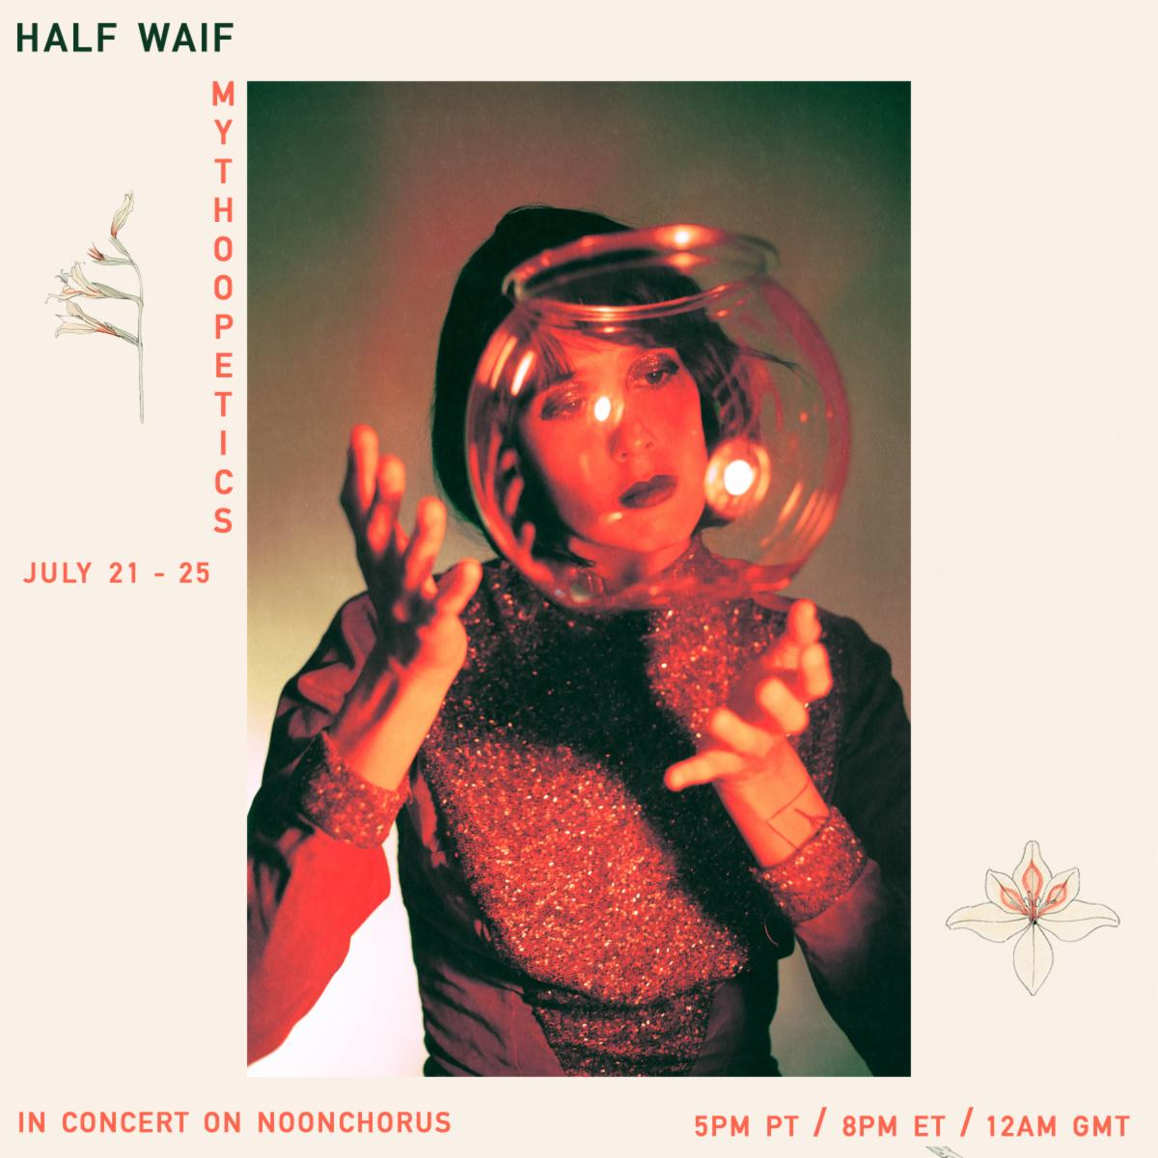
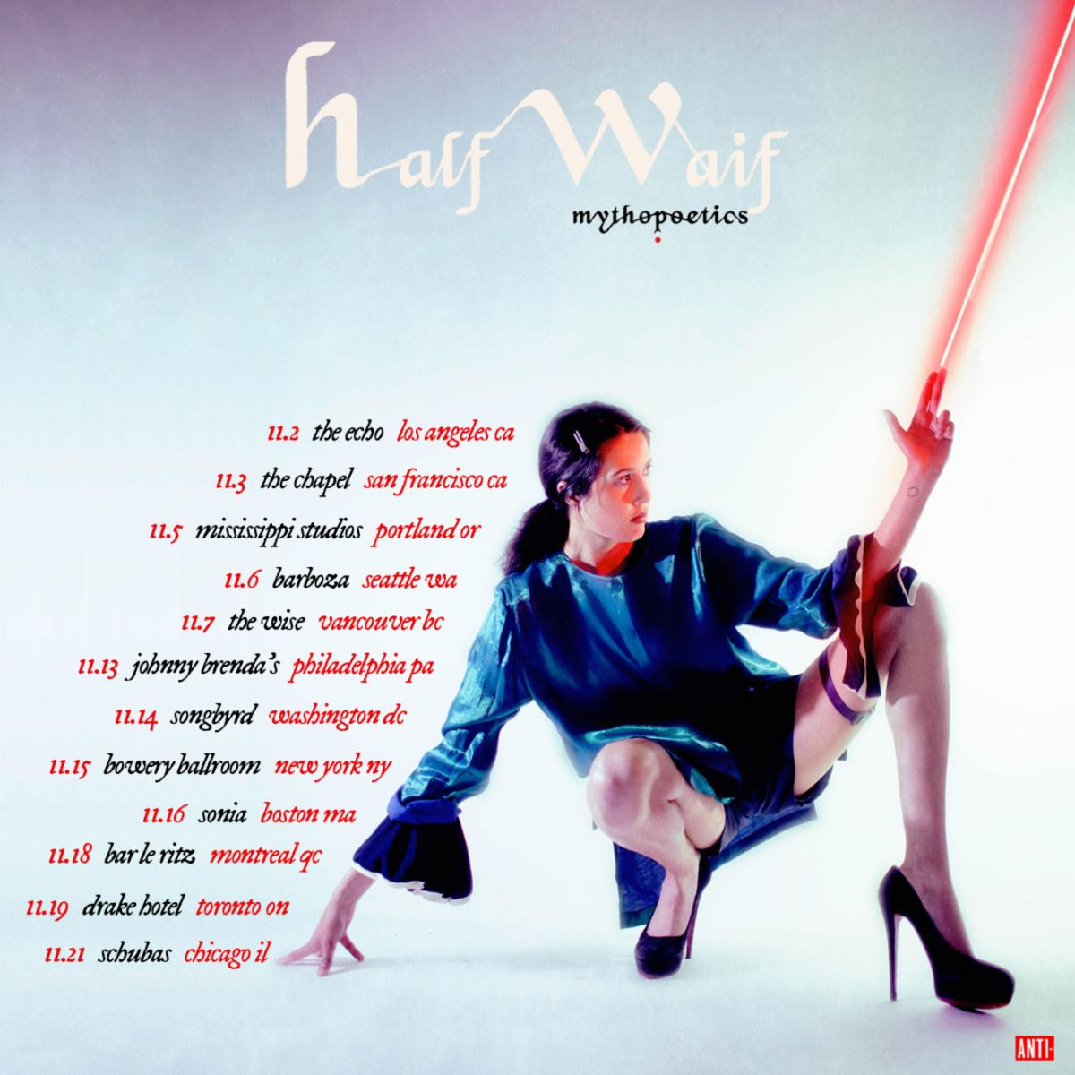
PRAISE FOR HALF WAIF:

"Evolves from an anxious rhythmic pulse to a chordal anthem, all larger than life."
-New York Times

"Half Waif's new album, The Caretaker, evokes the stifling feeling of wanting to force time forward and charge into a future that's nebulous and perpetually out of reach. These songs inadvertently speak to a period of uncertainty and isolation, and, though they're weighty, Half Waif's sombre elegance reflects the steely-eyed strength of a person who might just get through it."
-The New Yorker

"Beautifully rendered and deeply layered synth-pop."
-Pitchfork

"The swooping blend of organic instrumentation and fluttering electronics that has marked Nandi Rose's solo career as Half Waif looks to come into stark clarity with The Caretaker. A musician who has built her career on enigmatic presence and ambiguity steps into a lusher and more mature territory with her fourth album, guided as always by her clear and restless vocals, delivering poetic turns of phrase that can twist from grandly universal to painfully intimate within a single measure"
-The AV Club

"A whirring, deeply emotive window into self-sufficiency and the highs and lows of personal growth."
-NPR

"Stormy chord progressions and eerie pitch-shifts convey disquiet, while sweeping strings and Rose's soaring vocals crash in waves of catharsis."
-Nylon

"Sparse and spectral."
-The FADER

"Characteristically gorgeous, emotive."
-Stereogum

"Often resembles a reversion to her sparser early work and away from the cavernous jolts of her more recent output."
-Paste

"Whereas her debut solo record, Lavender, took a more intimate approach to music, this new one goes for big emotions and even bigger music."
-Consequence of Sound

"Nandi Rose dials into the electronic elements of her musical repertoire."
-UPROXX

"Downright euphoric."
-MTV

"Gorgeous, haunting"
-Brooklyn Vegan

For Nandi Rose, writing a song is an act of transformation. As Half Waif, Rose pieces together the patchworks of our darkest and most vulnerable moments with a golden thread, crafting a majestic evocation of the human experience that permeates with a graceful strength. On new album Mythopoetics, the Hudson Valley-based artist breaks the familial patterns handed down to her, transforming this source of pain into something bearable, beautiful and celebratory. It is an essential reminder that we have the power to shape the stories we tell and the myths we make of our lives.

Half Waif’s previous albums The Caretaker (2020), Lavender (2018) and Probable Depths (2016), garnered acclaim for their compelling journeys through solitude, desire and the search for independence, blanketed under a spectacle of deeply-layered synth-pop. Her fifth full-length sees her stretch her creative muscles, as Rose pushes through the barriers of self-scrutiny and transports us into a world of mythic proportions. Charting territories of addiction, memory and loss, Mythopoetics is animated by the traces of what’s been left behind: the ghost of orange blossoms, the tail of a meteor across the sky, the taste of loneliness in a crust of bread. It is a kind of modern-day storybook where memory is spun into song and the self is explored and acknowledged with tender, nourishing care.

To bring together the world of Mythopoetics, Rose once again collaborated with multi-instrumentalist, film composer and producer Zubin Hensler. The pair came together for a recording residency at Pulp Arts in Gainesville, Florida, with the intention of creating stripped-back recordings of old songs, solely focusing on Rose and her piano. However, the playground of the studio soon transformed the project into a texturally diverse and kaleidoscopic sonic universe.

Mythopoetics is an album about processing past traumas in the quest for a new, sun dappled pathway, and the transformation that takes place as we take each tentative step. The artwork, shot by Ali Cherkis, sees Rose screaming in bright colors on the front, and naked, with a stoic expression on the back, representing the spectrum of emotions explored throughout each track. Change, evolution and joy take real courage, and it’s in the catharsis of telling your story that the calm, confident aftermath can finally reach the surface. Here, Half Waif is shunning the shadowed mass of generational trauma and the patterns passed down to her. Instead, she plants a seed, urging the orange blossom to sprout through the cracks in the concrete.

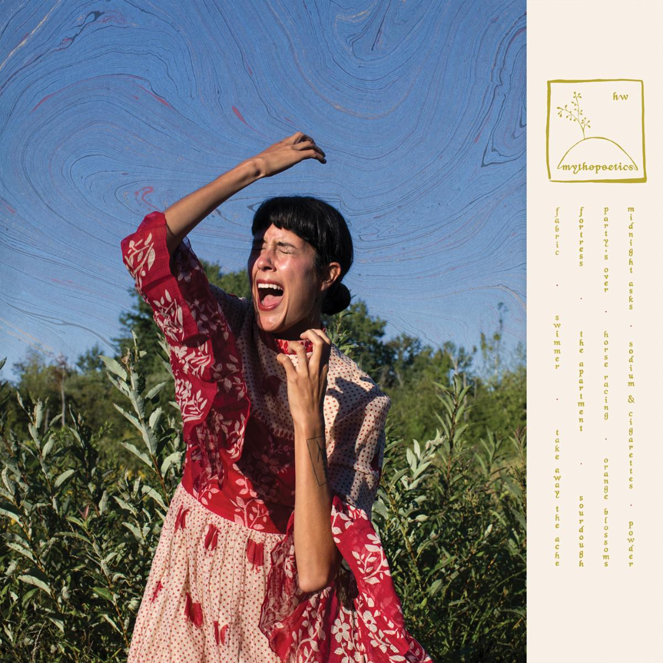

HALF WAIF
MYTHOPOETICS
ANTI- RECORDS
JULY 9, 2021
PRE-ORDER

1. Fabric
2. Swimmer
3. Take Away The Ache
4. Fortress
5. The Apartment
6. Sourdough
7. Party's Over
8. Horse Racing
9. Orange Blossoms
10. Midnight Asks
11. Sodium and Cigarettes
12. Powder

Website | Facebook | Twitter | Instagram

For more information please contact Grandstand Media & Management:
Eloy Lugo

