HALF WAIF

SHARES NEW SINGLE "SODIUM & CIGARETTES"

TOURING THIS FALL

MYTHOPOETICS OUT JULY 9TH VIA ANTI-

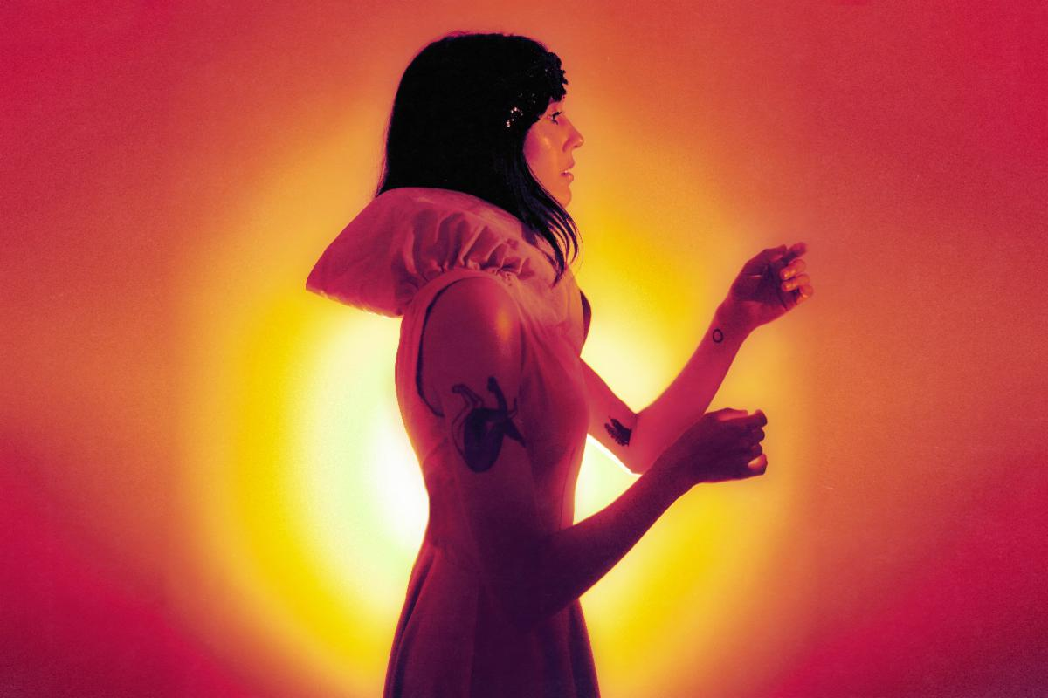
Photo Credit: Lissyelle Laricchia (download hi-res)

Half Waif, the project of Hudson Valley, NY-based artist Nandi Rose, shares "Sodium & Cigarettes," the hopeful and haunting new single from her anticipated upcoming album Mythopoetics.

"'Sodium & Cigarettes' follows the theme of many of the tracks on Mythopoetics and deals with the recognition that no one is going to magically save us or pull us out of our misery. The chorus 'okay, give it another day' is something I say to myself when I've had a really awful day and everything feels like a wash. It's a deep breath and a stab at courage - I can face tomorrow, and who knows what possibilities for joy and growth that will bring," says Rose. "While working on the album during the Democratic Primary in early 2020, the song took on new meaning for me in light of political conversations. "I believe in something more than what's in front of me" became a commentary on people saying, 'well, this system is what we've got and you can't ask for more.' I firmly believe that we have to fight for the world we imagine, that everything is possible. So this song is really a quiet encouragement for me, a way to tell myself to stop running, to face what's coming with clarity and vision and courage, to know there's another tomorrow."

Last month, Half Waif announced her anticipated new album Mythopoetics, with a video for lead single "Swimmer," which the New York Times hailed as "larger than life" and Stereogum called "massive-sounding." Mythopoetics is available for pre-order now and due July 9th via ANTI- Records.

Additionally Half Waif has announced a month-long Fall 2021 tour that kicks off in Los Angeles, CA on November 2nd and wraps in Chicago, IL on November 21st. Tickets are on sale now.

LISTEN TO "SODIUM & CIGARETTES"

TOUR DATES:

11/2 - Los Angeles, CA @ The Echo
11/3 - San Francisco, CA @ The Chapel
11/5 - Portland, OR @ Mississippi Studios
11/6 - Seattle, WA @ Barboza
11/7 - Vancouver, BC @ The Wise
11/13 - Philadelphia, PA @ Johnny Brenda’s
11/14 - Washington, DC @ Songbyrd
11/15 - New York, NY @ Bowery Ballroom
11/16 - Boston, MA @ Sonia
11/18 - Montreal, QC @ Bar le Ritz
11/19 - Toronto, ON @ Drake Hotel
11/21 - Chicago, IL @ Schubas

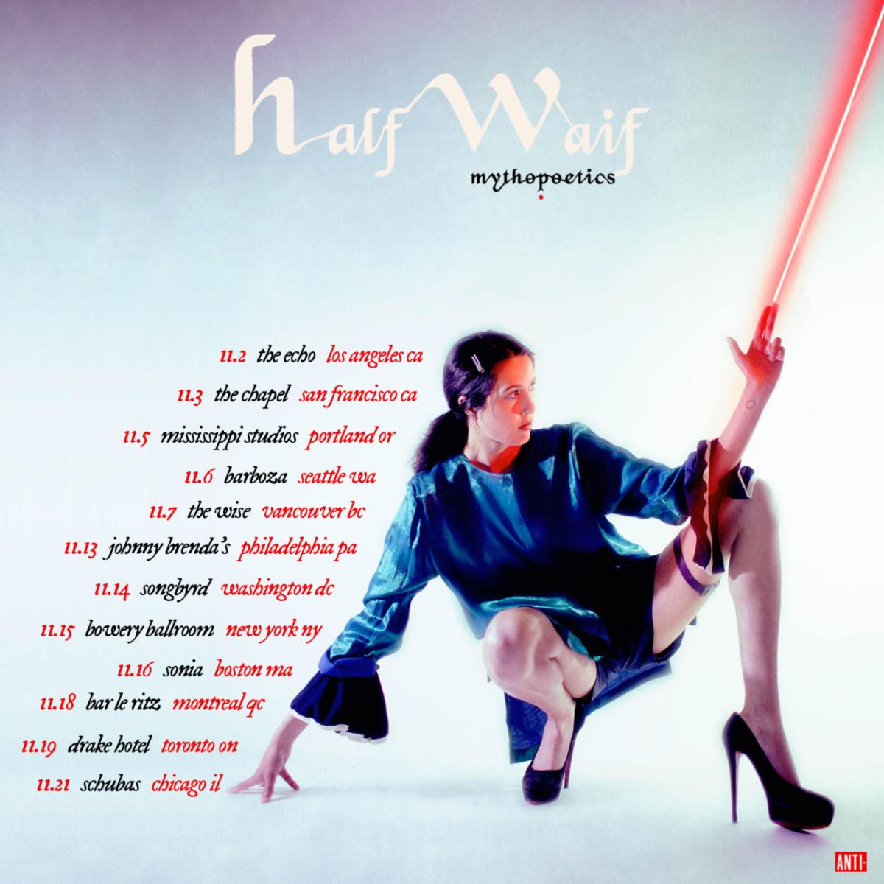

For Nandi Rose, writing a song is an act of transformation. As Half Waif, Rose pieces together the patchworks of our darkest and most vulnerable moments with a golden thread, crafting a majestic evocation of the human experience that permeates with a graceful strength. On new album Mythopoetics, the Hudson Valley-based artist breaks the familial patterns handed down to her, transforming this source of pain into something bearable, beautiful and celebratory. It is an essential reminder that we have the power to shape the stories we tell and the myths we make of our lives.

Half Waif’s previous albums The Caretaker (2020), Lavender (2018) and Probable Depths (2016), garnered acclaim for their compelling journeys through solitude, desire and the search for independence, blanketed under a spectacle of deeply-layered synth-pop. Her fifth full-length sees her stretch her creative muscles, as Rose pushes through the barriers of self-scrutiny and transports us into a world of mythic proportions. Charting territories of addiction, memory and loss, Mythopoetics is animated by the traces of what’s been left behind: the ghost of orange blossoms, the tail of a meteor across the sky, the taste of loneliness in a crust of bread. It is a kind of modern-day storybook where memory is spun into song and the self is explored and acknowledged with tender, nourishing care.

To bring together the world of Mythopoetics, Rose once again collaborated with multi-instrumentalist, film composer and producer Zubin Hensler. The pair came together for a recording residency at Pulp Arts in Gainesville, Florida, with the intention of creating stripped-back recordings of old songs, solely focusing on Rose and her piano. However, the playground of the studio soon transformed the project into a texturally diverse and kaleidoscopic sonic universe.

“This is the record I've been trying to make for 10 years,” Rose says. “My voice is changing, and my confidence has reached a point where I feel that I can sing however I want; I’ve finally come to a place where I don't have to conform to what I think other people want it to sound like.”

By unearthing this kind of self-assurance, Rose was poised to interrogate her life with a new lens. Lead single “Swimmer,” a song that examines the effect Alzheimer’s has on a loved one, sees Rose strive to use her voice as a tool for communication and healing. “I wanted to sing for you / So I'm going to sing for you,” she urges. “I thought of the voice as a wand, trying to reach across this boundary and remain connected with someone who's slipping away,” she says.

Mythopoetics is an album about processing past traumas in the quest for a new, sun dappled pathway, and the transformation that takes place as we take each tentative step. The artwork, shot by Ali Cherkis, sees Rose screaming in bright colors on the front, and naked, with a stoic expression on the back, representing the spectrum of emotions explored throughout each track. Change, evolution and joy take real courage, and it’s in the catharsis of telling your story that the calm, confident aftermath can finally reach the surface. Here, Half Waif is shunning the shadowed mass of generational trauma and the patterns passed down to her. Instead, she plants a seed, urging the orange blossom to sprout through the cracks in the concrete.

PRAISE FOR HALF WAIF:

"Evolves from an anxious rhythmic pulse to a chordal anthem, all larger than life."
-New York Times

"Half Waif's new album, The Caretaker, evokes the stifling feeling of wanting to force time forward and charge into a future that's nebulous and perpetually out of reach. These songs inadvertently speak to a period of uncertainty and isolation, and, though they're weighty, Half Waif's sombre elegance reflects the steely-eyed strength of a person who might just get through it."
-The New Yorker

"Beautifully rendered and deeply layered synth-pop."
-Pitchfork

"The swooping blend of organic instrumentation and fluttering electronics that has marked Nandi Rose's solo career as Half Waif looks to come into stark clarity with The Caretaker. A musician who has built her career on enigmatic presence and ambiguity steps into a lusher and more mature territory with her fourth album, guided as always by her clear and restless vocals, delivering poetic turns of phrase that can twist from grandly universal to painfully intimate within a single measure"
-The AV Club

"A whirring, deeply emotive window into self-sufficiency and the highs and lows of personal growth."
-NPR

"Stormy chord progressions and eerie pitch-shifts convey disquiet, while sweeping strings and Rose's soaring vocals crash in waves of catharsis."
-Nylon

"Sparse and spectral."
-The FADER

"Characteristically gorgeous, emotive."
-Stereogum

"Often resembles a reversion to her sparser early work and away from the cavernous jolts of her more recent output."
-Paste

"Whereas her debut solo record, Lavender, took a more intimate approach to music, this new one goes for big emotions and even bigger music."
-Consequence of Sound

"Nandi Rose dials into the electronic elements of her musical repertoire."
-UPROXX

"Downright euphoric."
-MTV

"Gorgeous, haunting"
-Brooklyn Vegan

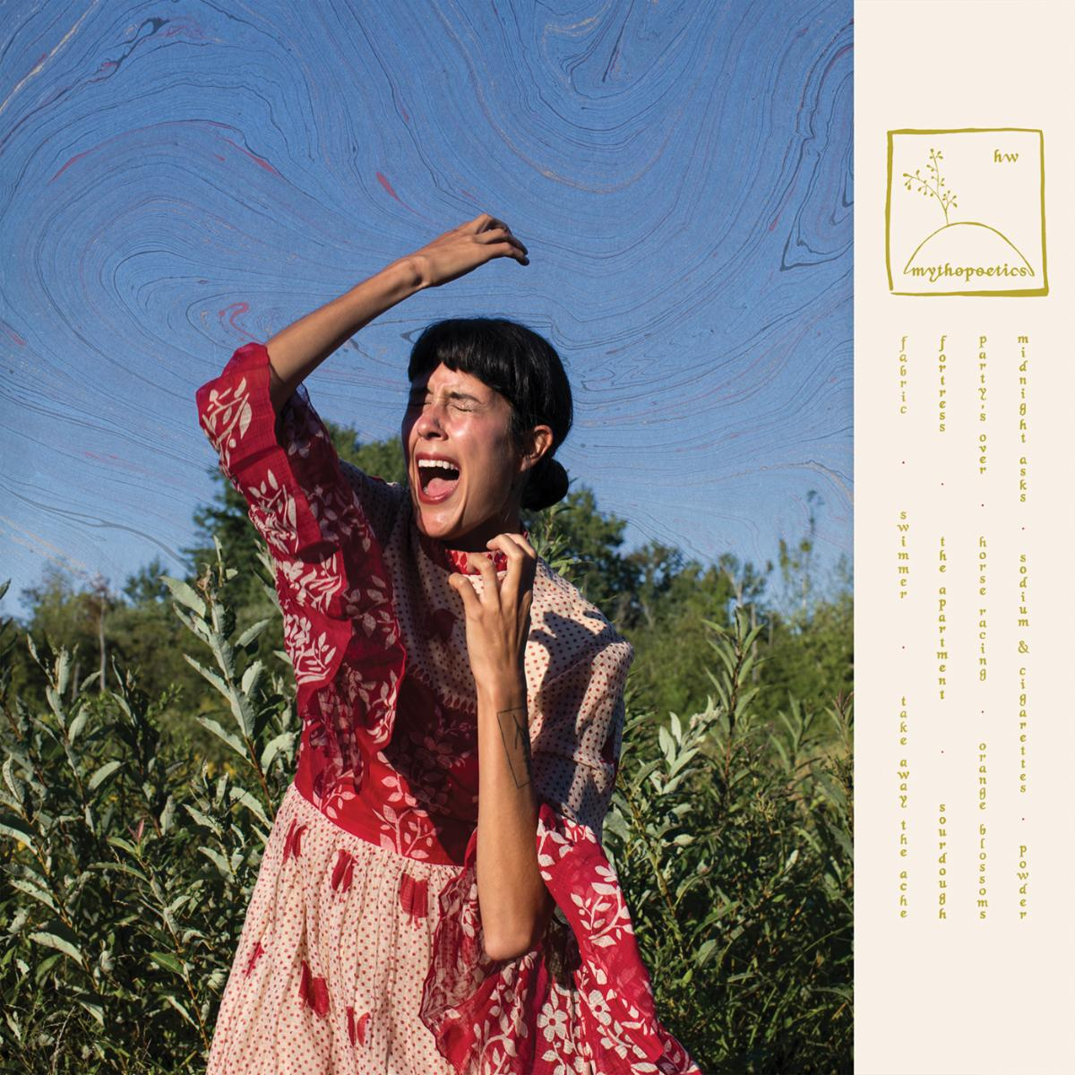

HALF WAIF
MYTHOPOETICS
ANTI- RECORDS
JULY 9, 2021
PRE-ORDER

1. Fabric
2. Swimmer
3. Take Away The Ache
4. Fortress
5. The Apartment
6. Sourdough
7. Party's Over
8. Horse Racing
9. Orange Blossoms
10. Midnight Asks
11. Sodium and Cigarettes
12. Powder

Website | Facebook | Twitter | Instagram

