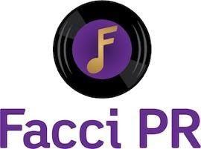

HEY, KING!
Release Debut EP, Be Still Today via
ANTI-Records
Produced by Ben Harper

CLICK HERE TO LISTEN

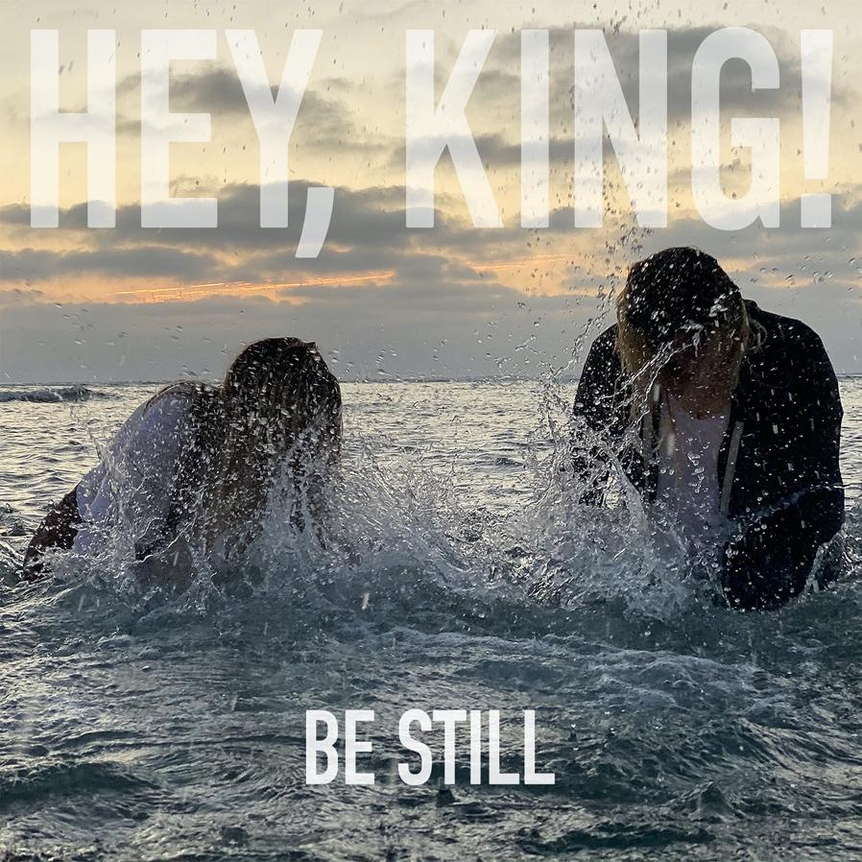

August 28, 2020, Today Indie rock duo, Hey, King!, released their debut EP Be Still via ANTI-Records. The entire 5 song EP was produced by multi GRAMMY Award winning musician and producer Ben Harper.

Ben Harper has been Hey, King!’s biggest champion, producing this debut and later taking them on the road. Their work with Harper in the studio evolved over the course of a year into a full-length album which will be coming out on ANTI- in 2021.

“Recording this EP in Sheldon Gomberg’s Carriage House with Ben was like creating in a musical playground,” says the band. “From vibraphones to horns to harp, we were able to tap into the full spectrum of emotions these five tracks brought to the table.”

The EP’s 4 original songs – “Half Alive”, “Sing Me To Sleep”, “Don’t Let Me Get Away” and “Lucky” – are powerful and humanity affirming. Songwriter, vocalist, and multi-instrumentalist Natalie London and her partner, vocalist and percussionist Taylor Plecity’s debut songs, show their love for each other and their craft is tangible. Hey, King! evokes the exuberance of Arcade Fire, the freewheeling simplicity of Tom Petty, and the wit-filled resonance of Fiona Apple.

In addition to the 4 original songs is a stand-out cover of the Animals classic hit, “We Gotta Get Outta This Place” which has always held a special significance for London. As she describes, “I actually mention this song in the first paragraph of the first chapter of my memoir ‘Lyme Light’ because this song is one of the building blocks of my childhood, my musical tastes, and in part my psyche. My mom sang this song to me at night before I fell asleep and it became an anthem. We were very much outsiders in our town and she was in an abusive relationship with my biological father; this song was like a secret that we would have a better life someday. When my mom was diagnosed with third stage melanoma in her lymph system she was only given three months to live. Due to an experimental treatment and nearly three years of mainly living in a hospital, she was lucky enough to survive. When she thought she was going to die, however, she asked me to sing this with a choir at her funeral. This song is so layered and so inspirational that the hope for a better life applies to this world as well as whatever world lies after death.”

“There was nothing more surreal than doing my first take on the vocals as Eric Burdon, the legend himself, walked into Studio B at Capitol Records and watched from behind the glass. I don’t think I’ve ever felt more honored to sing,” Plecity says. “Eric is timeless. When he sang, every single person in that room got chills.”

When you first hear indie rock band Hey, King! it immediately becomes clear
that each musical moment is rendered with precision, care, and a whole lot of heart.

Be Still is out everywhere at https://heyking.ffm.to/bestill

LINKS:
https://heykingofficial.com/
Facebook | Instagram | Twitter

CONTACT:
Facci PR

Sarah Facciolo- sarah@faccipr.com
610-764-8334

