For immediate release:

JACKSON+SELLERS PREMIERE NEW INDIE POP-ROCK SINGLE, “HUSH,” WITH FLOOD MAGAZINE

https://youtu.be/iu0uiA0l5Eg

JADE JACKSON AND AUBRIE SELLERS UNITE DURING THE PANDEMIC TO CREATE THE ROCK FOCUSED DUO ALBUM THEY WANTED TO MAKE THEIR ENTIRE CAREER AS ESTABLISHED INDIVIDUAL ARTISTS

PERFORMING AT AMERICANAFEST ON 9/23 AT CANNERY BALLROOM IN NASHVILLE
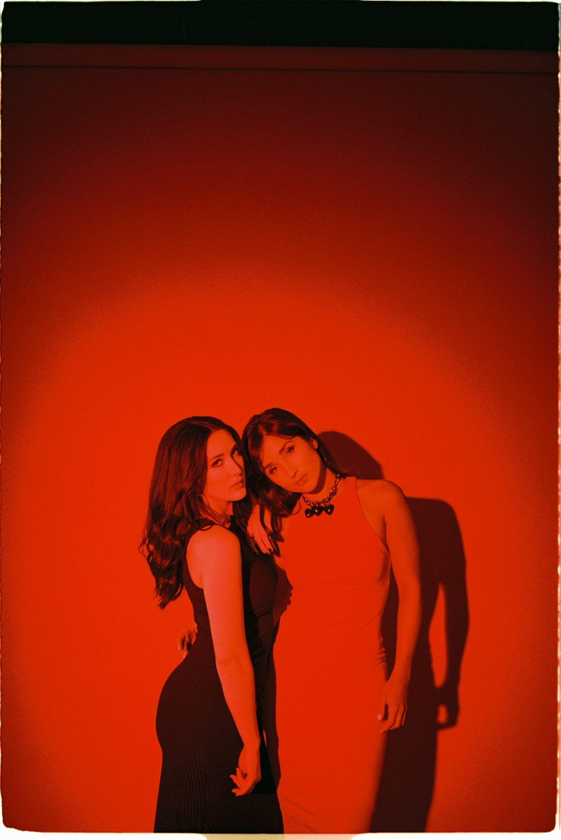
Credit: Ashley Osborne Download: here

LISTEN TO NEW SONG AND PRE-ORDER FORTHCOMING ALBUM, BREAKING POINT, RELEASED VIA ANTI-RECORDS ON OCTOBER 22 HERE:

https://jacksonsellers.ffm.to/breakingpoint
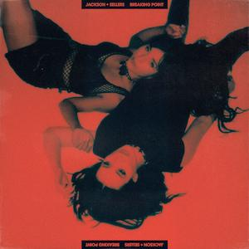

“Just being yourself in this industry can be considered inflammatory, I wanted to push even further into the rock & roll sound I’ve been on the edge of for my last two solo albums.”
Aubrie Sellers

“Jackson+Sellers Envision a Thorny Romance on Somber New Single ‘Hush’” FLOOD

“Harmonic bliss full of lush 70s rock that intertwines with modern indie pop” - FLAUNT

“Blistering rock and roll; guitars up, drums driving and the combined force of Jackson’s and Sellers’ Americana swagger front-and-center” - NPR Music

“Aubrie Sellers and Jade Jackson have combined their talents as they lean even further into rock sounds, pairing a scuzzy guitar riff with wild garage-punk energy.” ROLLING STONE

Wednesday September 15 - Today, Jackson+Sellers debut their new song “Hush,” a slow burning indie rock single from their forthcoming debut album, Breaking Point, which will be released on October 22 via ANTI- records and is available to pre-order, here. The song premiered with FLOOD MAGAZINE who described the Hush as playing, “like a twangier Marissa Nadler or Azure Ray, with a gothic shadow hanging over the track’s subtle folk melodies. True to its subject matter, the haunting guitars accompany a story of thorny romance.” FLOOD MAGAZINE also published a Q&A with Jackson+Sellers. The duo discussed their first writing session together, their shared rock influences and more. Read it in full here: https://floodmagazine.com/93528/jackson-sellers-hush-premiere/

“Hush,” which shares a warning about bad love, was written by Jade Jackson, not long after she first met Aubrie Sellers when she opened for her at a Nashville show. Formed during the pandemic after Jackson approached Sellers via a social media DM, the creative partnership quickly blossomed into a full duo project with Sellers and Jackson, fueled by their desire to write a rock focused record that reflected their expansive musical interests. “Just being yourself in this industry can be considered inflammatory,” Sellers said, adding, “I wanted to push even further into the rock & roll sound I’ve been on the edge of for my last two solo albums.”

Jackson instantly envisioned Seller’s voice as providing the perfect harmony for her new song “Hush.” Discussing the track and origins of the collaboration, Jackson said, “I really loved her voice and asked if she’d be interested in doing a co-write / duet.” She added, “I wasn’t expecting a response but moments after I sent the message she responded with she’d love to. I knew the song would benefit from heavy female vocal harmonies, but working with Aubrie was such a boost. Collaborating with someone who’s so energetically strong, it gives you even more creativity and license to explore.”

Jackson+Sellers’ L.A.-written, Nashville-recorded album is a masterclass in unexpected vocal harmonic convergence, soundtracked by raw guitars, driving drums and a singular pop-rock sound that weaves a sonic thread between 70s rock, 90s raucous roots, and modern indie pop. They exchanged lead vocals, reflecting on their own experiences of vulnerability, isolation, sensitivity and autonomy. They drew on changes in their personal relationships, intuitively capturing each other’s personal experiences, often before they had even discussed them with each other.

Recorded at The Cabin studio in East Nashville in late 2020, Breaking Point was co-produced by Sellers and Ethan Ballinger, with Jackson and Sellers contributing three tracks each and co-writing “Wound Up” with Ballinger. In addition to their own material, they selected deep-cut covers including their first single, a reimagination of Julie Miller’s blistering “The Devil Is an Angel.” They also recorded genre bending interpretations of Suzi Quatro’s defiant “The Wild One,” and Shannon Wright’s raucous “Has Been.”

With Breaking Point, Jackson+Sellers establish themselves as two powerful individual artists who have together created one of the most compelling duo albums of the last decade.

Jackson+Sellers will be performing on September 23, 2021 at Cannery Ballroom in Nashville for Americanafest. For more information please visit: https://americanamusic.org/about-americanafest

Tracklist
1. The Devil Is An Angel
2. Breaking Point
3. As You Run
4. The World Is Black
5. Waste Your Time
6. Hush
7. Fair Weather
8. Wound Up
9. The Wild One
10. Has Been

ENDS

For further information, please contact: Doug Hall | Big Feat PR | doug@bigfeatpr.com

==

IG: https://instagram.com/jacksonsellersmusic
Facebook: https://www.facebook.com/jacksonsellersmusic
Twitter: https://twitter.com/jacksonsellers_
TikTok: https://www.tiktok.com/@jacksonsellersmusic
Website: https://jacksonsellers.com/

Hush

Her soul’s slipping, her mind’s drifting
Like a ship letting go of her ropes
Sand’s shifting, her hand’s gripping
She just can’t let go

Hush little darlin, don’t you cry
Ain’t it time you learned to fly?

Wind’s wild, sparrow beguiled
By a rose of fragrance so sweet
She swooped down low like wind to an arrow
And crashed in its soil and seed

Hush little darlin, don’t you cry
Ain’t it time you said goodbye?

Her wing’s thorned, her feathers torn
Unable to fly
So she stayed in the nest and watched all the rest
Puff their breasts up toward the sky

Hush little darlin, don’t say a word
He’s a thorn and you’re the bird

