KRISTINE LESCHPER
FKA MOTHERS

SIGNS TO ANTI- RECORDS

SHARES VIDEO FOR NEW SINGLE “FIGURE AND I”

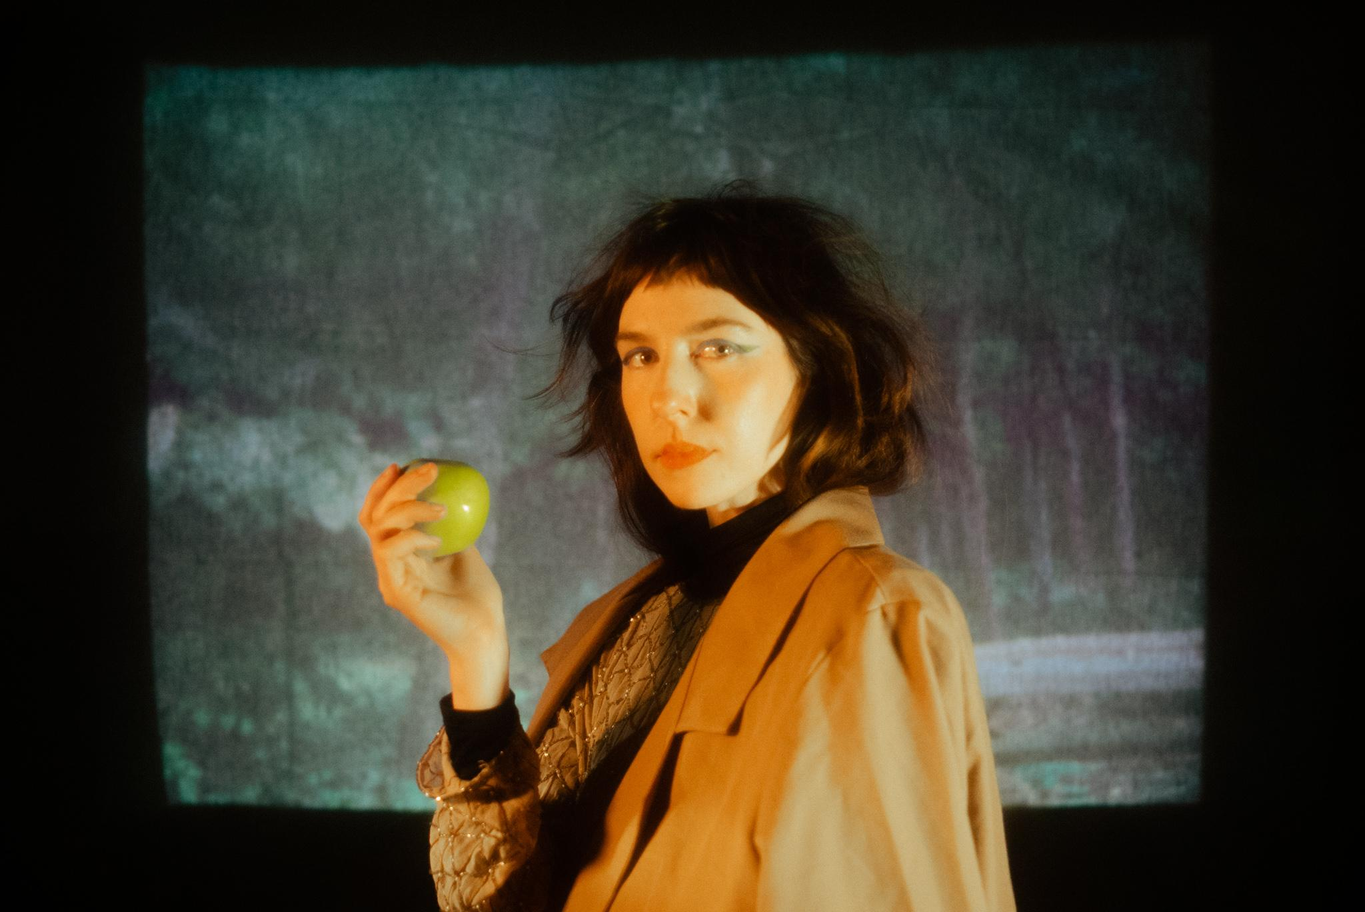
Photo Credit: Tyler Borchardt (download hi-res)
Kristine Leschper shares a video for her new single “Figure And I.” Having retired the moniker Mothers after eight years of performing and releasing music under it, “Figure And I” marks Leschper’s first release under her given name, and first for ANTI- Records.

Though both Mothers and her solo work are guided by Leschper’s idiosyncratic approach to songwriting, they couldn’t sound more different. While Mothers drew inspiration from the stark, skeletal sounds of post-punk and contemporary folk, Leschper’s new work is practically baroque, integrating an array of synthesizers, strings, woodwinds, and over a dozen percussive instruments.

“For the first time, I used my hands to clap out a rhythm that spoke to me. I don’t have much experience with percussion, so I was thrilled by the ease and accessibility of using hands as an instrument,” says Leschper. “It’s such a long-standing and fundamental way of making sound in folk traditions around the world, and to use it makes me feel rooted in a deeper sense of time. As a poet, too, I hold an enthusiasm for the symbolism of hands, as a symbol of work, of community or offering, or holding and being held.”

The video’s director, Lynne Sachs, adds “Kristine Leschper wrote to me with a very intriguing proposition: create a short film in response to her song ‘Figure and I.’ I knew that this deeply rhythmic two-minute song needed some kind of somatic imagery. I needed to move with my body and my camera as I was shooting it. A few days later, I went to ‘The New Woman Behind the Camera’ exhibition at the Metropolitan Museum of Art in New York City. In this show, I saw two photos by two women photographers from the 1920s whose work I had never seen before. These images guided me to a way of interpreting the physicality and the intimacy of Kristine’s song. Soon afterward, I invited my friend Kim Wilberforce to be in my film and to interpret the song herself, through her vibrant wardrobe and her precise, ecstatic clapping gestures.”

WATCH THE “FIGURE AND I” VIDEO
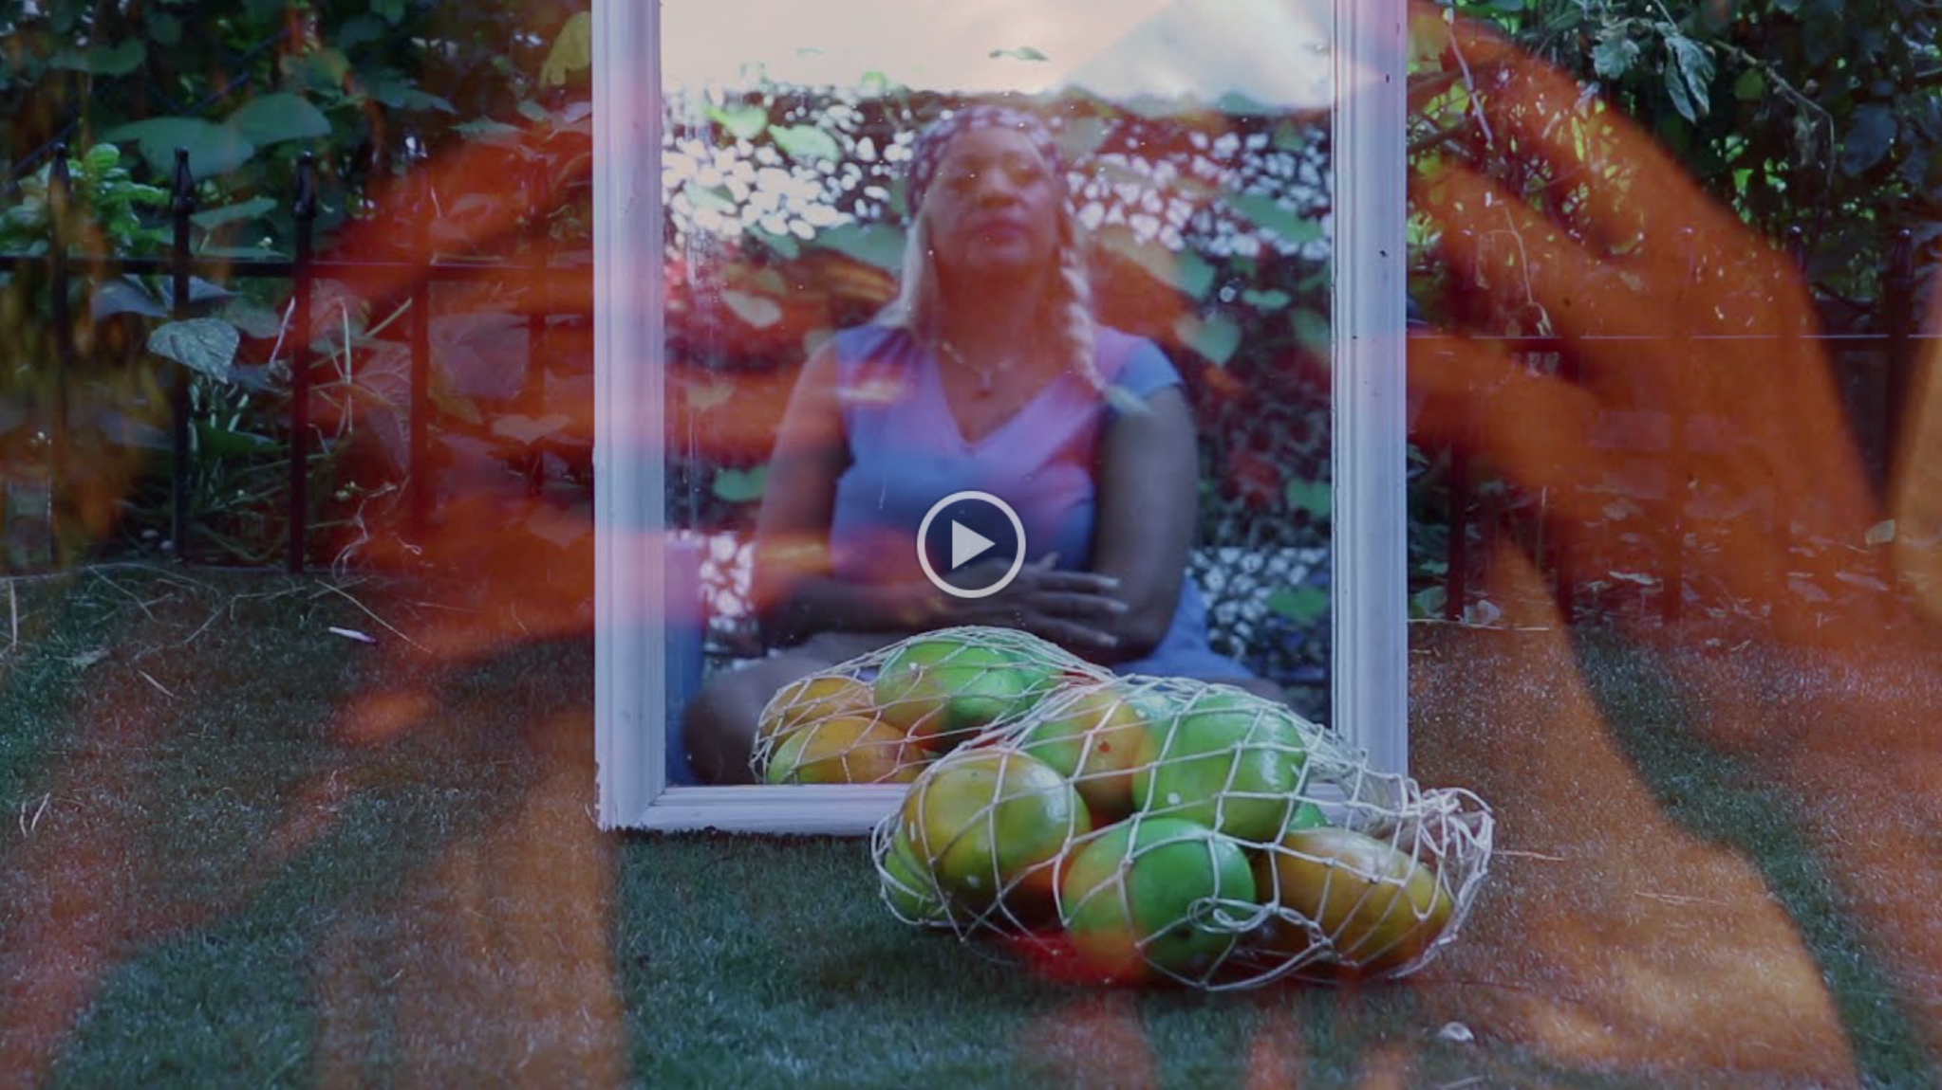

WEBSITE | BANDCAMP | SPOTIFY
TWITTER | INSTAGRAM | FACEBOOK

