November 17, 2020
For Immediate Release

Listen to Andy Shauf’s New Single, “You Slipped Away”
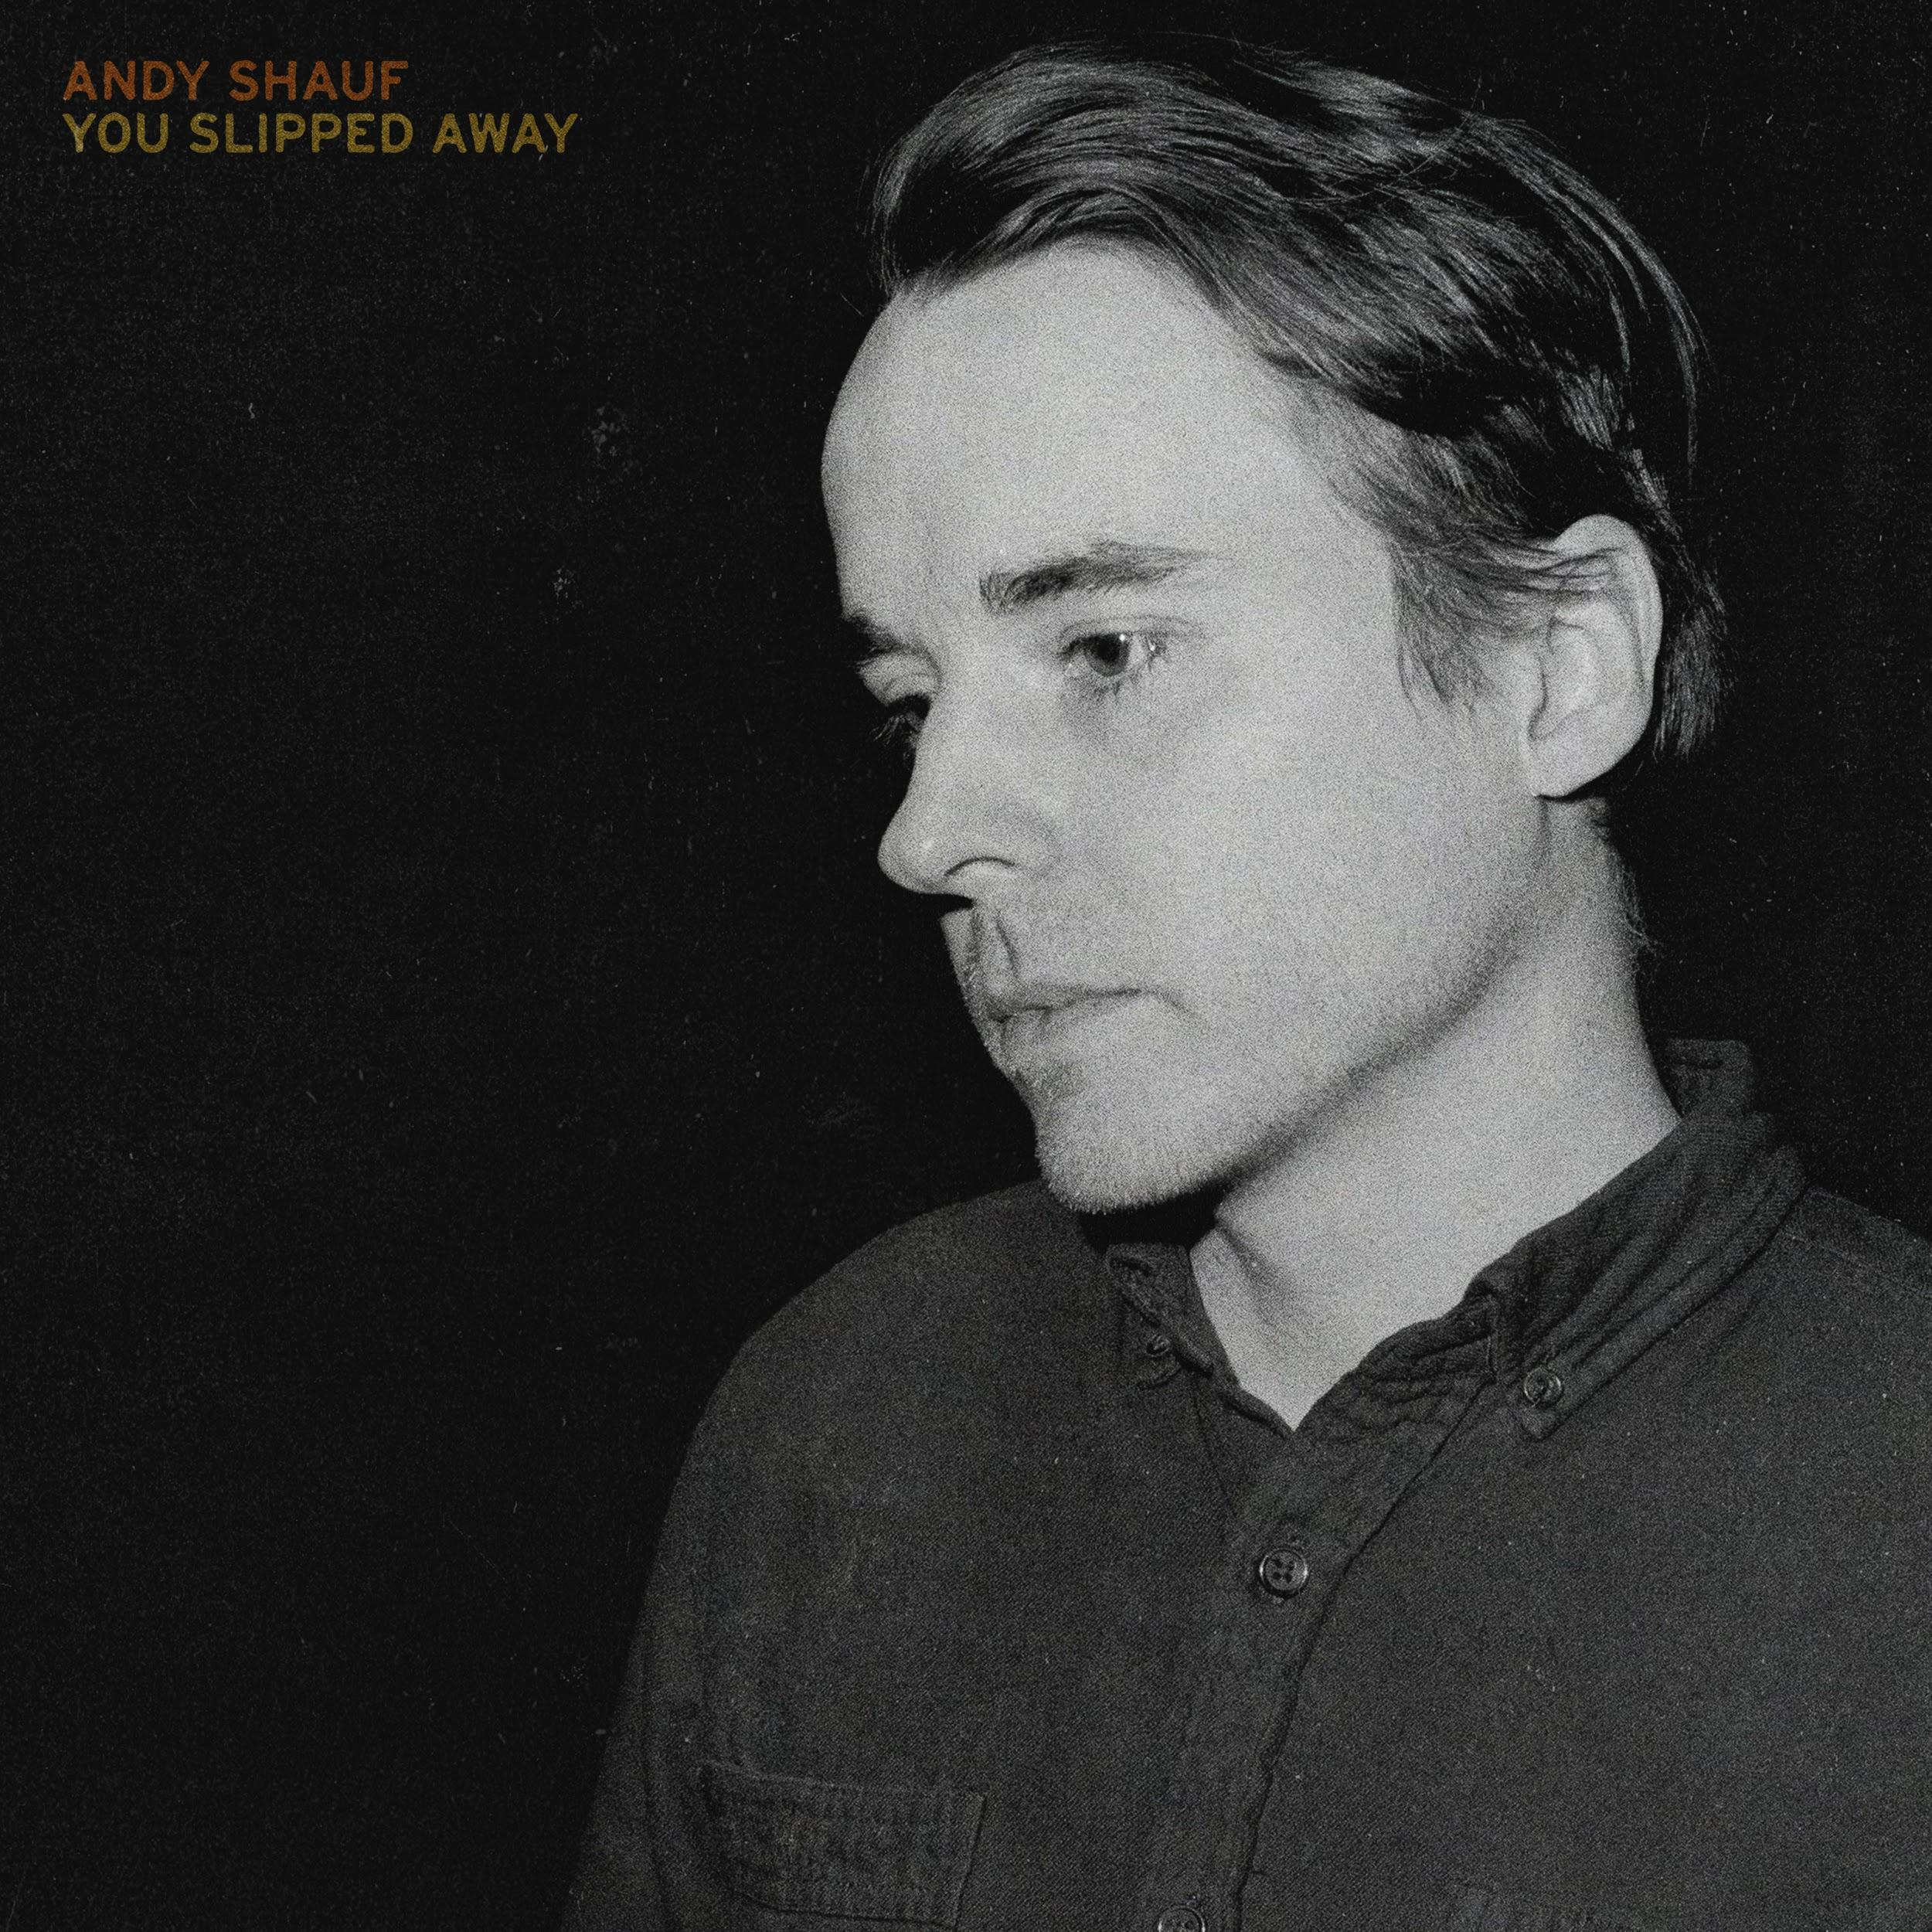

Today, Andy Shauf presents “You Slipped Away,” available to stream for the first time on all platforms. “You Slipped Away” was a demo recorded in the same sessions that spurred The Neon Skyline, one of this year’s most widely praised records. When The Neon Skyline’s narrative evolved, “You Slipped Away” revealed its own singular identity apart from the album. Shauf’s voice is subdued and beguiling over somber piano chords and skipping percussion. Back-up “ooos” build upon his vocals throughout. “‘You Slipped Away’ was a song that I wrote shortly after moving to Toronto, right after I’d just moved into an apartment and had acquired an 80s Yamaha CP60 stage piano,” says Shauf. “This song was an attempt to write something that sounded like an old standard, using big general metaphors and universal themes.”

Listen to Andy Shauf’s “You Slipped Away”

“You Slipped Away” follows last month’s stunning video for “Clove Cigarette,” a track off of The Neon Skyline. The video, directed by Colin Medley and Jared Raab, was made using a variety of cutting edge technologies: LiDAR, a 3D scanning technique using laser light that’s often used for 3D maps and self-driving cars, photogrammetry, and a video game engine.

Watch/Listen/Share:
Stream/Purchase The Neon Skyline
“Try Again” Video
“Things I Do” Stream
“Neon Skyline” Video
“Living Room” Stream
Jimmy Kimmel Live! Performance
"Clove Cigarette" Video

Mid-year Praise for The Neon Skyline:

“All singer-songwriters are storytellers of a sort, but neither term does justice to what Andy Shauf accomplishes on The Neon Skyline. ” - Stereogum, Best Albums of 2020 So Far

“Listening to an Andy Shauf album in full is akin to bingeing a particularly compelling TV show: Both pull you in with characters that feel just as real as you or me, who populate a world we’d like to escape to.” - Paste, Best Indie Rock Albums of 2020 (So Far)

“Andy Shauf’s songs are charming tales of everyday life. . . perhaps the least pretentious concept album you'll find.” -- Esquire, Best Songs of 2020 So Far

“The Neon Skyline is a wise and transportive album, with Shauf taking his place among the great contemporary songwriters.” -- Uproxx, The Best Indie Albums Of 2020 So Far

Website | ANTI- | Instagram | Facebook | Twitter | Bandcamp

For more information, contact:
Jessica Linker & Patrick Tilley | Pitch Perfect PR –
jessica@pitchperfectpr.com, patrick@pitchperfectpr.com

##

