M. Ward’s Acclaimed New Album Migration Stories Out Now on Anti;
Live Home Studio Concert To Stream On April 8th; The Late Show with Stephen Colbert Performance To Follow

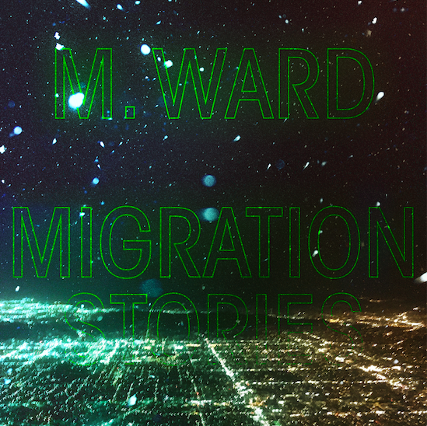

Today, M. Ward has released Migration Stories via Anti Records. The new album includes the captivating first singles “Unreal City,” “Migration Of Souls” and “Heaven’s Nail and Hammer.”

To celebrate the release of his already highly lauded tenth album, Ward will perform a concert from his home in Southern California on Wednesday, April 8 at 11am PT / 2pm ET / 7pm CET. The concert will be streamed on NPR Music Live Sessions, YouTube and Facebook in partnership with Record Store Day. Ward will also perform on an upcoming broadcast from The Late Show with Stephen Colbert. Watch this space for air date!

Listen to Migration Stories Here

A prolific writer, producer and performer, M. Ward has established himself as one of modern American music’s most unique and versatile voices. For his tenth album he journeyed to Quebec, Canada to work with Arcade Fire’s Tim Kingsbury, Richard Reed Parry, producer/mixer Craig Silvey (Arcade Fire, Arctic Monkeys, Florence and the Machine) and Teddy Impakt. Together they recorded a collection of 11 songs inspired by stories of human migration. Languid, hazy and often dream-like in narrative, these songs have their origins in pictures from newspaper and television reports, stories told by friends and tales from Ward’s own family history. At Arcade Fire’s Montreal studios the assembled talents recorded what he describes as “11 largely instrumental ballads - a sci-fi fast forward to a more silent night many generations from here to a maybe-era where movement is free again.”

Says Ward of the stories which informed these songs, “Some time went by, the stories wove together and I remember them now closer to characters in a dream of how people could treat each other than any kind of front-page news realism. I think music subconsciously - whether writing or listening - is a filter for me. Helping to process all the bad news into something new to build from. Some records to me are like self-fulfilling prophecies - visualizing change to wish something into being. Those records inspired this one.”

Early Praise for M.Ward’s Migration Stories:

"Ward employs the organic delicateness of his voice to tell these stories with a tender touch...Whether knowingly or not, Ward has made Migration Stories a tonic to soothe our worried minds." - No Depression

“Migration Stories is a spare and spacious 11-song album. It’s written from the point of view of people living their day-to-day amidst political chaos, relying on faith and hope to keep going to try and find better lives. Ever since early human history, people have migrated, immigrated and emigrated. So, Ward thought, he should tell some of their stories. And he does so in his signature restrained, hypnotic style.” - American Songwriter

"The intimate atmospherics, along with Ward’s storytelling acumen, make it an album practically designed for deep listening rather than skipping around to the singles." - The San Francisco Chronicle

"While 'Migration of Souls' leaned into Ward’s more sparse eerie folk roots, his latest single sits more in an ’80s-soaked synthy realm. Sparkling percussion, caramel-smooth synths, and tiny little punchy beats all meld in soothing sounds, with Ward’s own signature gravely timbre moving across with an unshakeable ease." - Consequence of Sound

“The record approaches the complex conditions of human passage, some of which evoke Ward’s family history. But it does so from a place of aspiration, projecting an image of free movement amid peace.” - The Oregonian

"His familiar dreamlike structural plodding is still intact with a bit of psych spaciness thrown in for good measure, moving the songwriter’s musical existence in forward motion." - SPIN

"He’s an expert folk guitarist and an engagingly laconic vocalist." - The Philadelphia Inquirer

Watch “Unreal City” Video
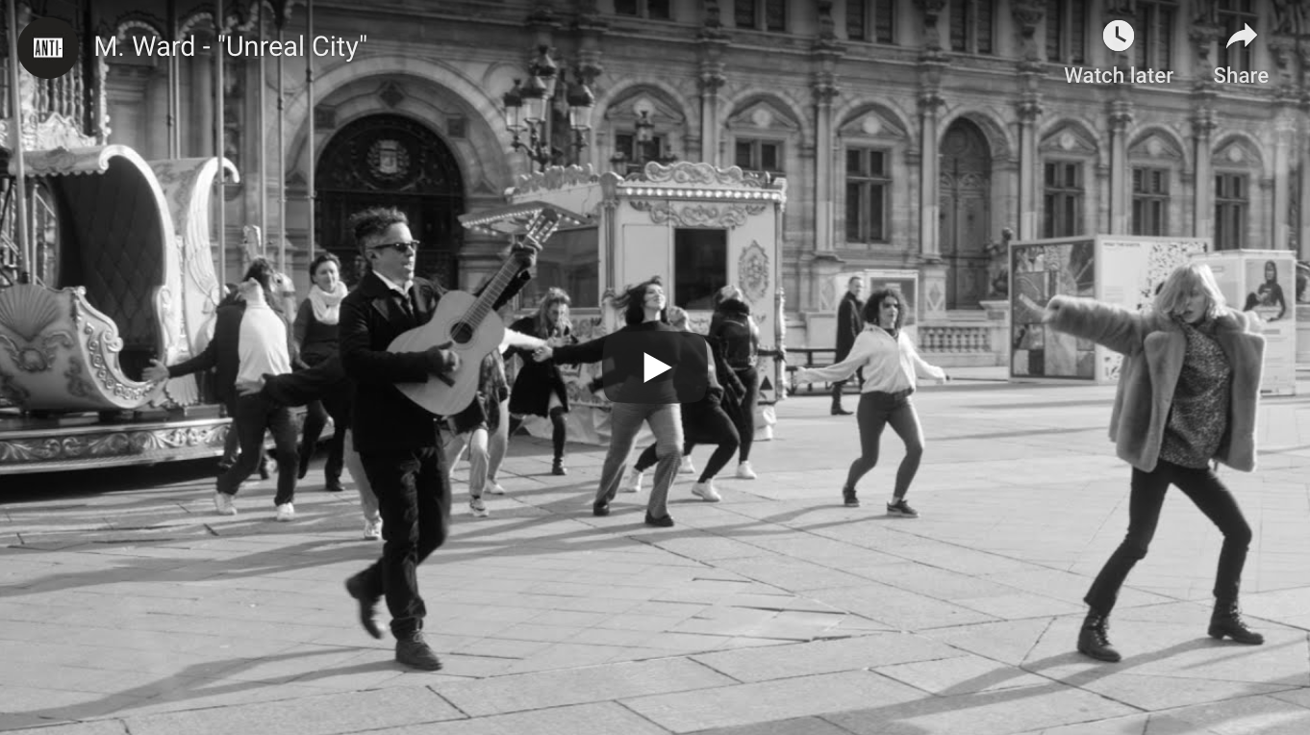

Migration Stories - Tracklist:
1. Migration Of Souls 7. Real Silence
2. Heaven's Nail and Hammer 8. Along the Santa Fe Trail #
3. Coyote Mary's Traveling Show 9. Chamber Music
4. Independent Man 10. Torch
5. Stevens' Snow Man 11. Rio Drone
6. Unreal City

# Written by Al Dubin, Hugh Williams

Keep up with M. Ward:
Instagram / Website / Facebook / Twitter

For more information on M. Ward contact Chloe Walsh or Shane Greenberg: ChloeW@GrandstandHQ.com / ShaneG@GrandstandHQ.com / 213 278 0320

