November 14, 2023
For Immediate Release

Madi Diaz and Kacey Musgraves Duet On New Single,
“Don’t Do Me Good,” Off New Album, Weird Faith, Out 2/9 on ANTI-

Watch “Don’t Do Me Good” Video

Announces 2024 North American Headline Tour
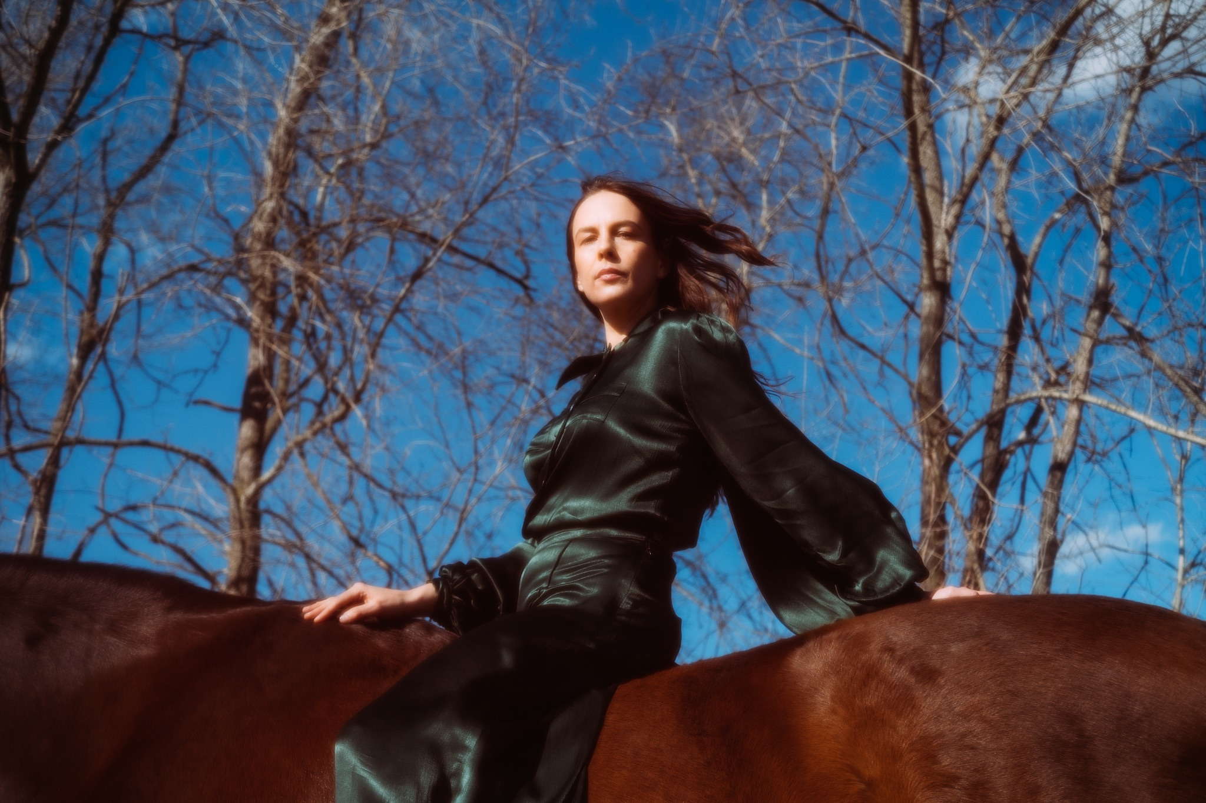
Photo Credit: Muriel Margaret

“What starts with modest acoustic guitar strumming rises with an orchestral crescendo
to match the urgency of [Madi Diaz’s] questions.” — New York Times

“[‘Same Risk’ is] another devastatingly great song” — Rolling Stone

“‘Same Risk’ confronts relationship messiness with blunt emotion and musical vulnerability — a few sounds creep into view to join Diaz’s honest vocals and guitar strums, but never enough to overwhelm her words.” — Billboard

Madi Diaz “is one of our most important songwriters, and her command of melody and language stands alone” (Paste). Today, Madi Diaz presents her second pre-release single, “Don’t Do Me Good,” off Weird Faith, out February 9th via ANTI-, and announces a 2024 North American headline tour. Following lead single, “Same Risk,” “Don’t Do Me Good” showcases Diaz’s collaborative spirit as she mourns the inevitable end of a relationship alongside musician and friend, Kacey Musgraves. “Every time I try to walk away I stay, you knew I would,” they sing, followed by the reverberating conclusion, “I know loving you, it don’t do me good.” A woman’s admission that peace eludes her is desperately lonely, but Diaz is bolstered by Musgraves’ accompaniment in this crushing ballad. “I wanted this song to feel like calling your friend,” explains Diaz. “That moment of needing to commiserate and to have that person say ‘yeah, I've been there’ and share that experience with you.”

Speaking more to the collaboration with Musgraves, Diaz commented, “I am so happy Kacey said ‘yes’ when I asked her to sing on ‘Don’t Do Me Good.’ This song would have been so awfully lonely without her and I am so grateful I get to hear her voice on this with mine.”

“This song is about that person that we keep coming back to,” Diaz explains, “no matter how many times they let us down. It's about waking up every day and making the choice to love a person unconditionally while it’s simultaneously getting harder and harder to ignore that nothing is getting better in the relationship. It’s stubborn, it’s defiant, it's hopeful, and it's aggressively optimistic. It’s about being a bit of a masochist and being so in love with the hard work of loving a person that you don’t know how to walk away from them.”

Diaz (vocals, guitar, bass, piano, organ) and Musgraves (vocals) are joined by the album’s co-producers Sam Cohen (bass) and Konrad Snyder (percussion), as well as The Walkmen’s Matt Barrick (drums, percussion). The song’s accompanying music video was directed by Elizabeth Olmstead.

Watch Madi Diaz’s “Don’t Do Me Good” Video

On her last album, History of a Feeling, Diaz confronted the dissolution of a long relationship and a nuanced breakup. On Weird Faith Diaz once again examines a romantic partnership, but this time, her songs are about falling for someone and the endless self-questioning a new relationship inspires. “After being really burned by love – maybe relentlessly burned by it – the album is about being brave and trying again. Doing it differently,” she says. “It’s in our nature to try to be brave like that. You see the car crash coming. Maybe it won’t happen, but you're bracing for it anyway.” In the throes of new love, she repeatedly encountered the same questions: “Am I ready for this? Can I do this? Can I trust myself to know the good from the bad?”

Pre-order Weird Faith

Watch Madi Diaz’s “Same Risk” Video

Madi Diaz Tour Dates:
(All Tickets On Sale Fri. Nov. 17th)
Sun. Jan. 14 - Morgantown, WV @ Mountain Stage
Wed. Feb. 21 - Atlanta, GA @ Terminal West *
Thu. Feb. 22 - Durham, NC @ Motorco Music Hall *
Fri. Feb. 23 - Charlotte, NC @ Neighborhood Theatre *
Sat. Feb. 24 - Charlottesville, VA @ Jefferson Theater *
Tue. Feb. 27 - Washington, DC @ The Atlantis *
Wed. Feb. 28 - Philadelphia, PA @ World Cafe Live
Thu. Feb. 29 - Cambridge, MA @ The Sinclair *
Fri. Mar. 1 - Brooklyn, NY @ Music Hall of Williamsburg
Sun. Mar. 3 - Toronto, ON @ The Danforth Music Hall *
Tue. Mar. 5 - Ann Arbor, MI @ The Ark #
Wed. Mar. 6 - Chicago, IL @ Lincoln Hall #
Thur. Mar. 7 - St. Louis, MO @ Off Broadway #
Fri. Mar. 8 - Nashville, TN @ Brooklyn Bowl #
Sat. Mar. 16 - Dallas, TX @ The Kessler Theater
Tue. Mar. 19 - Denver, CO @ Bluebird Theater %
Wed. Mar. 20 - Fort Collins, CO @ Aggie Theatre %
Fri. Mar. 22 - Salt Lake City, UT @ The State Room %
Mon. Mar. 25 - Vancouver, BC @ Fox Cabaret %
Tue. Mar. 26 - Seattle, WA @ Madame Lou's %
Wed. Mar. 27 - Portland, OR @ Doug Fir Lounge %
Fri. Mar. 29 - Oakland, CA @ The New Parish %
Sat. Mar. 30 - Felton, CA @ Felton Music Hall %
Tue. Apr. 2 - San Diego, CA @ Music Box %
Thu. Apr. 4 - Los Angeles, CA @ Troubadour %

With Special Guests:
* Olivia Barton
# Jack Van Cleaf
% Daniel Nunnelee

Download hi-res images and jpegs of Madi Diaz

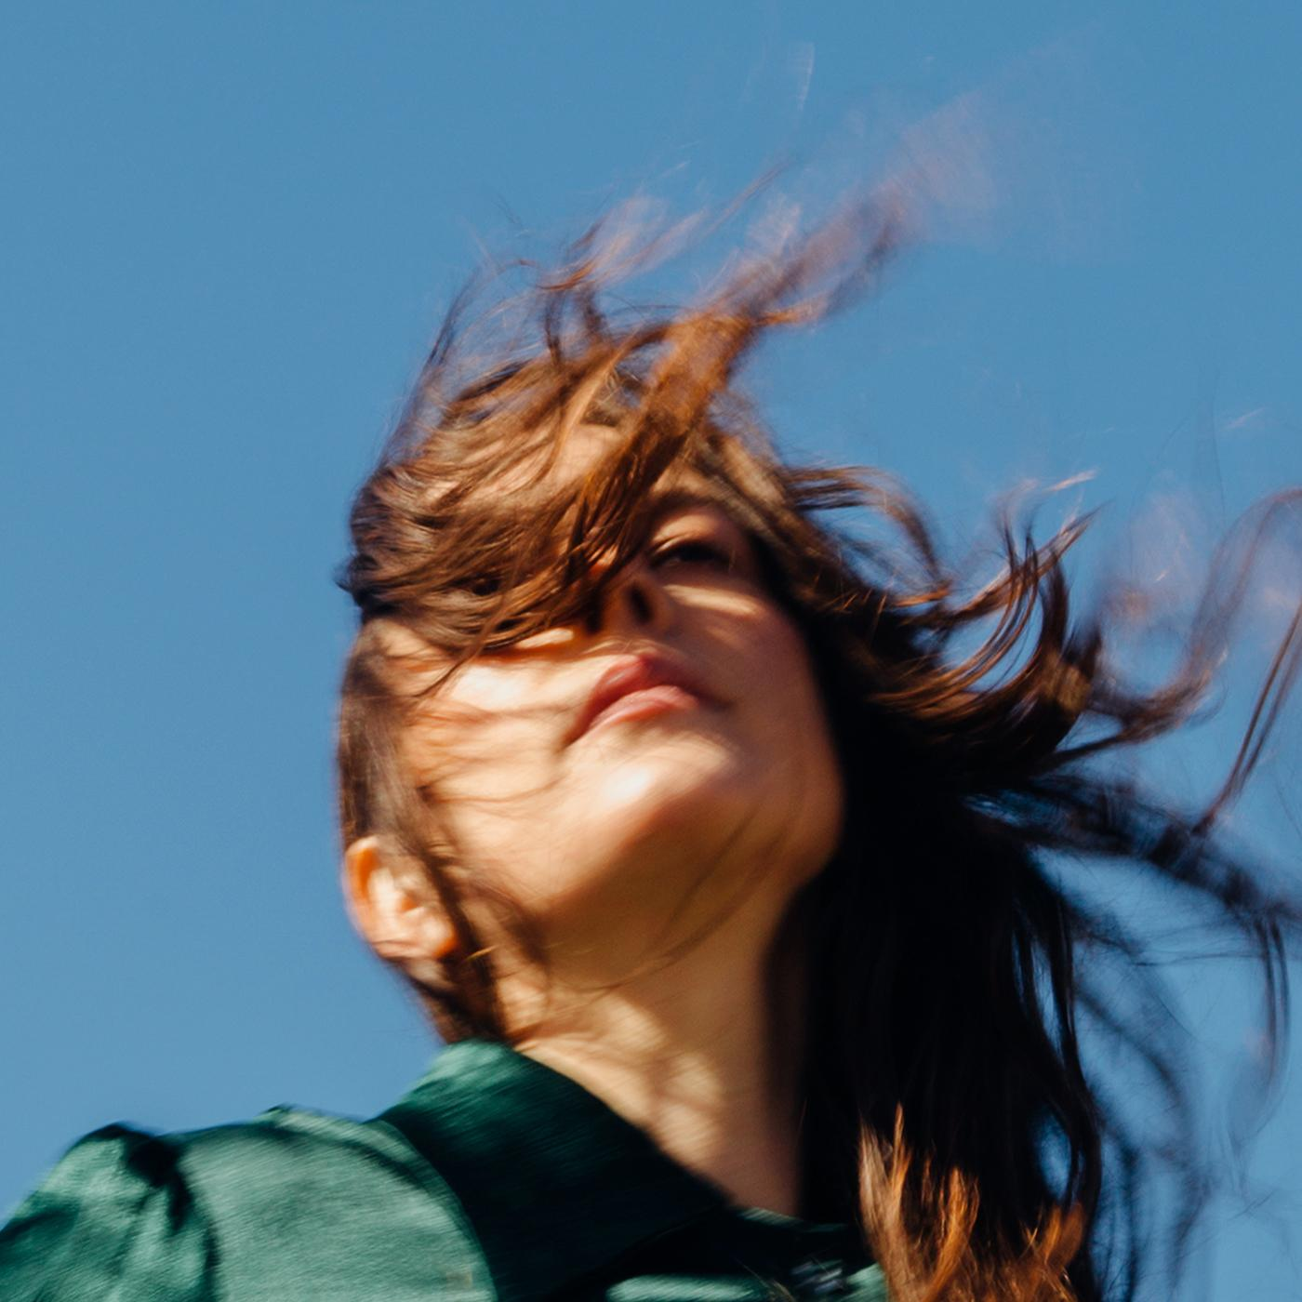
(Weird Faith Cover Artwork)

Madi Diaz Online:
Website | Instagram | Facebook | Twitter

For more information, contact:
Jessica Linker & Jaycee Rockhold | Pitch Perfect PR –
jessica@pitchperfectpr.com, jaycee@pitchperfectpr.com, 773-942-6954

