January 31, 2022
For Immediate Release

Madi Diaz Announces Same History, New Feelings EP,
Feat. Waxahatchee, Angel Olsen, Courtney Marie Andrews & Natalie Hemby, Out March 4th on ANTI-

Listen to “Resentment (New Feelings Version)” feat. Waxahatchee

Tour With Waxahatchee Kicks Off Next Month
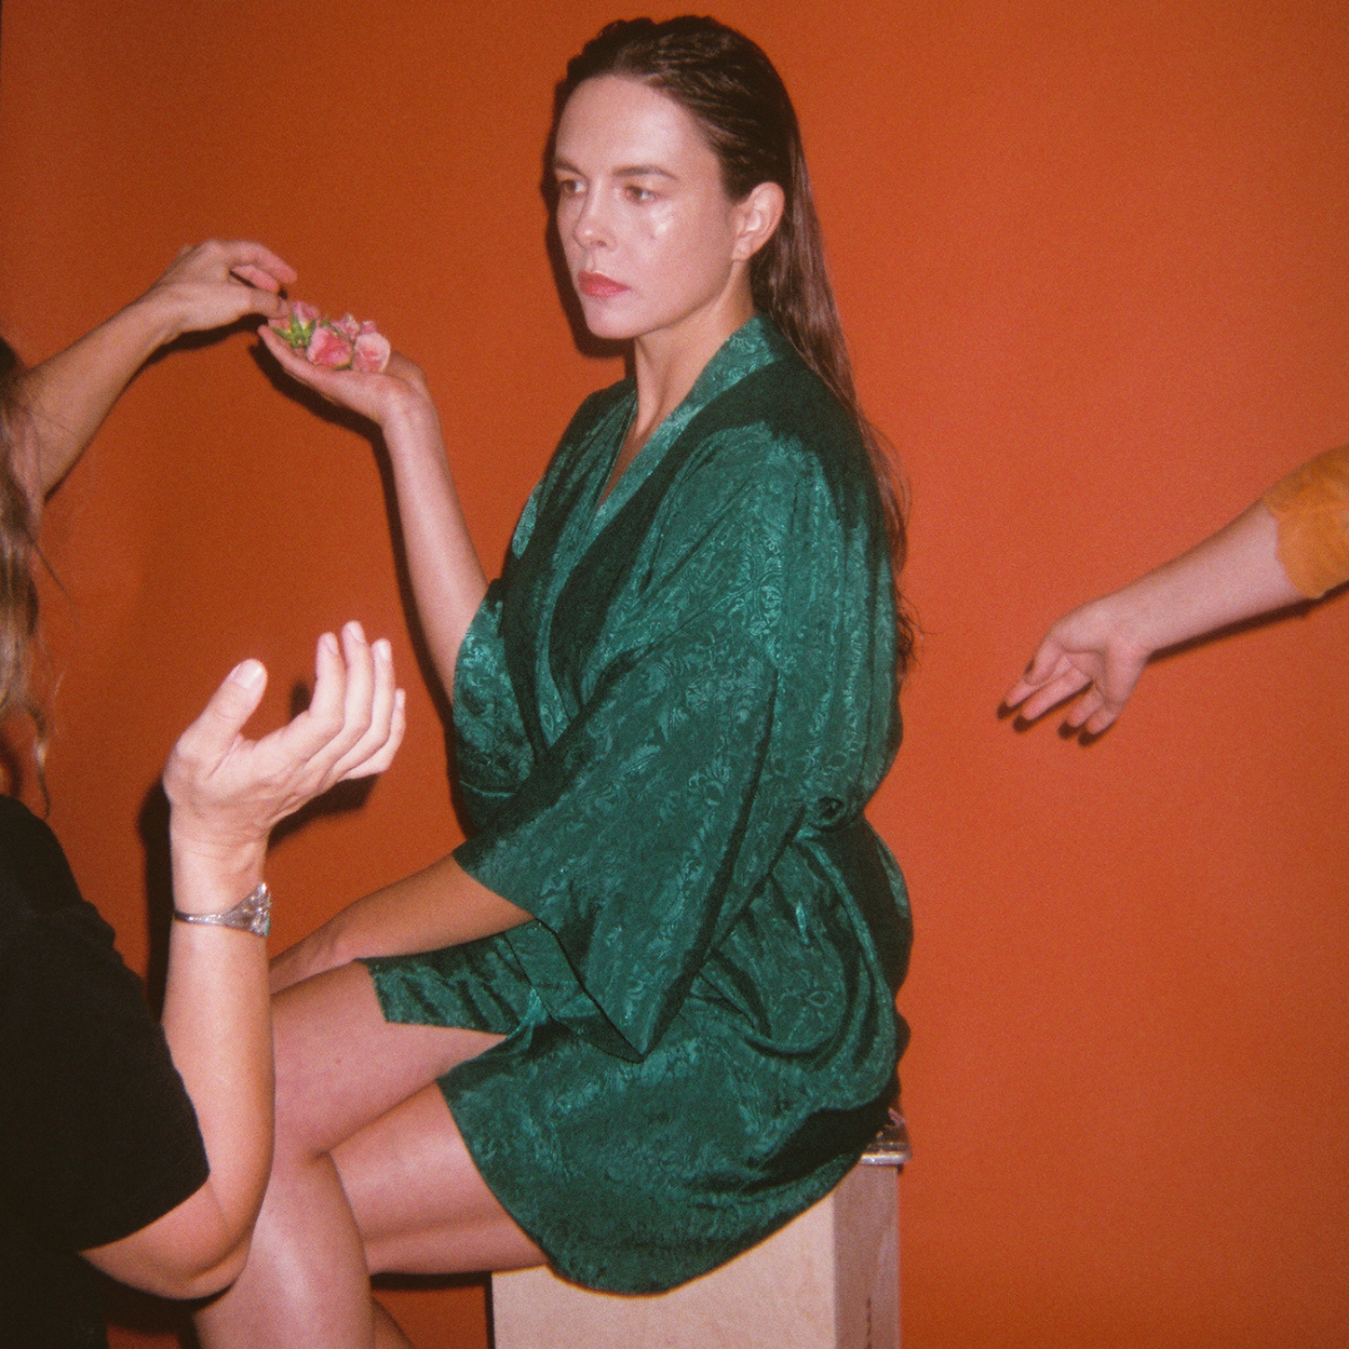
Same History, New Feelings EP Cover Artwork (Shot by Mackenzie K Moore, Art Direction by Andrea Behrends)

“[History Of A Feeling] is freaking superb.” - NPR Music

“History Of A Feeling is one of 2021’s best kept secrets.” - Rolling Stone

"[History Of A Feeling is] the rare record that captures how visceral it can feel to work through, and truly understand, your own feelings.” - Pitchfork

"Madi Diaz is simply stunning on History of a Feeling.” - Associated Press

"[History Of A Feeling is] a poignant record about heartbreak.” - Wall Street Journal

Madi Diaz announces the Same History, New Feelings EP featuring collaborations with Waxahatchee, Angel Olsen, Courtney Marie Andrews, and Natalie Hemby, out March 4th on ANTI-. The Same History, New Feelings EP is comprised of four reworkings of songs off 2021’s History Of A Feeling, an album in which Diaz’s stellar songwriting is on full display. A profound sense of intimacy and camaraderie is expressed through lyrics surrounding heartbreak and great change. Today, she offers up “Resentment (New Feelings Version)” featuring Waxahatchee, who Diaz will be supporting on tour throughout February and April. “Resentment” was an unexpected fan favorite off of History Of A Feeling, and this new version, produced by Brad Cook, has a warmer pulse, with dusky guitars that bolster Diaz and Katie Crutchfield’s complementary vocals.

“I’m so thrilled to have been asked to reimagine the song ‘Resentment’ from Madi Diaz’s album History Of a Feeling,” says Katie Crutchfield. “I listened to that album more than anything else last year and I think Madi is one of the most talented and exciting people putting out music right now. This specific song hits me so hard every time I hear it and having the chance to sing harmonies with Madi is always a true thrill."

Listen to Madi Diaz’s “Resentment (New Feelings Version)” (feat. Waxahatchee)

Diaz comments,“I've been listening as a fan to these four women for quite awhile now. I’m honored to call them my friends and to have their voices singing these songs with me is something that I still can’t quite fathom. I’m so thankful for their artistry and their stories giving these songs a whole new world and a whole new life. To share this earth and make music with them in this lifetime is a treasure and a gift from beyond the beyond.”

Diaz first got the idea for Same History, New Feeling by always being inspired by different interpretations of the same song. She specifically cites Whitney Houston’s version of Dolly Parton’s “I Will Always Love You”; “A universe of power is in that song though the artists singing it are from two different worlds.” When explaining the idea behind Same History, New Feeling, Diaz says “I love how when one person says a word or phrase that it can be attached to a completely different narrative than when I say the same word – I can have a totally different experience with a line of music than your experience. These little differences in us still find some alignment, share some understanding, and access some parts we recognize in one another when we come together over a song.”

Pre-order Same History, New Feelings EP

Same History, New Feelings EP Tracklist
1. Resentment (New Feelings Version) featuring Waxahatchee
2. History of a Feeling (New Feelings Version) featuring Natalie Hemby
3. New Person, Old Place (New Feelings Version) featuring Courtney Marie Andrews
4. Forever (New Feelings Version) featuring Angel Olsen

Purchase/Stream History Of A Feeling

Watch Madi Diaz Videos:
“Nervous”
“New Person, Old Place”
“Man In Me”
“Woman In My Heart”

Madi Diaz Tour Dates
Fri. Feb. 4 - Birmingham, AL @ Saturn * - SOLD OUT
Sat. Feb. 5 - Athens, GA @ Georgia Theatre *
Sun. Feb. 6 - Asheville, NV @ The Orange Peel *
Mon. Feb. 7 - Richmond, VA @ The National *
Wed. Feb. 9 - Providence, RI @ Columbus Theatre *
Thu. Feb. 10 - Brooklyn, NY @ Brooklyn Steel *
Fri. Feb. 11 - Tarrytown, NY @ Tarrytown Music Hall *
Sat. Feb. 12 - Asbury Park, NJ @ Asbury Lanes *
Mon. Feb. 14 - Cleveland, OH @ Agora Theatre *
Tue. Feb. 15 - Buffalo, NY @ Asbury Hall *
Wed. Feb. 16 - Woodstock, NY @ Levon Helm Studios *
Fri. Feb. 18 - Nelsonville, OH @ Stuart’s Opera House*
Sat. Feb. 19 - Grand Rapids, MI @ Fountain Street Church *
Sun. Feb. 20 - Chicago, IL @ Thalia Hall *
Mon. Feb. 21 - Chicago, IL @ Thalia Hall *
Tue. Feb. 22 - Evanston, IL @ Space
Sun. April 10 - Philadelphia, Pa @ Union Transfer * - SOLD OUT
Mon. April 11 - Philadelphia, Pa @ Union Transfer * - SOLD OUT
Tue. April 12 - Morgantown, WV @ 123 Pleasant Street *
Wed. April 13 - Cincinnati, OH @ Woodward Theater *
Fri. April 15 - Nashville, TN @ Ryman Auditorium *
Sat. April 16 - Memphis, TN @ Growlers *
Mon. April 18 - Fayetteville, AR @ George’s Majestic Lounge *
Tue. April 19 - Oklahoma City, OK @ The Jones Assembly*
Thu. April 21 - Santa Fe, NM @ Meow Wolf *
Fri. April 22 - Denver, CO @ Ogden Theatre *
Sat. April 23 - Aspen, CO @ Belly Up *

*= w/ Waxahatchee

Download hi-res images and jpegs of Madi Diaz

Website | Instagram | Facebook | Twitter

For more information, contact:
Jessica Linker | Pitch Perfect PR – jessica@pitchperfectpr.com, 773-942-6954

