August 29, 2022
For Immediate Release

Madi Diaz Makes Television Debut on CBS Saturday Morning

Headline North American Tour Runs October 22th-Nov. 18th

History Of A Feeling Out Now On ANTI-
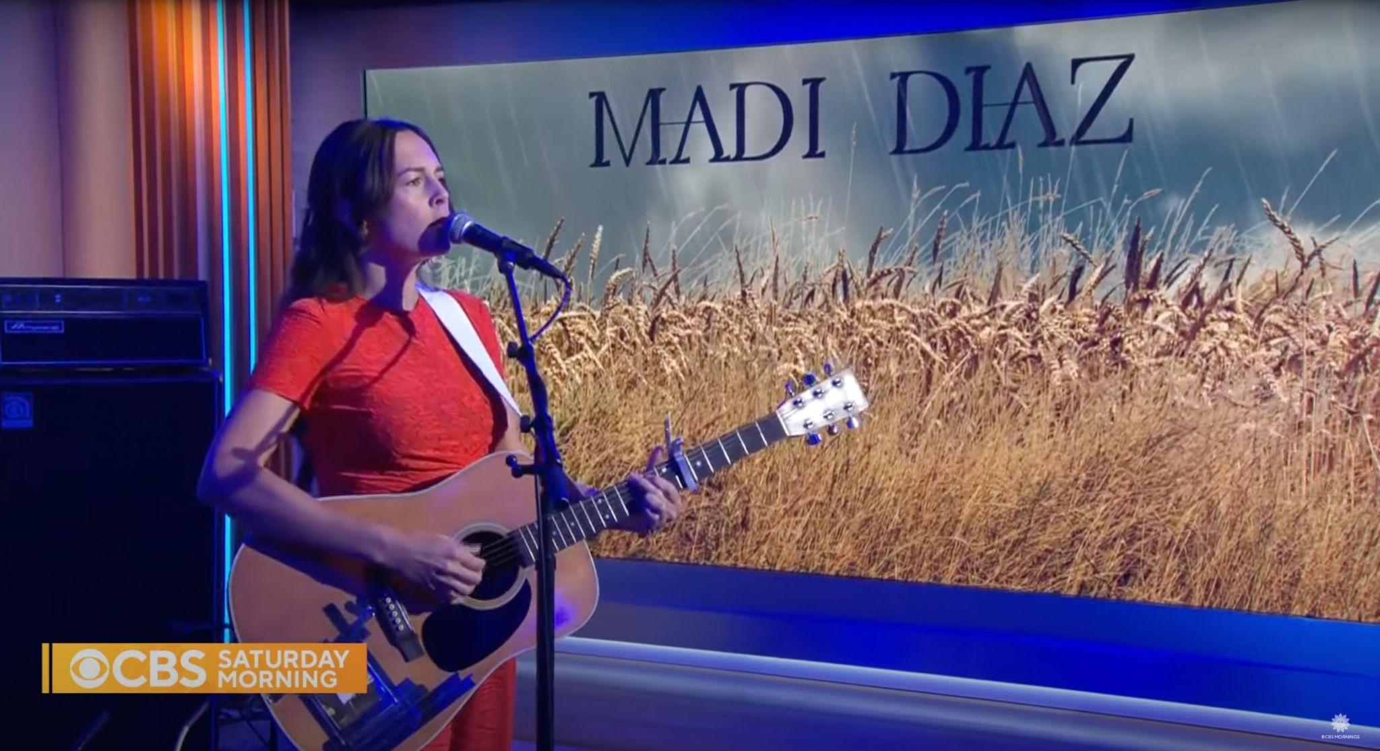
Photo Courtesy of CBS

Madi Diaz’s beloved album History Of A Feeling, released last year on ANTI-, was “one of 2021’s best kept secrets” (Rolling Stone). This past weekend, Diaz made her television debut on CBS Saturday Morning where she performed “Crying In Public” and “New Person, Old Place,” plus “Resentment” as a web-exclusive. Fresh off an extraordinary run of shows supporting Harry Styles and playing the Newport Folk Festival, this performance emphasizes Diaz’s keen ability to translate emotion to music, both live and on record. The secret is officially out: “Madi Diaz is simply stunning” (Associated Press).

Watch Madi Diaz on CBS Saturday Morning:
“Crying In Public”
“New Person, Old Place”
“Resentment”

This fall, Madi Diaz will embark on a headlining North American tour, giving many the opportunity to experience her cathartic live performances in person. Full dates are listed below and tickets are on sale now.

Madi Diaz Tour Dates
Mon. Aug 29 - Salt Lake City, UT @ Red Butte Garden w/ Jose Gonzalez
Tue. Aug. 30 – Arvada, CO @ Arvada Center for the Arts and Humanities w/ Jose Gonzalez
Sun. Sept. 4 - Nelsonville, OH @ Nelsonville Music Fest
Sat. Oct. 22 – Nashville, TN @ The Basement East *~
Tue. Oct. 25 – Washington, DC @ DC9 Nightclub *
Wed. Oct. 26 – Philadelphia, PA @ Johnny Brenda’s *
Thu. Oct. 27 – Brooklyn, NY @ Baby’s All Right *
Fri. Oct. 28 – Boston, MA @ Café 939 at Berklee *
Sun. October 30 – Montreal, Quebec @ Petit Campus *
Tue. Nov. 1 - Toronto, ON @ The Great Hall * (Sold Out)
Thu. Nov. 3 – Cleveland, OH @ Beachland Tavern *
Fri. Nov. 4 – Chicago, IL @ Sleeping Village *
Sun. Nov. 6 – Minneapolis, MN @ Turf Club * (Sold Out)
Mon. Nov. 7 – Davenport, Iowa @ Racoon Motel *
Wed. Nov. 9 – Denver, CO @ Globe Hall
Fri. Nov. 11 – Salt Lake City, UT @ Kilby Court ^
Sat. Nov. 12 – Boise, ID @ The Olympic ^
Mon. Nov. 14 – Seattle, WA @ Tractor Tavern ^
Tue. Nov. 15 – Portland, OR @ Mississippi Studios ^
Thu. Nov. 17 – San Francisco, CA @ The Chapel ^
Fri. Nov. 18 – Los Angeles, CA @ The Moroccan Lounge ^

Support from *John-Robert / ~Baerd / ^ Caroline Spence

Download hi-res images and jpegs of Madi Diaz

Praise for Madi Diaz & History Of A Feeling:

“[Madi Diaz] makes even the most immovable feelings open up with just a little time and space.” - Pitchfork

“[History Of A Feeling] is freaking superb.” - NPR Music

“'History of a Feeling' is a shining release and proves [Madi Diaz's] best is here and ahead.”
- Associated Press

“History Of A Feeling [is] a poignant record about heartbreak.” - Wall Street Journal

"As lush as Kate Bush and as pure as Wild Pink, often in the same space." - The AV Club

"[History Of A Feeling is] her most powerful record, a potent work of cherished folk beauty and open-hearted songwriting.” - Under The Radar

“History Of A Feeling is one of 2021’s best kept secrets [...] like gems hidden inside a dusty Nashville antique shop.” - Rolling Stone

Website | Instagram | Facebook | Twitter

For more information, contact:
Jessica Linker | Pitch Perfect PR – jessica@pitchperfectpr.com, 773-942-6954

