November 3, 2021
For Immediate Release

Madi Diaz Presents “Crying In Public (MUNA Remix)”

History Of A Feeling, “one of 2021’s best kept secrets” (Rolling Stone),
Out Now On ANTI-

Madi Announces 2022 Tour Supporting Waxahatchee;
Tour With CAAMP Begins This Month
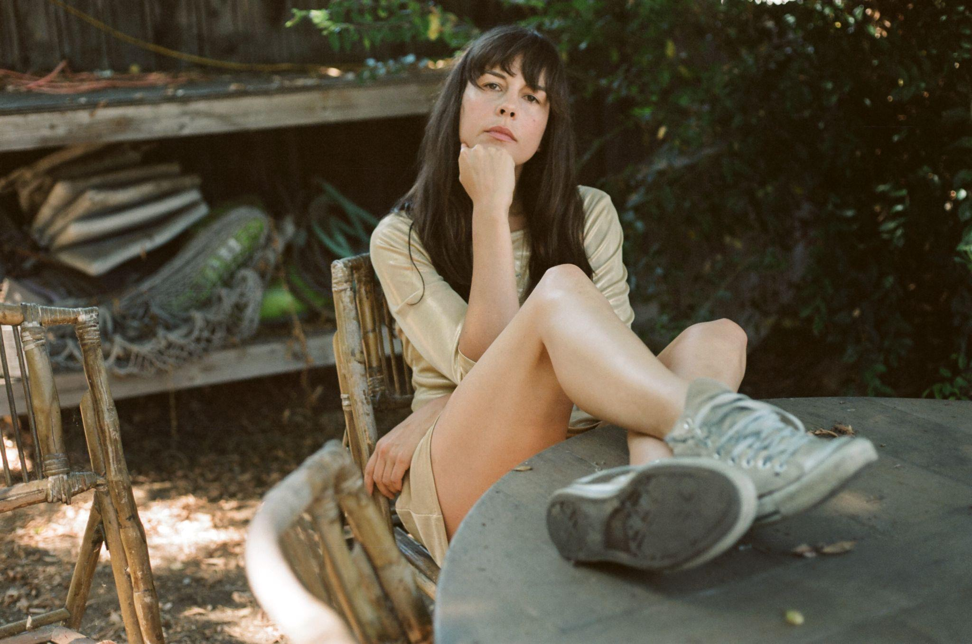
Photo Credit: Lili Pepper

"[History Of A Feeling is] the rare record that captures how visceral it can feel to work through, and truly understand, your own feelings.” - Pitchfork

“[History Of A Feeling] is freaking superb.” - NPR Music

“History Of A Feeling is a shining release and proves [Madi Diaz's] best is here and ahead.”
- Associated Press

“Madi Diaz passionately combines folk, country and grunge on History Of A Feeling, a poignant record about heartbreak.” - Wall Street Journal

"It’s a glorious, gut-punching listen, full of poisonous little details, exorcised across her rumbling electric.” - Guitar World

Nashville-based songwriter Madi Diaz released History Of A Feeling this past August via ANTI-. The record continues to resonate deeply amongst critics and fans, including the Los Angeles trio MUNA who have now remixed Madi’s song “Crying In Public.” The “Crying In Public (MUNA Remix)” translates Diaz’s unabated emotion onto the dancefloor while keeping her intimacy at the remix’s core.

“There’s something so ultimate and forgivable about crying in front of strangers that you will never see again. Just letting it fly in the dairy aisle while you’re checking your carton of eggs for cracked ones, letting out a good loud sob in the security line at an airport, screaming in your car at the top of your lungs parked in front of your house, just letting the full heat of violent emotion take the wheel and you’re just riding shotgun,” says Diaz. “I could not think of a single band better equipped to take ‘Crying In Public’ to the dance floor. MUNA does introspective expression on a whole different level, so it’s a true honor that they took my song and sent it soaring into this expansive emo alternate universe. It’s like I’m crying disco ball tears at the club with everyone I’ve ever loved.”

MUNA’s Naomi McPherson adds: “It’s always a lot of fun to be able to take a track like Madi’s that’s a relatively simple arrangement and flip it. The possibilities for a sonic scene change going in are kind of endless. I’m grateful to the very brilliant madi for letting me do my thing right quick and even more grateful that she’s happy with it.”

Listen to “Crying In Public (MUNA Remix)”

Watch Madi Diaz Perform “Crying In Public” (Live at The Sanctuary)

History Of A Feeling undeniably marks Diaz’s status as a first-rate songwriter, a craft she’s spent years refining. Across the album, she cycles through the full spectrum of emotions of coming to terms with the dissolution of a meaningful relationship. She plays the line between the personal and the general with dexterity: in Diaz’s hands, quiet moments of self-pity are transformed into grand meditations on heartbreak, and unwieldy knots of big existential feelings are smoothed out with a sense of clear-eyed precision.

Later this month, Madi will join CAAMP on tour, including sold-out stops in Philadelphia, DC, Boston, and more. Today, Madi announces she’ll support Waxahatchee on a North American tour in 2022. Tickets for newly-announced shows are on sale this Friday at 10am local time.

Purchase/Stream History Of A Feeling

Watch Madi Diaz Videos:
“Nervous”
“New Person, Old Place”
“Man In Me”
“Woman In My Heart”

Madi Diaz Tour Dates
(new dates in bold)
Tue. Nov. 9 - Millvale, PA @ Mr Small’s Theatre ^ - SOLD OUT
Fri. Nov. 12 - Philadelphia, PA @ The Foundry ^ - SOLD OUT
Sat. Nov. 13 - Cleveland, OH @ Agora Theater ^SOLD OUT
Wed. Dec. 1 - Harrisburg, PA @ Club XL ^
Fri. Dec. 3 - Washington, DC @ The Anthem ^ - SOLD OUT
Sat. Dec. 4 - Boston, MA @ House Of Blues ^ - SOLD OUT
Tue. Dec. 7 - Portland, ME @ State Theatre ^ - SOLD OUT
Wed. Dec.8 - Portland, ME @ State Theatre ^ - SOLD OUT
Fri. Feb. 4 - Birmingham, AL @ Saturn *
Sat. Feb. 5 - Athens, GA @ Georgia Theatre *
Sun. Feb. 6 - Asheville, NV @ The Orange Peel *
Mon. Feb. 7 - Richmond, VA @ The National *
Wed. Feb. 9 - Providence, RI @ Columbus Theatre *
Thu. Feb. 10 - Brooklyn, NY @ Brooklyn Steel *
Mon. Feb. 14 - Cleveland, OH @ Agora Theatre *
Tue. Feb. 15 - Buffalo, NY @ Asbury Hall *
Fri. Feb. 18 - Toronto, ON @ Danforth Music Hall *
Sat. Feb. 19 - Grand Rapids, MI @ Fountain Street Church *
Sun. Feb. 20 - Chicago, IL @ Thalia Hall *
Sun. April 10 - Philadelphia, Pa @ Union Transfer * - SOLD OUT
Mon. April 10 - Philadelphia, Pa @ Union Transfer * - SOLD OUT

^ = w/ Caamp
*= w/ Waxahatchee
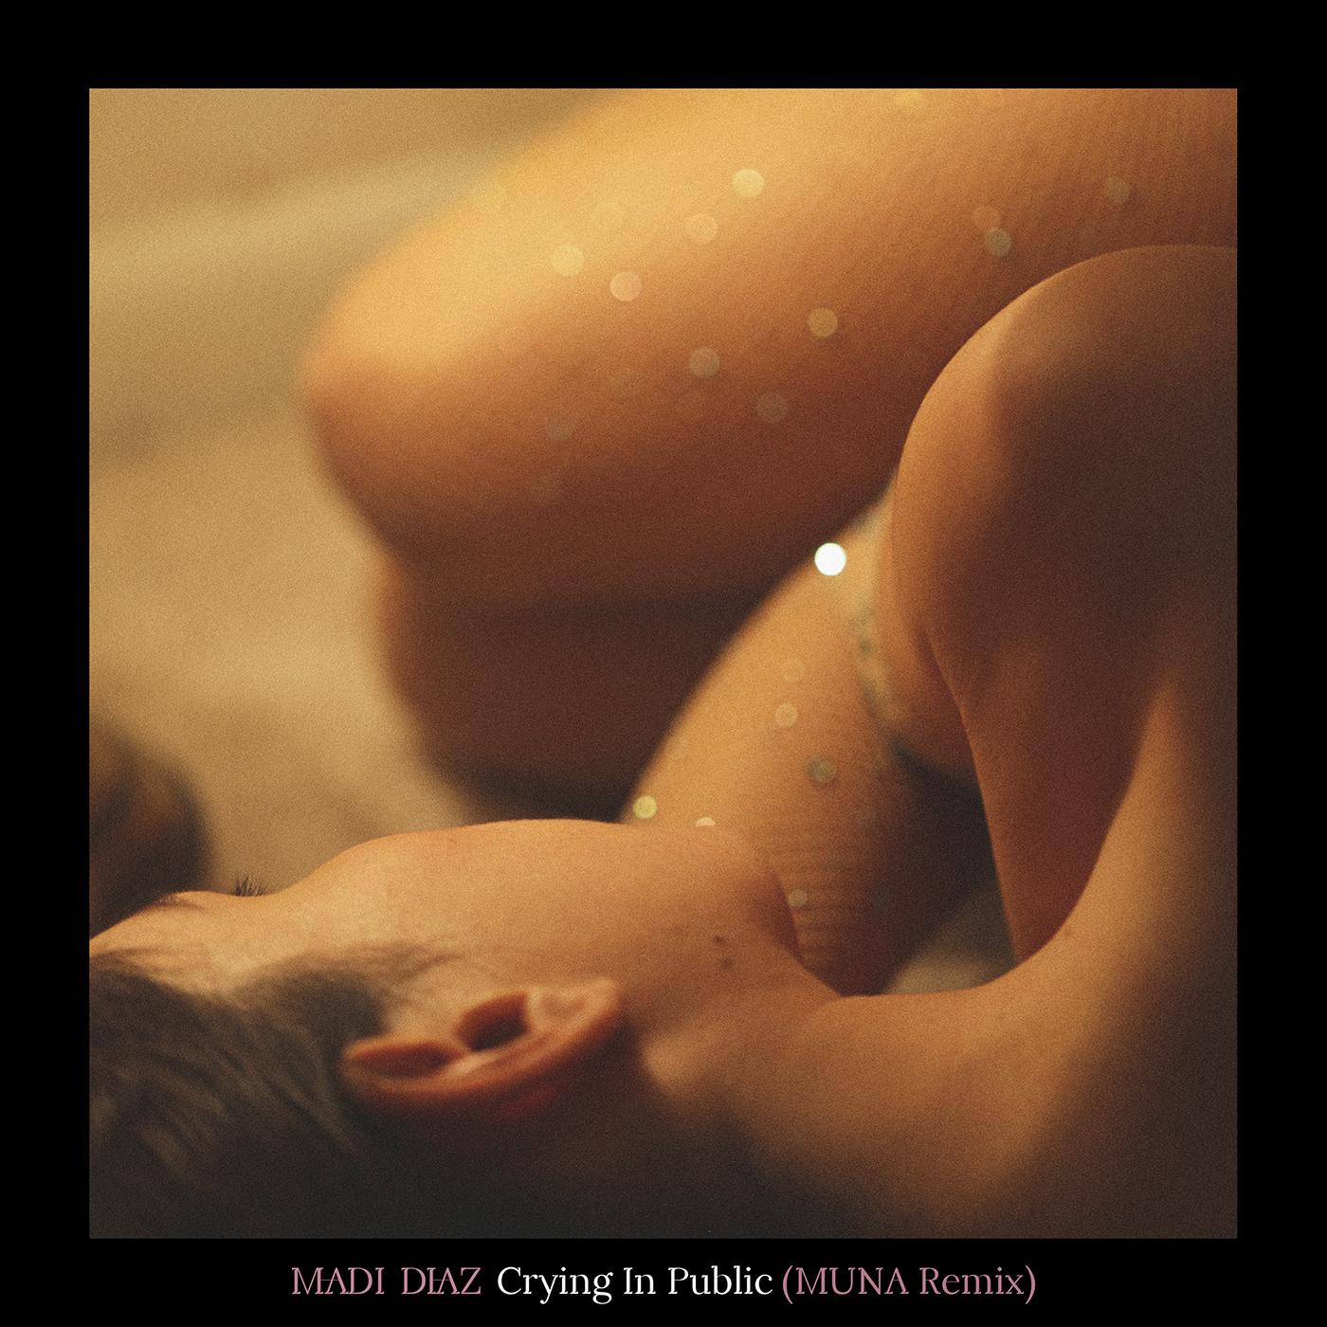
“Crying In Public (MUNA Remix)” Cover Artwork - photo by Alexa King

Website | Instagram | Facebook | Twitter

For more information, contact:
Jessica Linker | Pitch Perfect PR – jessica@pitchperfectpr.com, 773-942-6954

