November 7, 2022
For Immediate Release

Madi Diaz, S.G. Goodman, and Joy Oladokun Cover
Patty Griffin’s “Be Careful” Ahead of Midterm Elections

Proceeds Benefitting Abortion Within Reach Coalition
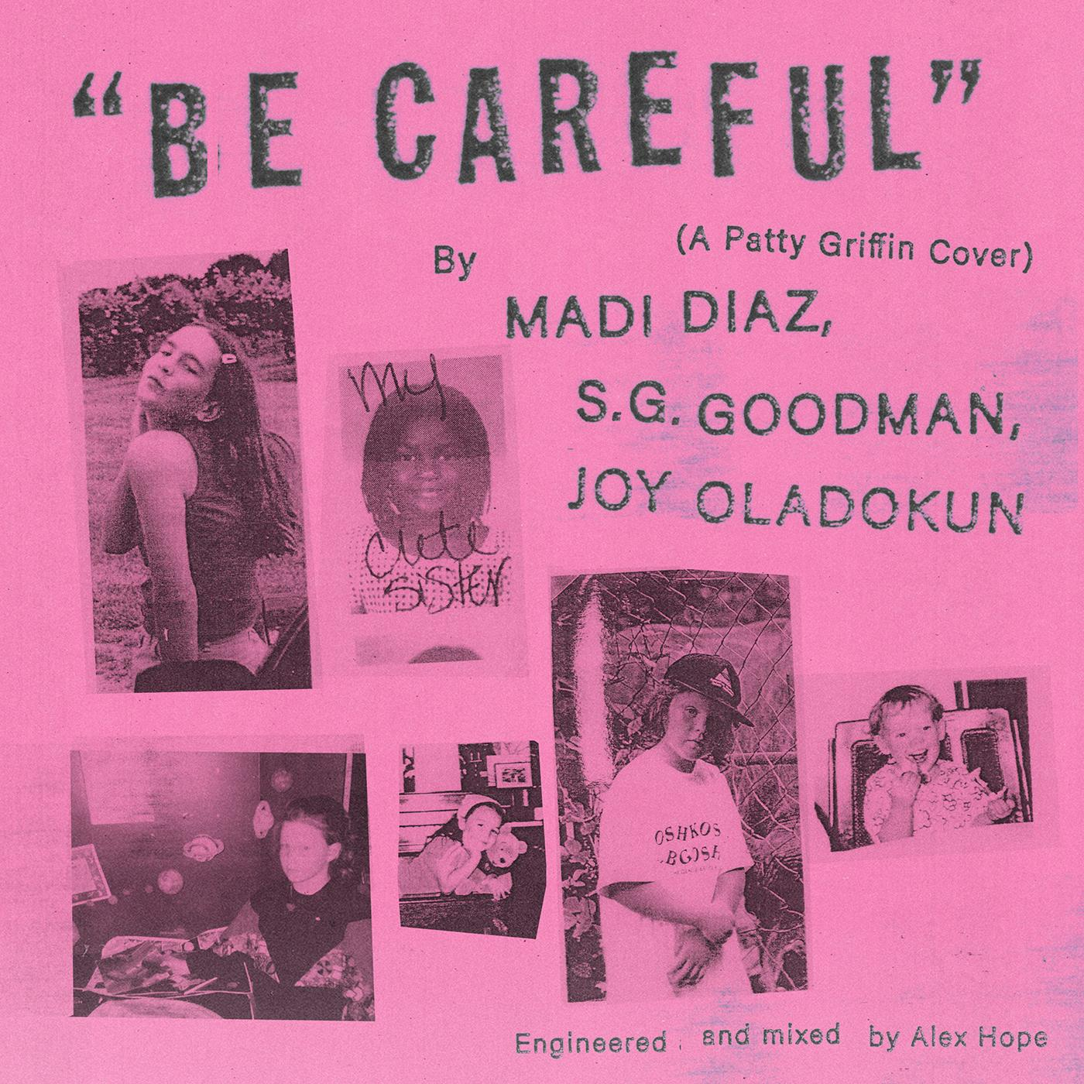
“Be Careful” Single Artwork

Leading into tomorrow’s midterm elections, Madi Diaz, Joy Oladokun and S.G. Goodman present a cover of Patty Griffin’s “Be Careful.” Diaz – whose music “captures how visceral it can feel to work through, and truly understand, your own feelings” (Pitchfork) – contributes her own verse to Griffin’s 2002 track, honoring the original’s sentiment while adding resonance for listeners two decades later: “For all the parents who are losing sleep // For all the babies that will come to be // For all the reasons that are ours to know // It’s my choice and I am not alone // For every man who’s standing next to me // and queer and trans and non-binary // For everybody with their own body // I will meet you all out on the streets // So be careful how you bend me // Be careful where you send me // Careful how you end me // Be careful with me.”

The proceeds from “Be Careful (A Patty Griffin Cover)” will benefit Abortion Within Reach Coalition, whose aim is to make abortion accessible, compassionate and affirming for all identities, and safe for everyone who needs it, free of politically motivated barriers and without cost as a barrier to care. The trio’s cover, produced by Diaz and Goodman and engineered by Alex Hope, is presented alongside a striking lyric video, and features backing vocals from Courtney Marie Andrews and Savana Santos.

Watch the “Be Careful” Lyric Video

“I’m excited and honored to be a part of this release because we’re at a moment in American politics where we have to remember and act on the truth that advocating for my neighbors’ rights is my advocating for my own rights.” - Joy Oladokun

"To be honest, having to emphasize why the message of 'Be Careful' is important at this very moment is tragic within itself. Unfortunately, it’s relevant. The need to plead for a vote ensuring women’s autonomy is relevant.” - S.G. Goodman

“When Roe V. Wade was overturned this past summer, Patty Griffin’s song ‘Be Careful’ slipped into my subconscious. It became a mantra of strength that was playing consistently in the back of my heart and mind day in and day out, gently encouraging me to keep putting one foot in front of the other. It became a sort of battle cry directed toward anyone that wants to take away my rights to my own body and my reproductive freedom. You’ve awakened the beast so you better ‘Be Careful.’ This Supreme Court decision affects all of us - ‘All the girls with the washing rags,’ ‘all the girls with the shopping bags,’ any person with a uterus and everybody with their own body. This is about control over another person’s human rights and freedoms - the right of making our own choices about our health and wellbeing. When it was so hard to talk about what had just happened in our country, writing about it felt a little easier, so my best friend, Morgan Elizabeth Peirce, and I wrote our own verse, using the brilliant Patty Griffin’s song as a springboard into our present. It felt good to say and sing something that means so much to us and I’m beyond thankful for this group of wonderful humans for coming together to put all of our voices and hearts on record, printing this moment in time, putting it out into the world and harnessing the power that is born when we unite and work together. I hope that anyone needing to hear this song, hears it and feels a little bit less alone. Vote with that in mind.” - Madi Diaz

Download hi-res images and jpegs of Madi Diaz

Madi Diaz Online:
Website | Instagram | Facebook | Twitter

For more information, contact:
Jessica Linker & Jaycee Rockhold | Pitch Perfect PR – jessica@pitchperfectpr.com,
jaycee@pitchperfectpr.com, 773-942-6954

