January 16, 2023
For Immediate Release

Madi Diaz, “Nashville’s Secret Weapon” (Rolling Stone),
Releases New Single “Everything Almost”
Off Weird Faith, Out February 9th on ANTI-

Watch the Lyric Video

North American Tour Begins Next Month
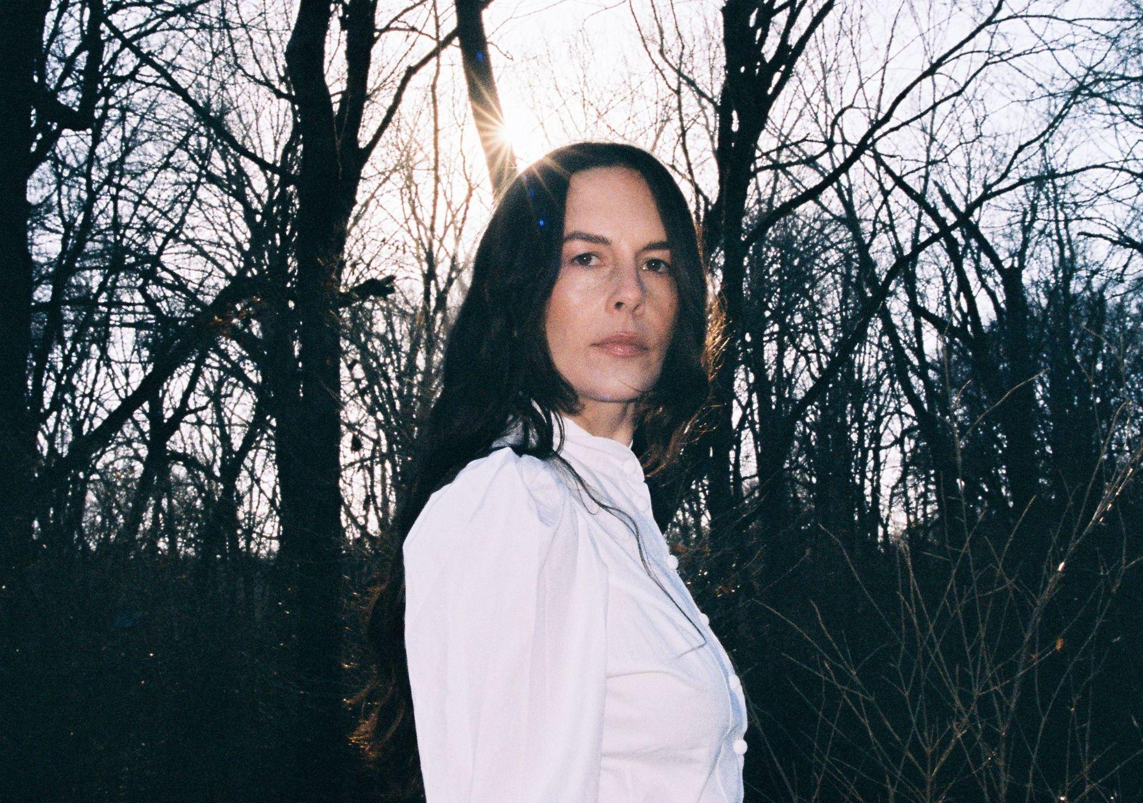
Photo Credit: Muriel Margaret

Nashville’s Madi Diaz, “one of indie rock’s most searing lyricists and vocalists” (NYLON), will release her new album, Weird Faith, on February 9th via ANTI-. Following 2021’s History of a Feeling, Weird Faith renders a self-portrait that captures Diaz in a fleeting moment in time, hungrily alive and forever searching. Today, Diaz presents the album’s third single, the upbeat and cathartic new number, “Everything Almost.”

“Everything Almost” is “about my constant wondering within a relationship,” comments Diaz. “How much should I be saying things out loud or am I saying too much out loud? What should I keep for myself? What’s mine that could become ours, that should become ours? What dreams are just mine that I could share with you only to discover they’re your dreams too? It's an investigation of the depth of how far this thing could go. Am I allowed to keep some of me for me? Saying all of this out loud feels important. It is about realizing I can’t ever be everything for someone but maybe I can be almost everything.” Weird Faith answers these questions bluntly, and chronicles a new relationship, but also a new relationship to Diaz herself, exploring how anxiety-inducing — if not downright humiliating — falling in love can be.

Joining Diaz (vocals, guitar, bass, piano) on “Everything Almost” are the album’s co-producers alongside Diaz, Sam Cohen (drum machine) and Konrad Snyder (drums, percussion), and The Walkmen’s Matt Barrick (drums, percussion). “Everything Almost” follows the previously released singles, “Same Risk” and the duet with Kacey Musgraves, “Don’t Do Me No Good.”

Watch the Lyric Video for “Everything Almost” directed by Elizabeth Olmsted

Diaz will embark on a North American headline tour later this year. A full list of dates is below, and tickets are on sale now.

Pre-order Weird Faith

Watch Madi Diaz’s “Don’t Do Me Good” Video

Watch Madi Diaz’s “Same Risk” Video

Madi Diaz Tour Dates:
Wed. Feb. 21 - Atlanta, GA @ Terminal West *
Thu. Feb. 22 - Durham, NC @ Motorco Music Hall *
Fri. Feb. 23 - Charlotte, NC @ Neighborhood Theatre *
Sat. Feb. 24 - Charlottesville, VA @ Jefferson Theater *
Tue. Feb. 27 - Washington, DC @ The Atlantis *
Wed. Feb. 28 - Philadelphia, PA @ World Cafe Live *
Thu. Feb. 29 - Cambridge, MA @ The Sinclair *
Fri. Mar. 1 - Brooklyn, NY @ Music Hall of Williamsburg *
Sun. Mar. 3 - Toronto, ON @ The Danforth Music Hall *
Tue. Mar. 5 - Ann Arbor, MI @ The Ark #
Wed. Mar. 6 - Chicago, IL @ Lincoln Hall #
Thur. Mar. 7 - St. Louis, MO @ Off Broadway #
Fri. Mar. 8 - Nashville, TN @ Brooklyn Bowl #
Sat. Mar. 16 - Dallas, TX @ The Kessler Theater
Tue. Mar. 19 - Denver, CO @ Bluebird Theater %
Wed. Mar. 20 - Fort Collins, CO @ Aggie Theatre %
Fri. Mar. 22 - Salt Lake City, UT @ The State Room %
Wed. Mar. 20 - Sun. Mar. 24 - Boise, ID @ Treefort Fest
Mon. Mar. 25 - Vancouver, BC @ Fox Cabaret %
Tue. Mar. 26 - Seattle, WA @ Madame Lou's %
Wed. Mar. 27 - Portland, OR @ Doug Fir Lounge %
Fri. Mar. 29 - Oakland, CA @ The New Parish %
Sat. Mar. 30 - Felton, CA @ Felton Music Hall %
Tue. Apr. 2 - San Diego, CA @ Music Box %
Thu. Apr. 4 - Los Angeles, CA @ Troubadour %
Fri. May 24 - Boston, MA @ Boston Calling

With Special Guests:
* Olivia Barton
# Jack Van Cleaf
% Daniel Nunnelee

Praise for Madi Diaz’s “Same Risk” and “Don’t Do Me Good”

“What starts with modest acoustic guitar strumming rises with an orchestral crescendo to match the urgency of her questions.” — New York Times on “Same Risk”

“A heart-wrenching ballad about accepting that a relationship has run its course, complete with a stunning melody and subtle instrumentation.” — Rolling Stone on “Don’t Do Me Good”

“[Madi and Kacey’s] voices beautifully intertwine and give what could be a solely devastating track a hint of an uplifting tone.” — PEOPLE on “Don’t Do Me Good”

“‘Same Risk,’ which precedes her 2024 album Weird Faith, proves that she hasn’t lost an ounce of the intimacy at the center of her 2021 full-length History of a Feeling.” — Billboard

“[Diaz] and Musgraves have inseparable chemistry together—their voices combining to commiserate into a stirring, emotional ballad.” — Paste on “Don’t Do Me Good”

“[‘Same Risk’] is a stadium pop song artfully disguised as a folk-country tune via unassuming acoustic guitar strumming that blossoms into an echoing arrangement replete with a string section and full-bodied backing vocals.” — The FADER

“A bracingly vulnerable folk-pop song about the terrible thrills of romance”
— Stereogum on “Same Risk”

“Weird Faith seems poised to cement Diaz’s place in the musical landscape of Americana.”
— them.

“Madi Diaz's soaring voice and candid lyricism are in fine form for her follow-up to 2021's excellent History of a Feeling.” — Brooklyn Vegan, 86 Albums We're Anticipating in 2024

Download hi-res images and jpegs of Madi Diaz

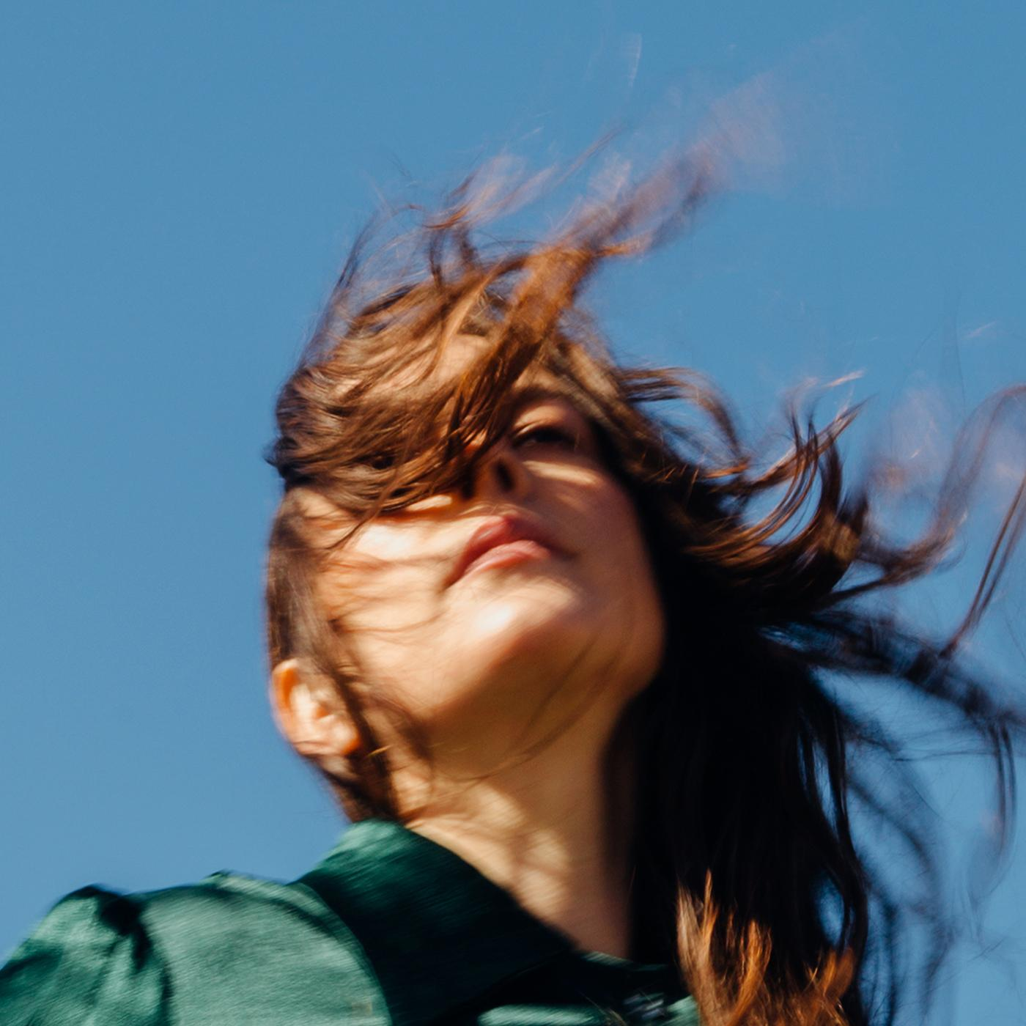
(Weird Faith Cover Artwork)

Madi Diaz Online:
Website | Instagram | Facebook | Twitter

For more information, contact:
Jessica Linker & Jaycee Rockhold | Pitch Perfect PR –
jessica@pitchperfectpr.com, jaycee@pitchperfectpr.com, 773-942-6954

