July 18, 2023
For Immediate Release

MJ Lenderman Signs To ANTI- and Presents New Single/Video, “Rudolph”

U.S. Tour Runs July 19 — September 24,
Including Pitchfork Music Festival
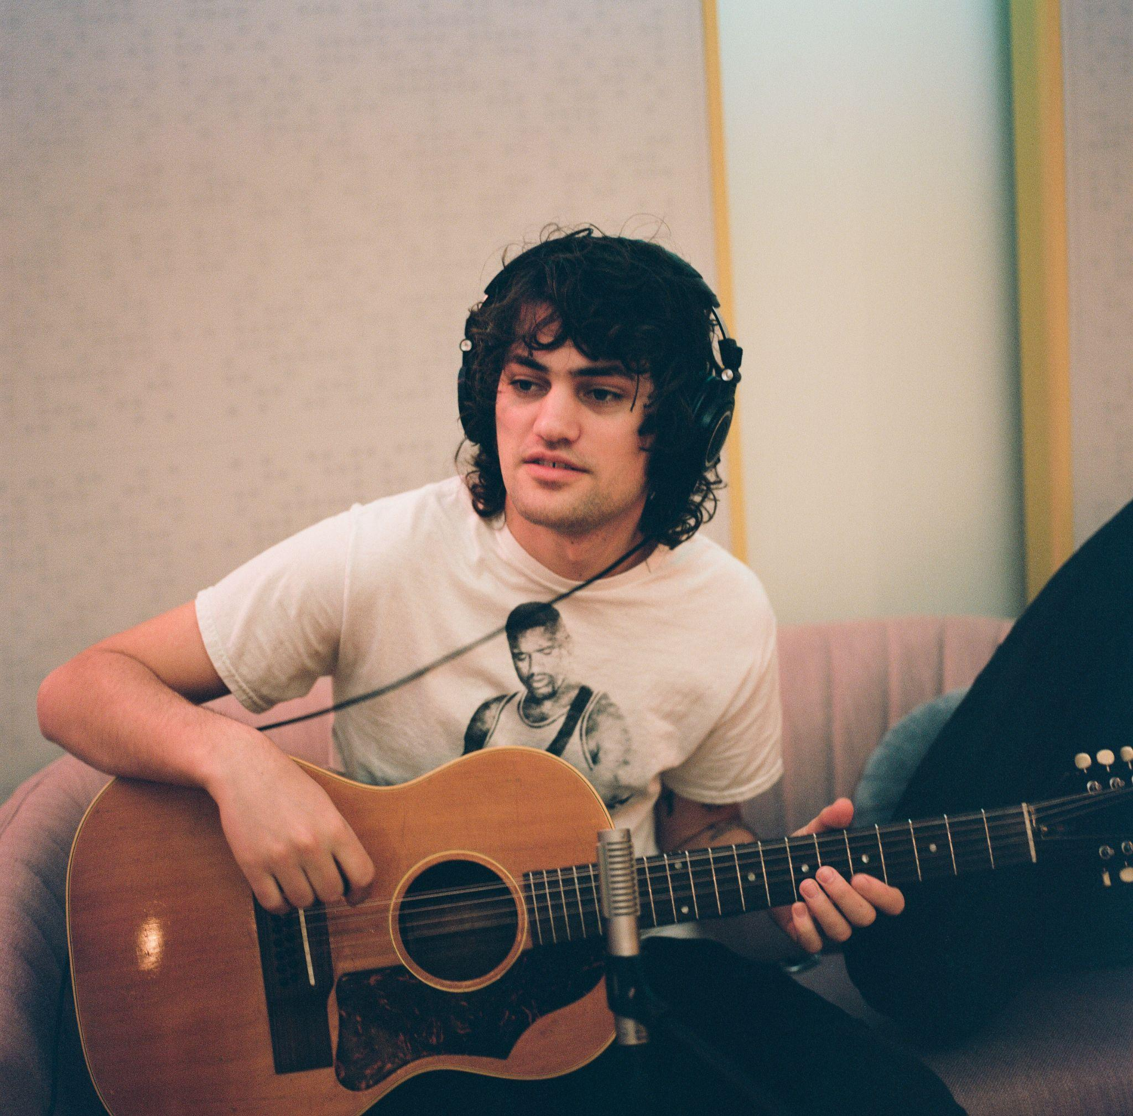
Photo Credit: Charlie Boss

"[MJ Lenderman] brings exceptional humor, wit and empathy to twangy tracks about fulfillment and failure" — NPR Music, The Best Rock Albums of 2022

"[MJ Lenderman] weaves together poetic hallucinations with unglamorous imagery of daily life”
— Pitchfork, The Best Albums of 2022

"[MJ Lenderman is] a new entrant to the pantheon inhabited by the likes of John Prine, Jason Molina, Mark Linkous (Sparklehorse), Patterson Hood (Drive-By Truckers), Vic Chesnutt, and others, those who sang proudly from and for their Middle American corners” - Uncut

Today, MJ Lenderman — Asheville, NC’s effortlessly disarming singer-songwriter and guitarist of the band Wednesday — announces his signing to ANTI- and presents a new single/video, “Rudolph.” “Rudolph” marks Lenderman’s first new music following the release of his breakthrough 2022 LP, Boat Songs, which was released to a wealth of praise and deemed one of the year’s best records by Pitchfork, Rolling Stone, NPR Music, Paste, and many others. Lenderman comments, “‘Rudolph’ was the first song I wrote after the release of Boat Songs. I had been sitting on the guitar part for a long time and slowly worked out the song whenever I could in between tours in 2022. I finished the lyrics with my friend one late night after a Wednesday gig in Atlanta.”

“Rudolph waking up in the road / Dew dripping off his red nose / Blue and black tire track torn / Through a beautiful doe” repeats the chorus, highlighting Lenderman’s juxtaposition of the gentle and the extreme. “Rudolph” will be the A-side to a forthcoming 7-inch single, which can be pre-ordered here and will be out this Fall.

Watch MJ Lenderman’s “Rudolph” Video

Warped pedal steels and skuzzed out guitar; a voice reminiscent of the high-lonesome warble of a choirboy; the keen observations and reflections of a front stoop philosopher. MJ Lenderman’s songs snake their way from a lo-fi home recording to something glossier made with longtime friends at a hometown studio, but the recording setting doesn’t seem to matter much – at its core, a Lenderman song rings true. His music spans stories about everything from a relationship disintegrating outside the high-end butcher shop to a sighting of football star Dan Marino at the local Harris Teeter; from a love song built around a t-shirt kiosk at the airport, or the malaise of a grill rusting in the rain. And those are just some of the things you might find across his three solo records: MJ Lenderman (2019, Sub-Fi), Ghost of Your Guitar Solo (2021, Dear Life), and acclaimed studio debut, Boat Songs (2022, Dear Life).

This week, Lenderman will embark on a U.S. tour, bringing his “righteously ragged” (Under The Radar) live show to the Pitchfork Music Festival in Chicago. Other stops include Nashville, Los Angeles, and a performance at Woodsist Festival. Full dates are listed below and tickets are on sale now.

MJ Lenderman Tour Dates
Wed. July 19 - Nashville, TN @ The Basement East
Thu. July 20 - Bloomington, IN @ The Bishop Bar
Fri. July 21 - Chicago, IL @ Lincoln Hall
Sat. July 22 - Chicago, IL @ Pitchfork Music Festival
Sun. July 23 - Nelsonville, OH @ Nelsonville Music Festival
Fri. Aug. 4 - Happy Valley, OR @ Pickathon
Tue. Aug. 8 - Pioneertown, CA @ Pappy + Harriet’s
Thu. Aug. 10 - Los Angeles, CA @ Lodge Room
Fri. Aug. 25 - Port Townsend, WA @ Thing Fest
Sat. Sept. 23 - Sun. Sept. 24 - Accord, NY @ Woodsist Festival

Download cover art & hi-res images of MJ Lenderman

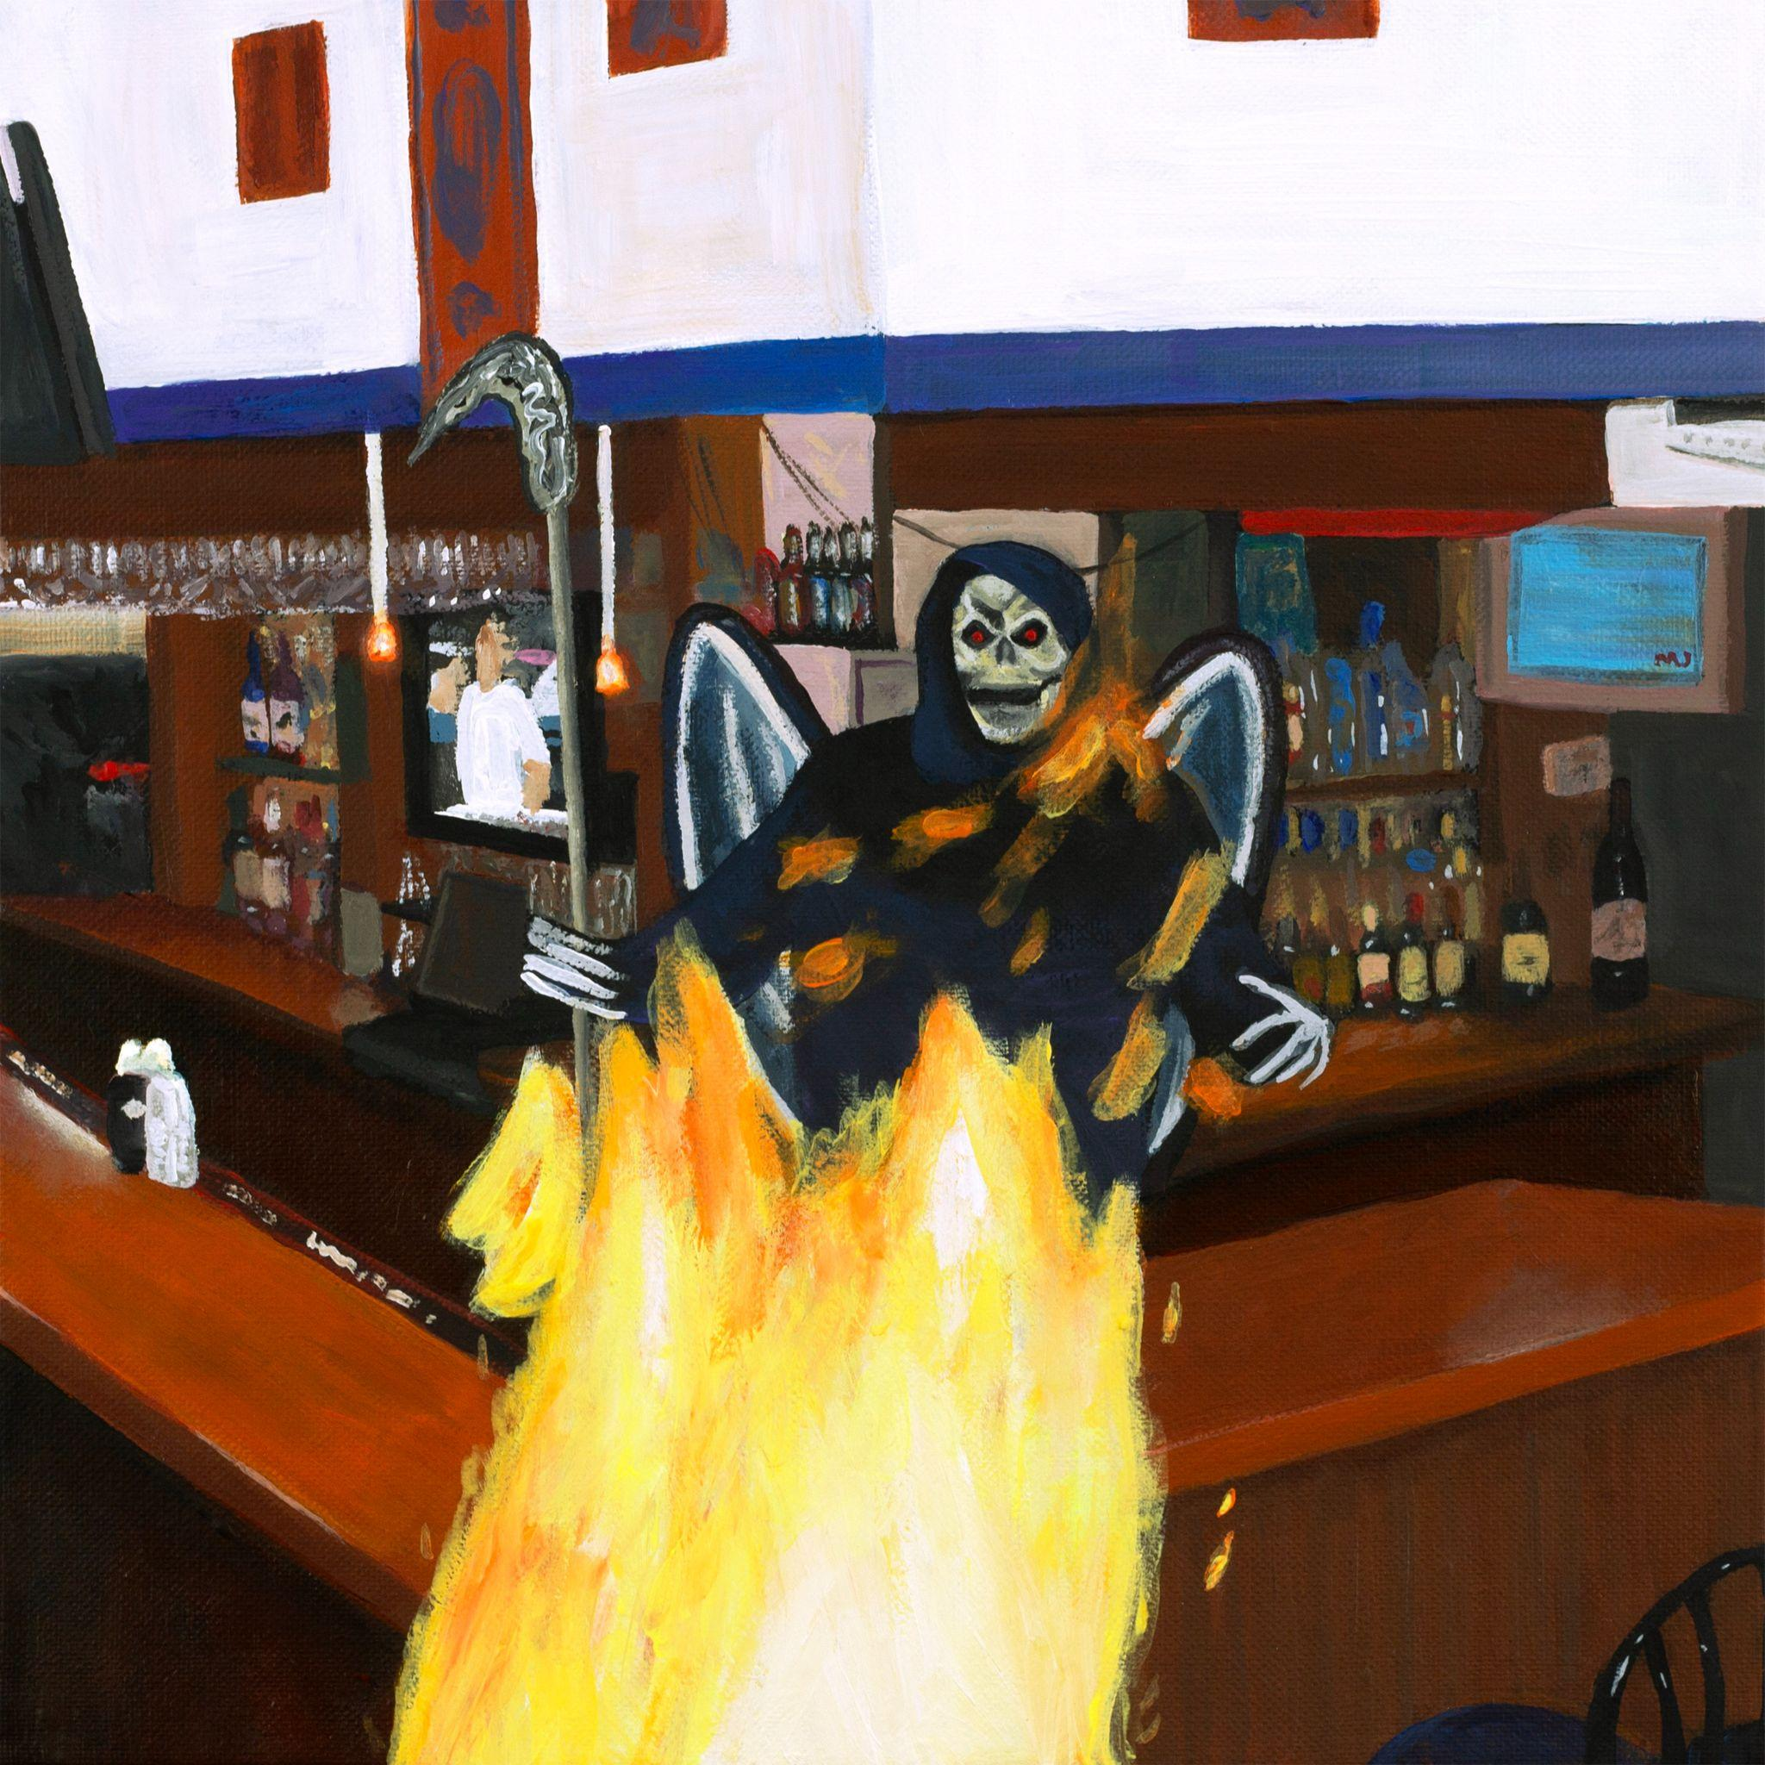
(“Rudolph” Cover Artwork)

Website | Bandcamp | Instagram | Twitter

For more information, contact:
Jessica Linker & Jacob Daneman | Pitch Perfect PR -
jessica@pitchperfectpr.com, jacob@pitchperfectpr.com, 773-942-6573

###

