PLAINS
JESS WILLIAMSON & WAXAHATCHEE’S KATIE CRUTCHFIELD

SHARE AIDY BRYANT-DIRECTED VIDEO
FOR NEW SINGLE “HURRICANE”

I WALKED WITH YOU A WAYS OUT THIS FRIDAY VIA ANTI-

NORTH AMERICAN FALL TOUR ANNOUNCED

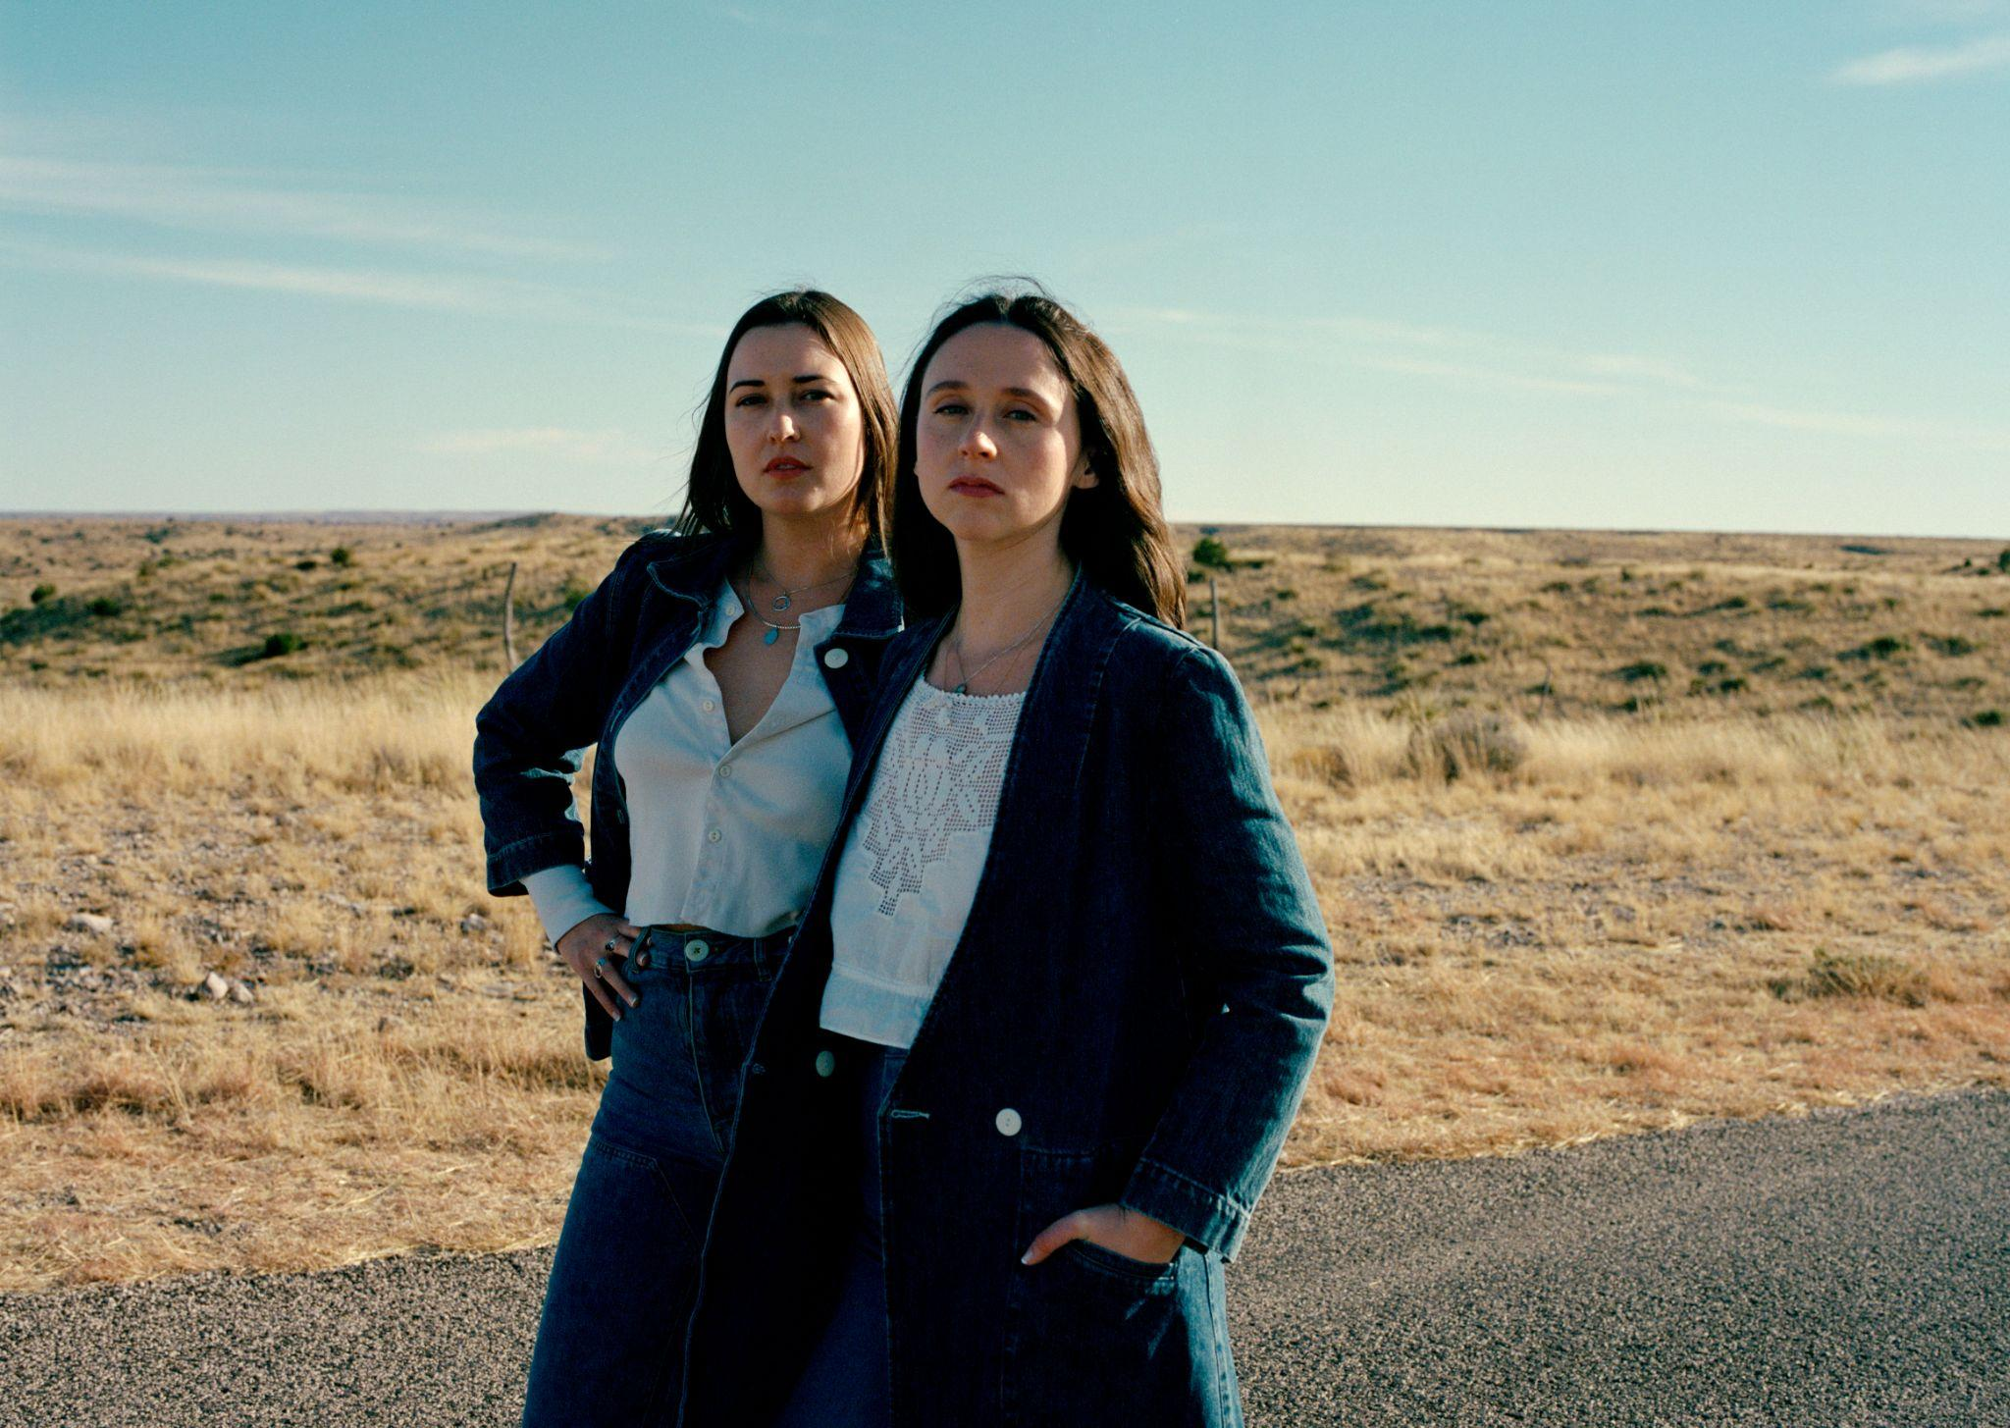
Photo Credit: Molly Matalon (download hi-res)

PRAISE FOR PLAINS:

“Katie Crutchfield and Jess Williamson embrace their roots, as Plains. Their joint project explores a spectrum of country influences and lets them reckon with their pasts.”
-The New York Times

“For her new project with Jess Williamson, Katie Crutchfield fully steps through the door she opened with 2020’s Saint Cloud, embracing her twang and Southern charm. Williamson’s prose complements Crutchfield’s tone, their songs imbued with the wisdom of those who made mistakes and managed to survive.”
-Pitchfork

"A stunner"
-NPR Music

"A songwriting force to be reckoned with"
-NYLON

"An instant hit that already makes Crutchfield and Williamson’s plan to only ever make one project together seem all too brief."
-The FADER

"Crutchfield and Williamson apply their honeysuckle drawls to one of the biggest, stickiest hooks that either of them have written"
-Stereogum

"With Plains, the pair get down to basics with twanging guitars, straightforward storytelling, and gently discordant."
-The Boot

Jess Williamson and Waxahatchee’s Katie Crutchfield’s one time collaborative project Plains share a dreamy Aidy Bryant-directed video for the final single from their anticipated album I Walked With You A Ways, out this Friday, October 14th on ANTI.

Of the collaboration with director Aidy Bryant, Katie Crutchfield says “I had always had a vision of Aidy’s involvement in this video that really ended with just getting her in the room. I trusted that she had the answer for the perfect way to visually accompany this song and from the jump she just deeply understood our vision, at moments better than we could have even explained it ourselves. I’m thrilled that she was so generous with her time and creative energy and I’m thrilled with how this turned out.”

“I've been a fan of Waxahatchee and Jess Williamson for a long time so when Katie asked if I would direct a music video for Plains I jumped at the chance,” Aidy Bryant explains. “We had a talented, hardworking crew and paid homage to Loretta Lynn's 70's TV performances. I'm also going to drive the bus for their tour, so see you on the road!”

Jess Williamson adds "’Hurricane’ was the last song that was written for our record. We knew we needed one more, and when Katie brought Hurricane to the table we both knew the album was complete. It was incredible for me to watch this song reveal itself; from the early moments of Katie playing it for me on an acoustic guitar just days before we went to make the album, and then blossoming in the studio with the band into this total banger with huge choruses. Aidy's video is the perfect companion for this tune, and we had a blast working with her and her team to make the visual world for this one come to life."

Plains are hitting the road on a full US tour with support from MJ Lenderman next week. Don’t miss the only opportunity to see this incredible album played live! All dates below.

Plains North American Tour
Fri Oct 21: Seattle WA @ The Neptune Theatre
Sat Oct 22: Portland OR @ Revolution Hall
Mon Oct 24: Sonoma CA @ Gundlach Bundschu Winery
Tue Oct 25: San Francisco CA @ The Regency Ballroom
Wed Oct 26: Los Angeles CA @ Belasco Theater
Fri Oct 28: Pioneertown CA @ Pappy and Harriet's
Sat Oct 29: Phoenix AZ @ Crescent Ballroom
Mon Oct 31: Dallas TX @ Studio at The Factory
Tue Nov 1: Austin TX @ Scoot Inn
Thu Nov 3: New Orleans LA @ Tipitina's
Fri Nov 4: Birmingham AL @ Saturn
Sat Nov 5: Nashville TN @ Brooklyn Bowl Nashville
Sun Nov 6: Atlanta GA @ Variety Playhouse
Mon Nov 7: Saxapahaw NC @ Haw River Ballroom
Wed Nov 9: Washington DC @ The Howard Theatre
Thu Nov 10: Philadelphia PA @ Union Transfer
Fri Nov 11: New York NY @ Webster Hall
Sat Nov 12: Jersey City NJ @ White Eagle Hall
Sun Nov 13: Boston MA @ Royale
Tue Nov 15: Toronto ON @ Danforth Music Hall
Wed Nov 16: Detroit MI @ Majestic Theatre
Thu Nov 17: Chicago IL @ Vic Theatre
Fri Nov 18: Minneapolis MN @ First Avenue
Sat Nov 19: Kansas City MO @ Knuckleheads

**All dates w/ MJ Lenderman.

In their solo endeavors you hear a specificity of experience that is so sharp and intimate that it brings the listener into a personal side of the experience of life. With Plains, we are invited into this spaciousness of story, to a shared narrative. There is an essence of their own friendship that clearly emerges that is just as much about joy and playfulness as it is about two people ushering each other through life’s great journeys.

Country music acts - from Waylon and Willie, to The Judds, The Chicks, Trio, and beyond - are groups that are formed out of family and friendship, which lyrically take their listeners on a voyage of sorrow and hope. Similarly, Crutchfield’s sharp, honest edge of truth telling paired with Williamson’s ability to paint the scene shine through on I Walked With You A Ways.

Written between Kansas City, Los Angeles, and Marfa, the album was recorded in Durham, NC with collaborator and producer Brad Cook. The creative magic of only a few vocal takes, tracking with a band comprised of Spencer Tweedy and Phil Cook, gives the album a feel of fresh, on-the-spot conception. The trust and history of Crutchfield and Cook’s collaborations (Saint Cloud, Great Thunder EP) set the tone for this new container of spontaneity and experimentation.
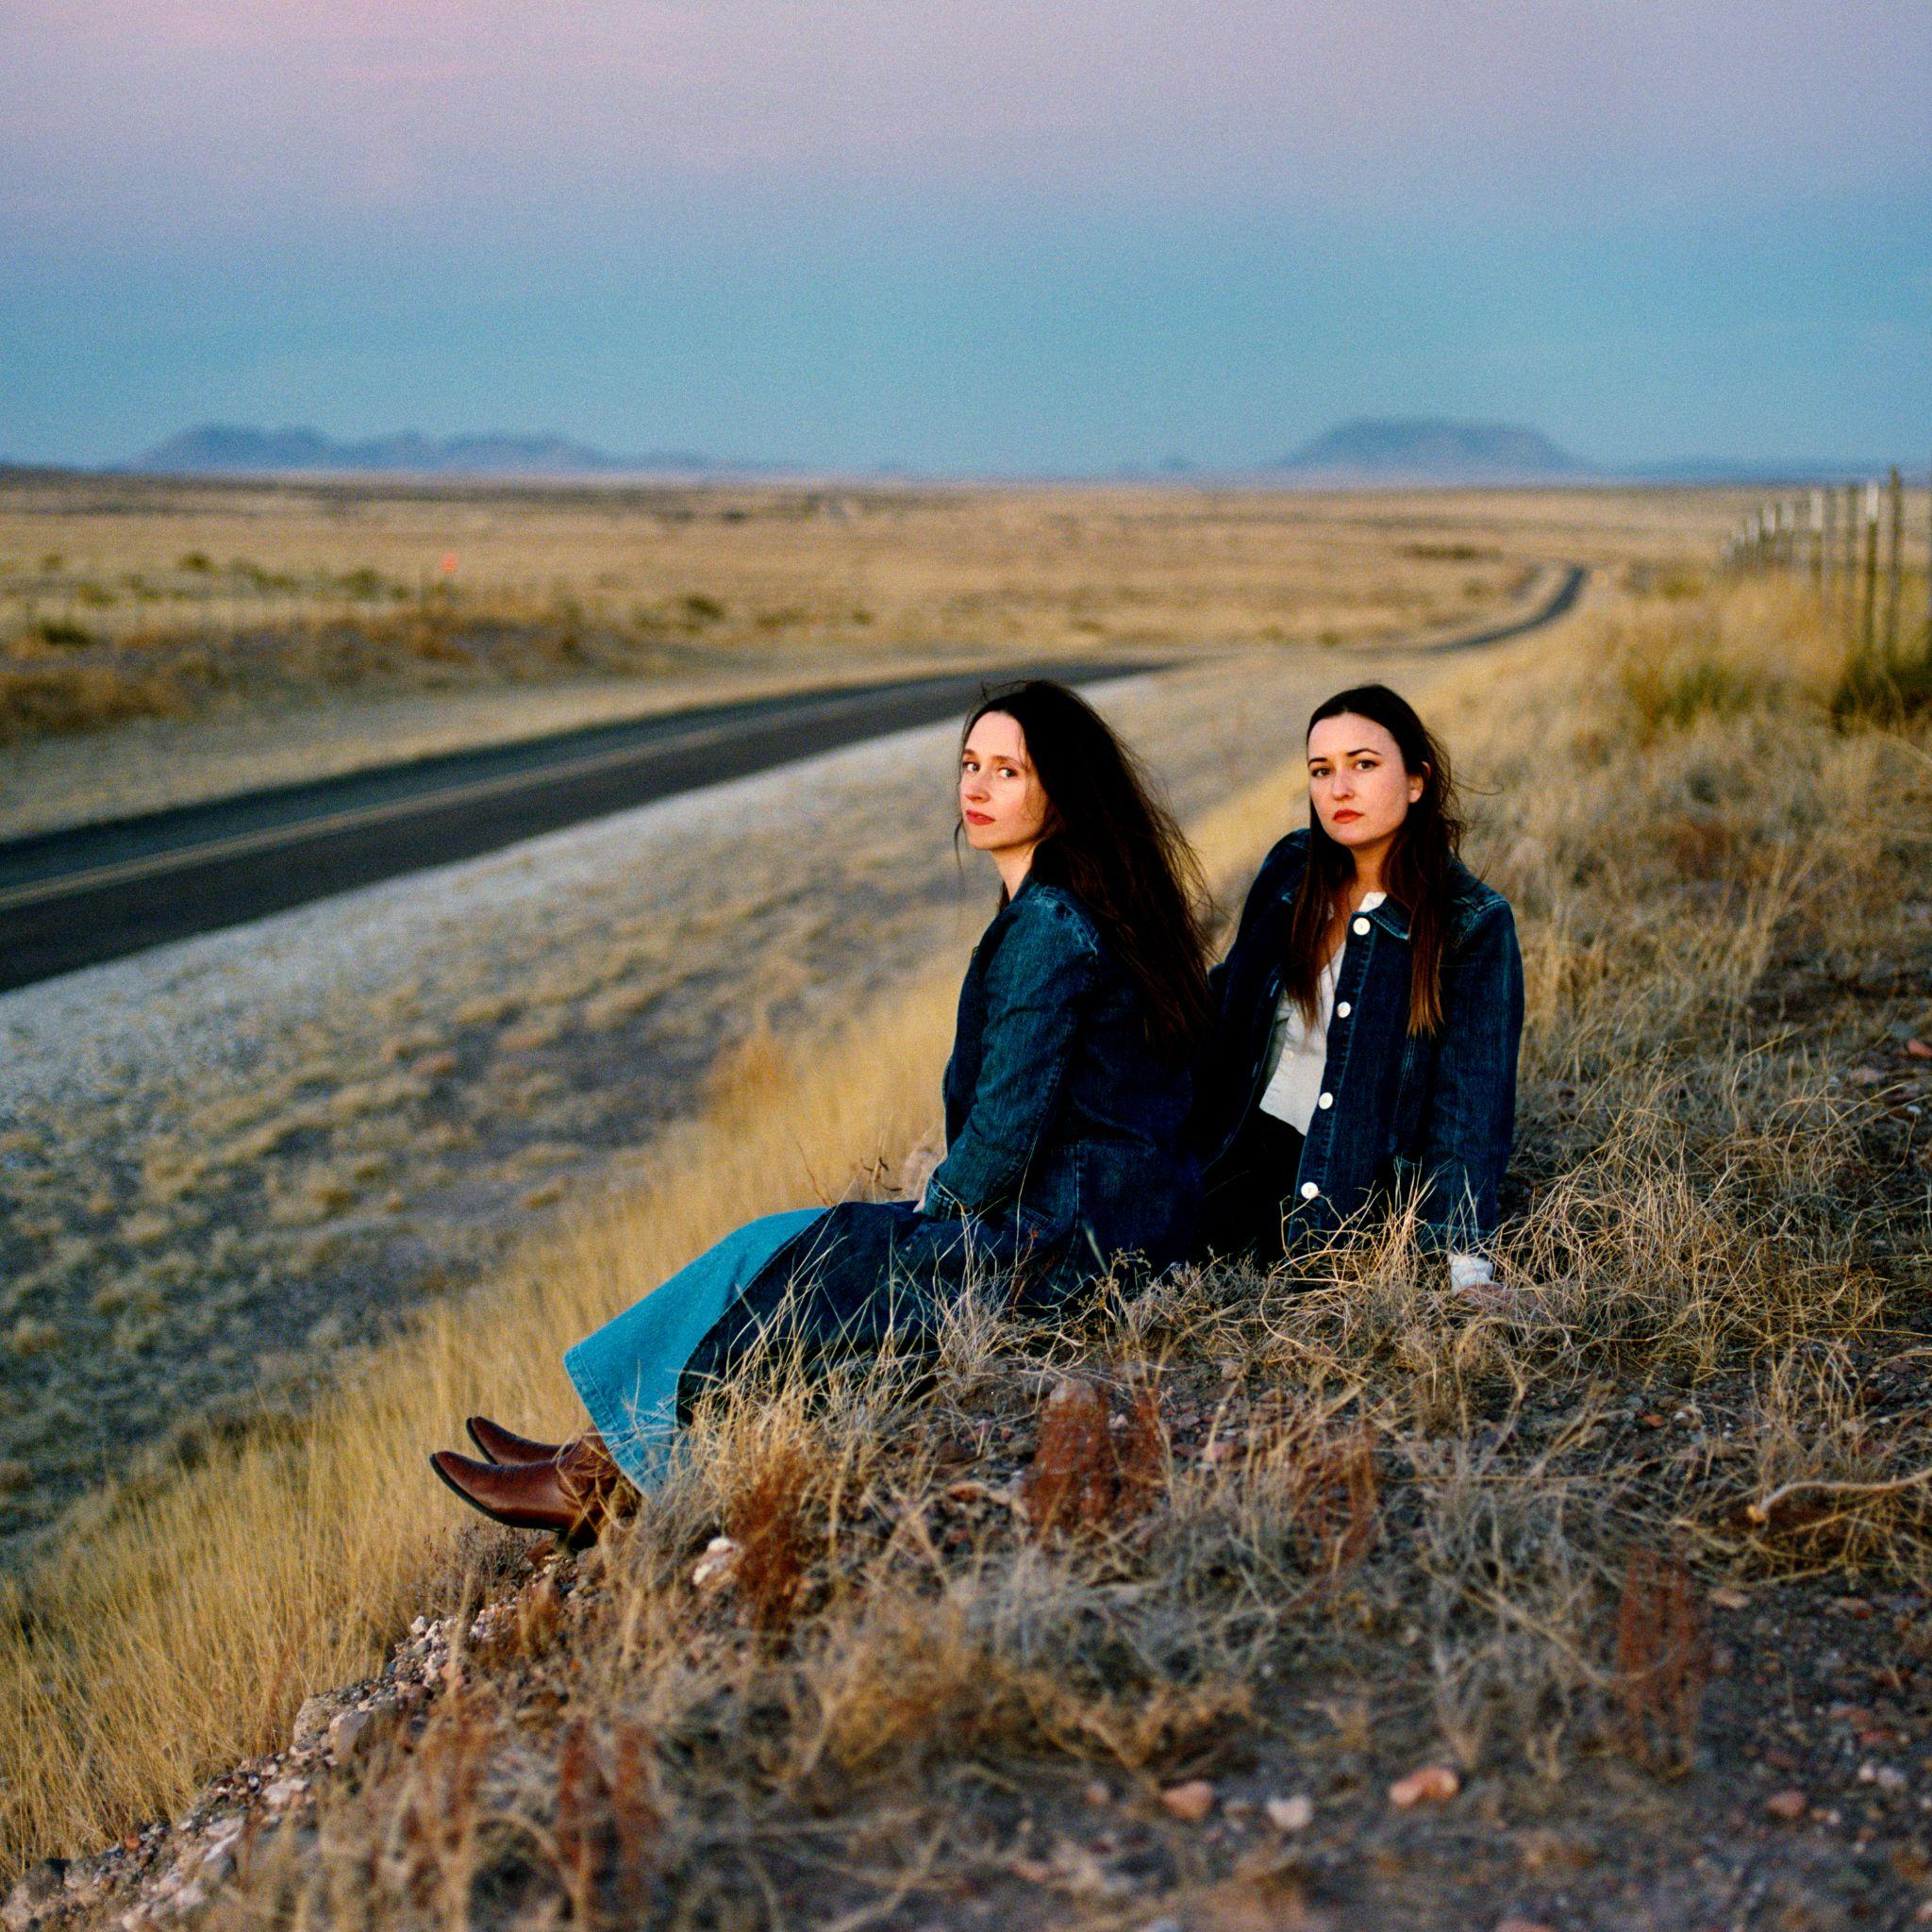
(download hi-res)

Track List:

1- Summer Sun
2- Problem With It
3- Line of Sight
4- Abeline
5- Hurricane
6- Bellafatima
7- Last 2 On Earth
8- Easy
9- No Record of Wrongs
10- I Walked With You A Ways

FOLLOW PLAINS
Website | Twitter | Instagram | Facebook | Spotify

FOLLOW WAXAHATCHEE
Website | Twitter | Instagram | Facebook | Spotify

FOLLOW JESS WILLIAMSON
Website | Twitter | Instagram | Facebook | Spotify

For more information please contact Grandstand Media & Management:
Eloy Lugo + Grace Jones
For tour related inquiries: Katie Nelson

