NEW YORK CITY-BORN, RAISED, AND FOREVER-BASED SONGWRITING PARTNERS PURR RELEASE “MANY DAYS” VIA ANTI-

LISTEN TO THE VULNERABLE, WARM TRACK HERE

Photo Credit: Angalis Field

Today, Purr, the project of songwriting partners Eliza Barry Callahan and Jack Staffen release a heartbreaking and intimate new single “Many Days.” The duo trades in harmony-driven warm-toned psych-pop for a more direct address on the pop-gaze track, "Many Days," a vulnerable and honest profession of hanging onto something that perhaps one should let go of but can’t—a faith in a foggy, fading, changing love.

Watch the video for “Many Days” here: https://youtu.be/wdT4PpUSD8U

Eliza and Jack met as young children, though never became friends until high school when a shared music teacher suggested that they try making music together. Just after the two had graduated high school they wrote a song and began their first musical project under their own names, Jack and Eliza. In 2018, they closed the book on Jack and Eliza and started a new project under the moniker Purr and released their debut LP, Like New (ANTI-), in late February 2020, which FADER called “storybook psych-pop with old school New York charm.” Like New established Purr as undeniably timeless songwriters with their distinctive harmonies spinning at center.

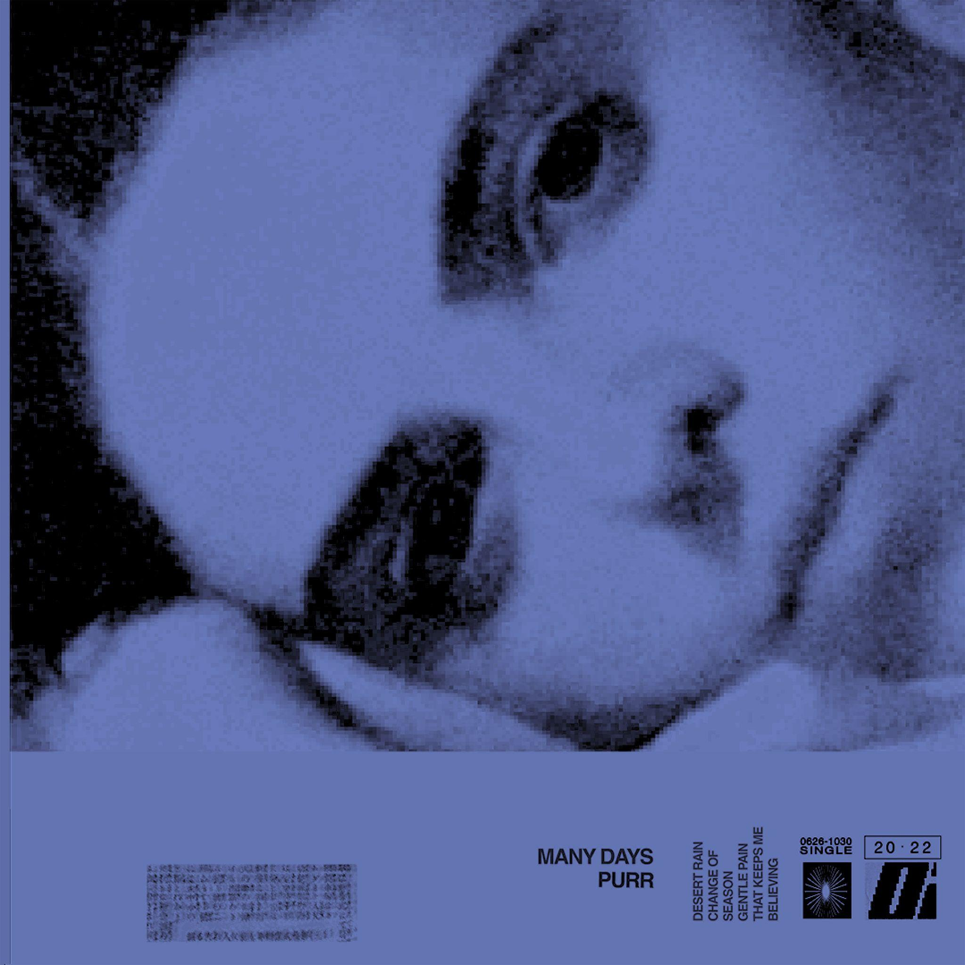

Purr Online:
instagram.com/purrband
facebook.com/purrnyc

For more information on Purr, contact Carrie Tolles (carrie@tcbpr.com), Felicia Bernardo (felicia@tcbpr.com), and Alison Smith (alison@tcbpr.com) at TCB Public Relations.

