“STORYBOOK PSYCH POP” (FADER) SONGWRITING PARTNERS PURR UNVEIL NEW SONG “STM” ( VIA ANTI-), A COUNTERPOINT TO AN EMOTIONAL JOURNEY THAT BEGAN WITH THEIR NEW SONG “MANY DAYS” RELEASED LAST MONTH

WATCH THE VISUALIZERS FOR THESE PERFECTLY ATTUNED NEW SINGLES BELOW:
“STM”
“MANY DAYS”

PRAISE FOR PURR’S 2020 DEBUT LIKE NEW
"Nostalgic sunshine pop" - Stereogum
“Steeped in dream pop and late 1960s and early 1970s AM radio… infectious melodies, sophisticated arrangements, gorgeous harmonies and enigmatic lyrics” - Forbes
“With a sound that is reminiscent of a 1960’s folk group like The Mamas & The Papas, Purr is honoring the organic genre of American Folk while putting their own unique twist on it.” – American Songwriter
“Purr write sunny indie pop for people weary about what the future holds.” - AdHoc

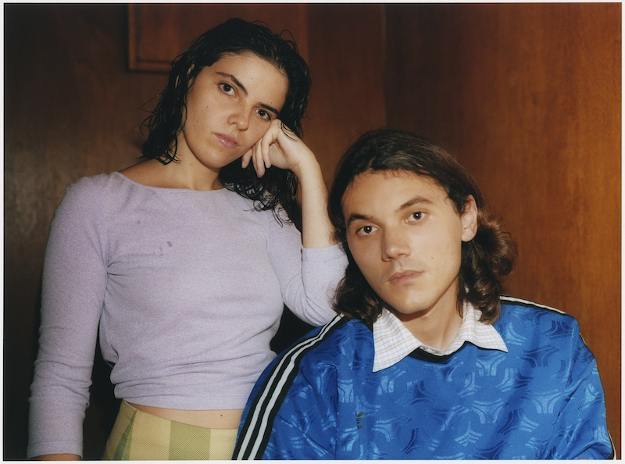
Photo Credit: Angalis Field

Today, Purr, the project of songwriting partners Eliza Barry Callahan and Jack Staffen release “STM,” an honest and courageous folk-pop track showcasing the duo's unadulterated, harmonizing voices over inviting and breezy guitars.

“STM,” serves as a counterpoint to and continues the brave emotional journey of recent single “Many Days,” a vulnerable and honest profession of hanging onto something that perhaps one should let go of but can’t—a faith in a foggy, fading, changing love.

“STM” is the next chapter, Eliza says it’s a song “about reversing out of a life, a love, a dream…”

Eliza, who is just finishing an MFA at Columbia University and a novel project, expands on the meaning and influences behind these new songs in a personal essay for the TalkHouse, read that here.

Watch the visualizer for “STM” here: https://youtu.be/IqwVSSHYi-I
Watch the visualizer for “Many Days” here: https://youtu.be/wdT4PpUSD8U

Eliza and Jack met as young children, though never became friends until high school when a shared music teacher suggested that they try making music together. Just after the two had graduated high school they wrote a song and began their first musical project under their own names, Jack and Eliza. In 2018, they closed the book on Jack and Eliza and started a new project under the moniker Purr and released their debut LP, Like New (ANTI-), in late February 2020, which FADER called “storybook psych-pop with old school New York charm.” Like New established Purr as undeniably timeless songwriters with their distinctive harmonies spinning at center.

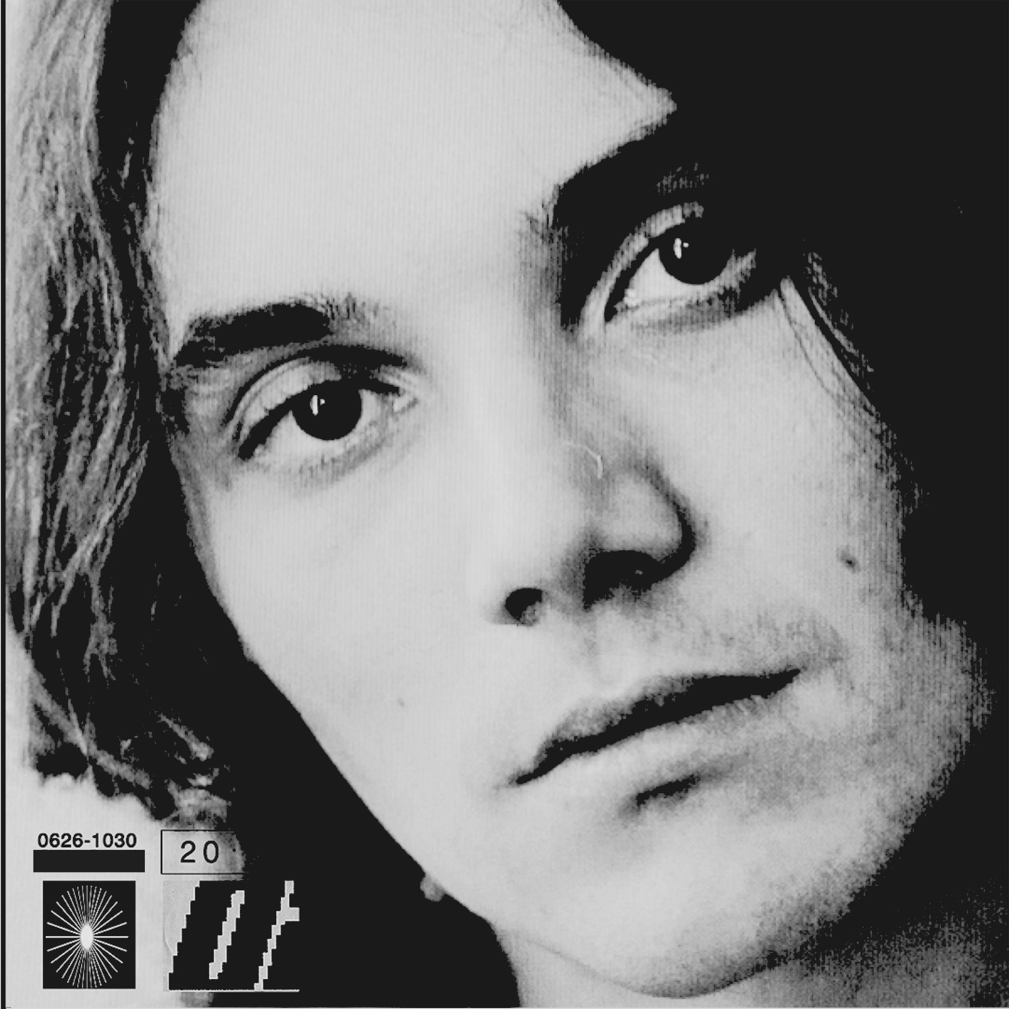

Purr Online:
instagram.com/purrband
facebook.com/purrnyc

For more information on Purr, contact Carrie Tolles (carrie@tcbpr.com) and Felicia Bernardo (felicia@tcbpr.com) at TCB Public Relations

