July 25, 2023
For Immediate Release

Slow Pulp Presents New Single, “Doubt”
From Yard, ANTI- Debut Out September 29th

North American Tour On Sale Now
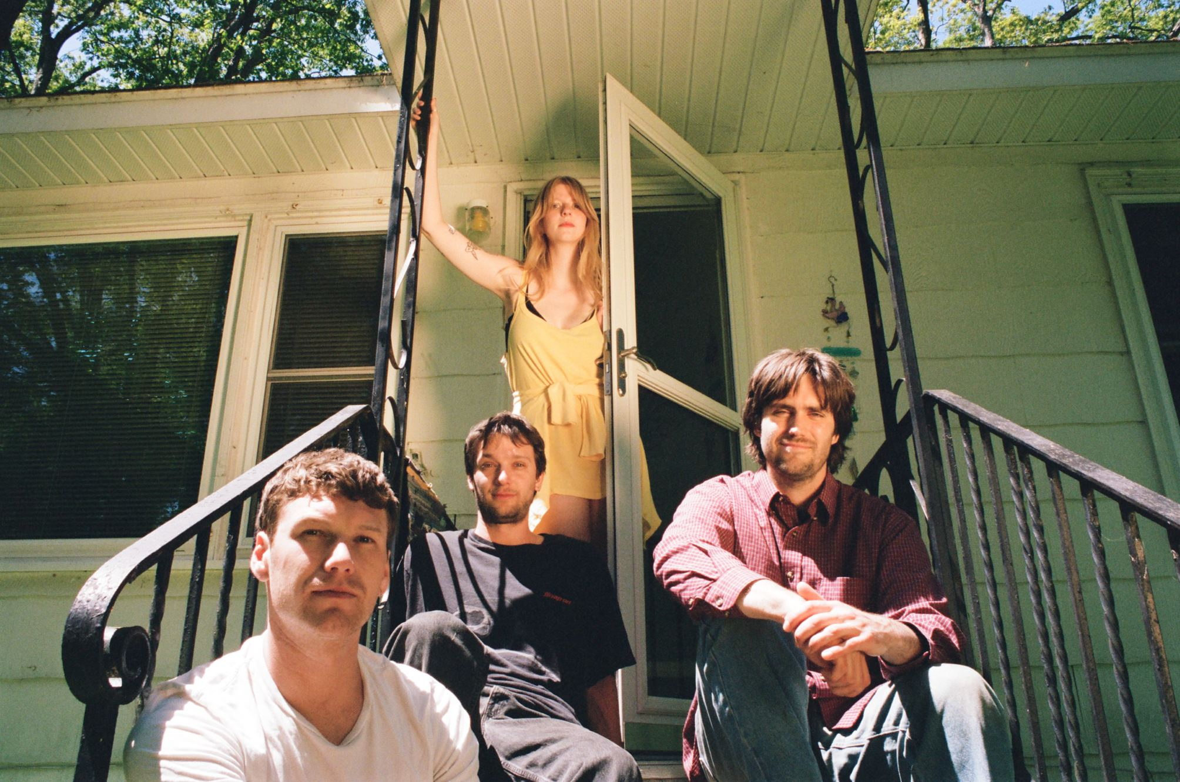
Photo Credit: Alexa Viscius

“A lot of great albums came out already this year, but even more are coming. Slow Pulp’s Yard is looking to be a highlight after the release of the sweeping ‘Cramps’ and the newest single ‘Slugs,’ a playful, languid earworm.” — Uproxx

“[‘Slugs’] combines their hazy slacker rock with warm, effervescent hooks.” — Consequence

“[‘Slugs’ is] the kind of song that displays the quiet confidence of a band that knows what they’re doing: There’s no roaring show-offy hook, just a satisfying hum that dissolves into a chorus that [is] sticky and sweet.” — Stereogum

Today, Chicago-via-Madison band Slow Pulp presents “Doubt,” the new single from their forthcoming album and ANTI- debut, Yard, out September 29th. Following lead single “Slugs” — which “was made for that hazy and sweet late summer crush” (NYLON) — “Doubt” is taunting and upbeat, a track about begging someone to validate your insecurities.

“In my process to fight against self-deprecation, I found this strange new pattern popping up where I fished for critiques from others,” says lead singer Emily Massey. “I wanted people close to me to validate the things I hated about myself. Self-doubt had found a home in me, it felt safer to stay in this familiar negative space than to like myself. I thought if others shared that with me I wouldn’t have to do the work to change.”

On Yard, Slow Pulp tackles the process of becoming comfortable with yourself — a balancing act with learning to trust, love, and lean on others. Building upon the sticky hooks and dreamy rock seen across their discography, “Doubt" is evident of Slow Pulp aiming bigger than ever before.

Watch Slow Pulp’s “Doubt” Visualizer

Through listless guitar, weepy americana, a raw-to-the-bone piano ballad, and belt-along worthy pop-punk, Yard is a lightning-in-a-bottle synthesis of what has made Slow Pulp one of the most beloved indie groups in recent memory. In many ways, their success is rooted in their decade-plus long friendships. Guitarist/producer Henry Stoehr and drummer Teddy Mathews attended elementary school together in Madison, and met bassist Alex Leeds through a local music program. Massey entered the fold in college, and the group’s early work quickly gained traction across YouTube channels and blogs. In 2018, the band relocated to Chicago; and, by 2019, they were on the road with Alex G, crafting their debut full-length record, Moveys.

Like they did for Moveys, Massey recorded vocals with her dad, Michael, in his small home studio. “Working together we can be very honest with each other in a way that I wouldn't be able to do with a stranger or a producer that's not my family,” says Massey. “He already has so much context for what the songs are about, knowing my life so intimately. He is able to be very direct, saying things I often don't want to hear but need to hear. I think it often leads to getting the best takes out of me.”

Within Slow Pulp, trust between members is evident in the playful collaboration that remains core to their creative process. Across Yard, they nestle comfortably into pockets of nuance, impressions, contradictions—sonics and lyrics finessed together to bottle the specific tension of a feeling you’ve never quite been able to find the right words for. Perhaps this spawns from the band’s own shared history and chemistry; in various ways, the four of them grew up—are still growing up—together.

Later this fall, Slow Pulp will embark on a lengthy North American/EU/UK tour, bringing their incredible live show to countless cities, including their largest headlining Chicago show to-date at Thalia Hall, two nights at New York’s Bowery Ballroom, and plenty of other stops along the way. A full list of dates is below and tickets are on sale now.

Watch “Slugs” Video

Watch “Cramps” Video

Pre-order Yard

Slow Pulp Tour Dates (New Dates in Bold):
Wed. Oct. 04 - Milwaukee, WI @ Colectivo - Backroom %
Thu. Oct. 05 - Minneapolis, MN @ Amsterdam Hall %
Fri. Oct 06 - Omaha, NE @ Slowdown %
Sun. Oct. 08 - Denver, CO @ Globe Hall %
Tue. Oct. 10 - Salt Lake City, UT @ Kilby Court % - SOLD OUT
Thu. Oct. 12 - Seattle, WA @ Neumos %
Fri. Oct. 13 - Vancouver, BC @ The Pearl on Granville %
Sat. Oct. 14 - Portland, OR @ Aladdin Theatre %
Mon. Oct. 16 - San Francisco, CA @ The Chapel %
Wed. Oct. 18 - Los Angeles, CA @ Teragram Ballroom %
Fri. Oct. 20 - San Diego, CA @ Voodoo %
Sat. Oct. 21 - Santa Ana, CA @ Constellation Room %
Sun. Oct. 22 - Phoenix, AZ @ Rebel Lounge %
Tue. Oct. 24 - Houston, TX @ White Oak Music Hall %
Wed. Oct. 25 - Dallas, TX @ Club Dada %
Thu. Oct. 26 - Austin, TX @ The Parish %
Sat. Oct. 28 - Atlanta, GA @ Purgatory %
Sun. Oct. 29 - Durham, NC @ Motoco %
Mon. Oct. 30 - Washington, DC @ Union Stage %
Tue. Oct. 31 - Philadelphia, PA @ The Foundry %
Wed. Nov. 1 - New York, NY @ Bowery Ballroom % - SOLD OUT
Fri. Nov. 3 - Boston, MA @ Brighton Music Hall %
Sat. Nov. 4 - New York, NY @ Bowery Ballroom %
Mon. Nov. 6 - Montreal, QC @ Bar Le Ritz %
Tue. Nov. 7 - Toronto, ON @ Horseshoe Tavern %
Fri. Nov. 10 - Madison, WI @ Majestic Theater %
Sat. Nov. 11 - Chicago, IL @ Thalia Hall %
Wed. Nov. 29 - Leeds, UK @ Brudenell Social Club #
Thu. Nov. 30 - Liverpool, UK @ Jimmy’s #
Fri. Dec. 1 - Glasgow, UK @ The Hug and Pint # - SOLD OUT
Sat. Dec. 2 - Dublin, IR @ The Workman's Club #
Mon. Dec. 4 - Manchester, UK @ YES (Basement) #
Tue. Dec. 5 - Bristol, UK @ Strange Brew #
Wed. Dec. 6 - London, UK @ The Garage #
Thu. Dec. 7 - Brighton, UK @ The Green Door Store #
Sat. Dec. 9 - Amsterdam, NL @ Paradiso Upstairs
Sun. Dec. 10 - Antwerp, BE @ TRIX #
Mon. Dec. 11 - Paris, FR @ L’International #
Wed. Dec. 13 - Berlin, DE @ Badehaus Szimpla #
Thu. Dec. 14 - Leipzig, DE @ Conne Island #
Fri. Dec. 15 - Schorndorf, DE @ Manufaktur #
Sat. Dec. 16 - Munster, DE @ Gleis 22 #

% w/ Babehoven
# w/ PACKS

Download cover art & hi-res images of Slow Pulp

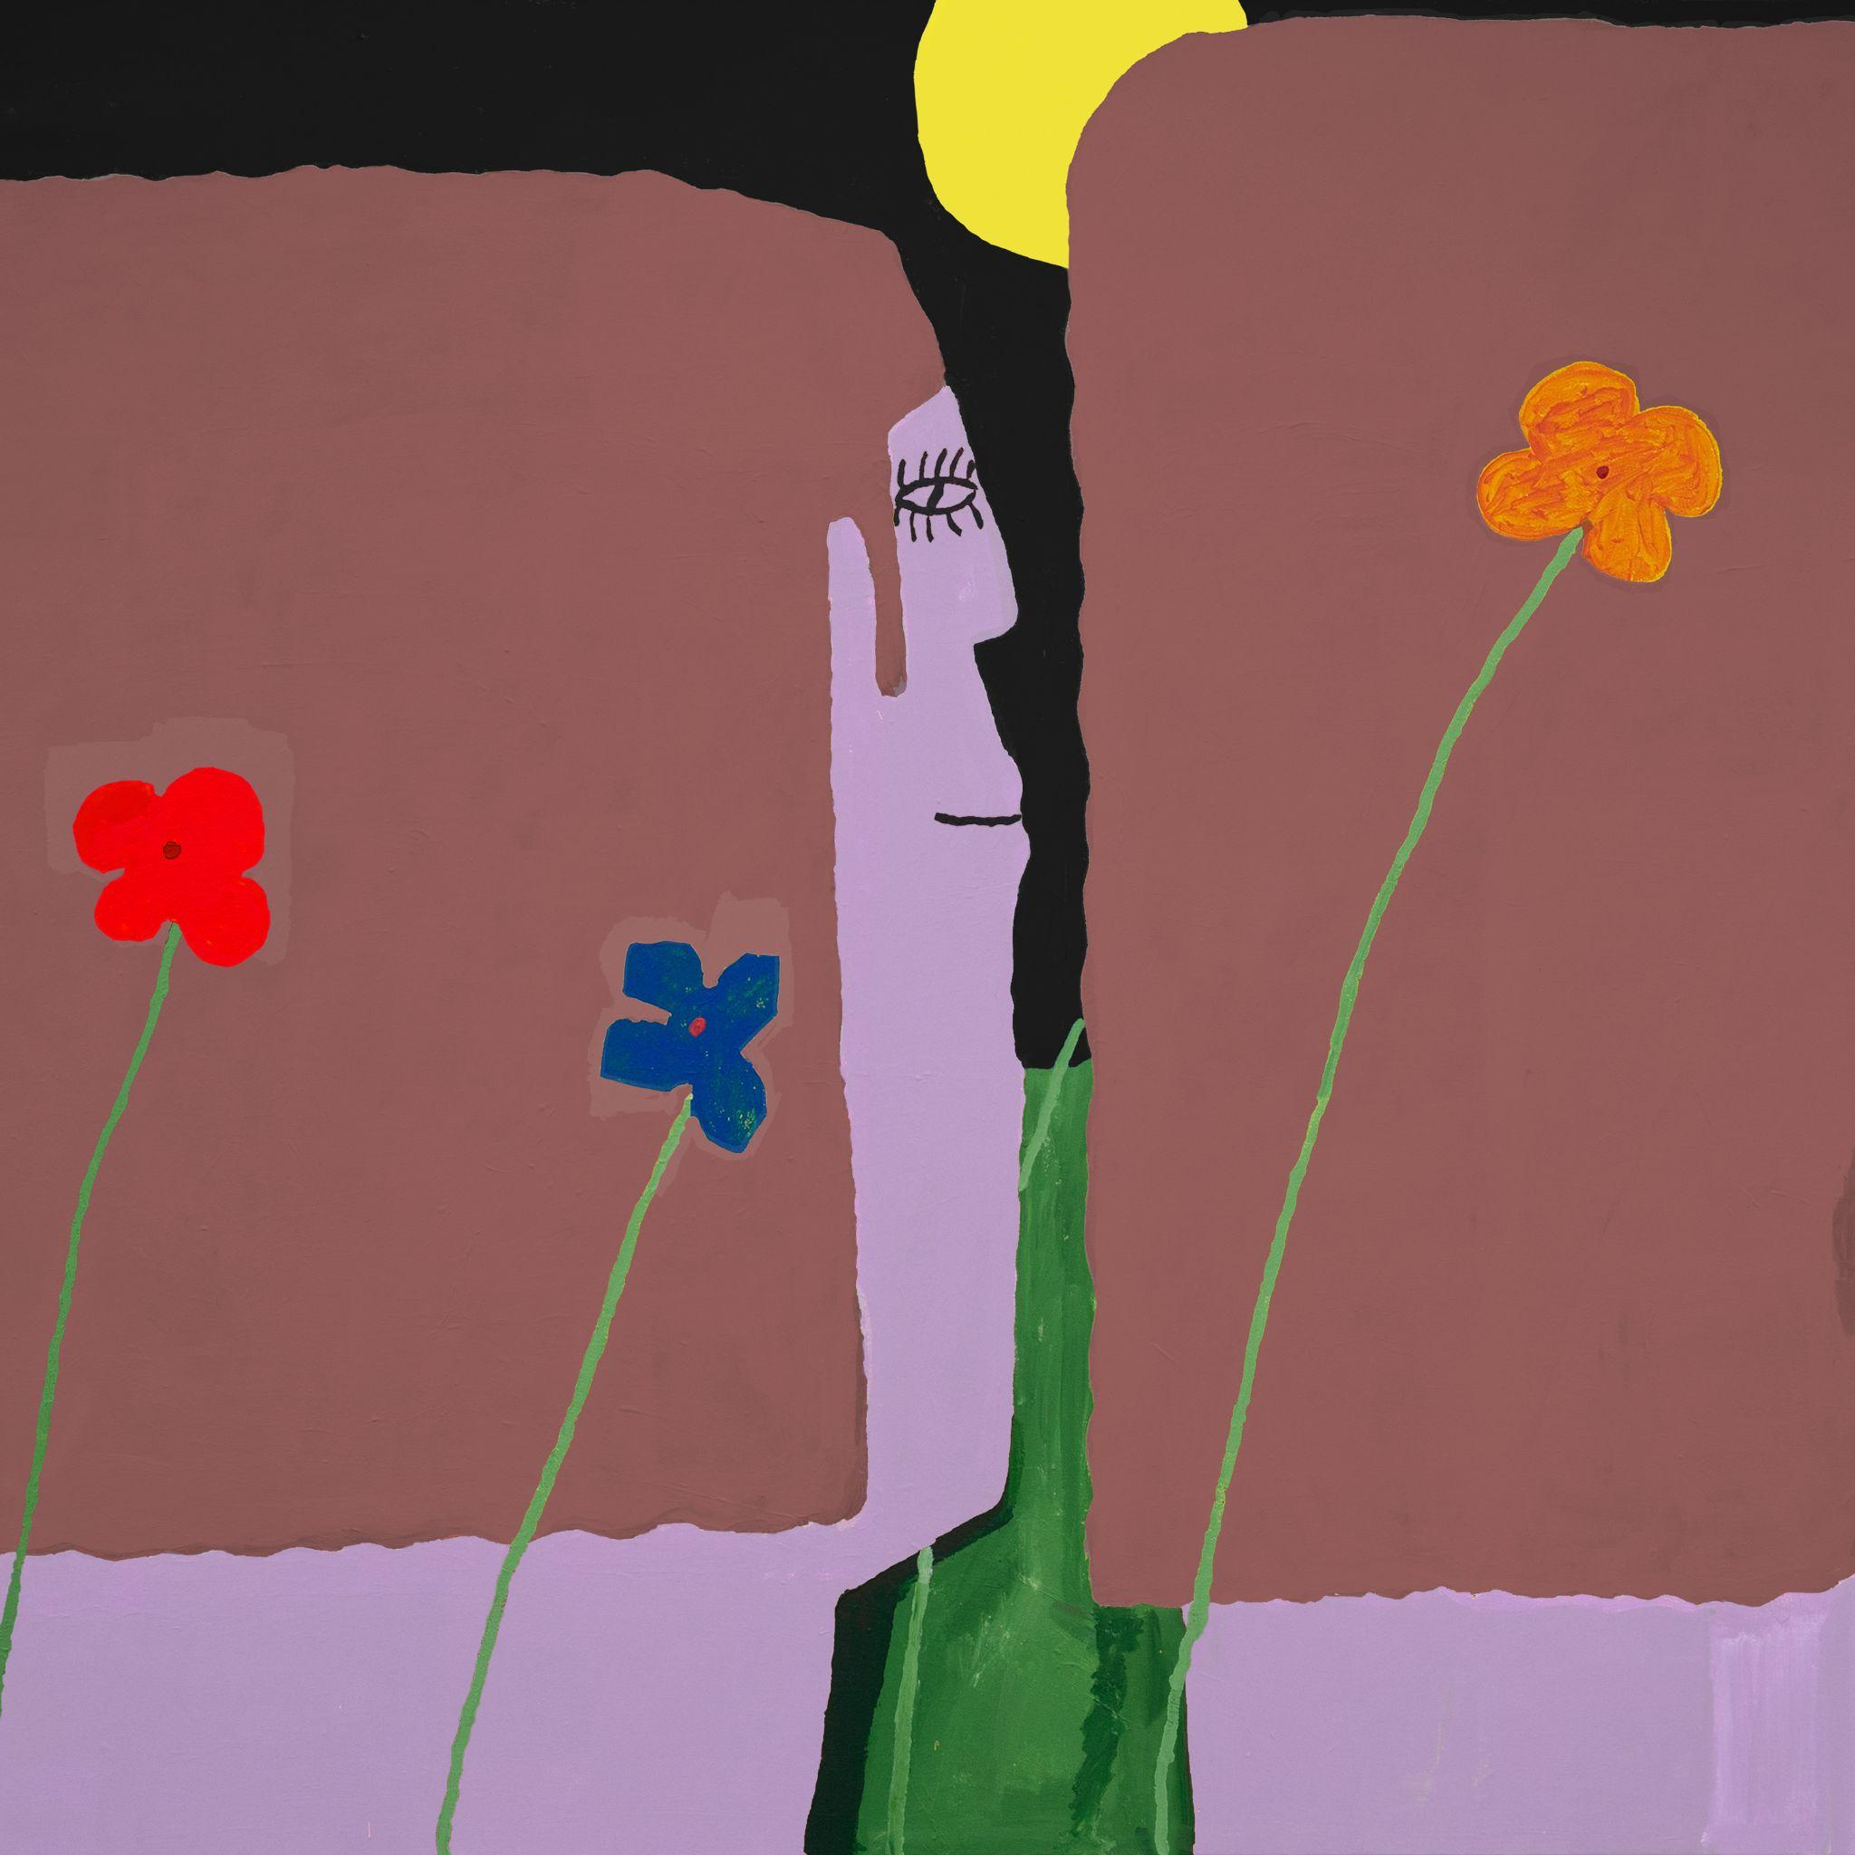
(Yard Cover Artwork by Henry Stoehr)

Slow Pulp Online:
Website | Instagram | Twitter | Facebook | Bandcamp | ANTI-

For more information, contact:
Patrick Tilley, Jaycee Rockhold | Pitch Perfect PR
patrick@pitchperfectpr.com, jaycee@pitchperfectpr.com

##

