November 6, 2019
For Immediate Release

Son Little Announces aloha, New Album Out January 31st On ANTI-, Presents Video For New Single, “suffer”

North American Tour Kicks Off Next Week

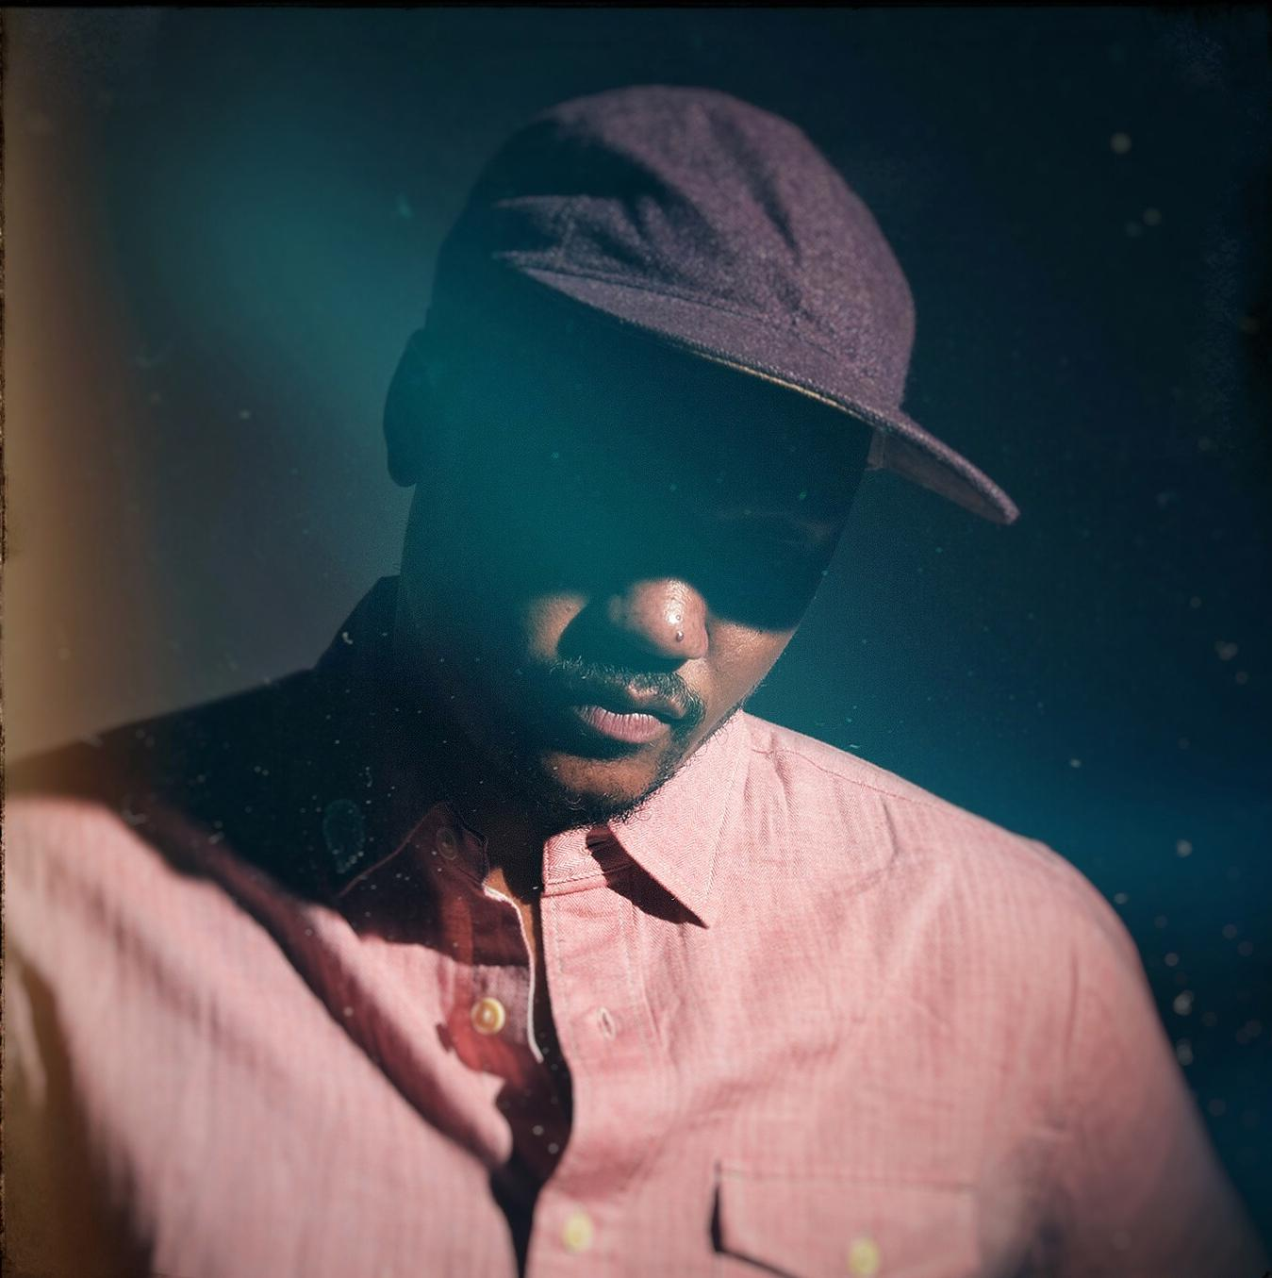
(Photo Credit: Shervin Lainez)

"With bluesy distorted guitar chords, a hint of Latin rhythm and perhaps a distant echo of the Zombies’ 'Time of the Season,’ Son Little offers a genial come-on in 'Hey Rose' from his new EP, ‘Invisible.'” — The New York Times

"The magic at the heart of Son Little‘s music is the way so many of his songs could be standards, but none of them could have come from anyone else.” — Afropunk

“You might want to get familiar with singer/songwriter, Son Little.” — VIBE

Son Little, the musical nom de plume of LA’s Aaron Earl Livingston, today announces his new album, aloha, due January 31st on ANTI-, and presents the Daria Geller-directed video for new single, “suffer”. As previewed with the release of last month’s invisible EP and early single, “hey rose,” which The New York Times described as comprising “bluesy distorted guitar chords, a hint of Latin rhythm and perhaps a distant echo of the Zombies’ 'Time of the Season’,” aloha blends classic soul and old-school R&B into a timeless swirl fueled by gritty instrumental virtuosity and raw, raspy vocals. Recorded at Paris’s iconic Studios Ferber with producer Renaud Letang (Feist, Manu Chao), aloha is Little’s first album to be recorded with an outside producer. The result is his boldest, most self-assured statement yet. It’s an ambitious work of vision and reflection, and an ecstatic testament to the freedom that comes from trusting the currents of life to carry you where you belong.

Watch Video For Lead Single, “suffer” -
https://youtu.be/xLo0a_mKmx4

Born to a preacher and a teacher in Los Angeles, Little first came to international prominence with his self-titled debut, released in 2015 on ANTI- Records. While Little’s collaborations with The Roots and RJD2 had already helped him make a name for himself by that point in his adopted hometown of Philadelphia, critics on both sides of the pond were quick to recognize the unique power of Little’s solo recordings. NPR Music hailed Little’s “impeccably crafted songs” as “honest and unpretentious,” while The Independent proclaimed him “a formidable talent,” and Vice declared that he was “dissolving the barrier between R&B and rock 'n' roll one tearjerker at a time.”

The following year, Little showed off his production chops, earning a GRAMMY Award for his work helming Mavis Staples’ acclaimed See That My Grave Is Kept Clean, and in 2017, he released his critically lauded sophomore album, New Magic.

In order to create aloha, Little began writing and assembling album demos in Petaluma, California. However, after his hard drive fried and he lost nearly a dozen detailed demos, he was forced to begin with a blank slate, leading him to write aloha in only eight days at a tiny house and its adjacent barn. While Little plays nearly every instrument on the album himself, he put his songs in the hands of an outside producer for the first time here. The entire project was an exercise in letting go, in ceding control, in surrendering to fate.

Recognizing the power of our own self-destructive tendencies is a recurring theme on aloha. Little mourns the suicide of a beloved uncle on “suffer,” using addiction and mental illness as a lens to explore forgiveness and empathy, laments the rapidly deteriorating world his two children are set to inherit on “o clever one,” and meditates on the dangers of succumbing to passion at the expense of reason on “belladonna.”

It would be easy to feel helpless in the face of such inexorable forces, to feel as if we are prisoners of fate rather than masters of our own destiny, but Little instead finds peace in perseverance on the album. “Hallelujah,” he sings on the gorgeous “neve give up,” “though I’m battered and blue / feel like I’m born to lose…Never will I give up.”

It is a potent reminder that letting go doesn’t mean giving in; in fact, quite the opposite. Letting go can be an act of defiance, of growth, of empowerment. Letting go requires a leap of faith, and, in Son Little’s case, that faith has been richly rewarded. Whether that means this album represents the end of one chapter or the beginning of the next is impossible to know just yet, but in either case, there’s really only one thing to say: aloha.

Pre-order aloha -
https://sonlittle.ffm.to/aloha

aloha Tracklist:
1. hey rose
2. about her. Again
3. mahalia
4. bbbaby
5. suffer
6. that’s the way
7. 3rd eye weeping
8. don’t wait up
9. o clever one
10. neve give up
11. after all (i must be wrong)

Son Little Tour Dates (new dates in bold):
Mon. Nov. 11 - San Francisco, CA @ Swedish American Hall
Wed. Nov. 13 - Portland, OR @ The Old Church
Thu. Nov. 14 - Seattle, WA @ The Crocodile
Sat. Nov. 16 - Salt Lake City, UT @ The State Room
Sun. Nov. 17 - Denver, CO @ Daniels Hall
Tue. Nov. 19 - Minneapolis, MN @ Cedar Cultural Center
Wed. Nov. 20 - Chicago, IL @ Old Town School of Folk Music
Thu. Nov. 21 - Ferndale, MI @ Magic Bag
Fri. Nov. 22 - Pittsburgh, PA @ Thunderbird Café & Music Hall
Sat. Nov. 23 - Lancaster, PA @ Chameleon Club
Mon. Nov. 25 - Cambridge, MA @ The Sinclair
Tue. Nov. 26 - New York, NY @ Bowery Ballroom
Fri. Nov. 29 - Philadelphia, PA @ World Cafe Live
Sat. Nov. 30 - Washington, DC @ Rock & Roll Hotel
Sun. Dec. 1 - Asheville, NC @ The Grey Eagle
Tue. Dec. 3 - Nashville, TN @ WMOT Finally Friday - 3rd & Lindsley
Wed. Dec. 4 - Atlanta, GA @ The Earl
Thu. Dec. 5 - New Orleans, LA @ Gasa Gasa
Fri. Dec. 6 - Austin, TX @ 3TEN ACL Live
Sat. Dec. 7 - Dallas, TX @ The Blue Light Dallas
Tue. Dec. 10 - Phoenix, AZ @ Valley Bar
Wed. Dec. 11 - San Diego, CA @ Soda Bar
Thu. Dec. 12 - Los Angeles, CA @ Lodge Room
Fri. Jan. 17 - Asbury Park, NJ @ Asbury Lanes
Thu. Jan. 23 - Charlotte, NC @ Blumenthal Performing Arts
Fri. Jan. 24 - Raleigh, NC @ Kings Barcade
Sat. Jan. 25 - Virginia Beach, CA @ Smartmouth Brewery
Tue. Jan. 28 - Northampton, MA @ Iron Horse Music Hall
Wed. Jan. 29 - Fairfield, CT @ Stage One
Fri. Jan. 31 - Burlington, VT @ Arts Riot
Sat. Feb. 1 - Portsmouth, NH @ 3s Artspace
Sat. Feb. 15 - Pioneertown, CA @ Pappy & Harriet’s
Sun. Feb. 16 - Morro Bay, CA @ The Siren
Mon. Feb. 17 - Mill Valley, CA @ Sweetwater Music Hall
Sat. Feb. 22 - Winnipeg, MB @ Festival du Voyager
Fri. March 27 - Brighton, UK @ Patterns
Sat. March 28 - London, UK @ Oslo
Mon. March 30 - Paris, FR @ La Maroquinerie
Tue. March 31 - Antwerp, BE @ Kavka VZW
Wed. April 1 - Amsterdam, NL @ Paradiso Noord
Thu. April 2 - Rotterdam, NL @ Bird
Sat. April 4 - Hamburg, DE @ Bahnhof Pauli
Sun. April 5 - Berlin, DE @ Privatclub
Mon. April 6 - Cologne, DE @ Blue Shell
Tue. April 7 - Zurich, CH @ Exil
Thu. April 9 - Zaragoza, ES @ Rock & Blues Café
Fri. April 10 - Barcelona, ES @ La Nau

Stream/Purchase Son Little’s invisible EP (digital only) -
https://sonlittle.ffm.to/invisible

Download album art & hi-res images of Son Little -
http://pitchperfectpr.com/son-little

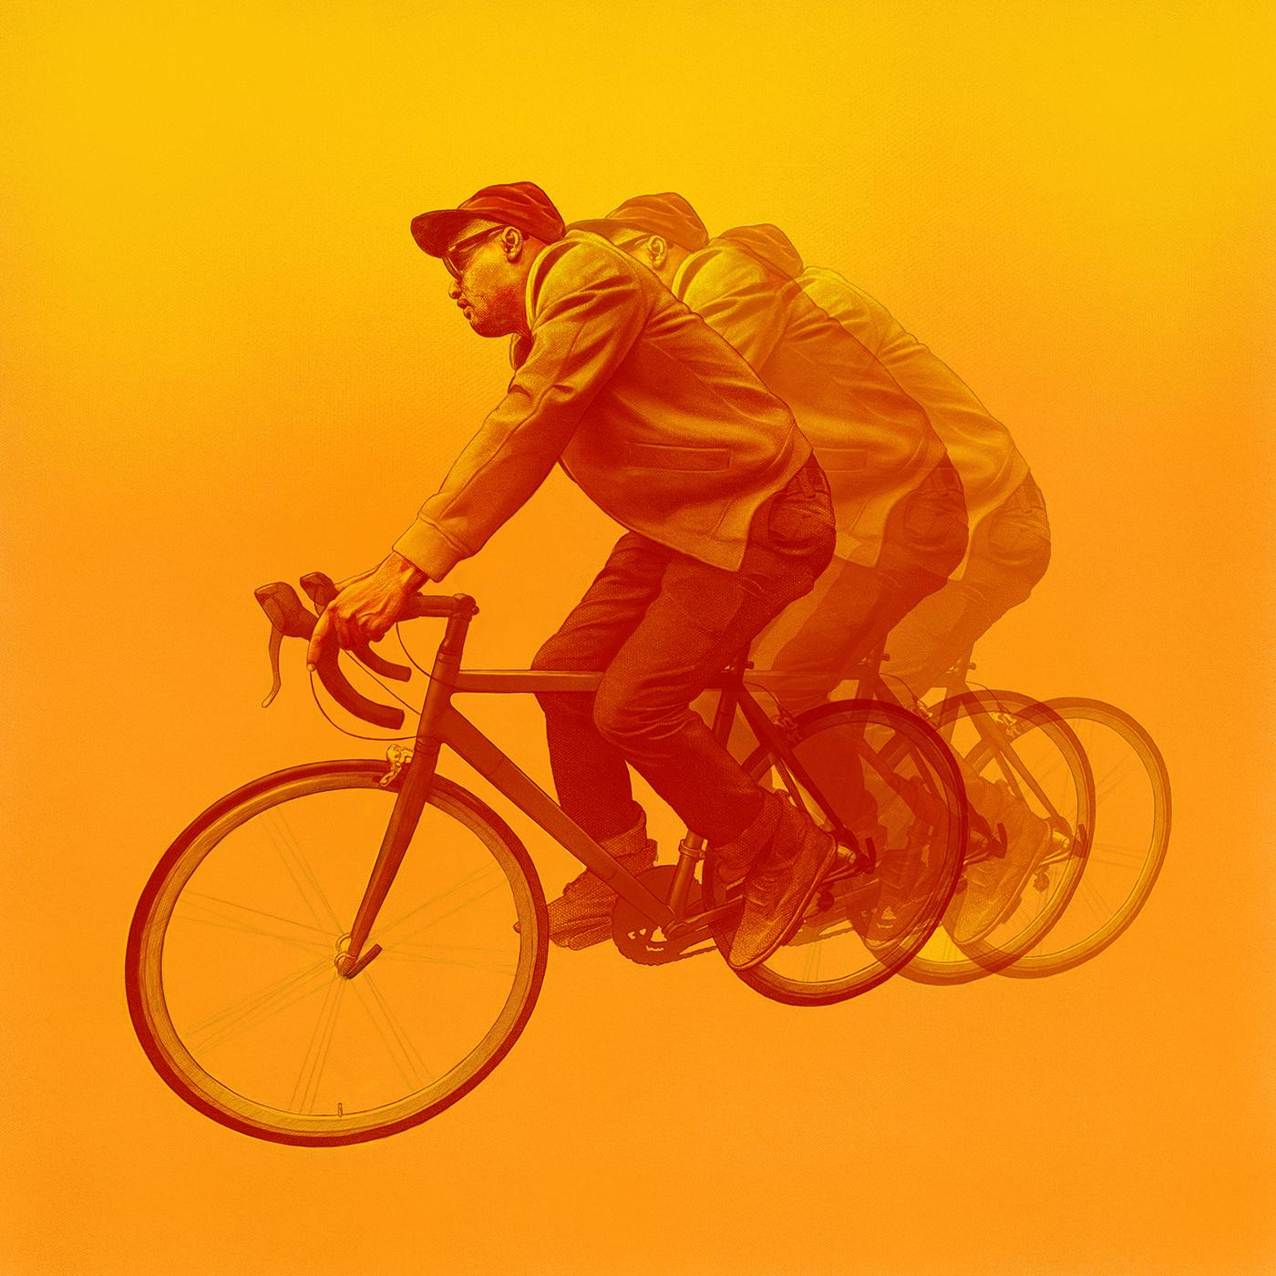
(aloha Cover Art)

Artist Site | Facebook | Twitter | Instagram | Youtube | ANTI-

For more information, contact:
Sam McAllister | Pitch Perfect PR - sam@pitchperfectpr.com, 773-271-6844

