August 29, 2022
For Immediate Release

Son Little Presents New Single “inside out”

New Album, Like Neptune, Out Next Friday Sept. 9th via ANTI-

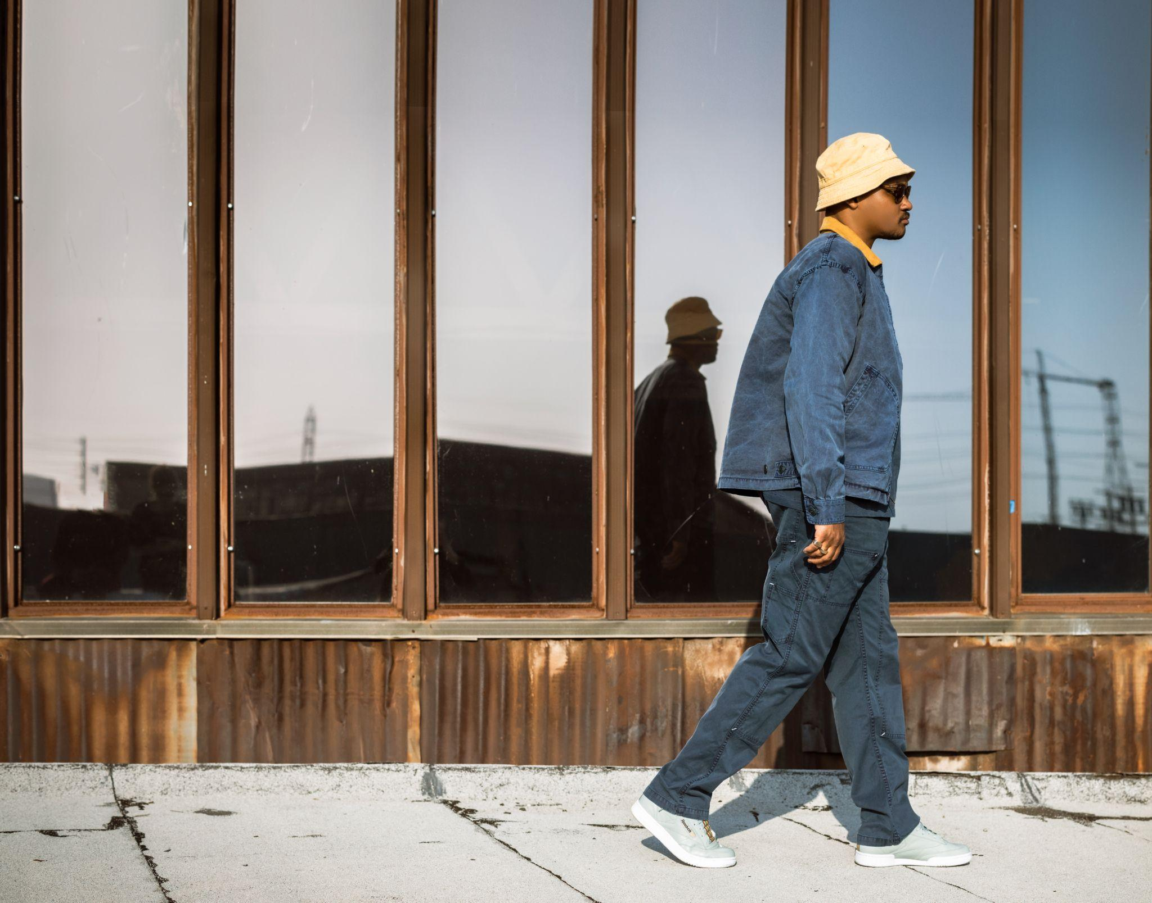
(Photo Credit: Cynthia Perez)

“The Roots and Mavis Staples collaborator balances past and future with stylish precision on uplifting fourth LP.” — MOJO, ****

“the languid “deeper” and the joyous “stoned love” are full of spiritual healing, as self-doubt is replaced by a hard-won inner radiance” — Uncut, 8/10

Son Little will release his new album, Like Neptune, next Friday, September 9th via ANTI-. Today, he presents its final pre-release single, “inside out,” the follow-up in a string of gorgeous singles - “deeper,” “stoned love,” and “6 AM.” Like Neptune is an open and vulnerable portrayal of unbridled joy and self-acceptance. In this verdant space of freedom, Son Little transmutes the chronic pain of self-doubt into a beautiful opus about overcoming generational trauma, decorating the altar of the primordial blues and elevating the labor of healing to high art. On “inside out,” an at once overly macho part of Son Little finds power in vulnerability. “It came to me very quickly and feels very natural,” says Son Little. “I looped up the piano and drums and then freestyled into this echo chamber effect and voila.” The song places balance and directness over possessiveness and toxicity with a groove inspired by both RZA and Prince.

Listen to Son Little’s “inside out”

Like Neptune was conceived in a cabin overlooking the Delaware River in upstate New York. At the beginning of lockdown, Aaron Livingston (aka Son Little) sorted through a closet and found a few boxes that contained 72 of his old writing books. “The oldest book I got as a Christmas present when I was 9,” explains Livingston. “In it, I wrote letters to myself about what was happening in my life. One page refers to a neighbor in Queens who abused me sexually around age 5. It was the first and only time I’d ever acknowledge this fact until after my 19th birthday, when I told my mother what had happened. She begged me to go to therapy. I went under protest. My attempt wasn’t sincere. I wasn’t ready. I thought I could just power through it.” Years of anxiety, depression, panic attacks and existential dread ensued, often dulled or numbed by the effects of alcohol, drugs, or sex. Following a car crash and arrest finally led him back into therapy in 2017. Aggressively employing progressive methods like EMDR and somatic healing, Livingston, with the help of a trusted therapist, began identifying the roots of his trauma, and where it lives in the body. But the biggest breakthrough came from Internal Family Systems, a methodology that recognizes responses to trauma triggers as distinct entities or ‘parts’ within the person, and requires the patient essentially have conversations with the different traumatized personalities within them.

Like Neptune establishes Son Little as the polyglot translator and rightful torchbearer of the celebrated musical tradition known as rhythm and blues. With it, he completes the daunting tasks of confronting himself and pushing his sound to completion. The result is a timeless body of work reflective of his deep internal desire to inhabit the most radiant version of himself and become a positive force in the lives of people around him.

Listen to “deeper” by Son Little

Listen to “stoned love” by Son Little

Listen to "6 AM" by Son Little

Pre-order Like Neptune

Son Little Tour Dates
Fri. Sept. 2 - Madrid, ES @ Sala Clamores
Sat. Sept. 3 - Zaragoza, ES @ Rock & Blues Cafe
Sun. Sept. 4 - Barcelona, ES @ La Nau Locales de Ensayo
Wed. Sept. 7 - Hamburg, DE @ Bahnhof Pauli
Thu. Sept. 8 - Berlin, DE @ Privatclub
Fri. Sept. 9 - Köln, DE @ Helios 37
Sat. Sept. 10 - Zürich, CH @ Exil
Mon. Sept. 12 - Antwerpen, BE @ Kavka
Wed. Sept. 14 - Amsterdam, NL @ Paradiso
Thu. Sept. 15 - Rotterdam, NL @ Bird
Fri. Sept. 16 - Paris, FR @ La Maroquinerie
Sat. Sept. 17 - London, UK @ The Garage
Sun. Sept. 18 - Brighton, UK @ The Hope & Ruin
Tue. Nov. 1 - Los Angeles, CA @ Troubadour
Wed. Nov. 2 - San Diego, CA @ Soda Bar
Fri. Nov. 4 - San Francisco, CA @ Great American Music Hall
Sat. Nov. 5 - Santa Cruz, CA @ Moe’s Alley
Mon. Nov. 7 - Seattle, WA @ Neumos
Wed. Nov. 9 - Portland, OR @ Doug Fir Lounge
Thu. Nov. 10 - Boise, ID @ The Olympic
Fri. Nov. 11 - Salt Lake City, UT @ The State Room
Sat. Nov. 12 - Denver, CO @ Bluebird Theater
Tue. Nov. 15 - Dallas, TX @ The Kessler Theater
Wed. Nov. 16 - Austin, TX @ 3TEN ACL Live
Fri. Nov. 18 - Memphis, TN @ Railgarten
Sat. Nov. 19 - Nashville, TN @ The Blue Room at Third Man Records
Thu. Dec. 1 - Charleston, SC @ The Pour House
Fri. Dec. 2 - Atlanta, GA @ Smith’s Olde Bar
Sat. Dec. 3 - Lake Wales, FL @ Orange Blossom Revue
Sun. Dec. 4 - Tampa, FL @ The Attic
Wed. Dec. 7 - Milwaukee, WI @ Back Room at Colectivo
Thu. Dec. 8 - St. Paul, MN @ Turf Club
Fri. Dec. 9 - Chicago, IL @ Chop Shop
Sat. Dec. 10 - Ferndale, MI @ The Loving Touch
Wed. Dec. 14 - Boston, MA @ The Sinclair
Thu. Dec. 15 - Sheffield, MA @ Race Brook Lodge
Fri. Dec. 16 - Brooklyn, NY @ Elsewhere
Sat. Dec. 17 - Philadelphia, PA @ Underground Arts

Download album art & hi-res images of Son Little

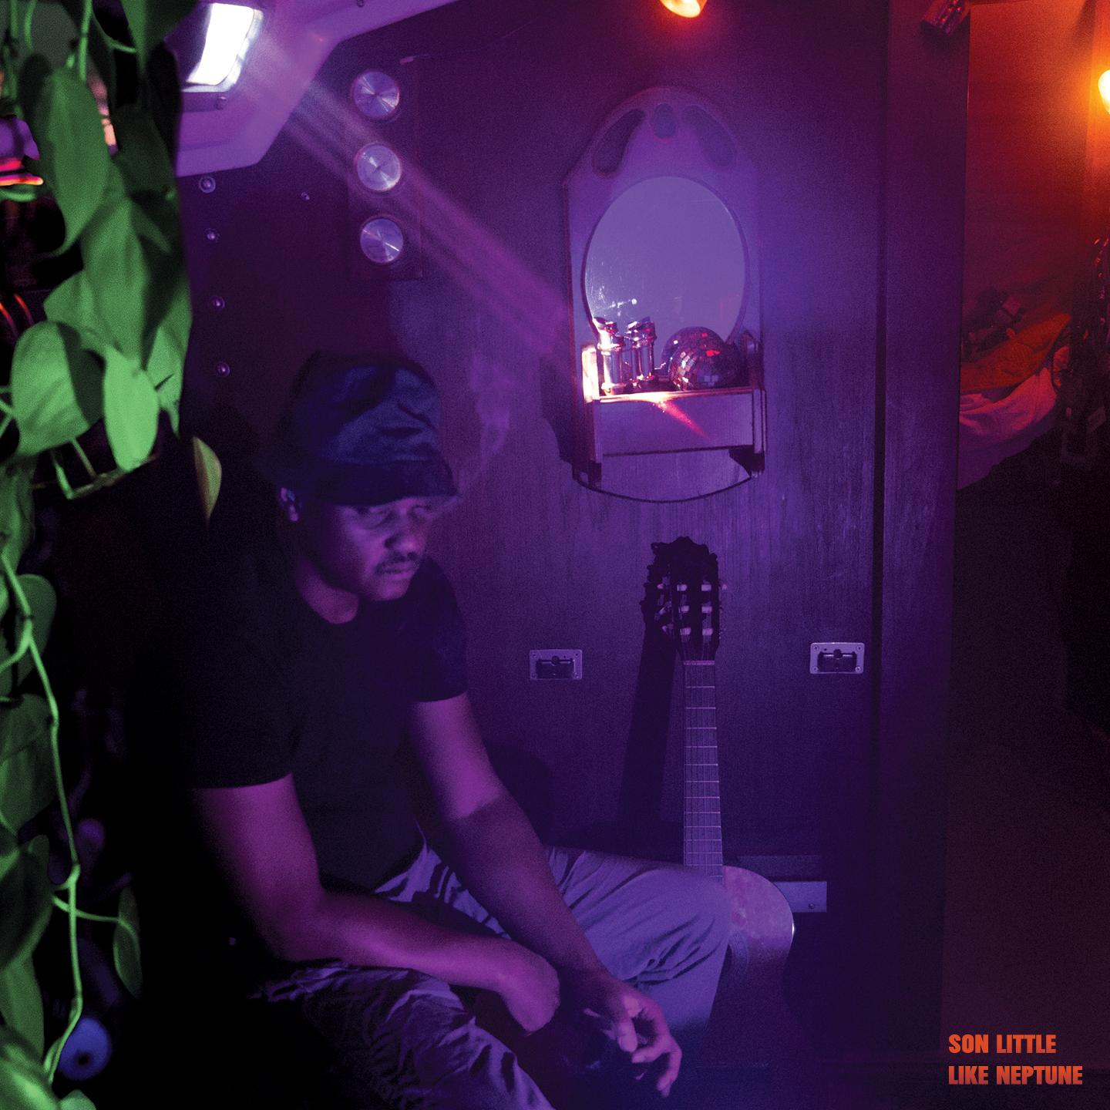
(Like Neptune Cover Artwork)

Artist Site | Facebook | Twitter | Instagram | Youtube | ANTI-

For more information, contact:
Sam McAllister | Pitch Perfect PR - sam@pitchperfectpr.com, 773-942-6573

###

