September 19, 2022
For Immediate Release

The Tallest Man On Earth To Release Too Late For Edelweiss,
New Covers Album, This Friday, September 23 on ANTI-

Listen to “Lost Highway” (Hank Williams Cover)

Announces Spring 2023 EU Tour
Photo Credit: Shervin Lainez

The Tallest Man On Earth – the project of Swedish musician Kristian Matsson – announces Too Late For Edelweiss, an album of new covers out this Friday, September 23 on ANTI- and releases his cover of Hank Williams’ “Lost Highway.” With Too Late for Edelweiss, Matsson weaves together a sparse collection of home recordings made in Sweden and North Carolina, captured fresh off a 39-date run with the adrenaline of tour rattling through his veins. His first release since 2019’s I Love You. It’s A Fever Dream, and his signing to ANTI-, the songs on Too Late For Edelweiss have been with Matsson since he started playing music as The Tallest Man on Earth in 2006. In those early years, Matsson used to perform “Lost Highway” before he had enough songs to flesh out a full set.

Listen to “Lost Highway” (Hank Williams Cover)
“This past year, I’ve spent a lot of time touring but also writing and recording an album that I’m wildly proud of and will see the light of day eventually. But in the small hours in between trips and sessions, mostly in my house in Sweden and an AirBnb in North Carolina, I lo-fi recorded some covers here and there. Many times as a reset button for my own song writing, to cleanse the palate from my whirlpool mind while writing songs,” says Matsson. “A little document of songs I had on my mind during those nights.”
As much as Too Late for Edelweiss feels like a scrapbook, an intimate memento with the ghosts of The Tallest Man’s earlier, sparser sound hovering at the edges, it’s also just the artifact of a moment - a flash of joy, of feeling recharged, of feeling good. These are the songs that happened to be in Matsson’s head at the time he sat down to record. It came together so simply and easily – and in that way, it’s the purest distillation of making music - and being a fan of it, charting the connective tissue of a songwriter’s life.

In July 2022, Matsson released a cover of Swedish super star Håkan Hellström’s “För sent för Edelweiss,” a precious song that has been The Tallest Man’s walk-on music before every performance for over a decade and what inspired the title of this covers album. Since then, in the lead-up to this announcement, he has quietly released other selections, including Lucinda Williams’ “Metal Firecracker,” Yo La Tengo’s “Tears Are In Your Eyes” and now “Lost Highway.” Mattson explains, “When I was a teenager I borrowed a Hank Williams album at the local library, and ‘Lost Highway’ has been haunting me ever since. Many vocal sound checks throughout my career have heard Hank’s advice.”

Through the pandemic, Matsson has been active in connecting with listeners across the globe; he performed frequent livestreams for fans, playing through covers and requests from his acclaimed and beloved albums including The Wild Hunt (2010), Dark Bird is Home (2015), and I Love You. It’s a Fever Dream, among others. Matsson also released the inventive full-length performance film, The Little Red Barn Show, created with friend and filmmaker Rolf Nylinder, in 2021.

In conjunction, Mattson announces a spring 2023 European tour. Dates are listed below and tickets will go on sale on September 23 here.

Pre-order Too Late For Edelweiss

Listen to “Tears Are In Your Eyes” (Yo La Tengo Cover)

Listen to “Metal Firecracker” (Lucinda Williams Cover)

Listen to “För sent för Edelweiss” (Håkan Hellström Cover)

Too Late For Edelweiss Tracklist
1. För sent för Edelweiss (Håkan Hellström)
2. Metal Firecracker (Lucinda Williams)
3. Little Birdie (Ralph Stanley)
4. Then You Can Tell Me Goodbye (The Casinos)
5. Blood Bank (Bon Iver)
6. Tears Are In Your Eyes (Yo La Tengo)
7. Fairest Of The Seasons (Jackson Browne & Nico)
8. Pink Rabbits (The National)
9. Lost Highway (Hank WIlliams)
10. In My Life (The Beatles)

The Tallest Man On Earth Tour Dates
Wed. Apr. 12 - Copenhagen, DK @ Amager Bio
Thu. Apr. 13 - Arhus, DK @ Voxhall
Sun. Apr. 16 - Glasgow, UK @ QMU
Mon. Apr. 17 - Dublin, IE @ Vicar Street
Tue. Apr. 18 - Manchester, UK @ Manchester Cathedral
Wed. Apr. 19 - Leeds, UK @ The Leeds Irish Centre
Fri. Apr. 21 - London, UK @ O2 Forum
Sat. Apr. 22 - Bristol, UK @ Trinity
Mon. Apr. 24 - Amsterdam, NL @ Paradiso
Tue. Apr. 25 - Antwerp, BE @ De Roma
Wed. Apr. 26 - Paris, FR @ La Cigale
Thu. Apr. 27 - Lausanne, CH @ Les Docks
Sat. Apr. 29 - Milan, IT @ Fabrique
Sun. Apr. 30 - Munich, DE @ Freiheitshalle
Mon. May 1 - Berlin, DE @ Metropol
Tue. May 2 - Hamburg, DE @ Uebel & Gefahlrlich
Wed. May 3 - Malmo, SE @ Plan-B
Fri. May 5 - Oslo, NO @ Sentrum Scene
Sat. May 6 - Stockholm, SE @ Cirkus
Tue. May 9 - Goteborg, SE @ Pustervik

Download hi-res jpegs & images of The Tallest Man On Earth

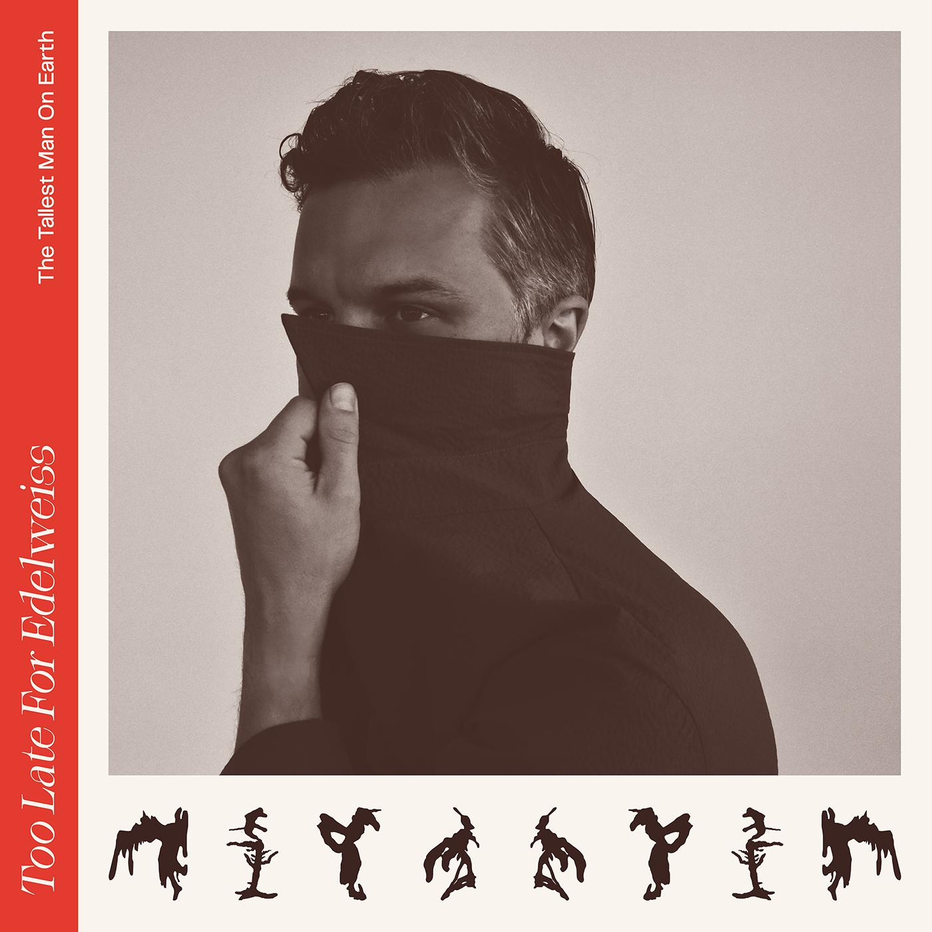
(Too Late For Edelweiss Cover Artwork)

Website | Instagram | Twitter

For more information, contact:
Yuri Kwon | Pitch Perfect PR – yuri@pitchperfectpr.com, 773-654-1477

