March 6, 2023
For Immediate Release

The Tallest Man On Earth Presents
“Henry St.” Single/Video,
Title Track Off New Album Out April 14th On ANTI-

Announces Fall North American Tour; Spring Tour Begins March 22nd
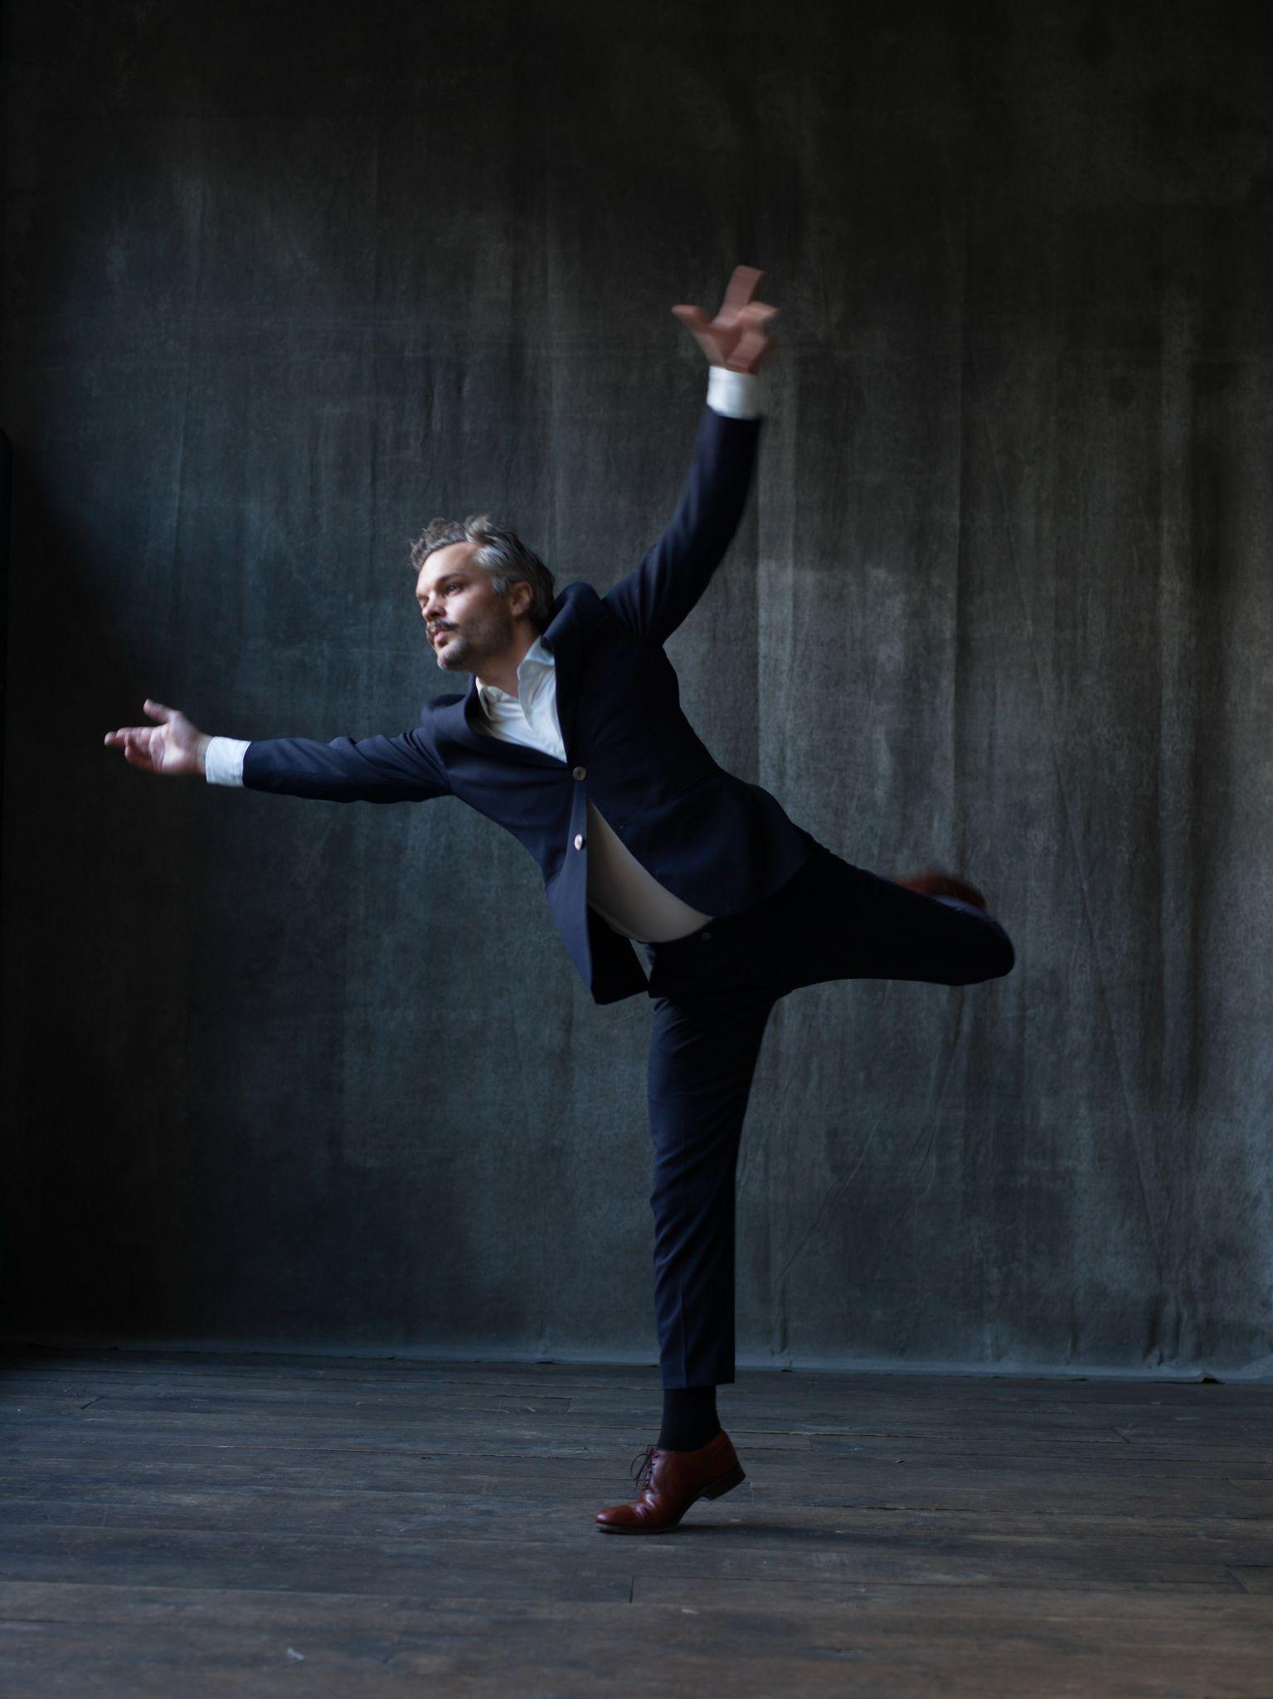
Photo Credit: Stephan Vanfleteren

The Tallest Man on Earth, the project of Sweden’s Kristian Matsson, recently announced his first new album in four years, Henry St., out April 14th on ANTI-. Throughout his career, Matsson’s “secret-weapon voice has remained a potent tool in the emotional arms race of modern music” (MTV). After releasing “Every Little Heart,” “urgent and unsettled, and underpinned by a skittering rhythm” (Guitar World), Matsson now releases the tender and pared back, “Henry St.,” which carries the album’s overarching theme of “how to be a person in this world.” Matsson comments, “As individuals, we’re told that we should strive for success. But when we have it, it doesn’t solve anything. The song is about stepping away and thinking: why am I actually doing this?” While writing the song back in Sweden, he knew it would be the centerpiece of the album. “It’s the low point and the turnaround: the other songs are a reminder that I will always be a stubborn optimist, even at the darkest of times.” He was about to record the track as a solo piece, until Phil Cook came in on his first day in the studio. “I had Phil basically hanging over my shoulders at the piano while we were playing, and then he recorded it. He improvised that beautiful outro. When he did, our jaws dropped––I was in tears.”

The accompanying music video was filmed in Amsterdam and is the second part of a trilogy of videos directed by Jeroen Dankers for the album. Dankers says the video is “inspired by adolescence. Doing stupid things, stuck in a place, being your smallest self and in the end getting to know yourself while coming out of it.”

Today, The Tallest Man On Earth also announces an extensive fall North American tour, including shows at Brooklyn Steel in New York, Union Transfer in Philadelphia, the Theatre at the Ace Hotel in Los Angeles, 9:30 Club in Washington, DC, Royale in Boston, and beyond. Tickets will be on sale Wednesday, March 8th at 9am local time. Leading into next month’s album release, Matsson will play a string of intimate, special engagement shows in North America before touring Europe. Full dates are listed below and tickets are on sale now.

Watch The Tallest Man On Earth’s “Henry St.” Video

Following 2015’s Dark Bird Is Home, his “most personal record… surreal and dreamlike” (Pitchfork) and the self-released I Love You, It’s a Fever Dream in 2019, The Tallest Man On Earth’s sixth album, Henry St., “is the most playful, most me album yet, because it covers so many of the different noises in my head.” “Having been away from it taught me that making music and performing is what I’m doing for the rest of my life, and I’m so grateful for it,” says Matsson. “It has given me new confidence and playfulness. This is what I do. It’s unconditional.”

Notably, Henry St. marks the first time Matsson recorded an album in a band setting. Sylvan Esso’s Nick Sanborn produced the album, which includes contributions from Ryan Gustafson (guitar, lap steel, ukulele), TJ Maiani (drums), CJ Camerieri of Bon Iver (trumpet , French horn), Phil Cook (piano, organ), Rob Moose of Bon Iver, yMusic (strings) and Adam Schatz (saxophone), all supporting and surrounding Matsson on vocals and guitars.

Watch The "Every Little Heart" Video

Pre-order Henry St.

The Tallest Man On Earth Tour Dates:
(new shows in bold)
Wed. Mar. 22 - Los Angeles, CA @ Hollywood Forever Cemetery Masonic Lodge - SOLD OUT
Thu. Mar. 23 - Los Angeles, CA @ Hollywood Forever Cemetery Masonic Lodge - SOLD OUT
Sat. Mar. 25 - Denver, CO @ Mission Ballroom *
Sun. Mar. 26 - Ft. Collins, CO @ Washington’s
Wed. Mar. 29 - San Francisco, CA @ The Chapel
Thu. Mar. 30 - San Francisco, CA @ The Chapel
Sat. Apr. 1 - Pioneertown, CA @ Pappy & Harriet's
Mon. Apr. 3 - New York, NY @ Bowery Ballroom SOLD OUT
Tue. Apr. 4 - Brooklyn, NY @ Music Hall of Williamsburg SOLD OUT
Wed. Apr. 12 - Copenhagen, DK @ Amager Bio
Thu. Apr. 13 - Aarhus, DK @ Voxhall - SOLD OUT
Sun. Apr. 16 - Glasgow, UK @ QMU
Mon. Apr. 17 - Dublin, IE @ Vicar Street
Tue. Apr. 18 - Manchester, UK @ Manchester Cathedral
Wed. Apr. 19 - Leeds, UK @ The Leeds Irish Centre
Fri. Apr. 21 - London, UK @ O2 Forum
Sat. Apr. 22 - Bristol, UK @ Trinity - SOLD OUT
Mon. Apr. 24 - Amsterdam, NL @ Paradiso
Tue. Apr. 25 - Antwerp, BE @ De Roma
Wed. Apr. 26 - Paris, FR @ La Cigale
Thu. Apr. 27 - Lausanne, CH @ Les Docks
Sat. Apr. 29 - Milan, IT @ Fabrique
Sun. Apr. 30 - Munich, DE @ Freiheitshalle
Mon. May 1 - Berlin, DE @ Metropol
Tue. May 2 - Hamburg, DE @ Uebel & Gefahlrlich
Wed. May 3 - Malmo, SE @ Plan B - SOLD OUT
Fri. May 5 - Oslo, NO @ Sentrum Scene
Sat. May 6 - Stockholm, SE @ Cirkus - SOLD OUT
Sun. May 7 - Stockholm, SE @ Cirkus
Mon. May 8 - Goteborg, SE @ Pustervik - SOLD OUT
Tue. May 9 - Goteborg, SE @ Pustervik - SOLD OUT
Tue. Sep. 5 - Durham, NC @ The Carolina Theatre
Thu. Sep. 7 - Washington, DC @ 9:30 Club
Fri. Sep. 8 - Philadelphia, PA @ Union Transfer
Sat. Sep. 9 - Boston, MA @ Royale
Sun. Sep. 10 - Brooklyn, NY @ Brooklyn Steel
Wed. Sep. 13 - Montreal, QC @ Corona Theatre
Fri. Sep. 15 - Toronto, ON @ The Danforth Music Hall
Sat. Sep. 16 - Detroit, MI @ The Majestic Theatre
Sun. Sep. 17 - Chicago, IL @ Thalia Hall
Tue. Sep. 19 - St. Paul, MN @ Palace Theatre
Thu. Sep. 21 - Bozeman, MT @ The Elm
Sat. Sep. 23 - Seattle, WA @ Neptune Theatre
Sun. Sep. 24 - Vancouver, BC @ Commodore Ballroom
Tue. Sep. 26 - Portland, OR @ Revolution Hall
Fri. Sep. 29 - Los Angeles, CA @ The Theatre at Ace Hotel
Sat. Sep. 30 - San Diego, CA @ The Observatory North Park
Sun. Oct. 1 - Tucson, AZ @ Rialto Theatre
Wed. Oct. 4 - Austin, TX @ Scoot Inn
Thu. Oct. 5 - Dallas, TX @ Granada Theater
Sat. Oct. 7 - Saint Louis, MO @ The Pageant
Wed. Oct. 11 - Nashville, TN @ Brooklyn Bowl
Thu. Oct. 12 - Knoxville, TN @ Bijou Theatre
Fri. Oct. 13 - Atlanta, GA @ Variety Playhouse
Sat. Oct. 14 - Asheville, NC @ The Orange Peel

* = with Elephant Revival

Download hi-res images & jpegs of The Tallest Man On Earth

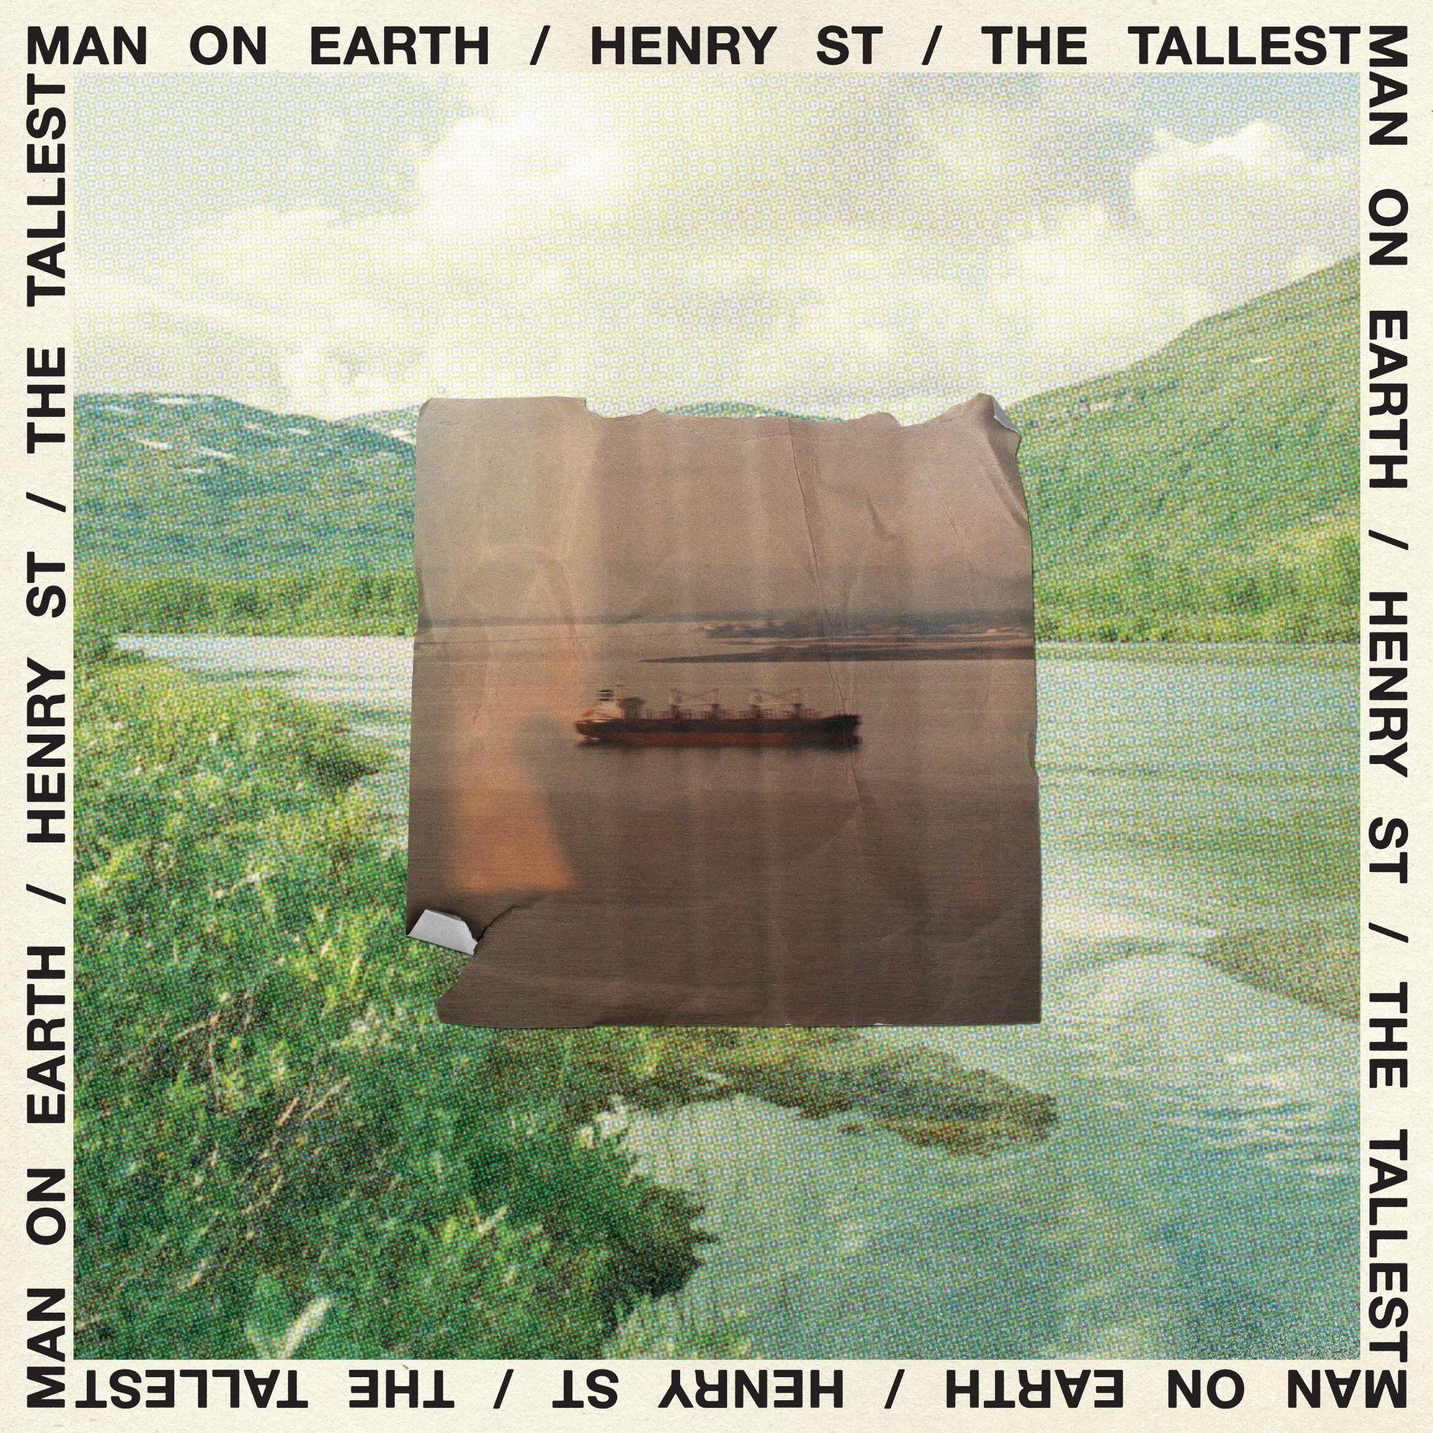
Henry St. Cover Artwork

Website | Instagram | Twitter

For more information, contact:
Jessica Linker | Pitch Perfect PR – jessica@pitchperfectpr.com, 773-942-6954
Yuri Kwon | Pitch Perfect PR – yuri@pitchperfectpr.com, 773-654-1477

