July 20, 2022
For Immediate Release

The Tallest Man On Earth Signs to ANTI- and Releases New Cover of
Håkan Hellström’s “För sent för Edelweiss”
Photo Credit: Shervin Lainez

The Tallest Man On Earth - project of Swedish musician Kristian Matsson - is pleased to announce his signing to ANTI-. In conjunction, he shares a new cover of beloved Swedish superstar Håkan Hellström’s 2008 hit “För sent för Edelweiss,” which is Matsson’s first release since his 2019 album I Love You. It’s A Fever Dream. At every single show for more than a decade, Matsson has walked on stage to this song, at the same line. Known for eccentric, lo-fi music and an unforgettable voice, Hellström has guided Matsson’s music for years. “För sent för Edelweiss” tells the story of a relationship gone awry, making it a perfect lead-in to a Tallest Man on Earth live set, which can be summed up by the misery of a break-up infused with a jolt of infectious energy. This song is a story of endings, but for The Tallest Man, it has always been the marker of a night beginning, of the fervent intensity of a live show unfolding, something he sorely missed until he finally returned to the road in fall 2021.

Matsson elaborates: “‘För sent för Edelweiss’ has been my intro song since 2010. My walk-on music. It’s become this very special song in my life; when I heard that song come on for my first show back since the beginning of the pandemic, when we played Dalhalla in Sweden, I was in tears. That song brings special meaning to me. It will wake up my mind to full focus. Somehow the misery of breakup songs can be uplifting – a way to find connection. I have a lot of sad love songs like that of my own. Why do I feel like this song is a buddy? I don’t know. But it’s always been my favorite Håkan Hellström song.”

Listen to The Tallest Man On Earth’s cover of Håkan Hellström “För sent för Edelweiss”

Through the pandemic, Matsson has been active in connecting with listeners across the globe; he performed frequent livestreams for fans, playing through covers and requests from his acclaimed and beloved albums including The Wild Hunt, Dark Bird is Home, and I Love You. It’s a Fever Dream, among others. Matsson also released the inventive full-length performance film, The Little Red Barn Show, created with friend and filmmaker Rolf Nylinder.

Upon returning from tour in spring 2022, Matsson immediately got to work on new original music for a forthcoming album - an ornate collection that might be his best yet. Then, as an exhalation after that intensive creative deluge, he tinkered with off-the-cuff home recordings across Sweden and North Carolina, spending time with old and new favorites by other artists: songs that have soundtracked his youth, his daily life and his days on the road, which is where this rendition of Hellstöm’s song came about.

In recent years, Matsson has undertaken single oriented projects that incorporate writing, producing and self-releasing songs and videos in regular intervals, often with purposefully intense deadlines. He’s described finding inspiration in the entire process, particularly the satisfaction of making something and having it out quickly. For listeners and viewers, the fascination has been in watching an artist work through his life, in problems and celebrations large and small, putting his thoughts out into the world while he’s still processing them himself and watching them evolve over time. Matsson's version of “För sent för Edelweiss” offers another taste of this process.

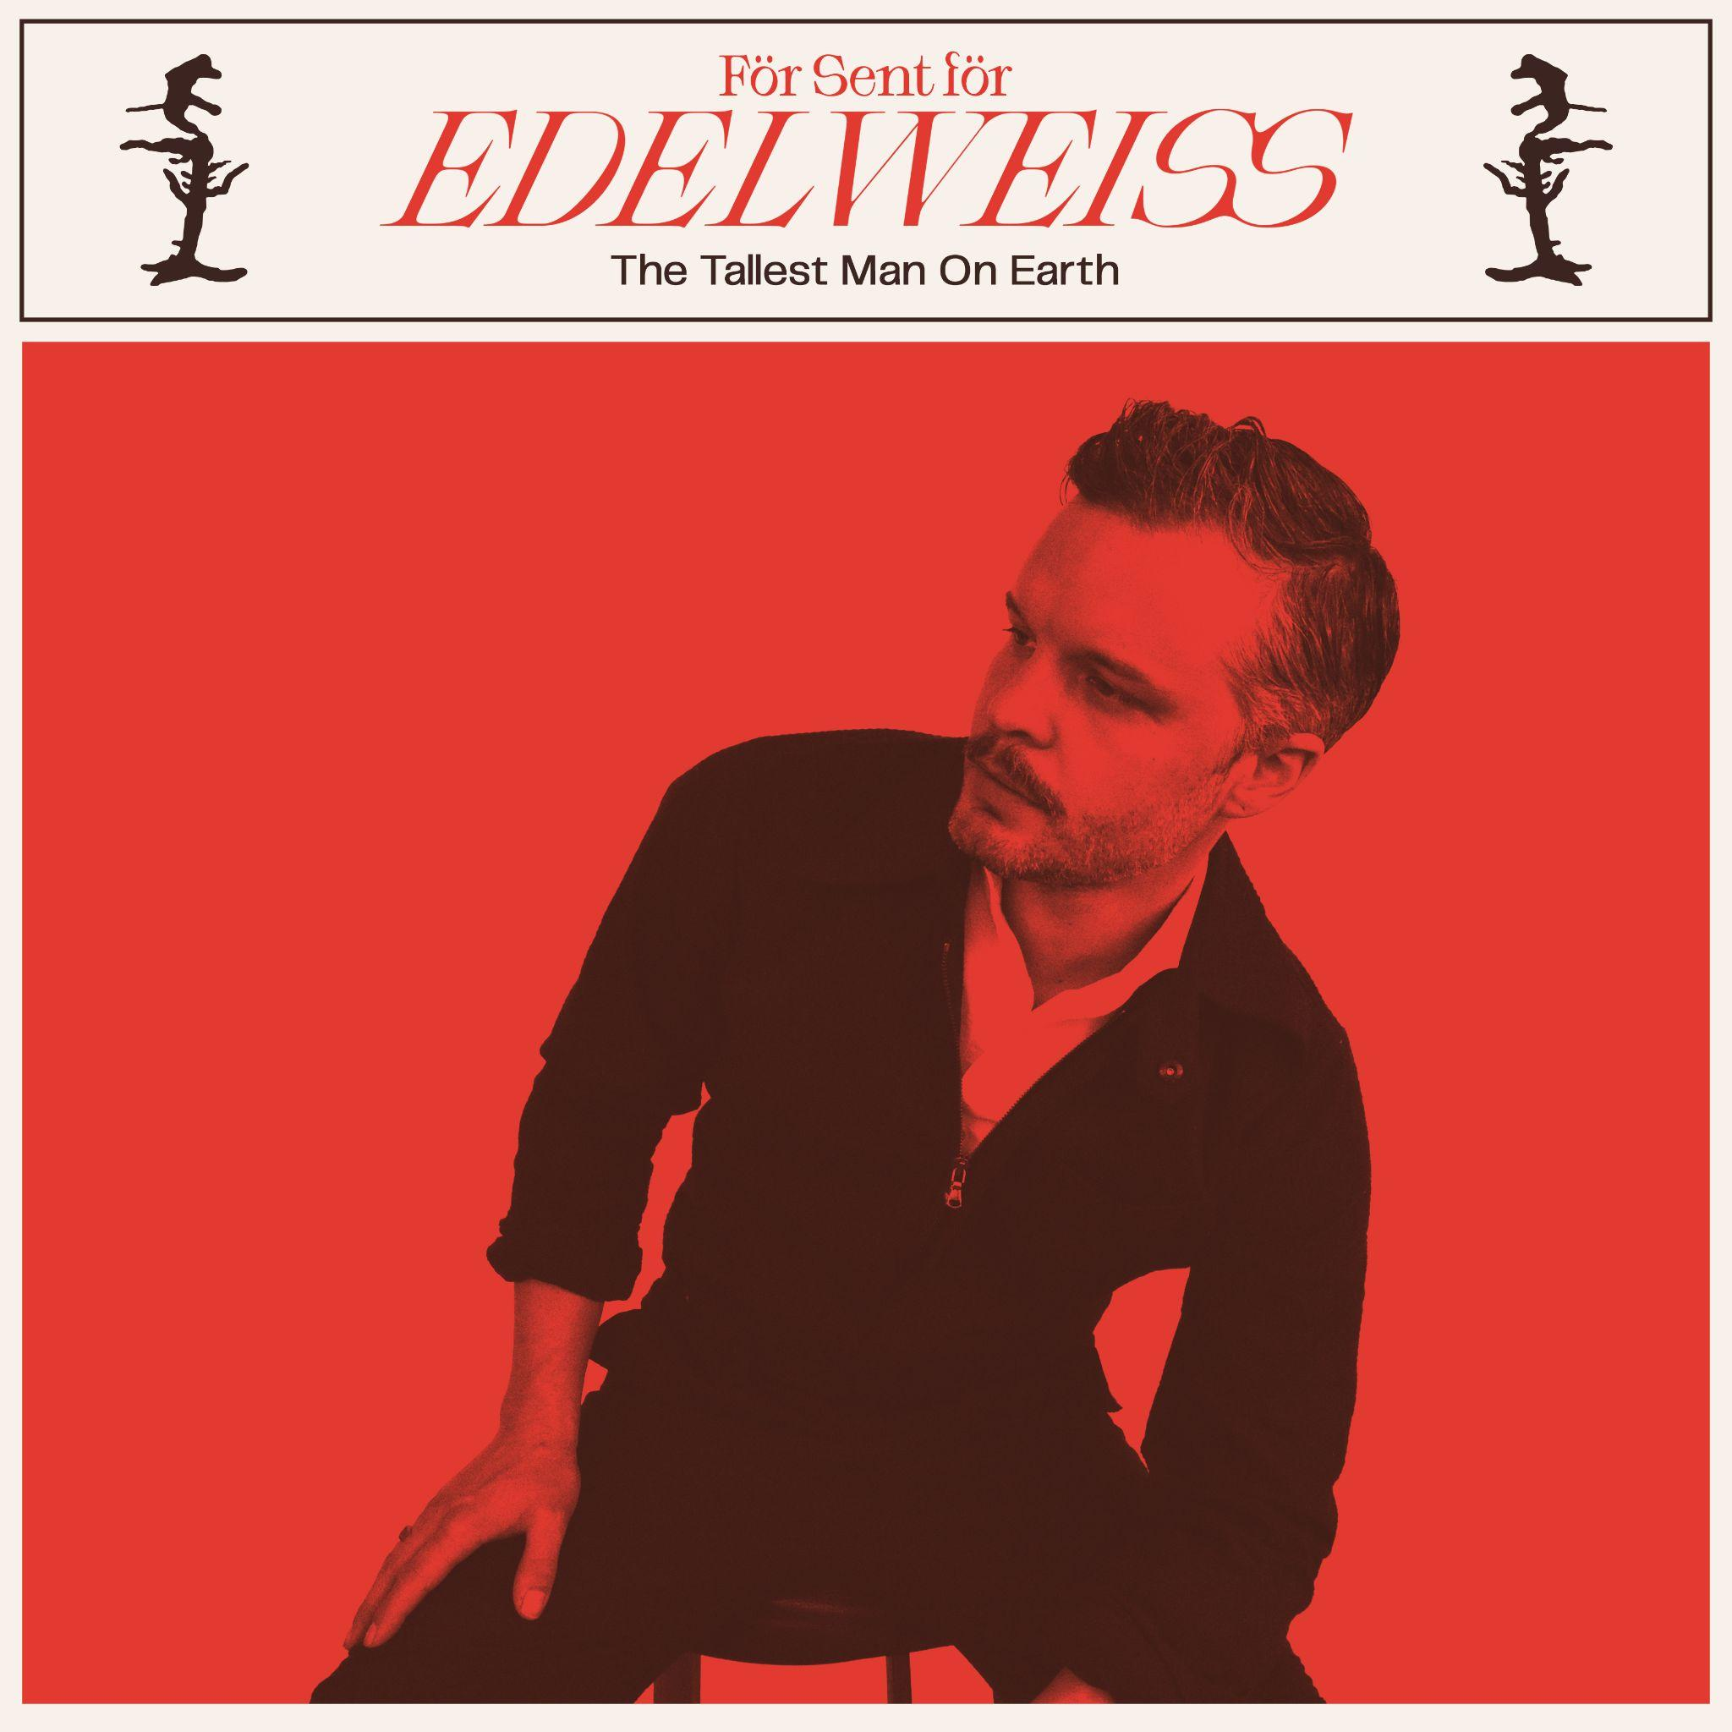
“För sent för Edelweiss” (Håkan Hellström Cover) Artwork

Website | Instagram | Twitter

For more information, contact:
Jessica Linker | Pitch Perfect PR – jessica@pitchperfectpr.com, 773-942-6954
Yuri Kwon | Pitch Perfect PR – yuri@pitchperfectpr.com, 773-654-1477

