March 28, 2022
For Immediate Release

Watch Madi Diaz’s Tiny Desk (Home) Concert

North American Tour with Waxahatchee Continues Next Month
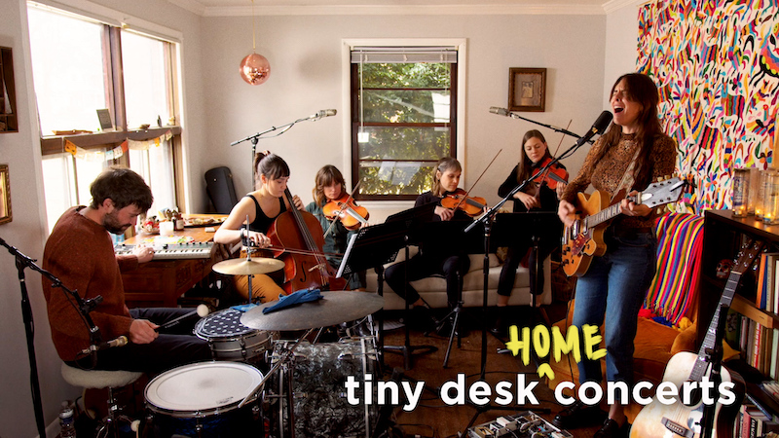

Madi Diaz “makes even the most immovable feelings open up with just a little time and space” (Pitchfork). This is especially apparent in her moving Tiny Desk (Home) Concert, during which she plays songs off of her ANTI- debut, History of a Feeling, (recently nominated for Best Americana Record at the 2022 A2IM Libera Awards). Diaz’s songs have a profound sense of intimacy and camaraderie, and this ethos is brought into the set-up of her Tiny Desk performance, filmed in the cozy quarters of her own living room where she wrote much of the album. Joined by Adam Popick (drums), Annalese Kowert and Kristin Weber (violin), Lydia Luce (viola), and Kaitlyn Raitz (cello), Diaz (guitar, vocals) plays History of a Feeling’s “Resentment,” “New Person, Old Place,” “Forever,” and “History of a Feeling.” All of these songs were recently reimagined on her Same History, New Feelings EP, out earlier this month. Diaz’s Tiny Desk (Home) Concert is a simply stunning performance, and highlights her magnetic and honest energy.

Watch Madi Diaz’s Tiny Desk (Home) Concert

Next month, Madi Diaz continues her North American tour with Waxahatchee. Following, she’ll open for Donovan Woods in Canada. All shows are listed below and tickets are on sale now.

Purchase/Stream History Of A Feeling
Purchase Same History, New Feelings EP

Madi Diaz Tour Dates
(new dates in bold)
Wed. Feb. 16 - Woodstock, NY @ Levon Helm Studios *
Fri. Feb. 18 - Nelsonville, OH @ Stuart’s Opera House*
Sat. Feb. 19 - Grand Rapids, MI @ Fountain Street Church *
Sun. Feb. 20 - Chicago, IL @ Thalia Hall * - SOLD OUT
Mon. Feb. 21 - Chicago, IL @ Thalia Hall *
Tue. Feb. 22 - Evanston, IL @ Space
Sun. April 10 - Philadelphia, Pa @ Union Transfer * - SOLD OUT
Mon. April 11 - Philadelphia, Pa @ Union Transfer * - SOLD OUT
Tue. April 12 - Morgantown, WV @ 123 Pleasant Street *
Wed. April 13 - Cincinnati, OH @ Woodward Theater *
Fri. April 15 - Nashville, TN @ Ryman Auditorium *
Sat. April 16 - Memphis, TN @ Growlers *
Mon. April 18 - Fayetteville, AR @ George’s Majestic Lounge *
Tue. April 19 - Oklahoma City, OK @ The Jones Assembly*
Thu. April 21 - Santa Fe, NM @ Meow Wolf *
Fri. April 22 - Denver, CO @ Ogden Theatre *
Sat. April 23 - Aspen, CO @ Belly Up *
Sun. April 24 - Boulder, Co @ ETown Theater
Tue. May 17 - Ottawa, ON @ National Arts Centre ^
Wed. May 18 - Ottawa, ON @ National Arts Centre ^
Thu. May 19 - Montreal, QC @ L’Astral ^
July 22-24 - Newport RI @ Newport Folk Festival

*= w/ Waxahatchee
^= w/ Donovan Woods

Download hi-res images and jpegs of Madi Diaz

Website | Instagram | Facebook | Twitter

For more information, contact:
Jessica Linker | Pitch Perfect PR – jessica@pitchperfectpr.com, 773-942-6954

