April 5, 2024
For Immediate Release

Watch Slow Pulp Play “Doubt” For The Late Show with Stephen Colbert’s #LateShowMeMusic Series: HERE

Tour with Death Cab For Cutie & The Postal Service
Kicks Off This Month
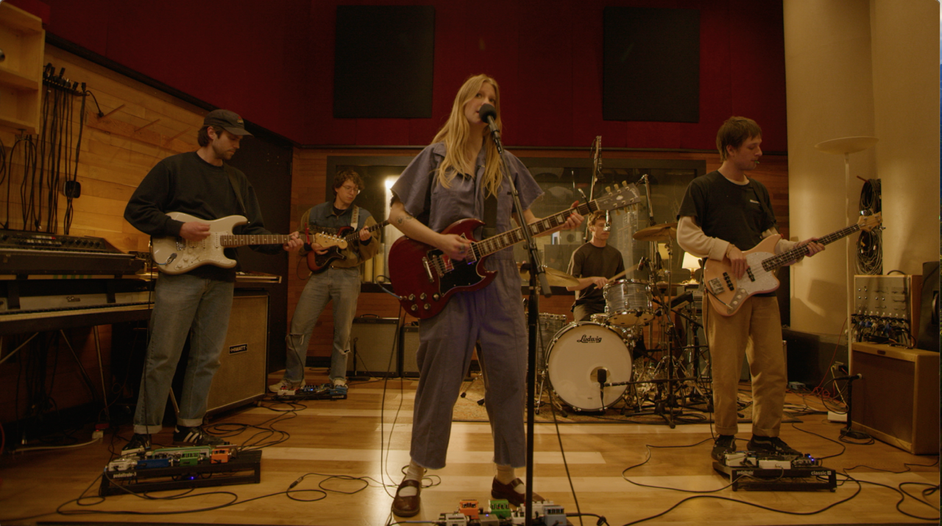
“[Yard] is full of deft storytelling and striking performances.” - Pitchfork

“The Chicago indie music scene is as robust as any in the country, and Yard illustrates why Slow Pulp belongs at the forefront of the community.” - i-D

"Yard feels like it’s on another level.” - Stereogum

“For all the buzz, [Yard] certainly does not disappoint.” - The Hard Times

“[Yard] has solidified Slow Pulp as one of the best young bands in the country.”
- Chicago Tribune

Today, Slow Pulp share their performance of “Doubt” for The Late Show with Stephen Colbert’s #LateShowMeMusic series. Taken from their new album, Yard, released last fall on ANTI-, the band “have leveled up to seismic proportions” (Paste), making their national television debut on CBS Saturday Morning earlier this year, earning profiles from Billboard, Variety, The FADER, Consequence, Uproxx, and selling out shows across the country. Today’s performance of “Doubt” previews Slow’s Pulp’s tour with Death Cab For Cutie and The Postal Service kicking off later this month. A full list can be found below and tickets are on sale now.

Watch Slow Pulp Play “Doubt” For The Late Show with Stephen Colbert’s #LateShowMeMusicSeries: HERE

Purchase Yard
Watch “Slugs” Video
Watch “Cramps” Video
Watch “Doubt” Visualizer
Watch “Broadview” Visualizer

Slow Pulp Tour Dates
Tue. April 23 - Alpharetta, GA @ America Bank Amphitheatre &
Wed. April 24 - Orlando, FL @ Amway Center &
Fri. April 26 - Charleston, SC @ Credit One Stadium &
Sat. April 27 - Raleigh, NC @ Coastal Credit Union Music Park at Walnut Creek &
Mon. April 29 - Nashville, TN @ Bridgestone Arena &
Tue. April 30 - Columbus, OH @ The Schottenstein Center &
Thu. May 2 - Pittsburgh, PA @ Petersen Events Center &
Fri. May 3 - Albany, NY @ MVP Arena &
Sat. May 4 - Toronto, ON @ Scotiabank Arena &
Mon. May 6 - Milwaukee, WI @ Miller High Life Theatre &
Tue. May 7 - St. Louis, MO @ Chaifetz Arena &
Thu. May 9 - Kansas City, MO @ T-Mobile Center &
Sat. May 11 - Salt Lake City, UT @ Kilby Block Party
Sun. May 12 - Boise, ID @ Idaho Central Arena &
Tue. May 14 - Vancouver, BC @ Doug Mitchell Thunderbird Sports Centre &
Wed. May 15 - Portland, OR @ Moda Center &
Sat. June 1 - Barcelona, ES @ Primavera Sound
Mon. June 3 - Milan, IT @ Arci Bellezza
Wed. June 5 - Paris, FR @ Point Ephemere
Thu. June 6 - Cologne, DE @ Bumann & Sohn
Fri. June 7 - Brussels, BE @ AB Club
Sun. June 9 - Hilvarenbeek, NL @ Best Kept Secret
Tue. June 11 - Brighton, UK @ Concorde 2
Wed. June 12 - Birmingham, UK @ Hare & Hounds
Fri. June 14 - Glasgow, UK @ The Classic Grand
Sat. June 15 - Dublin, IE @ Whelans
Sun. June 16 - Manchester, UK @ Band on the Wall
Tue. June 18 - Nottingham, UK @ The Bodega Social Club
Wed. June 19 - Cardiff, UK @ Clwb Ifor Bach
Thu. June 29 - London, UK @ Koko

&= w/ Death Cab For Cutie & The Postal Service

Download cover art & hi-res images of Slow Pulp

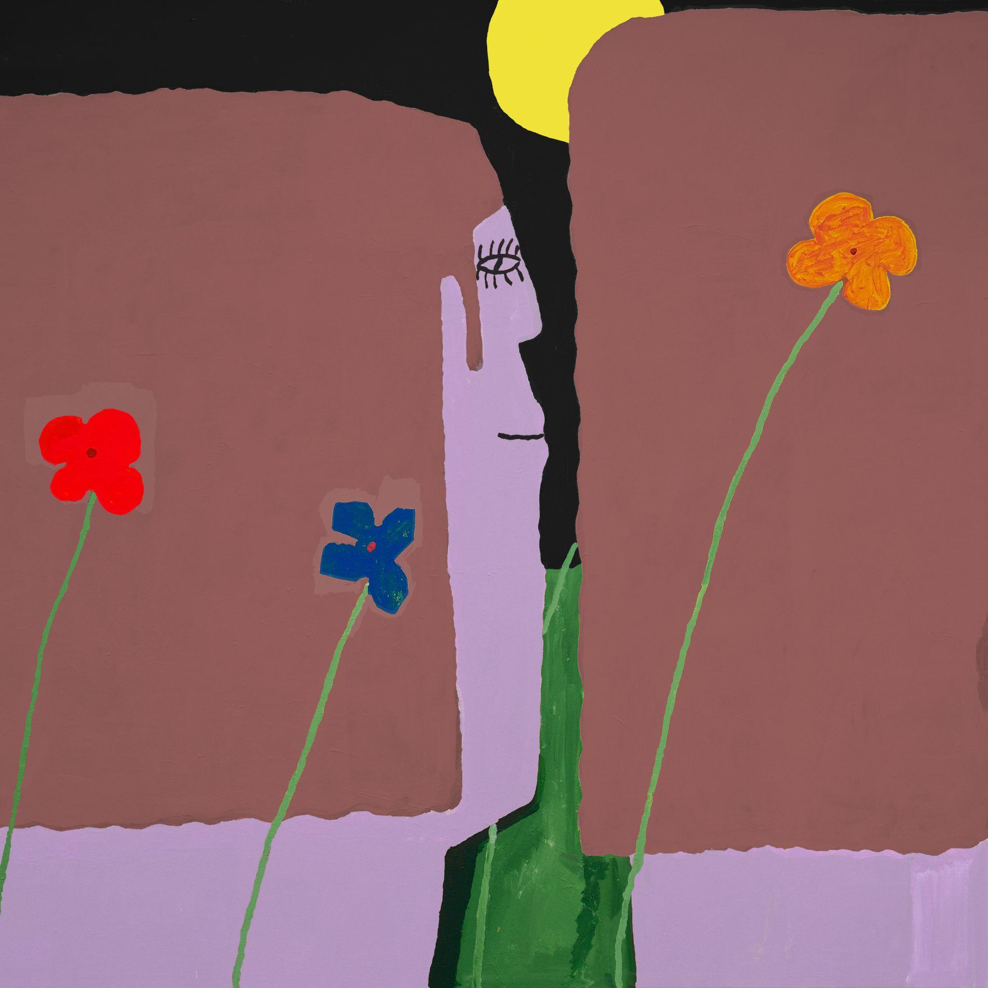
(Yard Cover Artwork by Henry Stoehr)

Slow Pulp Online:
Website | Instagram | Twitter | Facebook | Bandcamp | ANTI-

For more information, contact:
Patrick Tilley, Jaycee Rockhold | Pitch Perfect PR
patrick@pitchperfectpr.com, jaycee@pitchperfectpr.com

###

