WAXAHATCHEE

RETURNS WITH NEW ALBUM TIGERS BLOOD
OUT MARCH 22ND ON ANTI-

RELEASES NEW SONG + VIDEO “RIGHT BACK TO IT”

ANNOUNCES 2024 TOUR DATES

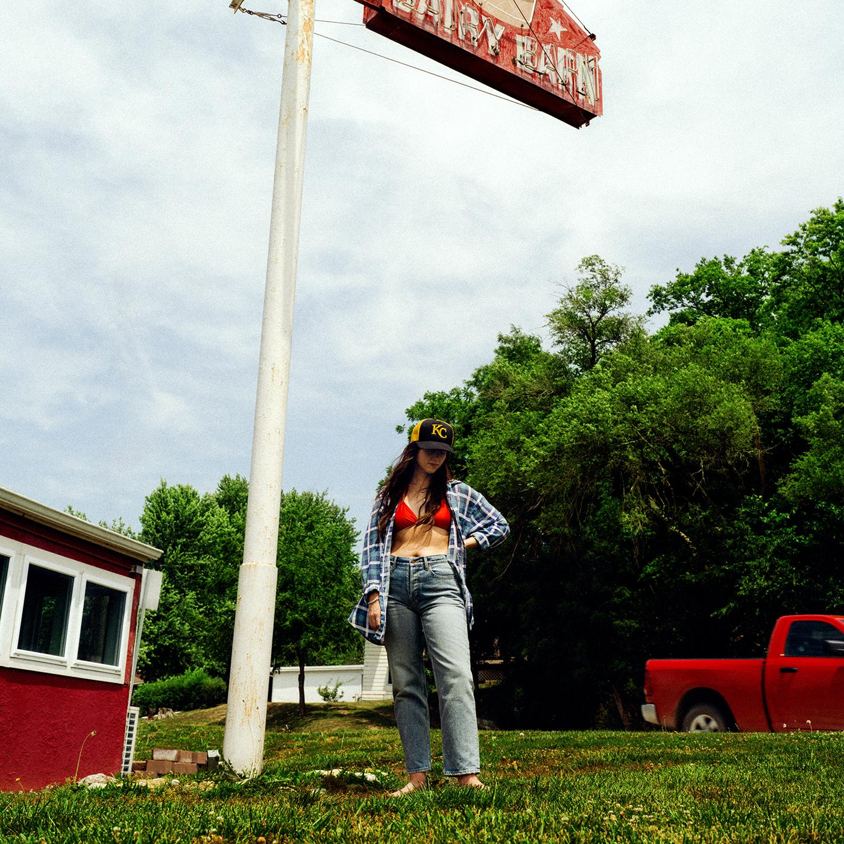
Album Art Credit: Molly Matalon | download hi-res here

Waxahatchee, the solo project of Alabama-born and Kansas City-based Katie Crutchfield, is returning with her most confident and resilient album to date. Her first on new label home ANTI-, Tigers Blood, is available for pre-order now, and due March 22nd. Here we see Crutchfield emerge as a powerhouse – an ethnologist of the self – forever dedicated to revisiting her wins and losses. But now she’s arriving at revelations and she ain’t holding them back. Tigers Blood also finds Crutchfield folding new collaborators into her world, with performances on the album by MJ Lenderman, Spencer Tweedy and Phil and Brad Cook.

Alongside the album announcement, Waxahatchee shares the single “Right Back To It" with a video directed by Corbett Jones & Nick Simonite. MJ Lenderman adds guitar and harmony vocals to the track, a nod to country duets like Emmylou Harris & Gram Parsons, winding over a steadfast banjo from Phil Cook.
Crutchfield tells us “Right Back To It" was an early song that came together for Tigers Blood. “I wrote it backstage at Wolf Trap when I was on tour opening for Jason Isbell and Sheryl Crow. I’m really interested in writing love songs that are gritty and unromantic. I wanted to make a song about the ebb and flow of a longtime love story. I thought it might feel untraditional but a little more in alignment with my experience to write about feeling insecure or foiled in some way internally, but always finding your way back to a newness or an intimacy with the same person.”

Crutchfield says that she wrote most of the songs on Tigers Blood during a “hot hand spell” while on tour at the end of 2022. And when it came time to record, Crutchfield returned to her trusted producer Brad Cook and the Sonic Ranch in the border town Tornillo, Texas, a collaborator and place that also helped bring her sound to a groundbreaking turning point on 2020’s Saint Cloud.

Saint Cloud was a breakthrough album for Waxahatchee, and despite being released in the height of the pandemic it entered #1 on Billboard’s Heatseekers Chart & Top 10 on the Emerging Artist chart. It was a welcome musical escape for many and cemented her status as an important voice in the indie-Americana scene. Now with Tigers Blood we see Crutchfield dig even deeper, the result is a complex and beautiful album that is sure to find a special place in people’s hearts once again.

Additionally Waxahatchee announces a 2024 tour in support of Tigers Blood that kicks off with a hometown show at Kansas City’s Uptown Theater on April 18th and goes through September. Tour highlights include shows at New York’s Beacon Theatre and Los Angeles’ Hollywood Palladium. All dates below.

Tigers Blood Track List:
1. 3 Sisters
2. Evil Spawn
3. Ice Cold
4. Right Back To It
5. Burns Out At Midnight
6. Bored
7. Lone Star Lake
8. Crimes Of The Heart
9. Crowbar
10. 365
11. The Wolves
12. Tigers Blood

Tour Dates:
April 18 – Kansas City, MO – Uptown Theater ^
April 19 – St. Paul, MN – Palace Theatre ^
April 20 – Chicago, IL – Salt Shed ^
April 21 – Detroit, MI – Majestic Theatre ^
April 23 – Toronto, ON – Massey Hall ^
April 25 – New Haven, CT – Toad's Place ^
April 26 – Boston, MA – Orpheum Theatre ^
April 27 – Brooklyn, NY – Brooklyn Paramount Theatre ^
April 28 – Richmond, VA – The National ^
April 30 – Asheville, NC – The Orange Peel ^
May 1 – Nashville, TN – Ryman Auditorium ^
May 3 – St. Petersburg, FL – Jannus Live ^
May 4 – Orlando, FL – The Beacham Theater ^
May 5 – Atlanta, GA – Shaky Knees Festival
May 6 – Birmingham, AL – Lyric Theatre ^
May 8 – Tulsa, OK – Cain's Ballroom ^
May 9 – Fort Worth, TX – Tannahill's Tavern & Music Hall ^
May 10 – Houston, TX – The Heights Theater ^
May 11 – Austin, TX – ACL Live at the Moody Theater ^
May 13 – Phoenix, AZ – The Van Buren ^
May 14 – The Observatory North Park – San Diego, CA ^
May 16 – Los Angeles, CA – Hollywood Palladium ^
May 17 – Paso Robles, CA – Barrelhouse Brewing Co. ^
May 18 – Oakland, CA – Fox Theater ^
May 19 – Sonoma, CA – Gundlach Bundschu Winery ^
May 21 – Salt Lake City, UT – The Depot ^
May 23 – Denver, CO – The Mission Ballroom ^
August 19 – Boise, ID – Treefort Music Hall %
August 21 – Fort Collins, CO – Washington's %
August 23 – St. Louis, MO – The Pageant %
August 24 – Madison, WI – The Sylvee %
August 25 – Kalamazoo, MI – Bell's Beer Garden %
August 26 – Pittsburgh, PA – The Warhol at Carnegie Music Hall %
August 28 – New York, NY – Beacon Theatre
August 29 – South Deerfield, MA – Tree House Summer Stage &#
August 30 – Portland, ME – State Theater &#
August 31 – Accord, NY – Arrowood Farms &#
September 1 – Asbury Park, NJ – Stone Pony Summerstage &#
September 6 – Vienna, VA – Filene Center - Wolf Trap &#
September 7 – Philadelphia, PA – The Fillmore #@
September 8 – Philadelphia, PA – The Fillmore &+

^ w/ Good Morning
% w/ Tre Burt
# w/ Tim Heidecker
& w/ Snail Mail
+ w/ Greg Mendez
@ w/ Gladie

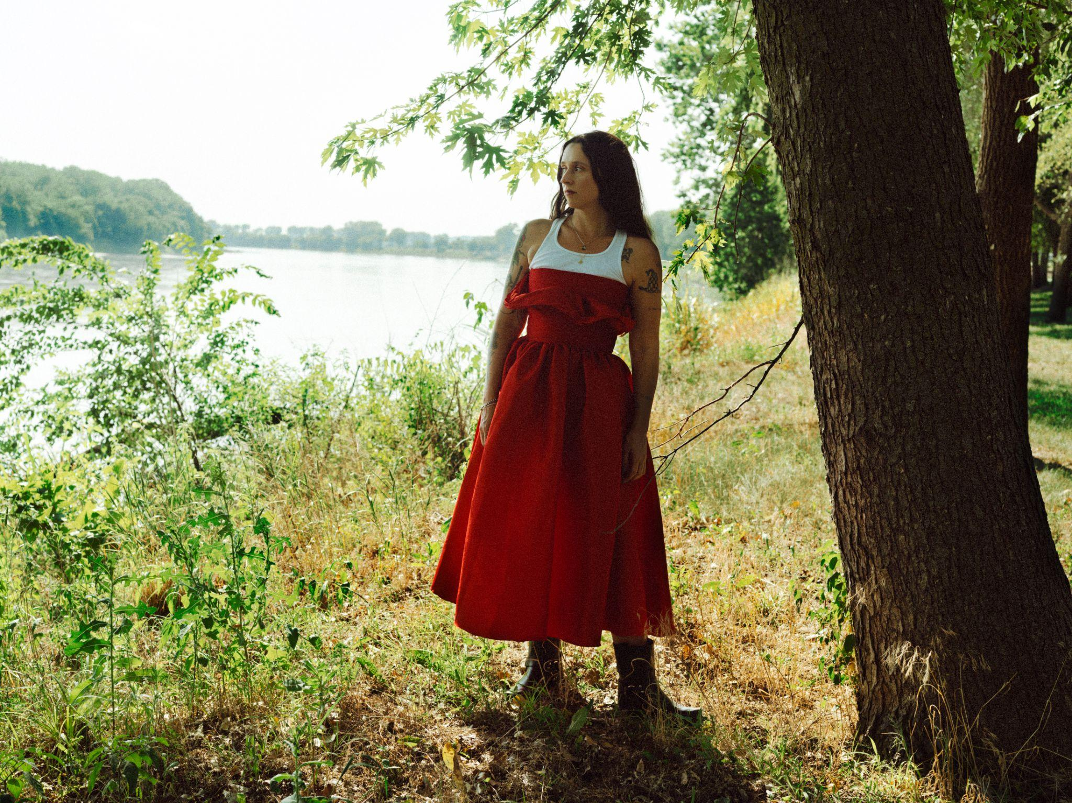
Photo Credit: Molly Matalon | download high-res here

Follow Waxahatchee:
Website | Instagram | Facebook | Twitter

For more information please contact Grandstand Media & Management:
Eloy Lugo + Grace Jones

