WAXAHATCHEE
RELEASES CRITICALLY ACCLAIMED
TIGERS BLOOD
ON ANTI-

WORLD TOUR ANNOUNCED
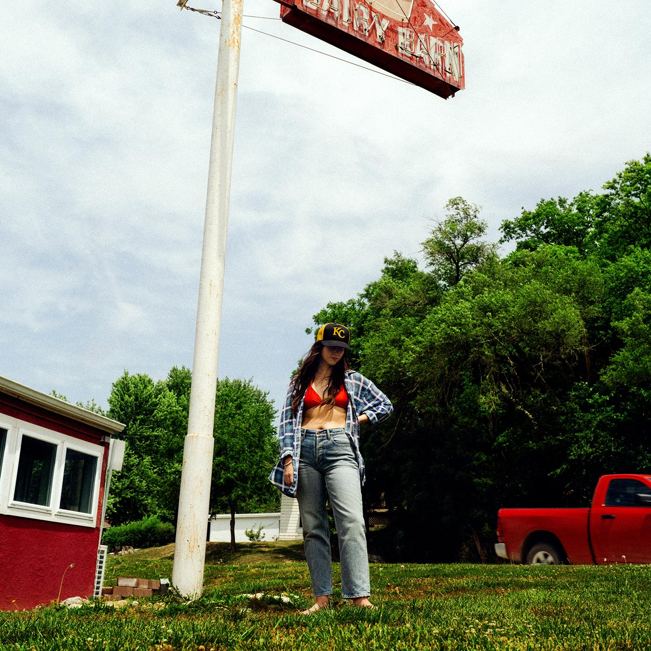
Album Art Credit: Molly Matalon | download hi-res here

ACCLAIM FOR TIGERS BLOOD

"Katie Crutchfield's voice is the centerpiece of her music as Waxahatchee. It's shaky in a way that feels resilient...She's finding herself on Tigers Blood. You can hear the confidence shining through." - NPR

"a record that feels like it’s going to be one of 2024’s landmark releases." - Rolling Stone

"a fiery and biting country-rock foot-stomper that allows Crutchfield to channel some serious had-it-up-to-here attitude." - New York Times

"Crutchfield elevates Waxahatchee to a fortified, admirable form on a new album that’s as immediate as the all-timer lead single "Right Back To It"" - Pitchfork

"Katie Crutchfield’s band follows its acclaimed 2020 album with a record of vivid, poetic songwriting and rootsy musical color...all a fan of her previous album could hope for, extending her hot streak as a songwriter while adding a few twists." - Wall Street Journal

"It feels like Crutchfield is making the music that she was always meant to make... These songs seem like they have always been around, filled with details that will leave your head spinning and your heart wrenching." - Stereogum

"Some of the best alt-country of the decade" - Paste Magazine

"Crutchfield is a singular talent and voice, and her new album, Tiger’s Blood, solidifies that status." - GQ

"Crutchfield has her feet firmly planted in this sonic universe, and she doesn’t seem to be going anywhere. Collaborating once again with producer Brad Cook, Crutchfield has found her sweet spot — a cozy place to land that suits the songs she’s been writing lately." - No Depression

"Crutchfield’s voice — with its rich country vibrato, its confiding just-us-talking hiccup and twitch, its bursts of punk rock agitation — is in full bloom here, as sure and vibrant as she’s ever sounded." - Aquarium Drunkard

Waxahatchee has today released one of the early contenders for album of the year. Tigers Blood is out now on ANTI- Records. On Tigers Blood we continue to see the wonderful evolution as Katie Crutchfield who emerges as a powerhouse – an ethnologist of the self – forever dedicated to revisiting her wins and losses.

Waxahatchee will be on tour in North America, Europe and the UK this spring and summer in support of Tigers Blood and additionally, has also announced a series of Tigers Blood listening parties, starting on this week and hosted at independent record stores worldwide. Listening party details here. All tour dates below.
Saint Cloud was a breakthrough album for Waxahatchee, and despite being released in the height of the pandemic it entered #1 on Billboard’s Heatseekers Chart & Top 10 on the Emerging Artist chart. It was a welcome musical escape for many and cemented her status as an important voice in the indie-Americana scene. Now with Tigers Blood we see Crutchfield dig even deeper, the result is a complex and beautiful album that is sure to find a special place in people’s hearts once again.

“Right Back to It” is ‘Tigers Blood’’s lead single. A nod to country duets like Gram and Emmylou, winding over a steadfast banjo from Phil Cook. Together, Crutchfield and Lenderman harmonize on the chorus: “I’ve been yours for so long/We come right back to it/I let my mind run wild/Don’t know why I do it/But you just settle in/Like a song with no end.” Crutchfield says it’s the first real love song she’s ever written.

The song “Bored” opens with blase drum beats from Spencer Tweedy that crash under Crutchfield as she throws her voice high: “I can get along/ My spine’s a rotted two by four/Barely hanging on/My benevolence just hits the floor.” Lenderman’s scuzzy riffs and Nick Bockrath’s climbing pedal steel add power to the album’s most ‘Southern Rock’ a la Drive-By Truckers moment.
“365” is a story of recognition told from a hard-won place of self-acceptance/forgiveness. Crutchfield initially started writing it for Wynonna Judd, with whom she has written and performed in the past, until the lyrics started hitting closer and closer to home. The writer Annie Ernaux says, “writing is to fight forgetting.” Like Lucinda Williams, Crutchfield’s lyrics are memoir. Throughout ‘Tigers Blood’ Crutchfield is addressing a “you,” but the ‘you’ in “365” evokes raw closeness, vulnerability. “Ya ain’t had much luck but grace is/In the eye of the beholder/And I had my own ideas but/I carried you on my shoulders, anyways.”
“365” is essentially ‘Tigers Blood’’s aria about addiction, with little to no accompaniment to Crutchfield’s voice. Her backing band is hushed, as if the spotlight’s coming down on her, alone on the stage, giving her testimony. Crutchfield slings her voice with arresting precision, reaching its highest harmony on the whole album. “So when you kill, I kill/And when you ache, I ache/And we both haunt this old lifeless town/And when you fail, I fail/ When you fly, I fly/And it’s a long way to come back down.”

“365” circles back to the beginning of ‘Tigers Blood,’ where Crutchfield’s words ring clear as a bell. Album opener “3 Sisters” starts with Crutchfield singing over hymn-like piano chords: “I pick you up inside a hopeless prayer/I see you beholden to nothing/I make a living crying it ain’t fair/And not budging.” ‘Tigers Blood’ is Crutchfield at her most confident and resilient. Staring straight at the truth, forgiving but not forgetting, not batting an eye.
World Tour Dates:
April 18 – Kansas City, MO – Uptown Theater ^
April 19 – St. Paul, MN – Palace Theatre ^
April 20 – Chicago, IL – Salt Shed ^ – SOLD OUT
April 21 – Detroit, MI – Majestic Theatre ^
April 23 – Toronto, ON – Massey Hall ^
April 25 – New Haven, CT – Toad's Place ^
April 26 – Boston, MA – Orpheum Theatre ^
April 27 – Brooklyn, NY – Brooklyn Paramount Theatre ^ – SOLD OUT
April 28 – Richmond, VA – The National ^
April 30 – Asheville, NC – The Orange Peel ^
May 1 – Nashville, TN – Ryman Auditorium ^
May 3 – St. Petersburg, FL – Jannus Live ^
May 4 – Orlando, FL – The Beacham Theater ^
May 5 – Atlanta, GA – Shaky Knees Festival
May 6 – Birmingham, AL – Lyric Theatre ^
May 8 – Tulsa, OK – Cain's Ballroom ^
May 9 – Fort Worth, TX – Tannahill's Tavern & Music Hall ^
May 10 – Houston, TX – The Heights Theater ^
May 11 – Austin, TX – ACL Live at the Moody Theater ^
May 13 – Phoenix, AZ – The Van Buren ^
May 14 – San Diego, CA – The Observatory North Park ^
May 16 – Los Angeles, CA – Hollywood Palladium ^
May 17 – Paso Robles, CA – Barrelhouse Brewing Co. ^
May 18 – Oakland, CA – Fox Theater ^
May 19 – Sonoma, CA – Gundlach Bundschu Winery ^ – SOLD OUT
May 21 – Salt Lake City, UT – The Depot ^
May 23 – Denver, CO – The Mission Ballroom ^
July 11 – Amsterdam, NL – Paradiso ~
July 12 – Köln, DE – Gebäude 9 ~
July 13 – Hamburg, DE – Mojo Club ~
July 14 – Bruges, BE – CactusfestivalJuly 15 – Berlin, DE – Festsaal Kreuzberg ~
July 17 – Schorndorf, DE – Club Manufaktur ~
July 18 – Feldkirch, AT – Poolbar Festival ~
July 19 – Sittersdorf, AT – Acoustic Lakeside Festival
July 21 – Zurich, CH – Bogen F ~
July 22 – Paris, FR – La Maroquinerie ~
July 24 – Brighton, UK – Chalk ~
July 25 – London, UK – O2 Forum Kentish Town ~
July 26 – Southwold, UK – Latitude Festival
July 27 – Manchester, UK – New Century ~
July 29 – Leeds, UK – The Leeds Irish Centre ~
July 30 – Glasgow, UK – Queen Margaret Union ~
July 31 – Belfast, UK – The Belfast Empire Music Hall ~
August 1 – Dublin, IE – Vicar Street ~
August 16 – Vancouver, BC – The Orpheum Theatre *
August 17 – Portland, OR – Pioneer Courthouse Square *
August 18 – Seattle, WA – Woodland Park Zoo Amphitheater * – SOLD OUT
August 19 – Boise, ID – Treefort Music Hall %
August 21 – Fort Collins, CO – Washington's %
August 23 – St. Louis, MO – The Pageant %
August 24 – Madison, WI – The Sylvee %
August 25 – Kalamazoo, MI – Bell's Beer Garden %
August 26 – Pittsburgh, PA – The Warhol at Carnegie Music Hall %
August 28 – New York, NY – Beacon Theatre
August 29 – South Deerfield, MA – Tree House Summer Stage &# – SOLD OUT
August 30 – Portland, ME – State Theater &#
August 31 – Accord, NY – Arrowood Farms &# – SOLD OUT
September 1 – Asbury Park, NJ – Stone Pony Summerstage &#
September 6 – Vienna, VA – Filene Center - Wolf Trap &#
September 7 – Philadelphia, PA – The Fillmore #@
September 8 – Philadelphia, PA – The Fillmore &+

^ w/ Good Morning
~ w/ Anna St. Louis
* w/ Woods
% w/ Tre Burt
# w/ Tim Heidecker
& w/ Snail Mail
+ w/ Greg Mendez
@ w/ Gladie
Tigers Blood Tracklisting
1. 3 Sisters
2. Evil Spawn
3. Ice Cold
4. Right Back to It
5. Burns Out at Midnight
6. Bored
7. Lone Star Lake
8. Crimes of the Heart
9. Crowbar
10. 365
11. The Wolves
12. Tigers Blood

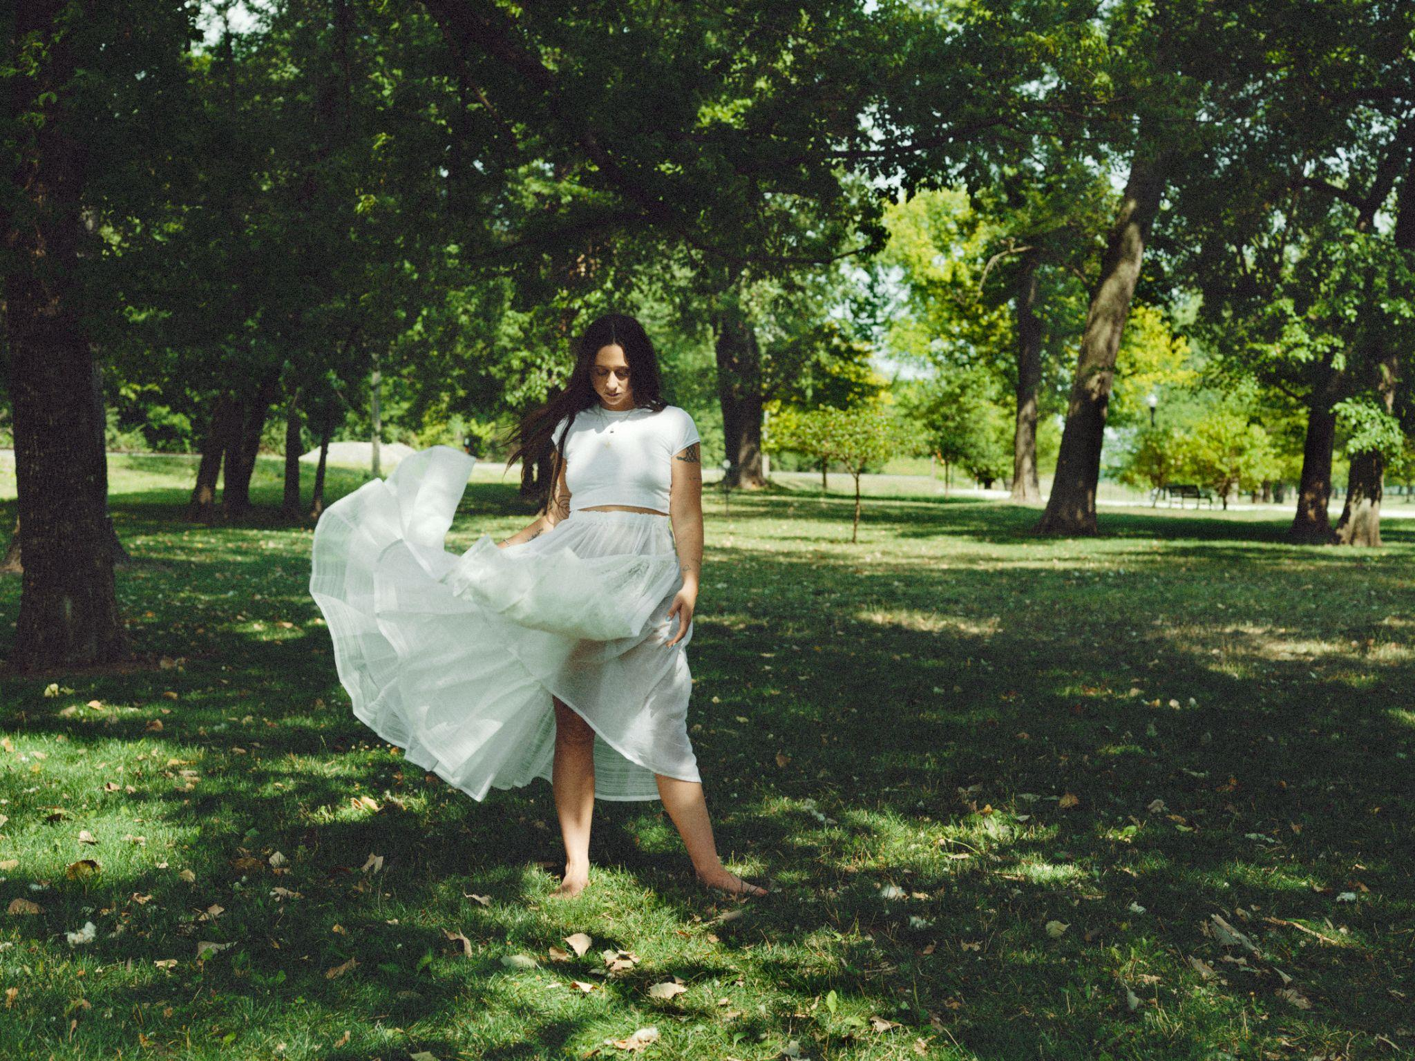
Photo Credit: Molly Matalon | download high-res here

Follow Waxahatchee:
Website | Instagram | Facebook | Twitter

For more information please contact Grandstand Media & Management:
Eloy Lugo + Grace Jones

