Xenia Rubinos Releases
“Dia Libre en el Yanky”

The Third Track In A Series Of Reimagined Songs From Her Critically Acclaimed Album ‘Una Rosa’ ft. A Collaboration With El Individuo

West Coast Tour Dates Announced!

Listen to “Dia Libre en el Yanky” HERE

Cred: Paula La Bloise Art

Xenia Rubinos, the prolific New York City-based artist who’s broken barriers of sound and style is back with “Dia Libre en el Yanky” - the third in a series of re-imagined tracks from her critically acclaimed album Una Rosa.
A play on the track “Working All the Time”, which reflects and critiques the toxic cycle of overwork for little payoff under capitalism, “Dia Libre en el Yanky” is what Xenia calls ‘a triumphant summer jam’- it maintains much of the original track’s spirit, including the repeated motif ‘and it was my day off,’ while layering in a cutting cypher and vocal improvisation. ‘Marco and I had a blast producing this track that felt like a celebration of the original song and a summer victory lap for Una Rosa,’ remarks Xenia. The track features a gut-punching cypher from Cuban rapper El Individuo, who was also featured on the recently released track “Madrugada”.

The series of re-works originated as a part of the Sonos podcast Music Is Everything! with Elia Einhorn (listen to the episode here), where Xenia worked on various reworks with a number of all-star collaborators.

‘This was the first track we worked on as a group during this session. It was an all-star cypher with musicians who had never met or played together coming together to improvise on tracks off of my record. My friend and poet/actor Modesto Flako Jimenez came in to overdub some hypeman vocals and kicks off the track with his characteristic Dominican swagger, then El Individuo just knocked it out of the park freestyling about his story as a rapper coming up and how he now found himself "En el Yanky" rapping with us in the studio. It was one of the first sessions he did since arriving in the states and we were so honored to have him with us,’ says Xenia, reflecting on the session.

The track also features piano from Leo Genovese and guitar from Yasser Tejeda. The beats are from the original recording, programmed by Marco Buccelli. The song’s cover art is by Mario Rubén Carrión, who also directed the video for “Working All The Time”- it comes from his archive of his street-style photos from Coney Island. ‘It felt like the perfect visualization of summer in America right now, the idea of a day off en el Yanky. Heat, in debt, on your last dime, luxury baking in the sun under a corporate freedom flag’ Says Xenia.

Xenia is just off of a mesmerizing performance at Pitchfork Festival this weekend and continues her Una Rosa tour in Europe next month followed by West Coast dates this Fall.

“Dia Libre en el Yanky” is out now via Anti- Records

Sat Aug 20 Coura, Portugal Paredes de Coura Festival
Fri Aug 26 Berlin, Germany Pop Kultur Fest
Sat Aug 27 Rotterdam, NL BIRD
Sun Aug 28 Antwerpen, BE Whisper Festival
Tues Aug 30 Bristol, UK Strange Brew
Wed Aug 31 Manchester, UK YES basement
Thurs Sept 1 London, UK Kings Place
Sat Sept 3 Salisbury, UK End of the Road Festival
Sat Oct 29 San Diego, CA Blacktronika Festival, UCSD
Tues Nov 1 San Francisco, CA The Independent
Thurs Nov 3 Portland, OR Polaris Hall
Fri Nov 4 Seattle, WA Barboza

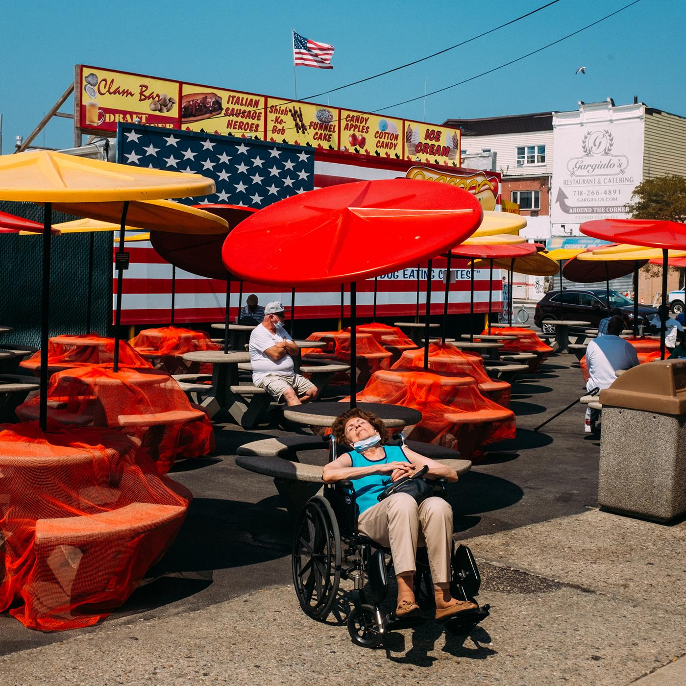
Dia Libre en el Yanky cover art by Mario Rubén Carrión

